Multivariate statistics II: PCR and PLSR
Solve Sæbø
Mar 18 2025

Topics for this lecture
- Motivation for dimension reduction in regression
- Principal Components regression (PCR)
- Partial Least Squares Regression (PLSR)

Motivation for dimension reduction in regression
- The ordinary least squares estimator is much used since:
  - It is an unbiased estimator
  - Among all unbiased estimators it has minimum variance
- However, it has some problems:
  - Requires $n>p$ (more observations than variables)
  - May suffer from inflated variances when $n∼p$, or…
  - …if the predictors are highly collinear

Example - Chemometrics/Spectroscopy
- Near Infra Red (NIR)-spectroscopy absorbance spectra.
- $p=700$ wavelenghts for $n=100$ samples.
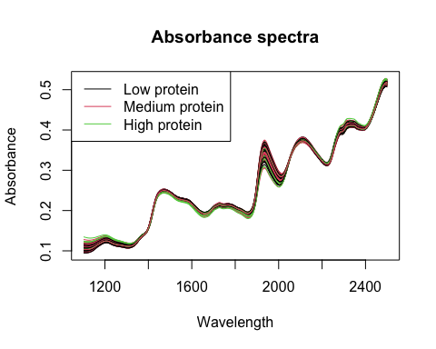

OLS under multi-collinearity, I
- Regression with one wavelength, w1522
##
## Call:
## lm(formula = Absorbance ~ NIR.w1522, data = NIRdata)
##
## Residuals:
## Min 1Q Median 3Q Max
## -1.68013 -0.52481 -0.03636 0.49450 1.56003
##
## Coefficients:
## Estimate Std. Error t value Pr(>|t|)
## (Intercept) 38.77 7.48 5.184 1.17e-06 ***
## NIR.w1522 -132.94 31.88 -4.169 6.60e-05 ***
## ---
## Signif. codes: 0 '***' 0.001 '**' 0.01 '*' 0.05 '.' 0.1 ' ' 1
##
## Residual standard error: 0.7131 on 98 degrees of freedom
## Multiple R-squared: 0.1507, Adjusted R-squared: 0.142
## F-statistic: 17.38 on 1 and 98 DF, p-value: 6.598e-05

OLS under multi-collinearity, II
- Regression with two highly correlated predictors
##
## Call:
## lm(formula = Absorbance ~ NIR.w1522 + NIR.w1532, data = NIRdata)
##
## Residuals:
## Min 1Q Median 3Q Max
## -1.3721 -0.4781 -0.1079 0.4943 1.5716
##
## Coefficients:
## Estimate Std. Error t value Pr(>|t|)
## (Intercept) 54.904 8.701 6.310 8.34e-09 ***
## NIR.w1522 -2052.372 592.367 -3.465 0.000792 ***
## NIR.w1532 1878.503 578.968 3.245 0.001614 **
## ---
## Signif. codes: 0 '***' 0.001 '**' 0.01 '*' 0.05 '.' 0.1 ' ' 1
##
## Residual standard error: 0.6808 on 97 degrees of freedom
## Multiple R-squared: 0.2338, Adjusted R-squared: 0.218
## F-statistic: 14.8 on 2 and 97 DF, p-value: 2.456e-06

A graphical view of multicollinearity
- A dynamic 3D-plot of wavelengths 1522 and 1524 vs protein (Y) using the rgl package. Try yourself!
library(rgl)
attach(NIRdata)
plot3d(NIR.w1522, NIR.w1532, Absorbance, col= "blue", radius=0.05, type="s", xlab="w1522", ylab="w1524", zlab="Absorbance")
detach(NIRdata)

3D plot
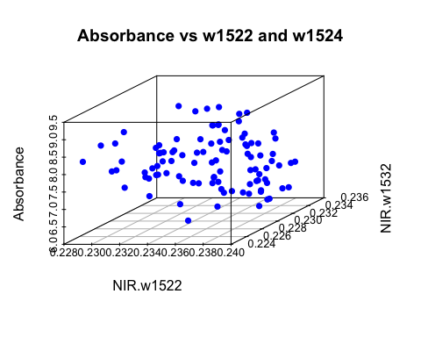

OLS and overfitting
- Pick a random set of 100 variables as predictors.
- Fit a linear model
- Compute the $R^{2}$ and adjusted $R^{2}$
vars <- sample(2:701, 50, replace=FALSE)
fmla <- as.formula(paste("Absorbance ~ ", paste(names(NIRdata)[vars], collapse= "+")))
lmfit3 <- lm(fmla, data=NIRdata)
res <- summary(lmfit3)
res$r.squared
res$adj.r.squared
## [1] 0.9366072
## [1] 0.8719208

How to handle these problems
- Forward variable selection in OLS? (data reduction)
- Use alternative estimator, e.g. PCR or PLSR (data reduction to ‘principal components’)

PCA of NIR data
- Let’s return to the 3D plot from above
- Locate the principal components
- Discuss the variances of the two principal components
- How many PC’s are needed to capture 99% of the variability in the entire NIR data?

PCR
- In PCR the principal components (PCs) replace the original X-variables as predictors in regression.
- Let $a$ be the number of PCs we choose to use (e.g. explaining 99% X-variability)
- Typically we use $a<<k$ components in the model.
The model with $a$ components:
$$Y=α_{0}+α_{1}Z_{1}+α_{2}Z_{2}⋯+α_{a}Z_{a}+ϵ$$
- The $α$’s are estimated by the Ordinary Least Squares method.

Example, NIR data
- Run PCA on the Wavelength data, check results, scree plot
pcafmla <- as.formula(paste("~ ", paste(colnames(NIRdata)[2:600], collapse= "+")))
PCAModel.3 <- prcomp(pcafmla, scale.= FALSE, data=NIRdata)
screeplot(PCAModel.3)

The Scree plot
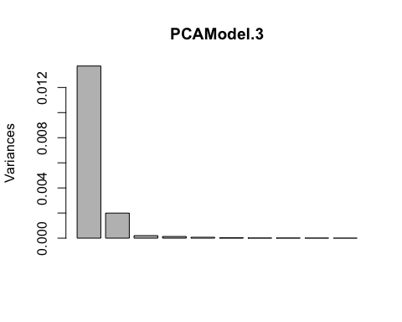

Saving some principal components as extra variables to the data
PCAdata <<- within(NIRdata, {
PC5 <- PCAModel.3$x[,5]
PC4 <- PCAModel.3$x[,4]
PC3 <- PCAModel.3$x[,3]
PC2 <- PCAModel.3$x[,2]
PC1 <- PCAModel.3$x[,1]
})

Regression model, PC1-PC5
LinearModel.4 <- lm(Y ~ PC1 + PC2 + PC3 + PC4 + PC5, data=PCAdata)
sumfit <- summary(LinearModel.4)
round(sumfit$coefficients,3)
## Estimate Std. Error t value Pr(>|t|)
## (Intercept) 7.588 0.052 145.807 0.000
## PC1 0.151 0.447 0.337 0.737
## PC2 4.061 1.171 3.468 0.001
## PC3 30.149 3.680 8.192 0.000
## PC4 3.063 4.520 0.678 0.500
## PC5 40.787 6.224 6.553 0.000
- Note that PC1 is not significant

Running the PCR in RStudio with the pls package
- After estimation of the $α$’s the regression coefficients for the original variables may be computed by a reverse transformation.
- These are easiest computed using the pcr function in the pls package.
library(pls)
pcrfit <- pcr(Absorbance ~ ., data=NIRdata, scale=FALSE)
summary(pcrfit)
coefs.pc11 <- coef(pcrfit, 11)

The regression coefficients plotted
- Here are the coefficients based on 11 PC’s

Better to be presisly wrong…
…than approximately right
The PCR-estimates for the model with original predictors has typically these properties:
- They are biased if $a<k$ (but being closer to zero than OLS)
- Have smaller variances than the least squares estimates.
Prediction error may be smaller for PCR than OLS model since:
Expected squared prediction error =
$σ^{2}$ + var(estimates) + bias(estimates)$​^{2}$

Choosing the number of components, $a$
- Cross-validation. As Leave-one-out (LOO-CV), or K-fold.
- Root Mean Squared Error of Prediction (RMSEP)
$$RMSEP_{LOO−CV}=\sqrt{\frac{1}{n}\sum_{i=n}^{n}{{\left(y_{i}−{\hat{y}}_{\left(i\right)}\right)}^{2}}}$$
where ${\hat{y}}_{\left(i\right)}$ is a prediction of $y_{i}$ based on a data set where observation $i$ has been left out.
- Compare RMSEP for $a=1,2,…$ and choose a simple, but good predictor.

LOO-CV example - R-code
MVRModel.7 <- pcr(Absorbance ~ ., data=NIRdata, scale=FALSE, ncomp=15, validation="LOO")
summary(MVRModel.7)

Summary with RMSEP-values
## Data: X dimension: 100 700
## Y dimension: 100 1
## Fit method: svdpc
## Number of components considered: 15
##
## VALIDATION: RMSEP
## Cross-validated using 100 leave-one-out segments.
## (Intercept) 1 comps 2 comps 3 comps 4 comps 5 comps 6 comps
## CV 0.7737 0.7805 0.7668 0.6406 0.6364 0.5576 0.5386
## adjCV 0.7737 0.7804 0.7667 0.6401 0.6363 0.5575 0.5385
## 7 comps 8 comps 9 comps 10 comps 11 comps 12 comps 13 comps
## CV 0.5499 0.5005 0.4381 0.4328 0.3978 0.4046 0.3979
## adjCV 0.5497 0.5003 0.4375 0.4326 0.3975 0.4044 0.3976
## 14 comps 15 comps
## CV 0.4041 0.3974
## adjCV 0.4038 0.3971
##
## TRAINING: % variance explained
## 1 comps 2 comps 3 comps 4 comps 5 comps 6 comps 7 comps
## X 84.80628 96.599 97.82 98.86 99.44 99.66 99.74
## Absorbance 0.09501 5.334 35.27 37.55 52.14 56.57 56.74
## 8 comps 9 comps 10 comps 11 comps 12 comps 13 comps 14 comps
## X 99.81 99.86 99.9 99.93 99.95 99.96 99.97
## Absorbance 65.32 74.00 75.2 79.34 79.43 80.42 80.62
## 15 comps
## X 99.98
## Absorbance 81.78

Plotting RMSEP
plot(RMSEP(MVRModel.7))
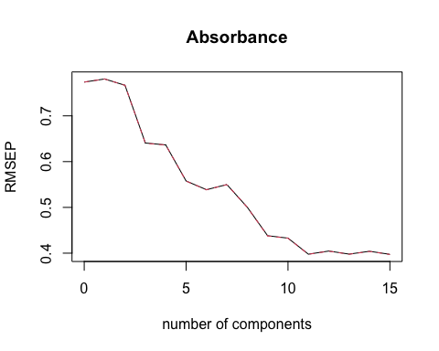

Partial Least Squares Regression
A problem with PCR is that the PC’s may not be good predictors for a response variable.
Partial Least Squares, on the other hand, is seeking PC’s that
- have maximum covariance between predictors and the response
- are orthogonal to each other
- search more directly for y-relevant information for prediction

An example
Let’s sketch a situation were PLS will find other latent components than PCA

Fitting the PLSR model in RStudio
MVRModel.8 <- plsr(Absorbance ~ ., data=NIRdata, scale=FALSE, ncomp=15)
summary(MVRModel.8)

Summary
## Data: X dimension: 100 700
## Y dimension: 100 1
## Fit method: kernelpls
## Number of components considered: 15
## TRAINING: % variance explained
## 1 comps 2 comps 3 comps 4 comps 5 comps 6 comps 7 comps
## X 45.489 95.56 97.74 98.35 98.76 99.53 99.71
## Absorbance 9.735 17.66 53.15 62.68 72.32 76.26 80.74
## 8 comps 9 comps 10 comps 11 comps 12 comps 13 comps 14 comps
## X 99.76 99.80 99.85 99.89 99.91 99.94 99.95
## Absorbance 83.11 85.33 86.83 87.75 88.68 89.11 90.35
## 15 comps
## X 99.97
## Absorbance 90.71

Running LOO-CV and RMSEP plot
MVRModel.8 <- plsr(Absorbance ~ ., data=NIRdata, scale=FALSE, ncomp=15, validation='LOO')
plot(RMSEP(MVRModel.8))

The RMSEP plot
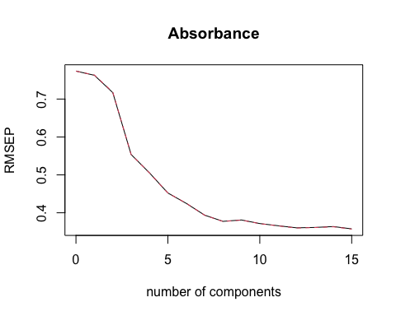

The regression coefficients plotted
- Here are the coefficients based on 8 PLS PC’s

Significance testing in PLSR
- No analytical expression for standard errors of estimates!
- No estimate of noise variance!
- Testing based on something called Jack-knifing

Jack-knifing
- Leave-one-out method
- A estimate the variance of the regression coefficients is computed from the saved estimated coefficients from the $n$ LOO-estimations.
- Readily computed in the pls package using the jack.test function.
$$Var\left(\hat{β}\right)=\frac{n−1}{n}\sum_{i=1}^{n}{{\left({\hat{β}}_{\left(−i\right)}−\hat{β}\right)}^{2}}$$

Jack-knifing in RStudio
MVRModel.8 <- plsr(Absorbance ~ ., data=NIRdata, scale=FALSE, ncomp=15, validation='LOO', jackknife=TRUE)
j.test <- jack.test(MVRModel.8, ncomp = 8, use.mean = FALSE)
print(j.test)

