**Test Backbone Video Manager (TBBYC)**

This is educational app for studying Backbone library.

**Technologies**:

1. NodeJS,
2. Express Framework
3. Backbone,
4. Underscore,
5. JQuery,
6. Bootstrap,
7. Webpack

**Entry points**:

Videos page

**Browsers**: IE 9+, Firefox, Chrome, Safari, Opera.

**Basic essence**:

1. Video - provides video entity data
2. Channel - provides a list of videos thats related with the channel, and channel data
3. Comment - provides text comment for video

In the development, we preferred to use CommonJS pattern.

**Main page:**

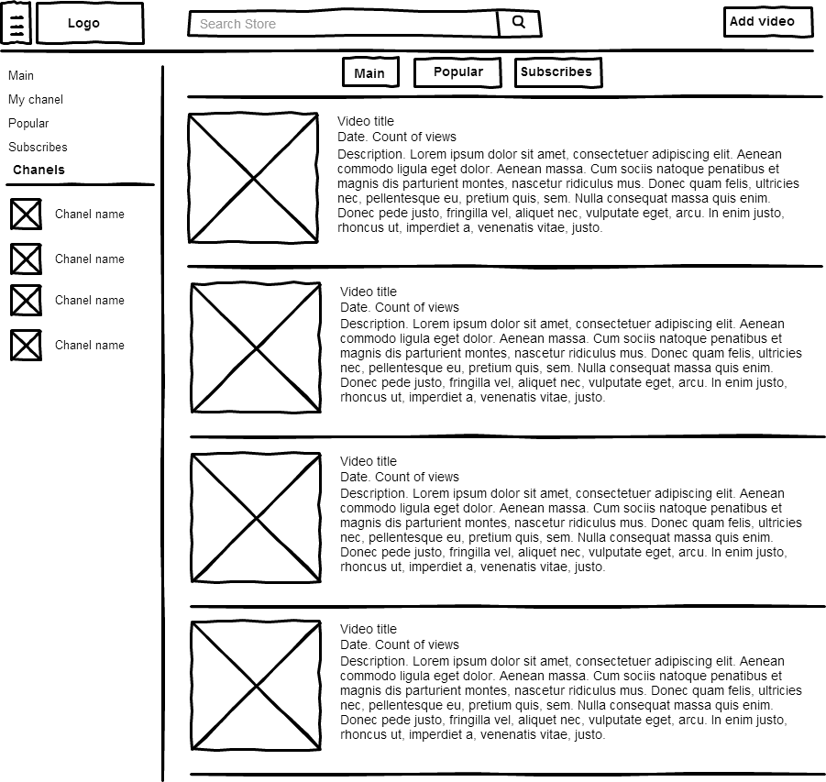

On this page user can search for videos, switch channels in menu, choose video.