1. Create git repository on git.epam.com/github.com

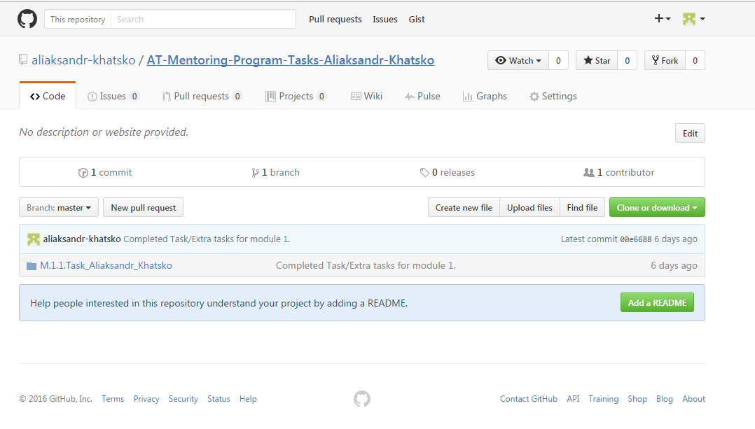

2. Clone using SSH keys

- generate SSH keys

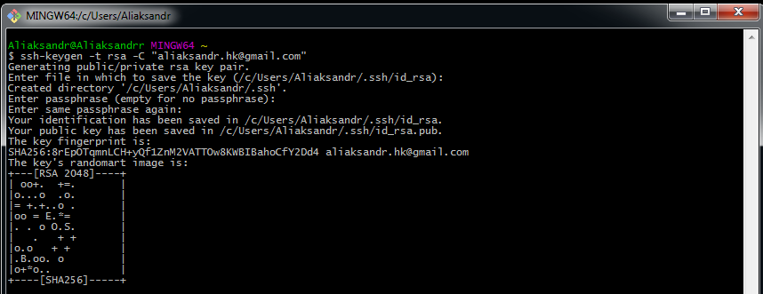

- Add public SSH key to github profile

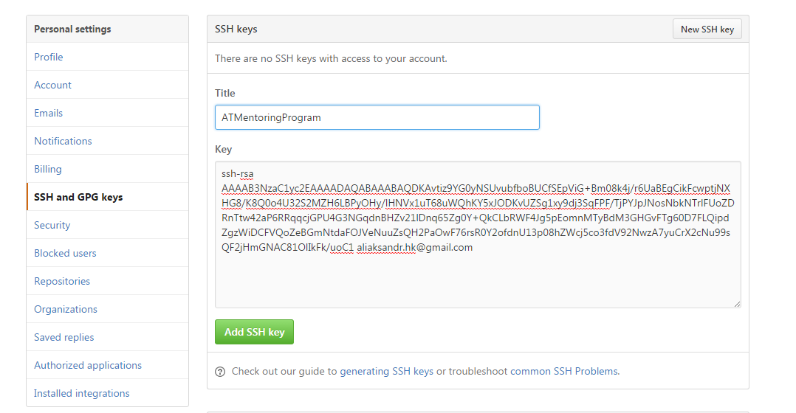

- Configure user name and email

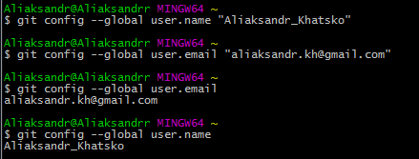

- clone repository

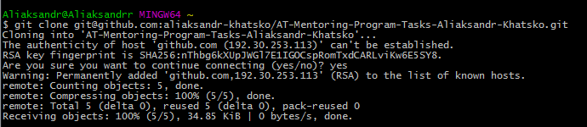  


3. Create 3 commits in master branch

- Add a file with home task  
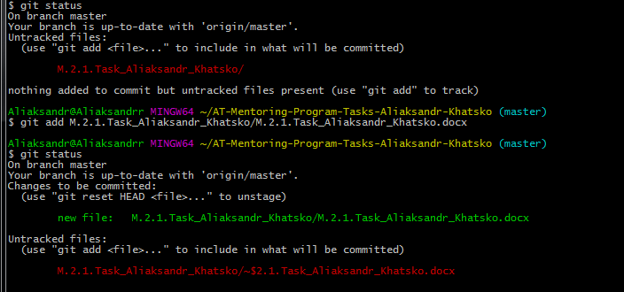

- First commit and push – Add two txt files for commits  
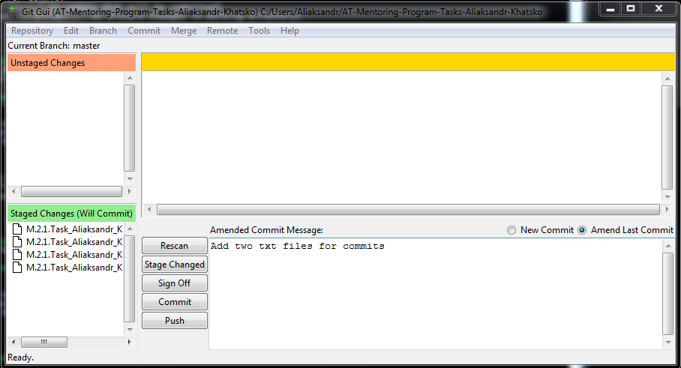

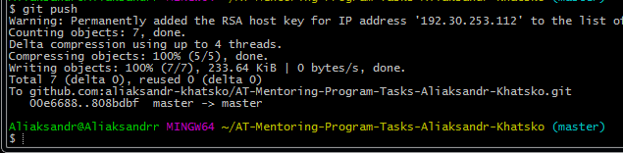

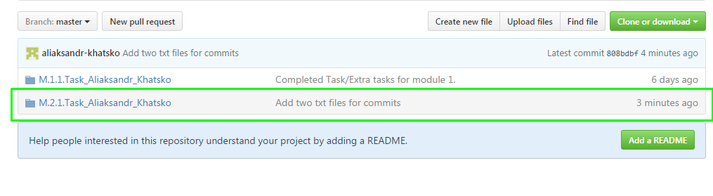

- Second commit – amend first commit (with new comment)

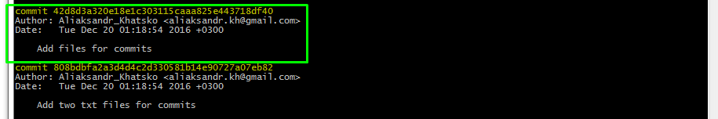

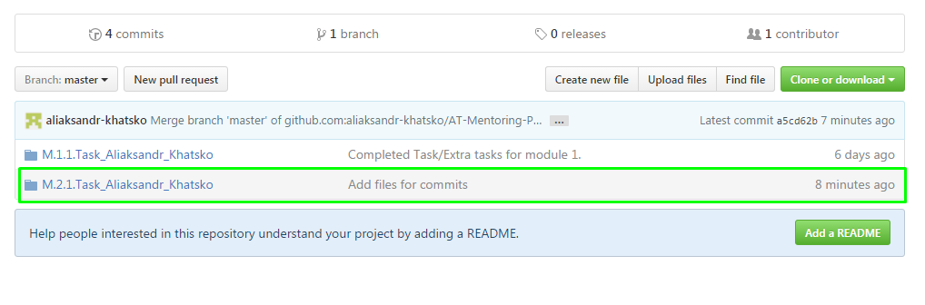

Third commit and push – Add “test” to txt files and update hometask

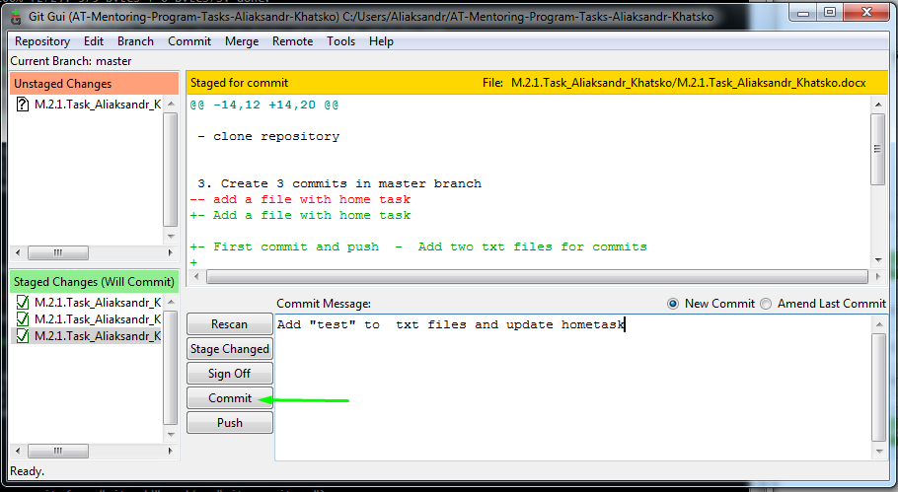

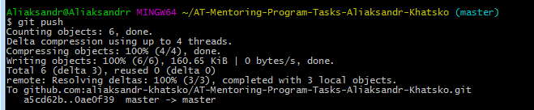

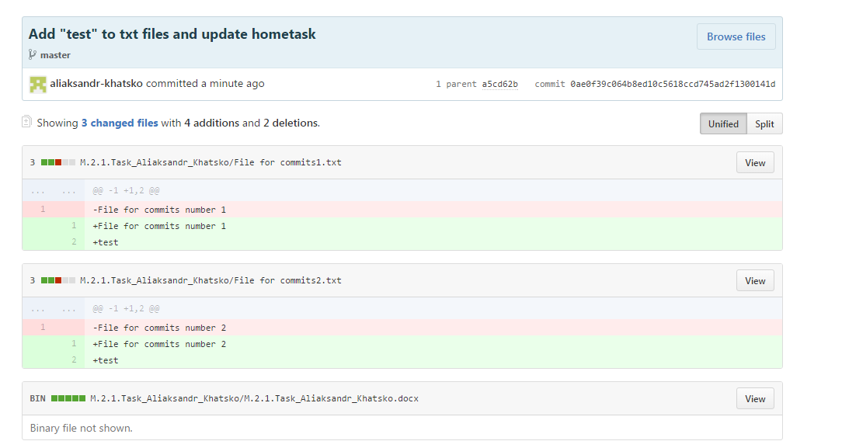

4. Create new "dev" branch and push 2 commits inside

- First commit – Delete spaces from file names

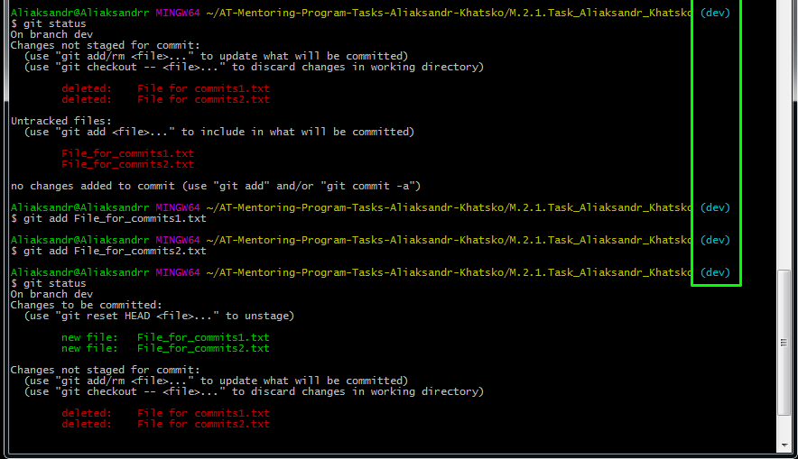

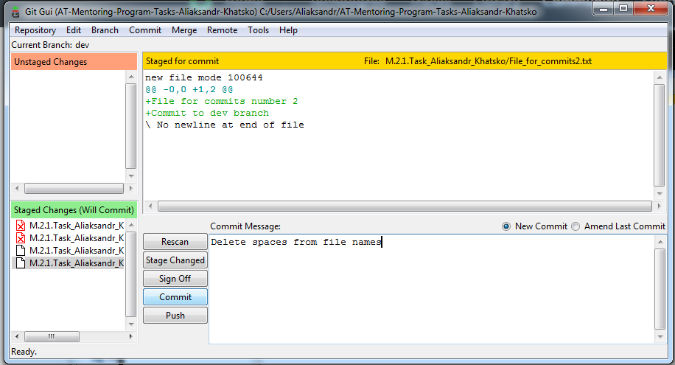

Second commit – Update File_for_commits with “Commit to dev branch”

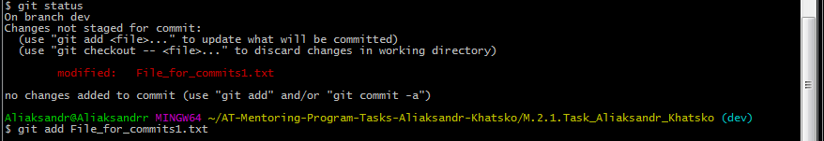

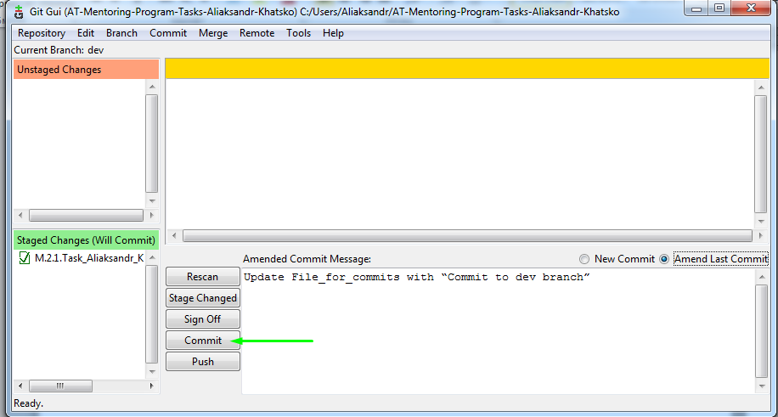

- push 2 commits

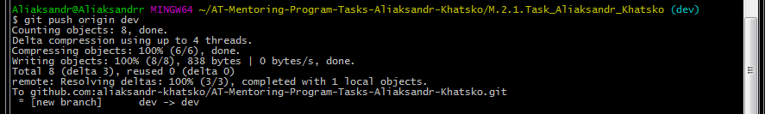

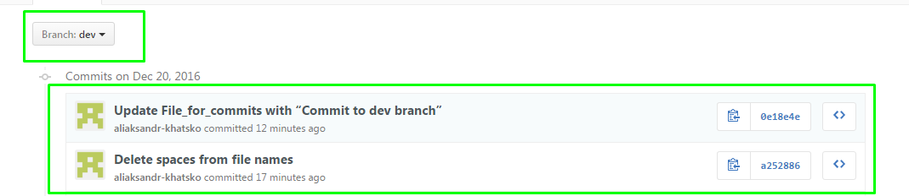

5. Merge "dev" to "master"

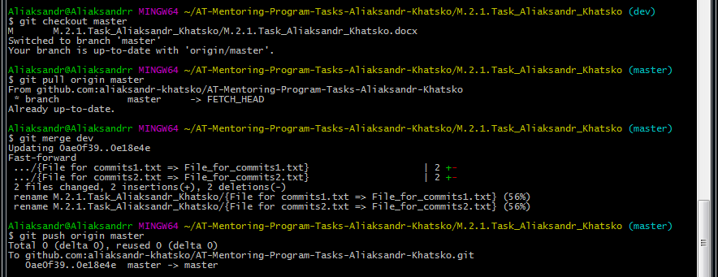

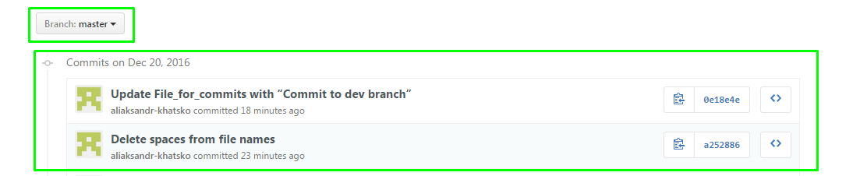

* 6. Add 2 additional commits to "dev", 1 commit in master. Rebase "dev" with new commits from "master"

* 7. Add 2 additonal commits in "dev". Cherry-pick first commit to master. Revert the second commit.