CI Hometask

Git repository: https://github.com/vitalliuss/helloci

1) Install Jenkins server on local or remote machine

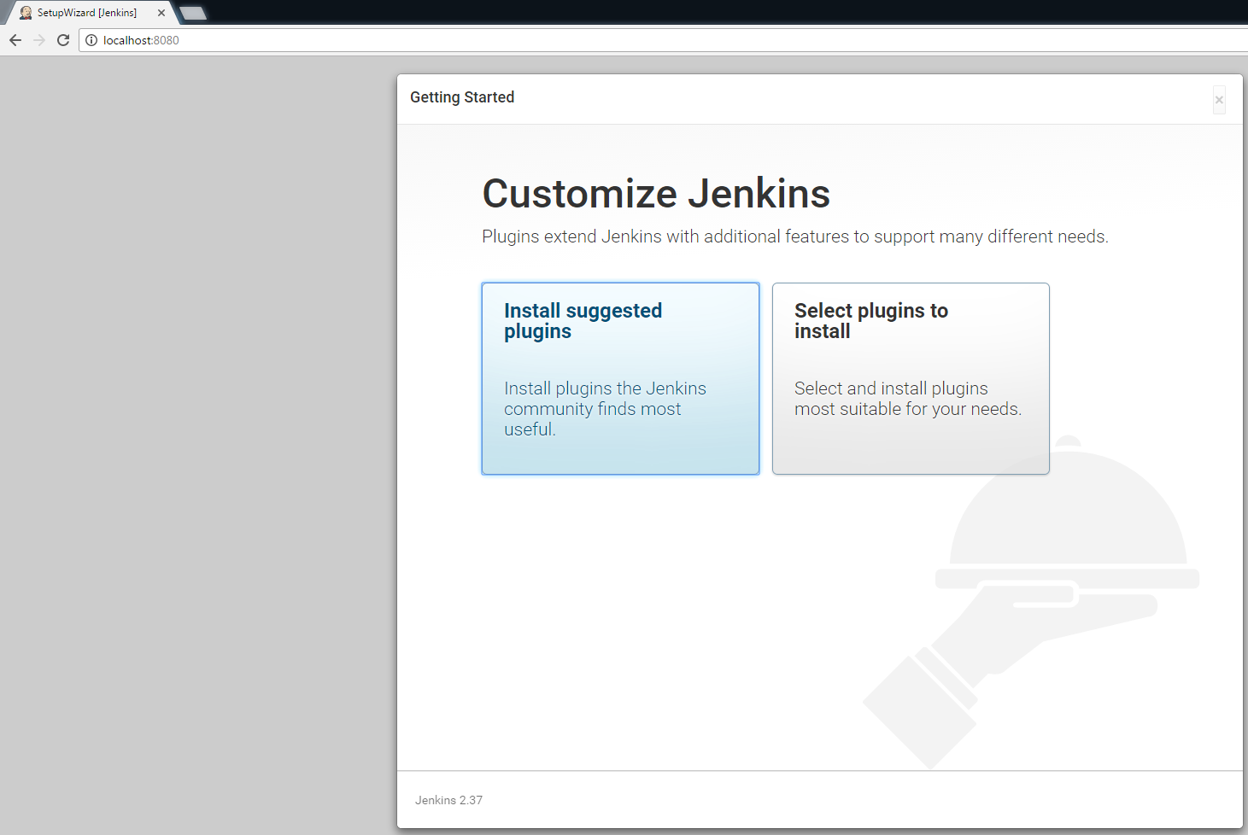

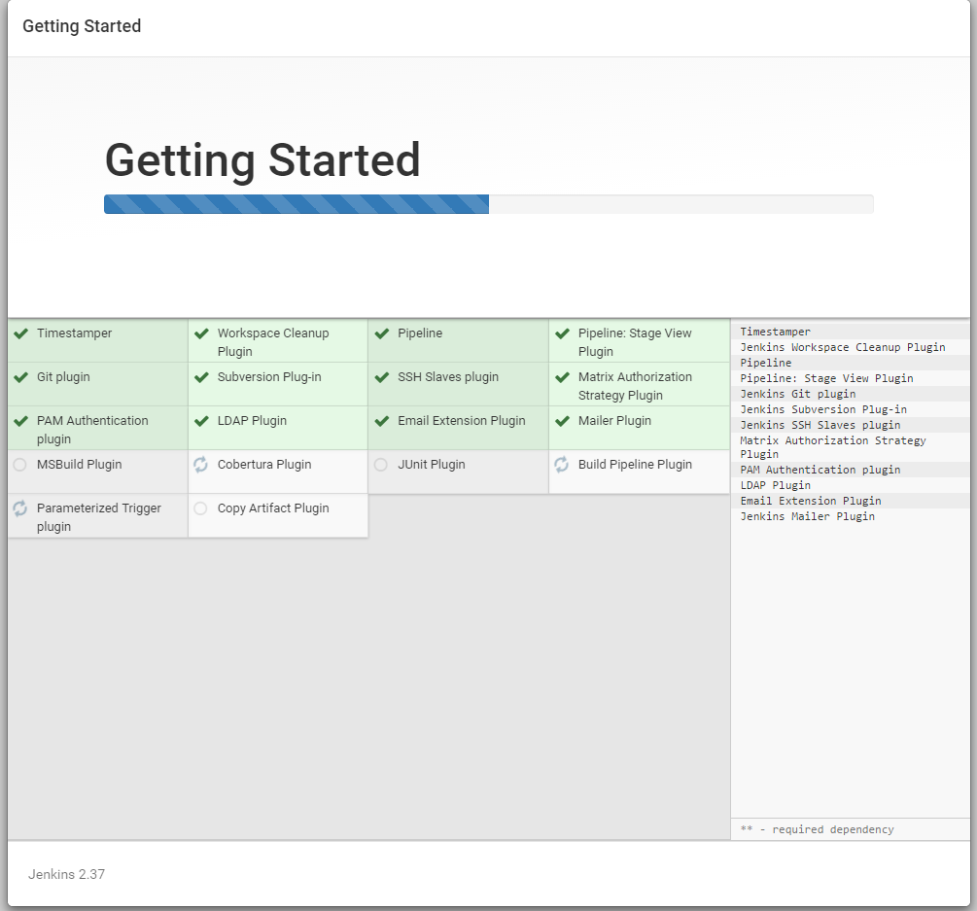

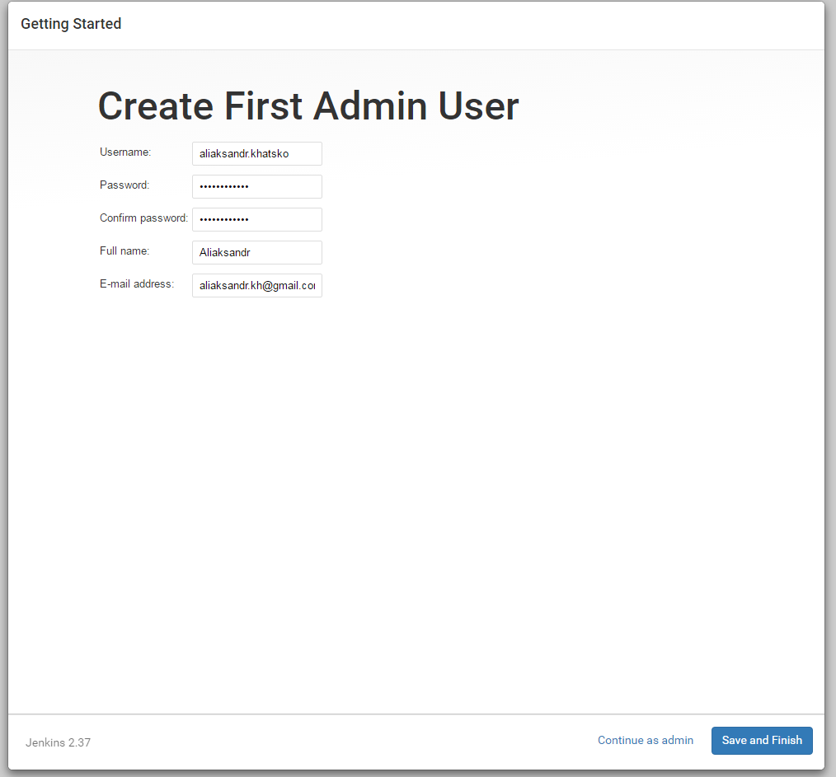

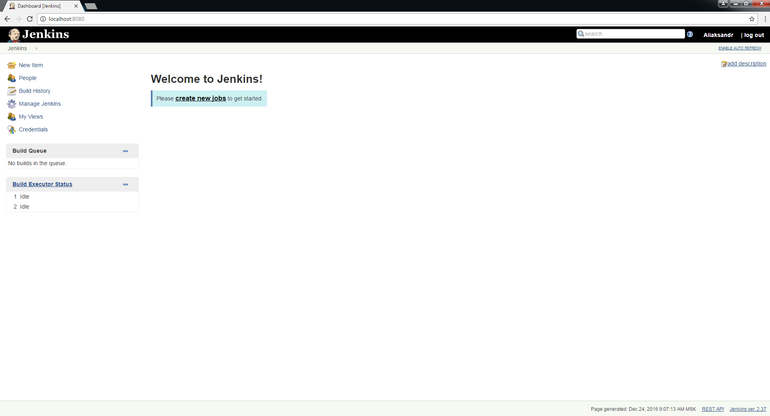

2) Change Jenkins default port to 8081  
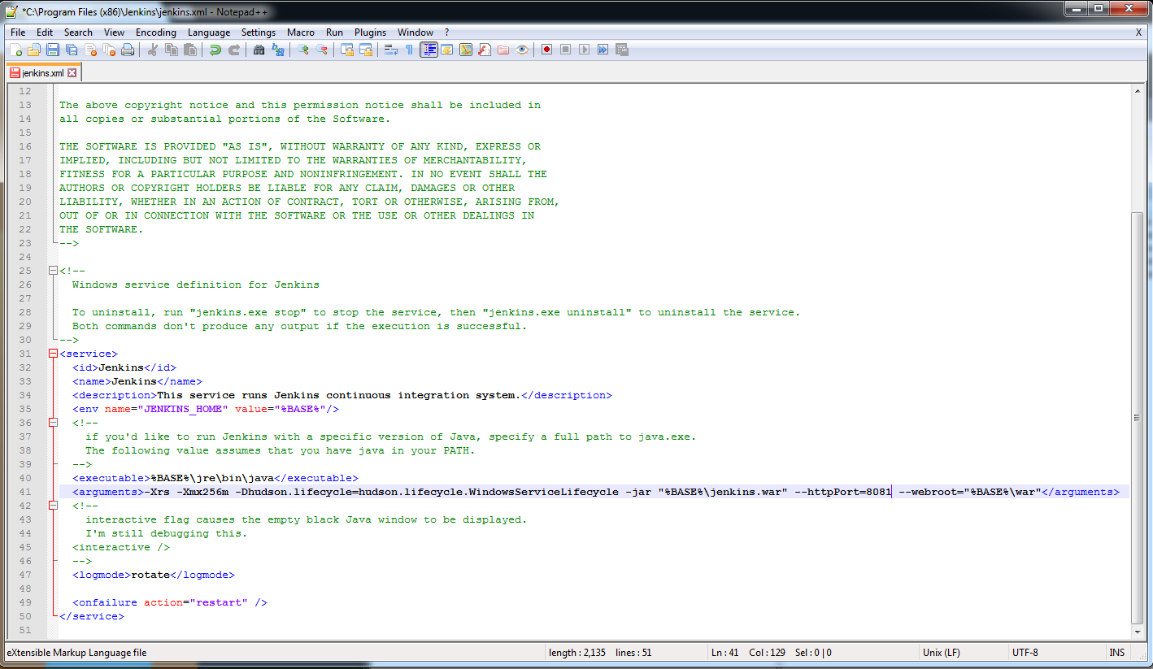

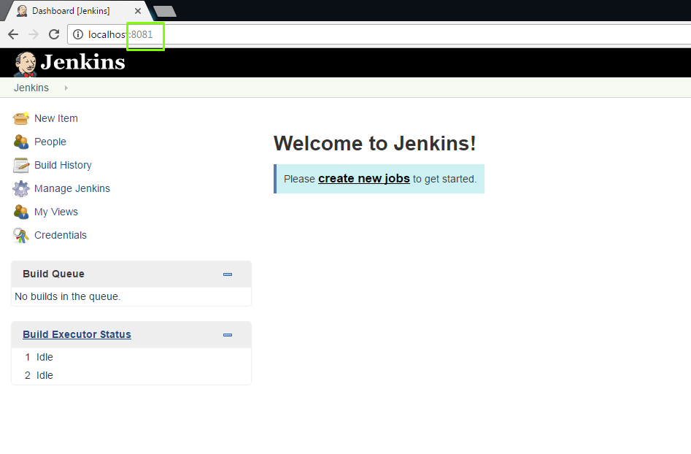

3) Create slave node on remote or local machine (you may use the same (one) machine for master and slave)

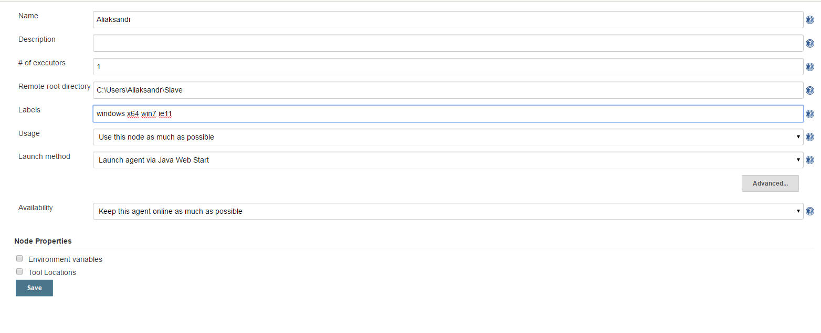

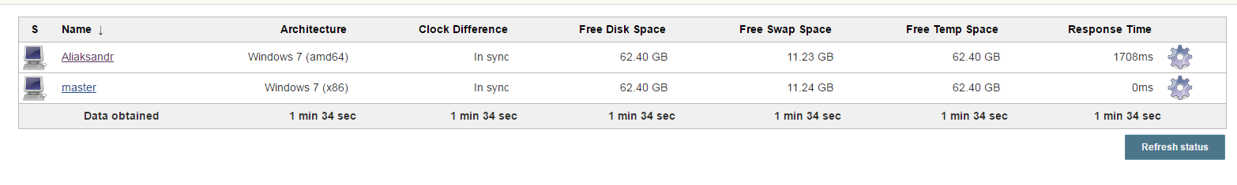

4) Create a job with the following steps:

a. Get code from git repository: https://github.com/vitalliuss/helloci

.NET: build solution (*.sln) with MSBuild

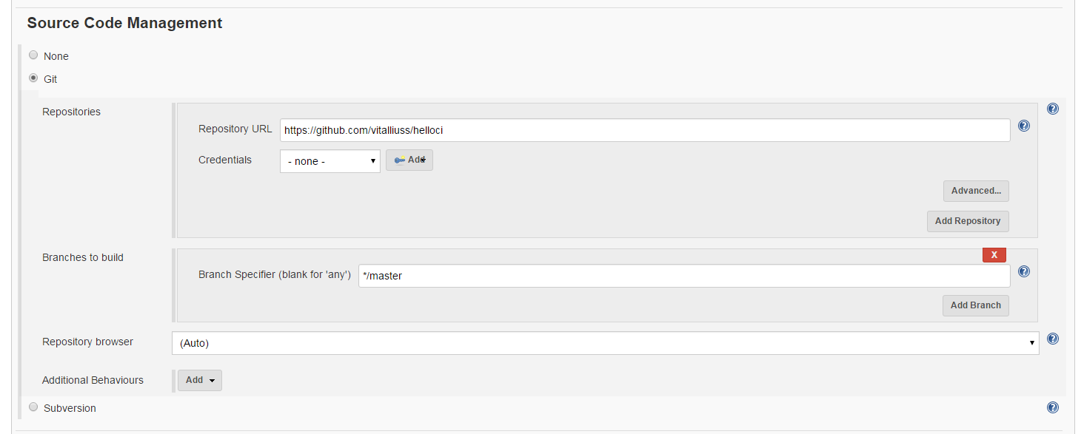

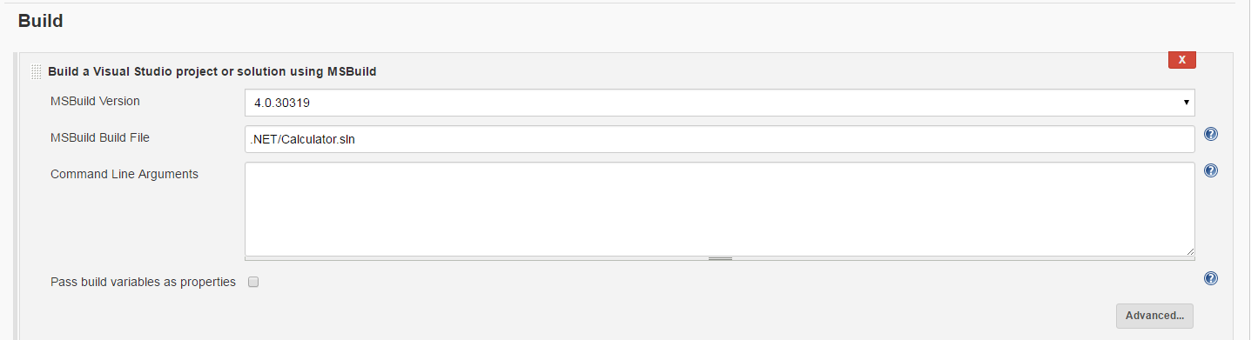

b. Set build triggers:

i. after commit in VCS no logner than in 5 minutes

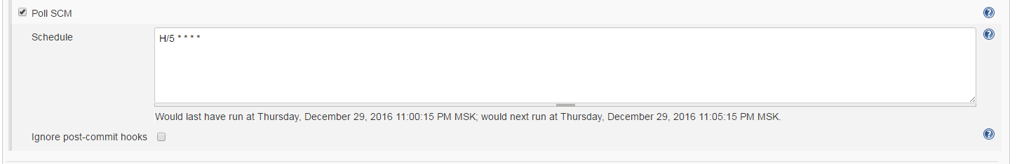

ii. at midnight every weekday (Mon-Fri)

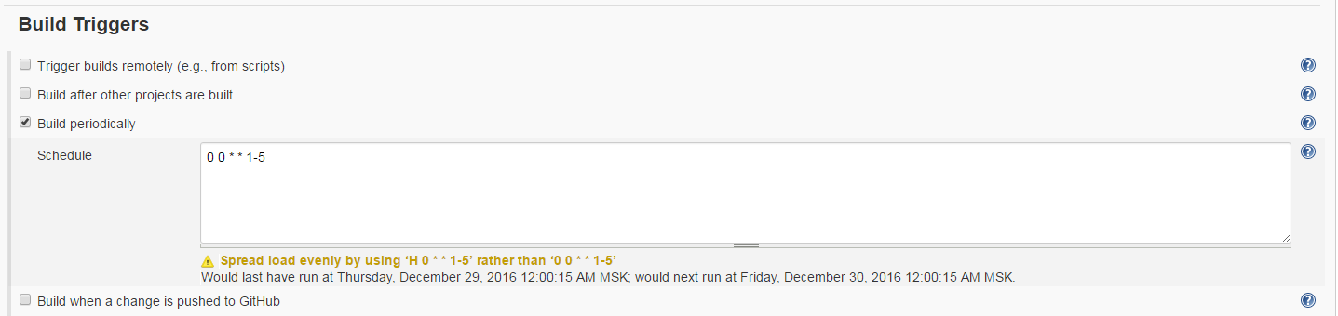

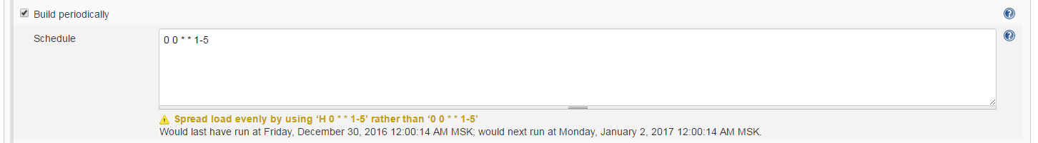

c. Job should run on slave only

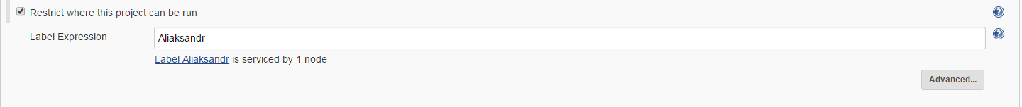

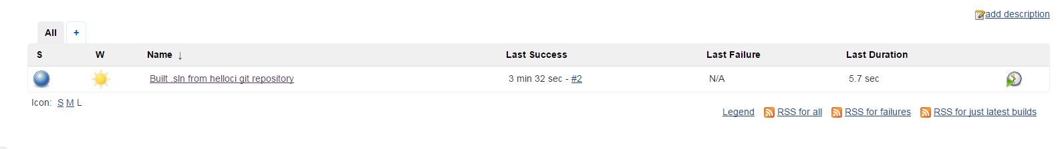



Started by timer

Building remotely on [Aliaksandr](http://localhost:8081/computer/Aliaksandr) (x64 win7 windows ie11) in workspace C:\Users\Aliaksandr\Slave\workspace\Built .sln from helloci git repository

Cloning the remote Git repository

Cloning repository <https://github.com/vitalliuss/helloci>

> C:\Program Files\Git\cmd\git.exe init C:\Users\Aliaksandr\Slave\workspace\Built .sln from helloci git repository # timeout=10

Fetching upstream changes from <https://github.com/vitalliuss/helloci>

> C:\Program Files\Git\cmd\git.exe --version # timeout=10

> C:\Program Files\Git\cmd\git.exe fetch --tags --progress <https://github.com/vitalliuss/helloci> +refs/heads/*:refs/remotes/origin/*

> C:\Program Files\Git\cmd\git.exe config remote.origin.url <https://github.com/vitalliuss/helloci> # timeout=10

> C:\Program Files\Git\cmd\git.exe config --add remote.origin.fetch +refs/heads/*:refs/remotes/origin/* # timeout=10

> C:\Program Files\Git\cmd\git.exe config remote.origin.url <https://github.com/vitalliuss/helloci> # timeout=10

Fetching upstream changes from <https://github.com/vitalliuss/helloci>

> C:\Program Files\Git\cmd\git.exe fetch --tags --progress <https://github.com/vitalliuss/helloci> +refs/heads/*:refs/remotes/origin/*

> C:\Program Files\Git\cmd\git.exe rev-parse "refs/remotes/origin/master^{commit}" # timeout=10

> C:\Program Files\Git\cmd\git.exe rev-parse "refs/remotes/origin/origin/master^{commit}" # timeout=10

Checking out Revision 37b68612ef77f4cda7425a3fe008ee847bb29d51 (refs/remotes/origin/master)

> C:\Program Files\Git\cmd\git.exe config core.sparsecheckout # timeout=10

> C:\Program Files\Git\cmd\git.exe checkout -f 37b68612ef77f4cda7425a3fe008ee847bb29d51

> C:\Program Files\Git\cmd\git.exe rev-list 37b68612ef77f4cda7425a3fe008ee847bb29d51 # timeout=10

Path To MSBuild.exe: C:\Windows\Microsoft.NET\Framework64\v4.0.30319\MSBuild.exe

Executing the command cmd.exe /C " C:\Windows\Microsoft.NET\Framework64\v4.0.30319\MSBuild.exe .NET/Calculator.sln " && exit %%ERRORLEVEL%% from C:\Users\Aliaksandr\Slave\workspace\Built .sln from helloci git repository

[Built .sln from helloci git repository] $ cmd.exe /C " C:\Windows\Microsoft.NET\Framework64\v4.0.30319\MSBuild.exe .NET/Calculator.sln " && exit %%ERRORLEVEL%%

Microsoft (R) Build Engine version 4.0.30319.18408

[Microsoft .NET Framework, version 4.0.30319.18408]

Copyright (C) Microsoft Corporation. All rights reserved.

Building the projects in this solution one at a time. To enable parallel build, please add the "/m" switch.

Build started 12/30/2016 12:00:04 AM.

Project "C:\Users\Aliaksandr\Slave\workspace\Built .sln from helloci git repository\.NET\Calculator.sln" on node 1 (default targets).

ValidateSolutionConfiguration:

Building solution configuration "Debug|Mixed Platforms".

Project "C:\Users\Aliaksandr\Slave\workspace\Built .sln from helloci git repository\.NET\Calculator.sln" (1) is building "C:\Users\Aliaksandr\Slave\workspace\Built .sln from helloci git repository\.NET\Calculator\Calculator.csproj" (2) on node 1 (default targets).

PrepareForBuild:

Creating directory "bin\Debug\".

Creating directory "obj\x86\Debug\".

ResolveAssemblyReferences:

A TargetFramework profile exclusion list will be generated.

CoreCompile:

C:\Windows\Microsoft.NET\Framework64\v4.0.30319\Csc.exe /noconfig /nowarn:1701,1702 /nostdlib+ /platform:AnyCPU /errorreport:prompt /warn:4 /define:DEBUG;TRACE /highentropyva- /reference:"C:\Program Files (x86)\Reference Assemblies\Microsoft\Framework\.NETFramework\v4.0\Profile\Client\Microsoft.CSharp.dll" /reference:"C:\Program Files (x86)\Reference Assemblies\Microsoft\Framework\.NETFramework\v4.0\Profile\Client\mscorlib.dll" /reference:"C:\Program Files (x86)\Reference Assemblies\Microsoft\Framework\.NETFramework\v4.0\Profile\Client\System.Core.dll" /reference:"C:\Program Files (x86)\Reference Assemblies\Microsoft\Framework\.NETFramework\v4.0\Profile\Client\System.Data.DataSetExtensions.dll" /reference:"C:\Program Files (x86)\Reference Assemblies\Microsoft\Framework\.NETFramework\v4.0\Profile\Client\System.Data.dll" /reference:"C:\Program Files (x86)\Reference Assemblies\Microsoft\Framework\.NETFramework\v4.0\Profile\Client\System.dll" /reference:"C:\Program Files (x86)\Reference Assemblies\Microsoft\Framework\.NETFramework\v4.0\Profile\Client\System.Xml.dll" /reference:"C:\Program Files (x86)\Reference Assemblies\Microsoft\Framework\.NETFramework\v4.0\Profile\Client\System.Xml.Linq.dll" /debug+ /debug:full /filealign:512 /optimize- /out:obj\x86\Debug\Calculator.dll /target:library /utf8output Calc.cs Properties\AssemblyInfo.cs "C:\Users\Aliaksandr\AppData\Local\Temp\.NETFramework,Version=v4.0,Profile=Client.AssemblyAttributes.cs"

CopyFilesToOutputDirectory:

Copying file from "obj\x86\Debug\Calculator.dll" to "bin\Debug\Calculator.dll".

Calculator -> C:\Users\Aliaksandr\Slave\workspace\Built .sln from helloci git repository\.NET\Calculator\bin\Debug\Calculator.dll

Copying file from "obj\x86\Debug\Calculator.pdb" to "bin\Debug\Calculator.pdb".

Done Building Project "C:\Users\Aliaksandr\Slave\workspace\Built .sln from helloci git repository\.NET\Calculator\Calculator.csproj" (default targets).

Project "C:\Users\Aliaksandr\Slave\workspace\Built .sln from helloci git repository\.NET\Calculator.sln" (1) is building "C:\Users\Aliaksandr\Slave\workspace\Built .sln from helloci git repository\.NET\CalculatorTest\CalculatorTest.csproj.metaproj" (3) on node 1 (default targets).

Project "C:\Users\Aliaksandr\Slave\workspace\Built .sln from helloci git repository\.NET\CalculatorTest\CalculatorTest.csproj.metaproj" (3) is building "C:\Users\Aliaksandr\Slave\workspace\Built .sln from helloci git repository\.NET\CalculatorTest\CalculatorTest.csproj" (4) on node 1 (default targets).

PrepareForBuild:

Creating directory "bin\Debug\".

Creating directory "obj\Debug\".

CoreCompile:

C:\Windows\Microsoft.NET\Framework64\v4.0.30319\Csc.exe /noconfig /nowarn:1701,1702 /nostdlib+ /errorreport:prompt /warn:4 /define:DEBUG;TRACE /highentropyva- /reference:"C:\Users\Aliaksandr\Slave\workspace\Built .sln from helloci git repository\.NET\Calculator\bin\Debug\Calculator.dll" /reference:"C:\Program Files (x86)\Reference Assemblies\Microsoft\Framework\.NETFramework\v4.0\Microsoft.CSharp.dll" /reference:"C:\Program Files (x86)\Reference Assemblies\Microsoft\Framework\.NETFramework\v4.0\mscorlib.dll" /reference:"C:\Users\Aliaksandr\Slave\workspace\Built .sln from helloci git repository\.NET\Calculator\Lib\nunit.framework.dll" /reference:"C:\Program Files (x86)\Reference Assemblies\Microsoft\Framework\.NETFramework\v4.0\System.Core.dll" /reference:"C:\Program Files (x86)\Reference Assemblies\Microsoft\Framework\.NETFramework\v4.0\System.Data.DataSetExtensions.dll" /reference:"C:\Program Files (x86)\Reference Assemblies\Microsoft\Framework\.NETFramework\v4.0\System.Data.dll" /reference:"C:\Program Files (x86)\Reference Assemblies\Microsoft\Framework\.NETFramework\v4.0\System.dll" /reference:"C:\Program Files (x86)\Reference Assemblies\Microsoft\Framework\.NETFramework\v4.0\System.Xml.dll" /reference:"C:\Program Files (x86)\Reference Assemblies\Microsoft\Framework\.NETFramework\v4.0\System.Xml.Linq.dll" /debug+ /debug:full /filealign:512 /optimize- /out:obj\Debug\CalculatorTest.dll /target:library /utf8output Properties\AssemblyInfo.cs TestCalculator.cs "C:\Users\Aliaksandr\AppData\Local\Temp\.NETFramework,Version=v4.0.AssemblyAttributes.cs"

**TestCalculator.cs(77,34): warning CS0618: 'System.Configuration.ConfigurationSettings.AppSettings' is obsolete: 'This method is obsolete, it has been replaced by System.Configuration!System.Configuration.ConfigurationManager.AppSettings' [C:\Users\Aliaksandr\Slave\workspace\Built .sln from helloci git repository\.NET\CalculatorTest\CalculatorTest.csproj]**

**TestCalculator.cs(79,30): warning CS0618: 'System.Configuration.ConfigurationSettings.AppSettings' is obsolete: 'This method is obsolete, it has been replaced by System.Configuration!System.Configuration.ConfigurationManager.AppSettings' [C:\Users\Aliaksandr\Slave\workspace\Built .sln from helloci git repository\.NET\CalculatorTest\CalculatorTest.csproj]**

_CopyFilesMarkedCopyLocal:

Copying file from "C:\Users\Aliaksandr\Slave\workspace\Built .sln from helloci git repository\.NET\Calculator\bin\Debug\Calculator.dll" to "bin\Debug\Calculator.dll".

Copying file from "C:\Users\Aliaksandr\Slave\workspace\Built .sln from helloci git repository\.NET\Calculator\Lib\nunit.framework.dll" to "bin\Debug\nunit.framework.dll".

Copying file from "C:\Users\Aliaksandr\Slave\workspace\Built .sln from helloci git repository\.NET\Calculator\bin\Debug\Calculator.pdb" to "bin\Debug\Calculator.pdb".

_CopyAppConfigFile:

Copying file from "App.config" to "bin\Debug\CalculatorTest.dll.config".

CopyFilesToOutputDirectory:

Copying file from "obj\Debug\CalculatorTest.dll" to "bin\Debug\CalculatorTest.dll".

CalculatorTest -> C:\Users\Aliaksandr\Slave\workspace\Built .sln from helloci git repository\.NET\CalculatorTest\bin\Debug\CalculatorTest.dll

Copying file from "obj\Debug\CalculatorTest.pdb" to "bin\Debug\CalculatorTest.pdb".

Done Building Project "C:\Users\Aliaksandr\Slave\workspace\Built .sln from helloci git repository\.NET\CalculatorTest\CalculatorTest.csproj" (default targets).

Done Building Project "C:\Users\Aliaksandr\Slave\workspace\Built .sln from helloci git repository\.NET\CalculatorTest\CalculatorTest.csproj.metaproj" (default targets).

Done Building Project "C:\Users\Aliaksandr\Slave\workspace\Built .sln from helloci git repository\.NET\Calculator.sln" (default targets).

Build succeeded.

"C:\Users\Aliaksandr\Slave\workspace\Built .sln from helloci git repository\.NET\Calculator.sln" (default target) (1) ->

"C:\Users\Aliaksandr\Slave\workspace\Built .sln from helloci git repository\.NET\CalculatorTest\CalculatorTest.csproj.metaproj" (default target) (3) ->

"C:\Users\Aliaksandr\Slave\workspace\Built .sln from helloci git repository\.NET\CalculatorTest\CalculatorTest.csproj" (default target) (4) ->

(CoreCompile target) ->

**TestCalculator.cs(77,34): warning CS0618: 'System.Configuration.ConfigurationSettings.AppSettings' is obsolete: 'This method is obsolete, it has been replaced by System.Configuration!System.Configuration.ConfigurationManager.AppSettings' [C:\Users\Aliaksandr\Slave\workspace\Built .sln from helloci git repository\.NET\CalculatorTest\CalculatorTest.csproj]**

**TestCalculator.cs(79,30): warning CS0618: 'System.Configuration.ConfigurationSettings.AppSettings' is obsolete: 'This method is obsolete, it has been replaced by System.Configuration!System.Configuration.ConfigurationManager.AppSettings' [C:\Users\Aliaksandr\Slave\workspace\Built .sln from helloci git repository\.NET\CalculatorTest\CalculatorTest.csproj]**

2 Warning(s)

0 Error(s)

Time Elapsed 00:00:00.30

Finished: SUCCESS

As the result share the link to Jenkins OR set of detailed screenshots of Jenkins and job configuration & logs with your mentor.