CI Extra Hometask

1. Create Build in TeamCity for a new environment.

* Create a subproject for QAVendor.

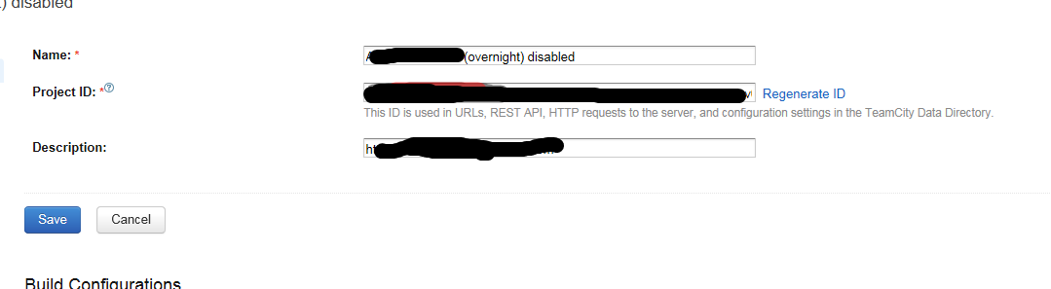

* Copied build configurations

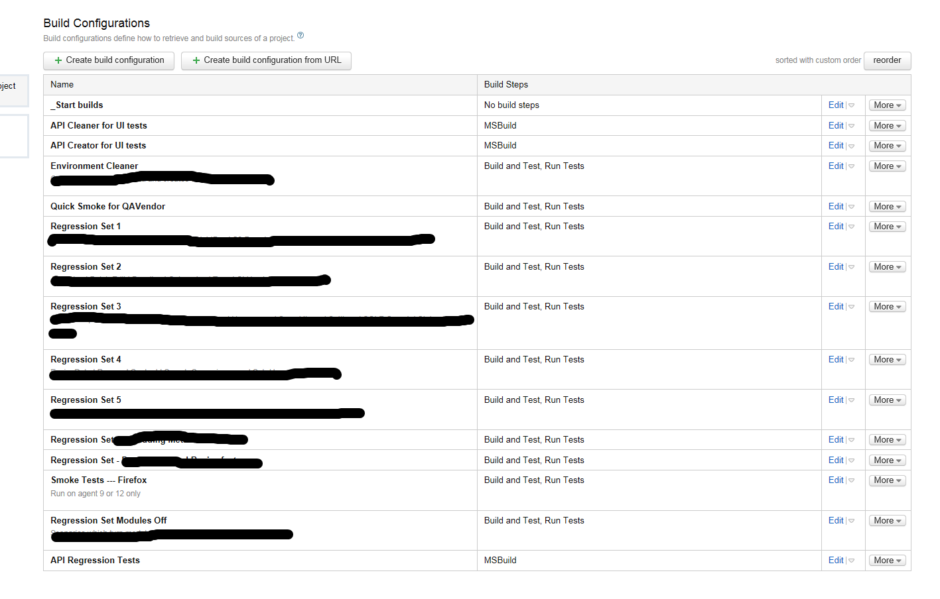

* Set up Start build trigger

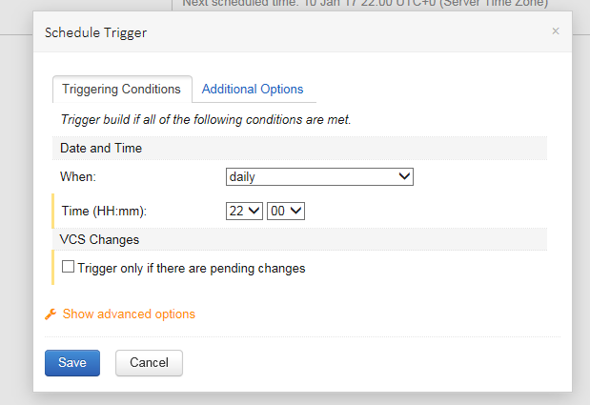

* Set up project source code checking by attaching VCS root

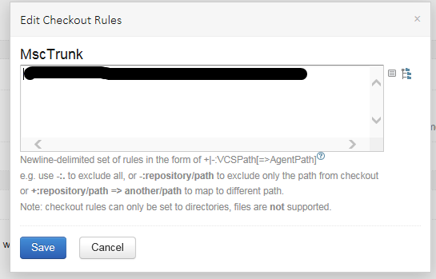

* Create build steps (set up build path and trigger, e.g. “If all previous steps finished successfully”)

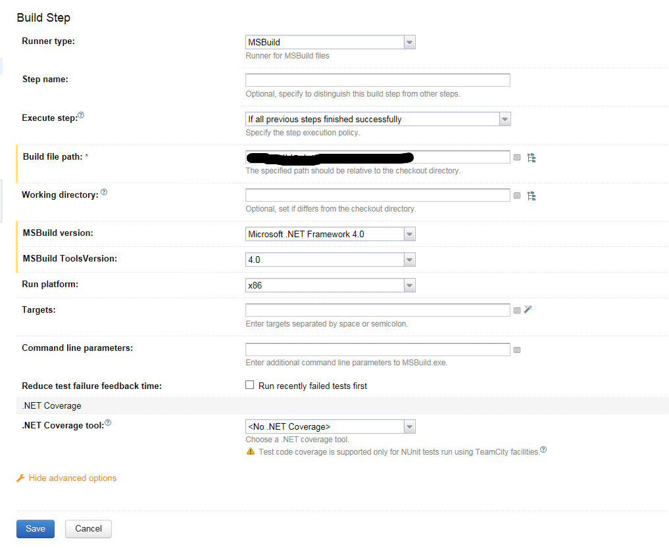

* Set up parameters and variables

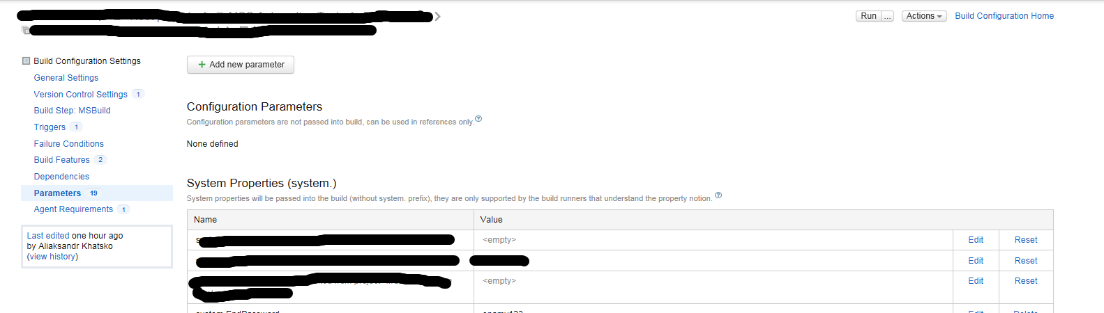

* Set up Agent requirements.

