Homework

1. Write unit tests for the calculator dll library (Calculator1.dll).

Requirements:

* Add Calculator1.dll to your project references.

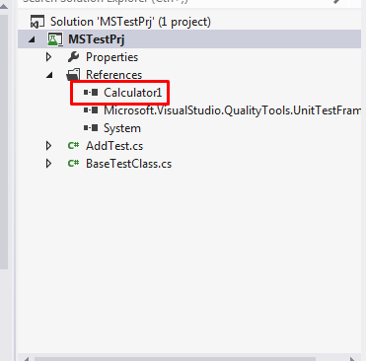

* Write tests using Nunit and MsTest.

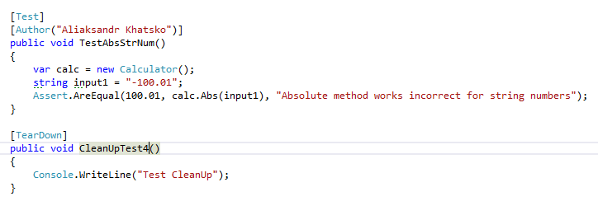

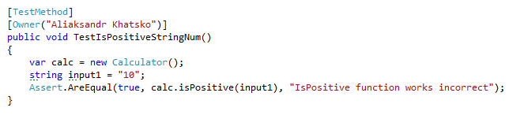

* Each class should test only one method in library (1 method – 1 class).

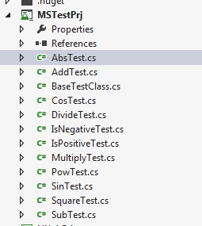

* Should test ability to enter numbers as well as string numbers.

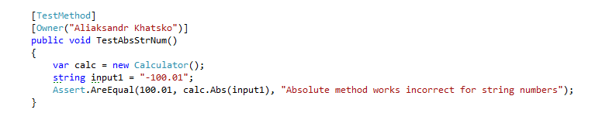



* Run tests in Visual Studio. (screenshots)

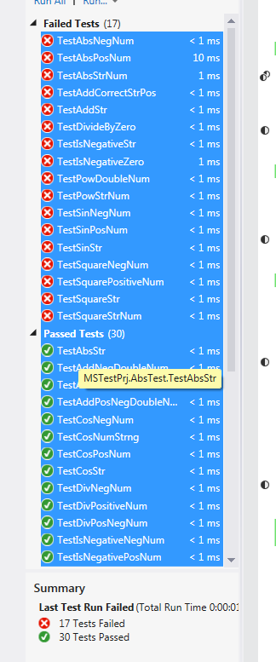

* Run tests in command line (MSTest , nunit-console) with

specified output directory for results. (screenshots)

NUnit:

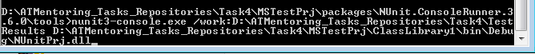

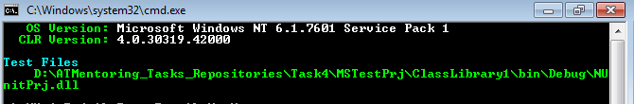

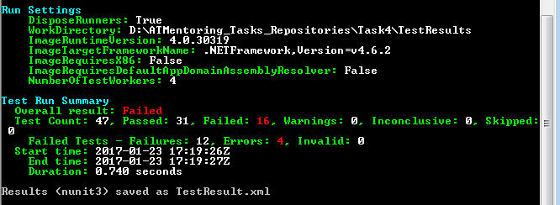

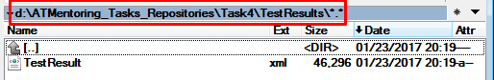

MSTest:

