**Selenium Webdriver – JS, Actions, Remote, Grid - hometask #3**

**PREREQUISITES**: project with Selenium WebDriver HW-s (parts 1 and 2) done.

1. **MANDATORY:**  add at least 2 new Actions implementations to the project from Module 6-2 (*for example: 1 for mouse actions and 1 for keyboard)*.

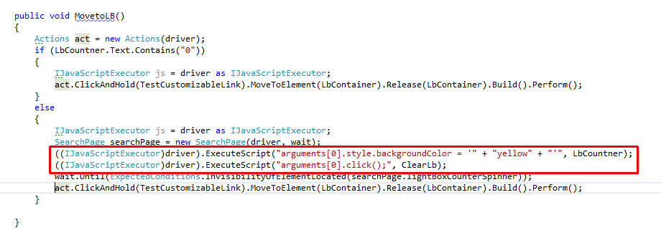

1. **MANDATORY:**  add at least 2 implementation of JavaScript Executor usage\**(for example: implement WebElement highlighter, JS Executor based clicker or WebElement finder)***;**

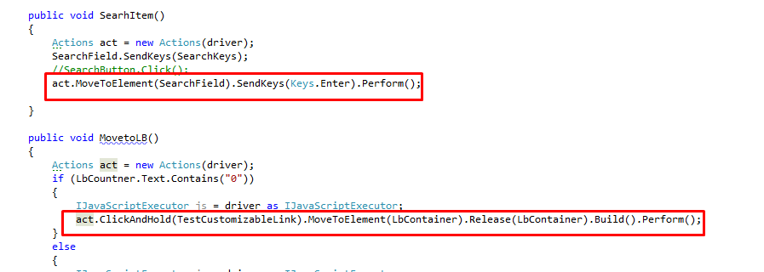

1. **MANDATORY:** set up Selenium Grid with at least two nodes and run all your test suites on the grid**.**

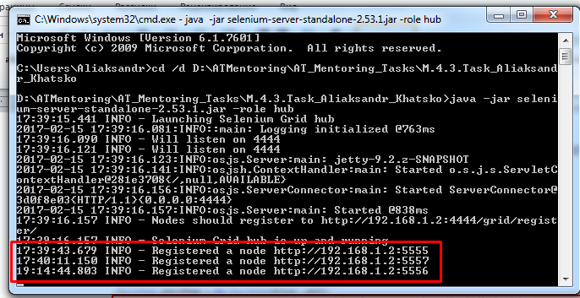

**Chrome**

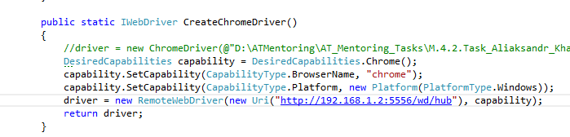

**FF**

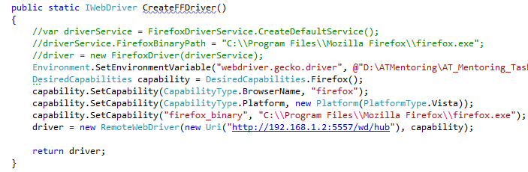

**IE**

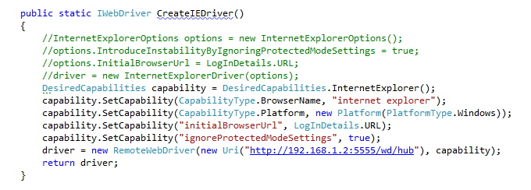

***[*] discuss a concrete assignment with your mentor***

**OPTIONAL TASKS**:

1. make your tests cross-browser (discuss browsers prioritization with your mentor; ideally your tests support launches in Firefox, Chrome and IE).

