TA for Mobile Applications Hometask

1. Install Node.js tools

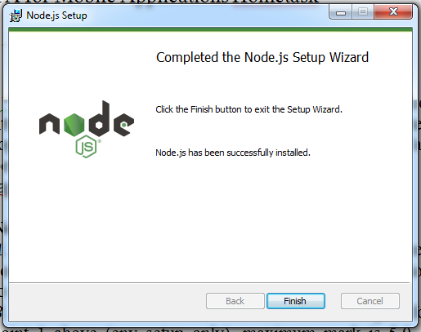

2. Set up PATH environment variable.

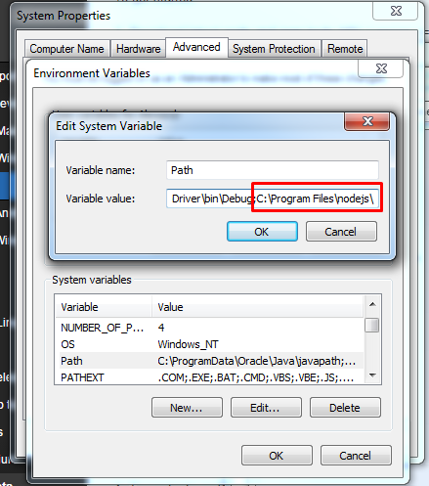

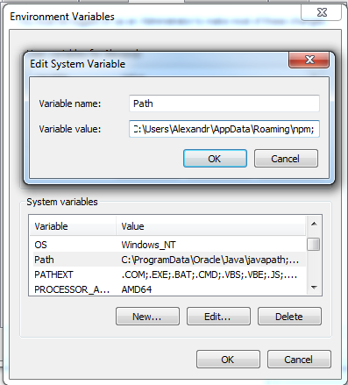

3. Install Java JDK

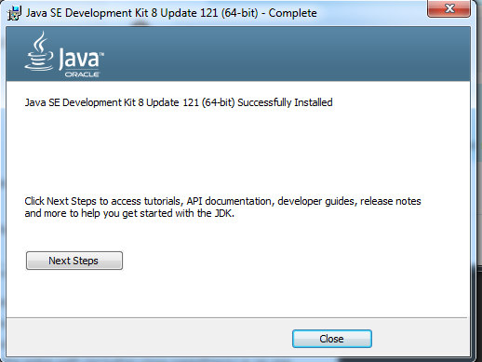

4. Set JAVA_HOME PATH environment variable.

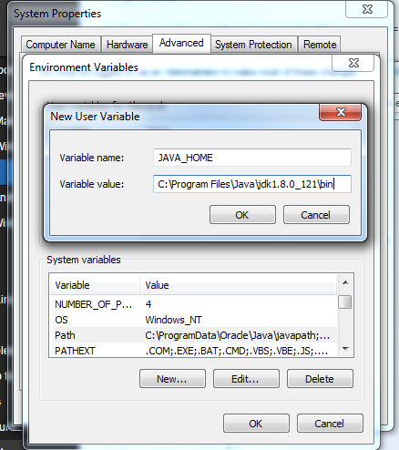

5. Install Android JDK

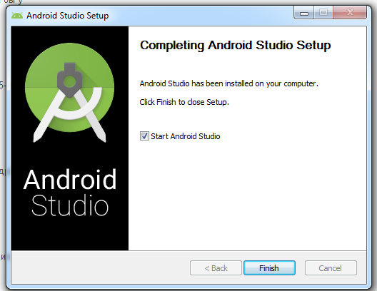

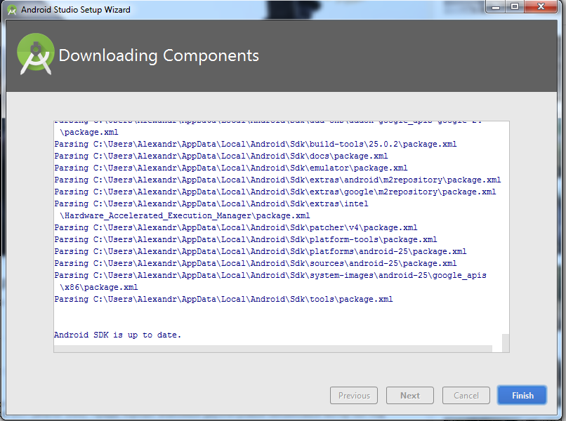

6. Set ANDROID_HOME PATH environment variable.

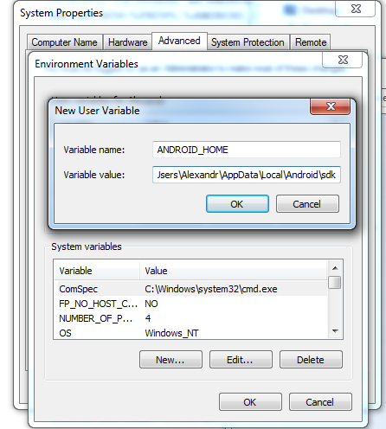

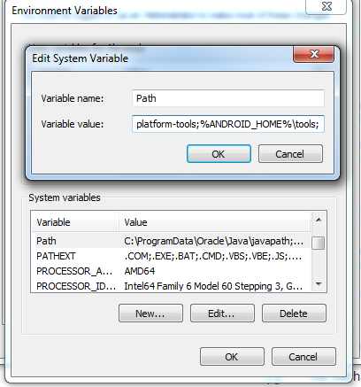

7. Istall Appache Ant.

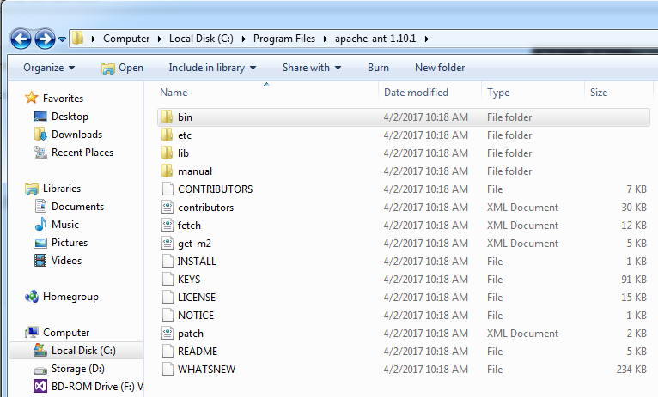

8. Set PATH environment variable for Apache Ant.

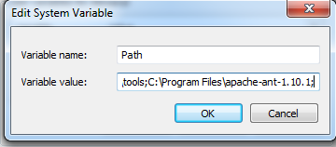

9. Install Apache Maven

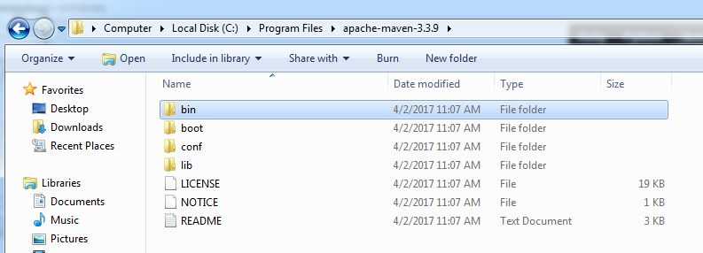

10. Set M2_HOME and M2 PATH environment variable.

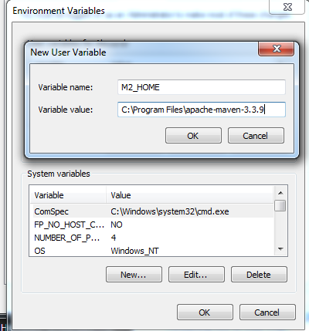

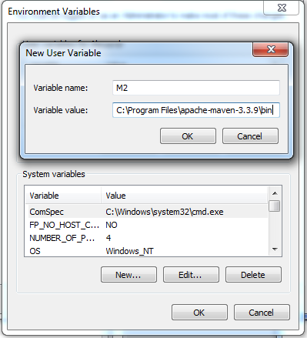

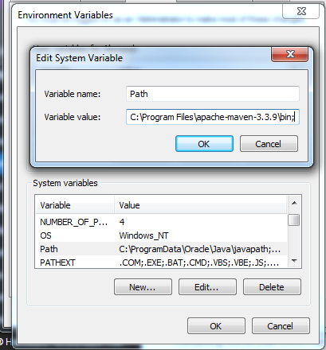

11. Install Appium

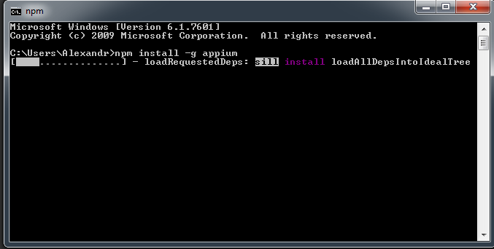

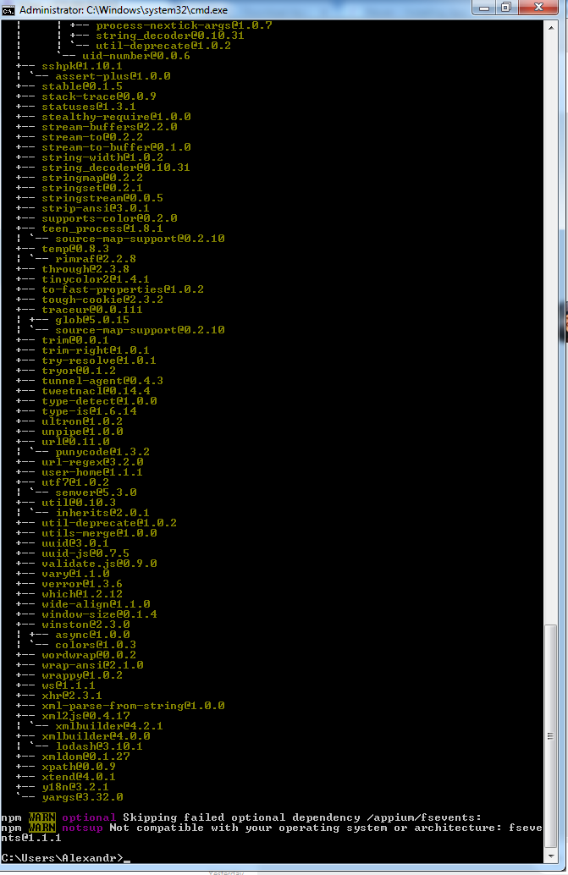

12. Run Appium



**Extra Task**

2*. Execute existing one of the existing tests for any android app in repository (see https://github.com/appium/sample-code) and run your test on android emulator (optional). Also, see additional steps at http://appium.io/slate/en/v1.6.0-beta3/?java#setting-up

-appium.

1. Set up Virtual Device in Android Studio

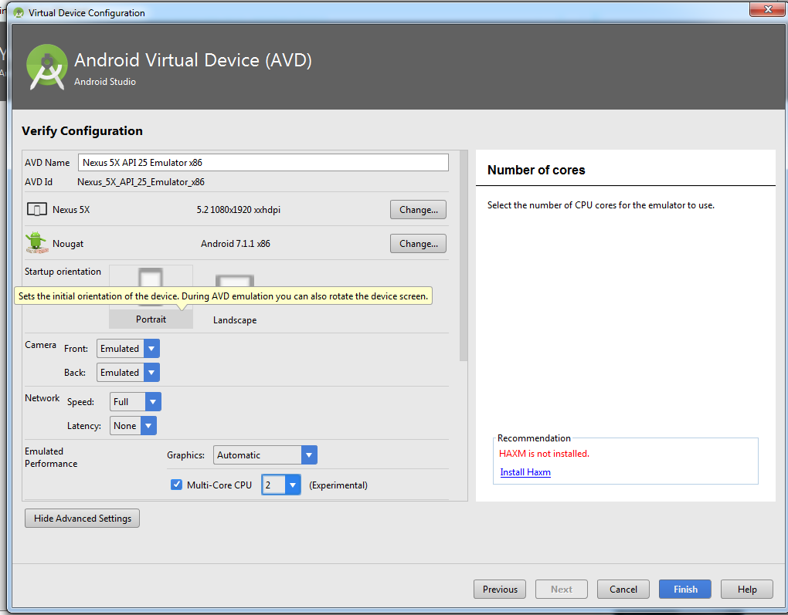

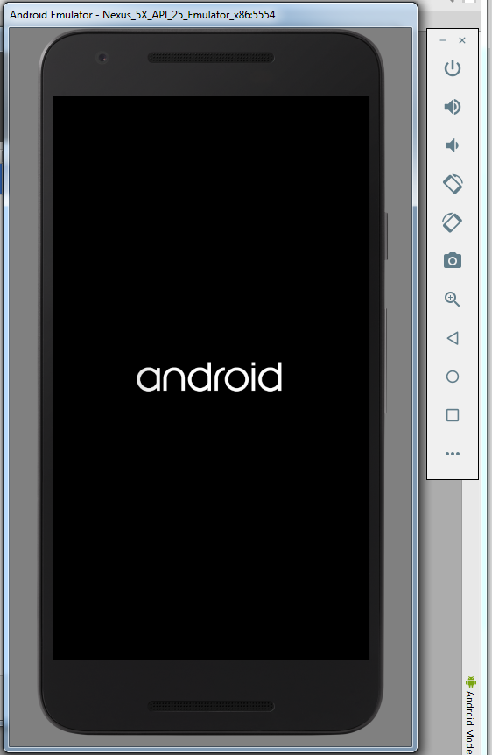

1. Enable Developer Mode and Set it up

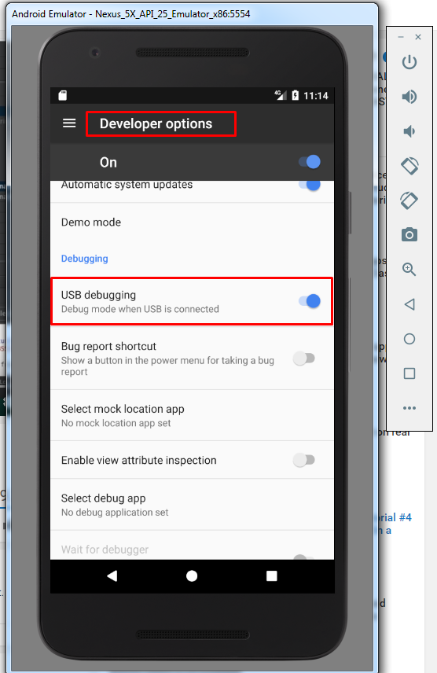

1. Install Applications to an Emulator

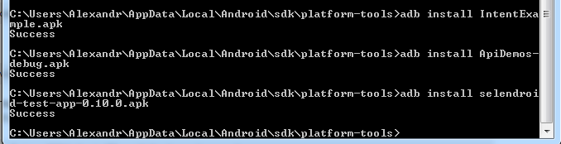

1. Set Correct version of Android Emulator to run a test

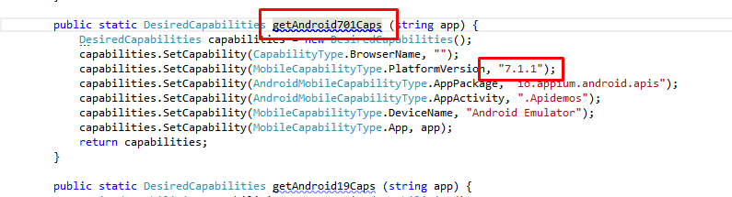

1. Run Tests

