1 TA FrameWork Reporting Module Test

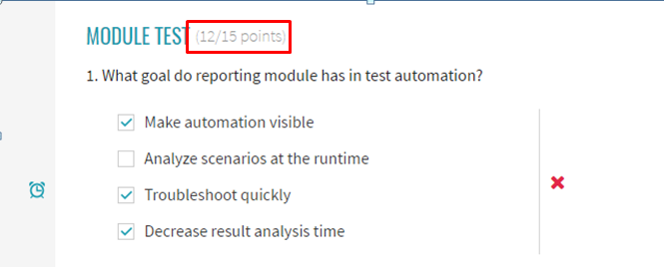

2.1 Test Automation and It's Issues. Ideas Behind Report Portal Test

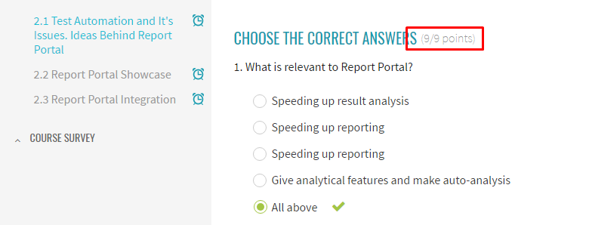

2.2 Report Portal Showcase Test

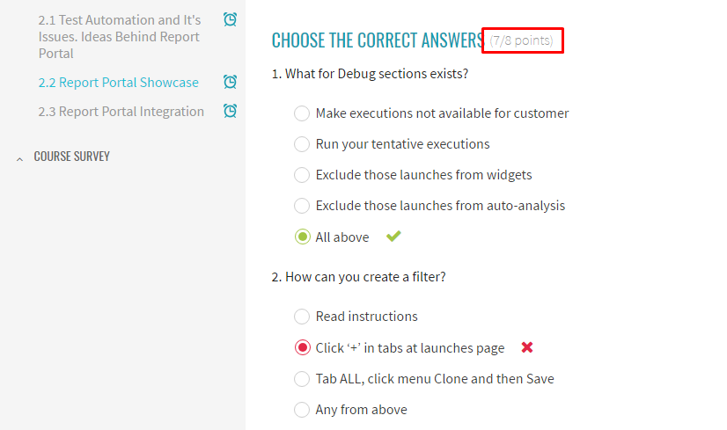

2.3 Report Portal Integration Test

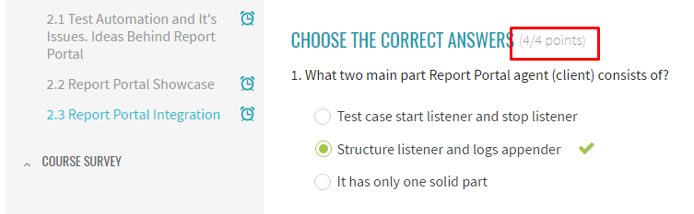

Extra Task:

1. Added Log4net to project references

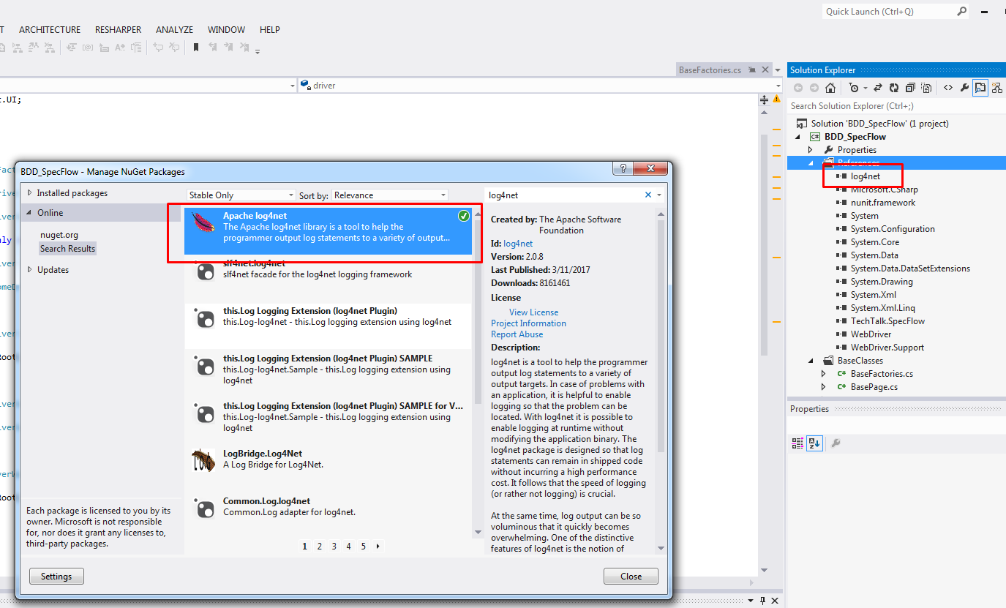

1. Configured configSections in App.Config file



1. Configured appender App.Config file

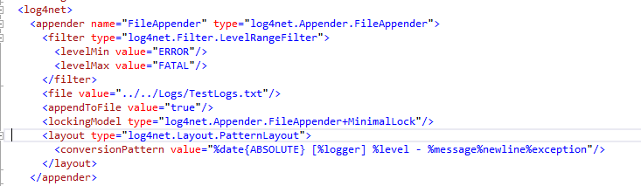

1. Configured root App.Config file

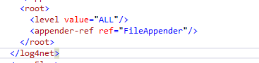

1. Added filters to appender

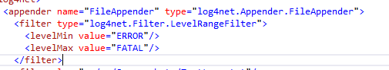

1. Created ScreenshotTaker

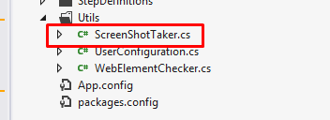

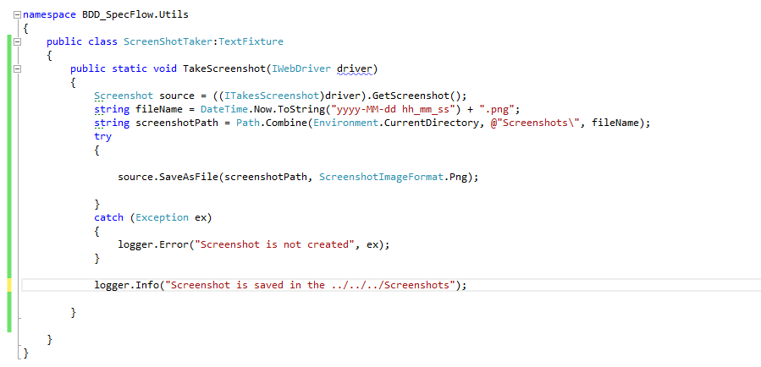

1. Creating of logger instance in tests set up

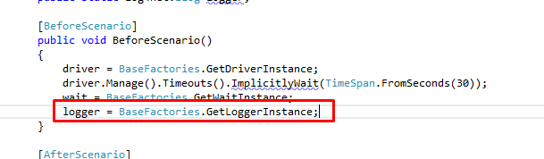

1. Using of logger and screenshot taker for each step in step deffinitions

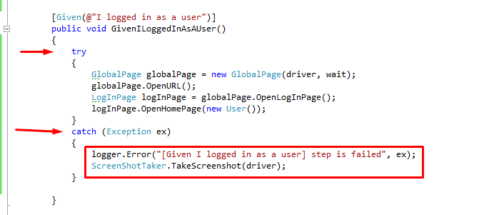

1. **Reviewing Tests Results:**

