1. Open chrome
2. Open url chrome://extensions/
3. 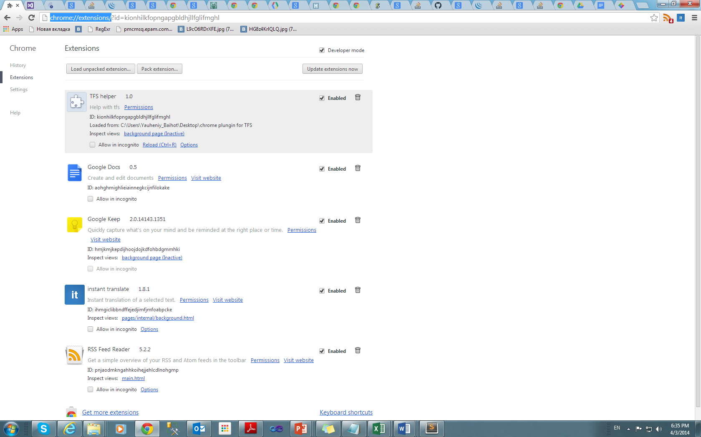
4. Click check box “Developer mode”
5. Click “Load unpacked extension”
6. Select path to folder with manifest file.