Course Project: Part 2

Aliaksei Sysa

November 23, 2014

## Warning: package 'knitr' was built under R version 3.1.2

## Warning: package 'gridExtra' was built under R version 3.1.2

Summary of means and standard deviations of each supplement and dose combination.

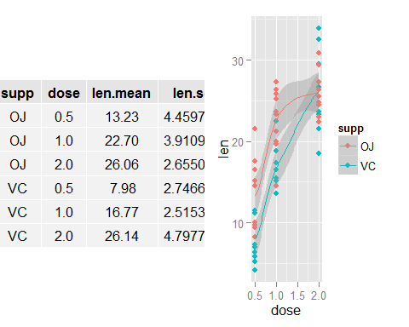

Hypothesis: OJ corresponds to greater tooth growth than VC across all dosages. Assumptions: Subjects are not identical in the two groups.

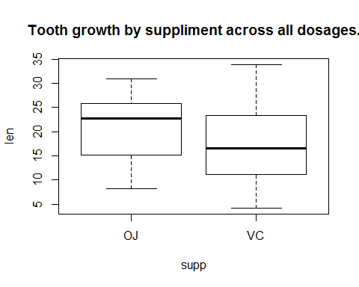

##   
## Welch Two Sample t-test  
##   
## data: len by supp  
## t = 1.9153, df = 55.309, p-value = 0.03032  
## alternative hypothesis: true difference in means is greater than 0  
## 95 percent confidence interval:  
## 0.4682687 Inf  
## sample estimates:  
## mean in group OJ mean in group VC   
## 20.66333 16.96333

CI is entirely greater than 0, which suggests OJ corresponds to greater tooth growth.