Confy

Requirements Specification and Analysis

1.0

21.11.2020

Ali Albaali

Uğur Kaya Küçükkaptan

Bekir Malik Özkuran

Atila Ersun

Altan Öztürk (did not contribute)

Prepared for

SE301 Software Engineering

Resim ekleniyor...

**Table of Contents**

1. Introduction..................................................................................................... 1

1.1. Purpose of the System.............................................................................. 1

1.2. Scope of the System................................................................................. 1

1.3. Objectives and Success Criteria of the Project........................................ 1

1.4. Definitions, Acronyms, and Abbreviations............................................. 1

1.5. Overview.................................................................................................. 1

2. Current System................................................................................................ 2

3. Proposed System............................................................................................. 2

3.1. Overview.................................................................................................. 2

3.2. Functional Requirements......................................................................... 2

3.3. Nonfunctional Requirements................................................................... 3

Usability............................................................................................................ 3

Reliability.......................................................................................................... 3

Performance...................................................................................................... 3

Supportability.................................................................................................... 3

Implementation................................................................................................. 3

Interface............................................................................................................. 3

Packaging.......................................................................................................... 4

Legal.................................................................................................................. 4

3.4. System Models......................................................................................... 4

Scenarios........................................................................................................... 4

Use case descriptions...................................................................................... 12

Use case model................................................................................................ 25

Object model................................................................................................... 25

4. Glossary......................................................................................................... 26

5. References..................................................................................................... 26

**REQUIREMENT ANALYSIS DOCUMENT**

1. ***Introduction:***
   1. ***Purpose of the System:***

There are several conference management systems applications or websites on the internet include papers submitted. Confy is maintaining paper submission as the focus but also maintaining simplified user interface. The simplified user interface aims to make navigation easier, faster, comfortable, and because it is on the phone it makes more reachable in the system.

* 1. ***Scope of the System:***

Confy is a conference management system where users can create conferences, become reviewer for conferences and authors who submit their articles on conference pages. Users create their own conferences, edit them, select minimum grades, and start and end date for conferences, grade the papers on the conferences, they can add articles also they could edit articles again.

* 1. ***Objectives and Success Criteria of Project:***
* Project is completed on time.
* Project documentation arrived on time.
* Project meets functional requirements.
* Project meets non-functional requirements.
* 30% of the bugs found in the projects are fixed.
* 75%of the feedback are positive.
* Project provides the items described in the system scope
  1. ***Definitions, Acronyms, and Abbreviations***
* RAD – Requirements Analysis Document
* UI – User Interface
* Firebase Realtime Database – A cloud-hosted database provided by Google which allows to store and sync the data over the internet.
  1. ***Overview***

Rest of the RAD explains the differences from other systems, supported features, functionality of the project.

1. ***Current System:***

Confy is a papers-articles submit system based on like others conference management systems. It tries to have cleaner, simpler user interface to be more become user-friendly. Confy is a more private based conference management system than others. Confy, aims to sustain a good support to user for their conference environments simple and reliable.

1. ***Proposed System:***
2. ***Overview:***

This section provides further information regarding the supported features by describing their requirements.

1. ***Functional Requirements:***
   * Users should be able to register.
   * Users should be able to login.
   * Users should be able to logout.
   * Users should be able to edit their profile.
   * Users should be able to create a conference.
   * Users should be able to join a conference via an invitation link.
   * Users should be able to use the chat during a conference.
   * Users should be able to upload files to the system.
   * Users should be able to download files from the system.
   * Users should be able to edit their uploaded files until the conference start date.
   * Users should be able to submit their papers for review.
   * Users should be able to view other conference members.
   * Users should be able to check if their papers are approved or not after the end date of conference.
   * Users should be able to block other users.
   * Users should be to get a notification from the system when the conference starts.
   * Conference creators should be able to set a minimum grade for the papers to be accepted.
   * Conference creators should be able to remove other users from the conference.
   * Reviewers should be able assign grades to the papers.
   * Reviewers should be able to review other users’ papers.
2. ***Non-Functional Requirements:***

**Usability**

* Users should be able to use system without training.
* Users should be able to easy to understand and use.
* Users with poor English should be also able to navigate through the system.
* The system should be easy to use for adult users.
* Users should be able to create the conference with 2 clicks.
* Users should be able view their profiles with one click.

**Reliability**

* The system should be stable at least %80 of the time.
* The system should be able to back-up all data automatically every day.
* The system should provide clear error message when an error happens.

**Performance**

* The system should be able to create a profile less than 8 seconds.
* A conference meeting should be able to create within 5 seconds.
* The system should not lose any user data.
* The system should be available 97% of the time.

**Supportability**

* The system should support the English language
* The system should support the Turkish language
* The system should be able handle complex operations without affecting the performance.

**Implementation**

* The system should be written in Android Studio.
* The system should run at least %83 of android devices.
* The system should use Firebase Realtime Database as its database**.**

**Interface**

* The system should have a bottom navigation bar, search, profile as the main destinations.
* The system should support Android Phones with API 23 and above

**Packaging**

* The system should have an APK as an installation package.

**Legal**

* The system should be licensed as freeware.
* The system should be open-sourced.

1. ***System Models:***

**Scenarios**

**1)**

|  |  |
| --- | --- |
| ***Scenario Name*** | Sharing an Idea |
| ***Participating Actors*** | Joe: The User |
| ***Flow of Events*** | 1. Joe, who is a computer science student, is working on a project about robot. But he is needed some funds to keep continue it. 2. Each member of the financial department gets their phone and activates the **“Register User”** function. 3. Each member enters their Name, Email and Password. A Minute after they get a verification code to their emails. They use the verification code to continue their registration. 4. After that Joe starts waiting about return from society |

**2)**

|  |  |
| --- | --- |
| ***Scenario Name*** | Important Conference |
| ***Participating Actors*** | Joseph: The User |
| ***Flow of Events*** | 1. Joseph has a bunch of papers he must review of his students. 2. Joseph creates a conference meeting with the function of **‘’create a conference’’** and creates a conference. 3. With the help of his assistant reviewers he reviews the papers and grades them in a short time. |

**3)**

|  |  |
| --- | --- |
| ***Scenario Name*** | Company’s financial strategies |
| ***Participating Actors*** | Mark: The User |
| ***Flow of Events*** | 1. Mark’s company needs to discuss their financial strategies regarding publishing a new product to the market. Mark shares an “**invitation link”** to the company’s financial department to join the conference. 2. Each member of the financial department gets their phone and activates the **“Register User”** function. 3. Each member enters their Name, Email and Password. A Minute after they get a verification code to their emails. They use the verification code to continue their registration. |

**4)**

|  |  |
| --- | --- |
| ***Scenario Name*** | Checking File |
| ***Participating Actors*** | Anthony: The Visitor |
| ***Flow of Events*** | 1. Anthony joins for a conference the company conference about what will company do in next years. 2. Anthony prepares a lot of files about on it and he sends the one he most liked. 3. Then Anthony notice that he posted wrong file because they confuse their name, but he cannot be sure. So, he selects **“download”** file button. 4. After downloading file Anthony sees and be sure about, he posted right file. |

**5)**

|  |  |
| --- | --- |
| ***Scenario Name*** | Hesitant User |
| ***Participating Actors*** | Helen: The User |
| ***Flow of Events*** | 1. At Helen’s university they create new school club about the physics but they got a very special head teacher for it so there is a lot of application for it. 2. So, they decide to make a conference who are going to selected for it. Helen want to join to this club so much due to her love to physic science. So, she gives a try 3. She writes an article about it and upload to system. But she unsure about the project then she did not submit it. 4. But until the deadline day she did not have better idea on his article she open conference and hit the **“submit”** the file button. |

**6)**

|  |  |
| --- | --- |
| ***Scenario Name*** | Company Conference |
| ***Participating Actors*** | Ivy: The User |
| ***Flow of Events*** | 1. Ivy has a company conference today’s morning to discuss her project topic with her co-workers. She installs the application from app store and opens. So, she activates the **“Login”** function. 2. She enters her E-mail and Password and submits, after few seconds. She sees home screen. |

**7)**

|  |  |
| --- | --- |
| ***Scenario Name*** | Conference Link |
| ***Participating Actors*** | Gerard: The User |
| ***Flow of Events*** | 1. Gerard and his company are planning to find a strategy for marketing their product. 2. Gerard decides that he can use Confy by inviting everyone into the app and activate their **“Chat”** functionality. 3. Then everyone will be able to share their opinions and thoughts. |

**8)**

|  |  |
| --- | --- |
| ***Scenario Name*** | Asking Friends |
| ***Participating Actors*** | Johnny: The User  Alex: The User |
| ***Flow of Events*** | 1. Johnny and his Friend Alex are both students for Chemistry Science. They talk about very big named company take intern for next summer 2. Johnny said he is entering the conference of the company and Alex said he is also joined in very long time, but he said he cannot post any article on it. 3. Then Johnny wants to be sure about it and enter the conference and hit the **“Conference Members”** button. Then a list comes to his screen, but he checks Alex name on it he cannot be seen. 4. Then they realize Alex join the not valid conference so he could join to valid one. |

**9)**

|  |  |
| --- | --- |
| ***Scenario Name*** | Long Awaited Grade |
| ***Participating Actors*** | Victor: The User |
| ***Flow of Events*** | 1. Victor has an important article work to complete in a limited time. He works hard and prepares it after days of work. 2. Victor sends his article for review via Confy and waits stressfully to see if his work is approved or not. Only to see his article is approved via **“checking his grade after the review is over”**. He was not this relaxed for a while. |

**10)**

|  |  |
| --- | --- |
| ***Scenario Name*** | Profile Rescue |
| ***Participating Actors*** | John: The User |
| ***Flow of Events*** | 1. John receives a link from his friend, he opens the site, the site request to enter his Confy Credentials, so he enters his credentials. 2. John later finds out that the site is malicious, so he activates the **“Edit Profile”** function. 3. John enters his E-mail, his current Password, and the new Password. He submits it. 4. Moments after, his information change and the malicious site has invalid info by now. |

**11)**

|  |  |
| --- | --- |
| ***Scenario Name*** | Spammer |
| ***Participating Actors*** | Ringo: The User |
| ***Flow of Events*** | 1. Ringo is looking for someone to share his project idea with them. He finds someone he knows in his school. 2. He sends them an invitation link to join a conference to tell him about the idea. 3. The school guy started becoming childish and spamming the conference chat. 4. Eventually Ringo activates the **“Block”** functionality to stop the school guy from spamming. |

**12)**

|  |  |
| --- | --- |
| ***Scenario Name*** | Forgotten |
| ***Participating Actors*** | Maria: The User |
| ***Flow of Events*** | 1. Maria after finishing University she starts the looking for a job. She sees a conference from a company she wanted to work but she saw start date of conference is more than a month. 2. After two weeks she got a **“notification from “Confy App**” Your conference start day is today”. 3. After she opens the app, and she realizes it the conference date be early in two weeks and she starts about her article which sending to company. |

**13)**

|  |  |
| --- | --- |
| ***Scenario Name*** | Wrong File |
| ***Participating Actors*** | Kurt: The User |
| ***Flow of Events*** | 1. Kurt is invited to a conference he was supposed to attend for his article. He uploads his file and starts to wait for the time of review. 2. Kurt then finds out that he sent the wrong pdf file. Realizing he still has time, he calmly **“edits** the file he sent” and sends the correct document he needs to send. 3. Kurt wonders what would have happened if he did not realize sooner the mistake he did. |

**14)**

|  |  |
| --- | --- |
| ***Scenario Name*** | Improve the Idea |
| ***Participating Actors*** | Jennifer: The User |
| ***Flow of Events*** | 1. Jennifer sending to article about his projects for reviewing. But she sees an information about projects so she decided to her can improve it also. 2. Then she restarts about it and edited the files as necessarily. 3. Then she goes the Confy app and select the conference, but she saws **“edit”** button did not appear. 4. Then she realizes she could not add anything because the deadline they over so she cannot **“able to see their papers during the reviewing process”**. |

**15)**

|  |  |
| --- | --- |
| ***Scenario Name*** | Setting the Threshold |
| ***Participating Actors*** | Barbara: The User |
| ***Flow of Events*** | 1. Barbara is an instructor in a very prestigious university. She gives one of the toughest courses to pass in the curriculum. 2. In the course, she expects students to write a very lengthy and difficult article about a certain topic. She uses Confy and creates a conference for a certain group. 3. Since she is the conference creator and the instructor, she **“she sets the minimum passing grade for the article”** a little too high. 4. While some pass, many people fail the course, returning and trying to pass again next semester. |

**16)**

|  |  |
| --- | --- |
| ***Scenario Name*** | Recruiting |
| ***Participating Actors*** | John: The User |
| ***Flow of Events*** | 1. John is a recruiter for an IT company. They want him to recruit a new guy with progressive ideas. 2. Then John decide to create a conference where the candidates post their projects. 3. John open the Confy app activates “**Create Conference**” button. He enters a name on it after that he choose **“Start Date”** and **“Finish Date”** on the system. Then he presses “Finish” button and create new conference |

**17)**

|  |  |
| --- | --- |
| ***Scenario Name*** | Intruder in the Conference |
| ***Participating Actors*** | Jamie: The User |
| ***Flow of Events*** | 1. Jamie creates a conference using Confy to review a certain article his student is working on. 2. But unfortunately, he invites the wrong student by misreading the school number of the student. 3. When he realizes this, he uses the conference creator's **“remove a user from conference**” option by choosing the intruder and kicking him out. 4. He then invites the correct student and apologizes to him for inconvenience before the starts reviewing his work. |

**18)**

|  |  |
| --- | --- |
| ***Scenario Name*** | Getting help from Co-Workers |
| ***Participating Actors*** | Ron: The User  Harry: The User |
| ***Flow of Events*** | 1. Harry selected as a reviewer for a conference by his company. So, Harry due to read all articles and graded them. 2. When conference and Harry realize there is so much attendance also there is a lot of article for read by one people. 3. Then he wants help from his coworker Ron to help him. He sends invite link to Ron and then he selects his as a “Reviewer”. 4. Then Ron open conference room and sees all the article list, he saw the articles which reading by Harry glow green, so he clicks “review” button on the right side of article and review it. |

**19)**

|  |  |
| --- | --- |
| ***Scenario Name*** | Mobile Internet |
| ***Participating Actors*** | Can: The User |
| ***Flow of Events*** | 1. Can while he went to the village for vacation he realizes if he “submits” the article for conference or not. 2. But because of his phone provider his internet connection was not available. Then he wants his friend phones if he has internet connection. 3. After he got his friends phone, he downloaded app then “Login” into their profile, go to “conference”. Then he looked he submit his article his system. 4. After checked it he returned main page and click “Logout” button for safety issues. |

**Use Case Descriptions**

**1)**

|  |  |
| --- | --- |
| ***Use Case Name*** | Upload File |
| ***Participating Actors*** | Initiated by User |
| ***Flow of Events*** | 1. The user goes to “Conference Page” and activate to “Upload File” button. 2. The user selects the file from his gallery and activate upload button. 3. System checks the file and save it for a ready to submit and sent info about files date about upload etc. |
| ***Entry Condition*** | The User activates “Upload File” button |
| ***Exit Condition*** | The User returns to Conference Page |
| ***Quality Requirements*** | The User successfully upload file to system |

**2)**

|  |  |
| --- | --- |
| ***Use Case Name*** | Login |
| ***Participating Actors*** | Initiated by Visitor |
| ***Flow of Events*** | 1. The Visitor opens the app. 2. App shows a login form. 3. The Visitor fills the form by entering a valid E-mail address and a password. 4. The Visitor submits the form by clicking the “Login” button and activates the “Login” functionality. |
| ***Entry Condition*** | The Visitor has opened the app. |
| ***Exit Condition*** | The Visitor has been re-directed to the home screen. |
| ***Quality Requirements*** | The Visitor gets re-directed to the home screen within less than 5 seconds. |

**3)**

|  |  |
| --- | --- |
| ***Use Case Name*** | Register User |
| ***Participating Actors*** | Initiated by Visitor |
| ***Flow of Events*** | 1. The Visitor activates the “Register User” functionality from the by clicking the Sign-Up text. 2. System presents a form to user to fill. The visitor fills the form by entering their email, full name, and a password. 3. System checks the email and sends a confirmation email to the address. 4. The Visitor receives a confirmation e-mail. 5. The Visitor activates the complete button on the email. 6. The Visitor receives a success message on the application and registration process ends. |
| ***Entry Condition*** | The Visitor has clicked the Sign-Up button. |
| ***Exit Condition*** | The Visitor received the success message. |
| ***Quality Requirements*** | The Success message shows up after a short while when The Visitor clicks the Complete button. |

**4)**

|  |  |
| --- | --- |
| ***Use Case Name*** | Download File |
| ***Participating Actors*** | Initiated by User |
| ***Flow of Events*** | 1. The User goes to Conference page and click his file. 2. The System returns the information about the file uploaded by user. 3. The Visitor fills the form by entering a valid E-mail address and a password. 4. The system downloads users file from database. |
| ***Entry Condition*** | User activates download button. |
| ***Exit Condition*** | Users click the cancel or exit button. |
| ***Quality Requirements*** | User successfully download the file and returned to conference page. |

**5)**

|  |  |
| --- | --- |
| ***Use Case Name*** | Logout |
| ***Participating Actors*** | Initiated by User |
| ***Flow of Events*** | 1. The User activates the “Logout” functionality from the profile screen by clicking on the “Logout” button. 2. The app shows a warning and asks the User to confirm the operation. 3. The User reads the message and clicks the “Confirm” button. 4. The app re-directs the user to the Login screen. |
| ***Entry Condition*** | The User has clicked the Logout button. |
| ***Exit Condition*** | The User has been re-directed to the Login screen.  The Visitor has clicked the Cancel button. |
| ***Quality Requirements*** | The Visitor is re-directed instantly to the Login screen. |

**6)**

|  |  |
| --- | --- |
| ***Use Case Name*** | Edit Profile |
| ***Participating Actors*** | Initiated by User |
| ***Flow of Events*** | 1. The User activates the “Edit profile function from the profile screen by selecting edit profile. 2. System responds by showing a screen where user can change his/her e-mail, password, or name. 3. After the User selects the option by clicking the button of his choice whether to change e-mail, password or name, a new form is presented for User to enter his/her new e-mail/password/name. 4. User fills the form and clicks “Change”. 5. System receives the form and sends the User to the home page. |
| ***Entry Condition*** | User clicked the Edit Profile option. |
| ***Exit Condition*** | User is re-directed to Home Page |
| ***Quality Requirements*** | User should be re-directed to Homepage after the operation is over. |

**7)**

|  |  |
| --- | --- |
| ***Use Case Name*** | Create Conference |
| ***Participating Actors*** | Initiated by User |
| ***Flow of Events*** | 1. The User selects the option of “Create Conference” in homepage. 2. The User is asked to configure Starting Date and End Date for the conference. 3. The User is also asked for the people to invite to the conference. 4. System receives the given information and creates a conference. |
| ***Entry Condition*** | The User clicks the Create Conference option. |
| ***Exit Condition*** | The User is sent to the Conference screen.  The User clicked back during the Conference creation. |
| ***Quality Requirements*** | The User is in a created conference less than 5 seconds. |

**8)**

|  |  |
| --- | --- |
| ***Use Case Name*** | Show Conference List |
| ***Participating Actors*** | Initiated by All Actors |
| ***Flow of Events*** | 1. The User goes to conference page and click the “Show People in Conference” button top right of the page. 2. System respond as a presenting user info’s in a table. (names and roles). |
| ***Entry Condition*** | Users press the “Show People in Conference” button |
| ***Exit Condition*** | User clicked on Cancel button |
| ***Quality Requirements*** | User successfully return conference page. |

**9)**

|  |  |
| --- | --- |
| ***Use Case Name*** | Edit Upload |
| ***Participating Actors*** | Initiated by User |
| ***Flow of Events*** | 1. The User clicked “Edit Upload” button from the conference page. 2. System responds by creating a file upload functionality and a “Back” button. 3. The User uploads the new file by clicking “Upload” and old file is erased. 4. Clicking “Done” option sends The User to the Conference page. |
| ***Entry Condition*** | User clicked Edit Upload button. |
| ***Exit Condition*** | User clicked Back option  User is sent to the Conference page. |
| ***Quality Requirements*** | User is immediately re-directed to Conference page. |

**10)**

|  |  |
| --- | --- |
| ***Use Case Name*** | Submit Papers |
| ***Participating Actors*** | Initiated by User |
| ***Flow of Events*** | 1. The User activates the “Submit File Button” from the conference page. 2. System checks if user already upload a file already. If they uploaded one returns “Are you sure?” message to user. 3. The User press the “Yes” button. 4. System saves file as a “submitted” on the system. |
| ***Entry Condition*** | The user activated Submit button |
| ***Exit Condition*** | The user did not upload any files previously.  The user clicked back option. |
| ***Quality Requirements*** | User is immediately re-directed to Conference Page |

**11)**

|  |  |
| --- | --- |
| ***Use Case Name*** | Block Users |
| ***Participating Actors*** | Initiated by User |
| ***Flow of Events*** | 1. The User activates the “Block User” functionality by clicking on the “Block User” button. 2. The app shows a warning and asks the User to confirm the operation. 3. The User reads the message and clicks the “Confirm” button. 4. The app blocks the User. |
| ***Entry Condition*** | The User has clicked on the Block User button. |
| ***Exit Condition*** | The app blocks the user. |
| ***Quality Requirements*** | The User will not receive anything from the blocked user. |

**12)**

|  |  |
| --- | --- |
| ***Use Case Name*** | Notification of Conference |
| ***Participating Actors*** | Initiated by Conference Creator |
| ***Flow of Events*** | 1. The Conference Creator sets the “Starting Date” during “Conference Creation” function. 2. The Conference Creator chooses the “Conference Settings” button from the Conference Screen. 3. The Conference Creator is given an option for “Set Conference Date”. 4. After the selecting Conference Date, system sends a notification an hour before the Conference starts. |
| ***Entry Condition*** | The User selected the “Set Conference Date option”. |
| ***Exit Condition*** | The User selected “Back” during “Set Conference Date”  The User is re-directed to Conference Screen. |
| ***Quality Requirements*** | The User should be notified exactly 1 hour before conference starts. |

**13)**

|  |  |
| --- | --- |
| ***Use Case Name*** | Remove Other Users |
| ***Participating Actors*** | Initiated by Conference Creator  Communicates with The User |
| ***Flow of Events*** | 1. The Conference Creator activates “Show Conference Member” button. 2. The system responds with a presenting “Conference member list” 3. The Conference Creator click activates the button of the right side of the name of user which is “Remove user”. 4. The system sent warning message “Do you want to kick this User” 5. Conference Creator click “Yes” Button 6. The System make ineligible The Selected User to see the Conference Page. 7. The system sent message to user “Conference Creator kicked you from this session”. |
| ***Entry Condition*** | Conference Creator activates “Remove user” Button. |
| ***Exit Condition*** | The User re-directed to Main Page.The User is re-directed to Conference Screen. |
| ***Quality Requirements*** | Conference Creator returns to Conference Member List |

**14)**

|  |  |
| --- | --- |
| ***Use Case Name*** | Assign Grade |
| ***Participating Actors*** | The Reviewer |
| ***Flow of Events*** | 1. The Reviewer starts reviewing and can only “Assign Grade” papers during the conference start date and end date. 2. The Reviewer selects an uploaded document. 3. System responds by giving a “Assign Grade” option for the document. 4. The Reviewer enters the grade he/she assigns to the document. 5. The System calculates the authors approval by taking in the account of the grades given by Reviewers and minimum approval rating given by Conference Creator. |
| ***Entry Condition*** | The Reviewer has clicked the Assign Grade button. |
| ***Exit Condition*** | The Reviewer is re-directed to the Conference Screen.  The Reviewer choose “Back” during “Assign Grade” screen. |
| ***Quality Requirements*** | The Reviewer should be redirected to the Conference page after whether he/she choose the “Back” or “Assign Grade” option. |

**15)**

|  |  |
| --- | --- |
| ***Use Case Name*** | Invitation Link |
| ***Participating Actors*** | Initiated by Conference Creator |
| ***Flow of Events*** | 1. The Conference Creator can send invitation links through the e-mail and application before the Conference Start Date. 2. At the Conference Screen Conference Creator can click invite button. 3. System responds by giving Conference Creator a typing box to write the e-mail of the attendee. 4. After Conference Creator writes the e-mail of the attendee and clicks submit, the System responds by sending an invitation link of Conference to the e-mail of the attendee. |
| ***Entry Condition*** | The Conference Creator clicks invite button. |
| ***Exit Condition*** | The Conference Creator clicks back during the “Invite” screen.  The Conference Creator is re-directed to the Conference Screen. |
| ***Quality Requirements*** | The papers will not be gradable after. |

**16)**

|  |  |
| --- | --- |
| ***Use Case Name*** | Review the Papers |
| ***Participating Actors*** | Initiated by Reviewer |
| ***Flow of Events*** | 1. The Reviewer activates the “Review the papers” buttons. On the Conference page. 2. The system responds with a presenting with a one of the Papers of the User. 3. The Reviewer review the papers and click the “Exit Review” button. 4. The system sent message “Do you want to grade this paper” 5. The Reviewer chooses “No” option. |
| ***Entry Condition*** | Reviewers activate the “Review Papers” button. |
| ***Exit Condition*** | Reviewer presses cancel button. |
| ***Quality Requirements*** | Reviewers successfully returns the Conference Page. |

**17)**

|  |  |
| --- | --- |
| ***Use Case Name*** | Users Check Submitted File While Reviewing Process |
| ***Participating Actors*** | Initiated by The User |
| ***Flow of Events*** | 1. The User goes to conference page and activates the Review file button 2. The system responds with a presenting “While Reviewing process continues users cannot see their papers”. 3. The user clicks “Okay” button. |
| ***Entry Condition*** | The User activates Review File button. |
| ***Exit Condition*** | The user press back button. |
| ***Quality Requirements*** | The User successfully redirected to Conference Page. |

**18)**

|  |  |
| --- | --- |
| ***Use Case Name*** | Approved |
| ***Participating Actors*** | Initiated by Reviewers |
| ***Flow of Events*** | 1. Reviewers Submit his grades on the papers which is Users submitted 2. Reviewers Submit his grades on the papers which is Users submitted 3. Until deadline date all reviewer could grade the papers. 4. Then System take all grades from reviewers and calculate if the paper is approved or not. |
| ***Entry Condition*** | Reviewers Submit grades on paper |
| ***Exit Condition*** | The paper could not review by enough reviewers. |
| ***Quality Requirements*** | System successfully saves grades and decide grading of papers. |

**19)**

|  |  |
| --- | --- |
| ***Use Case Name*** | Conference Date |
| ***Participating Actors*** | The Conference Creator |
| ***Flow of Events*** | 1. The Conference Creator opens the app and clicks on “New Conference” button. 2. The app requests the Conference Creator to fill the conference info including the “Start Date” and “End Date”. 3. The Conference Creator fills the information and clicks “Create Conference” button. |
| ***Entry Condition*** | The Conference Creator has clicked on “New Conference” button and selects a “Start Date” and “End Date”. |
| ***Exit Condition*** | The Conference Creator gets re-directed to the home screen. |
| ***Quality Requirements*** | The conference should be created within 3 seconds. |

**Use Case Model**

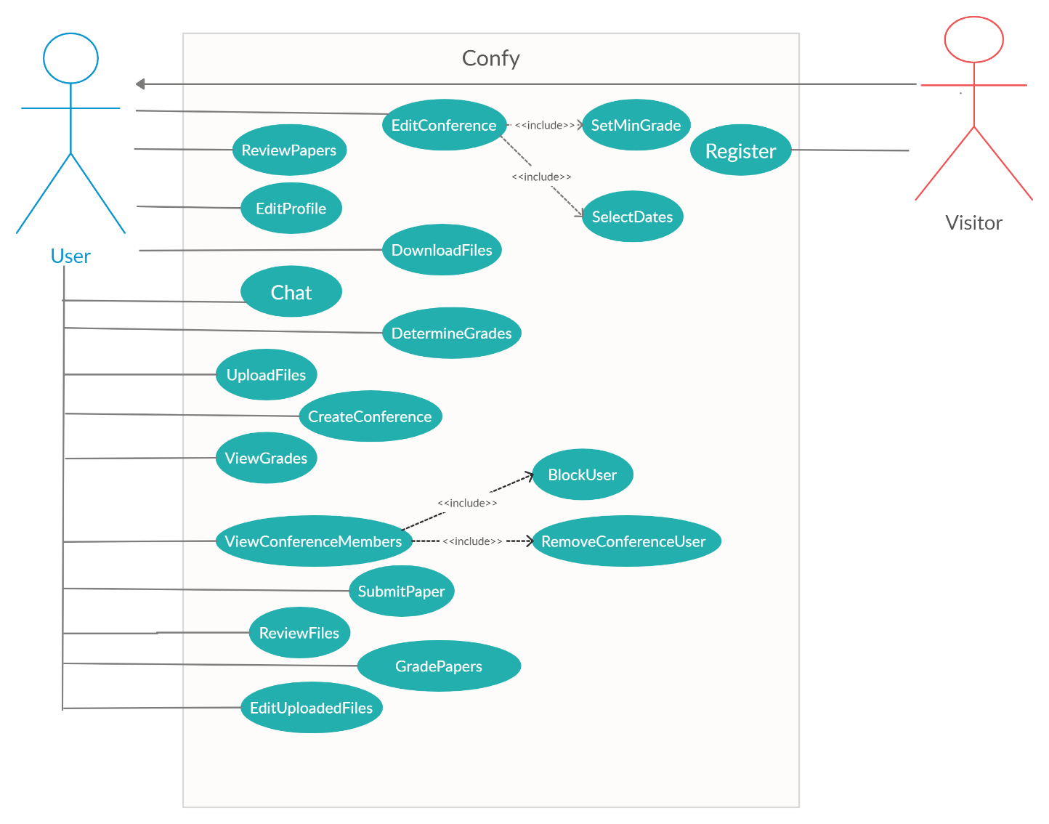

**Object Model**

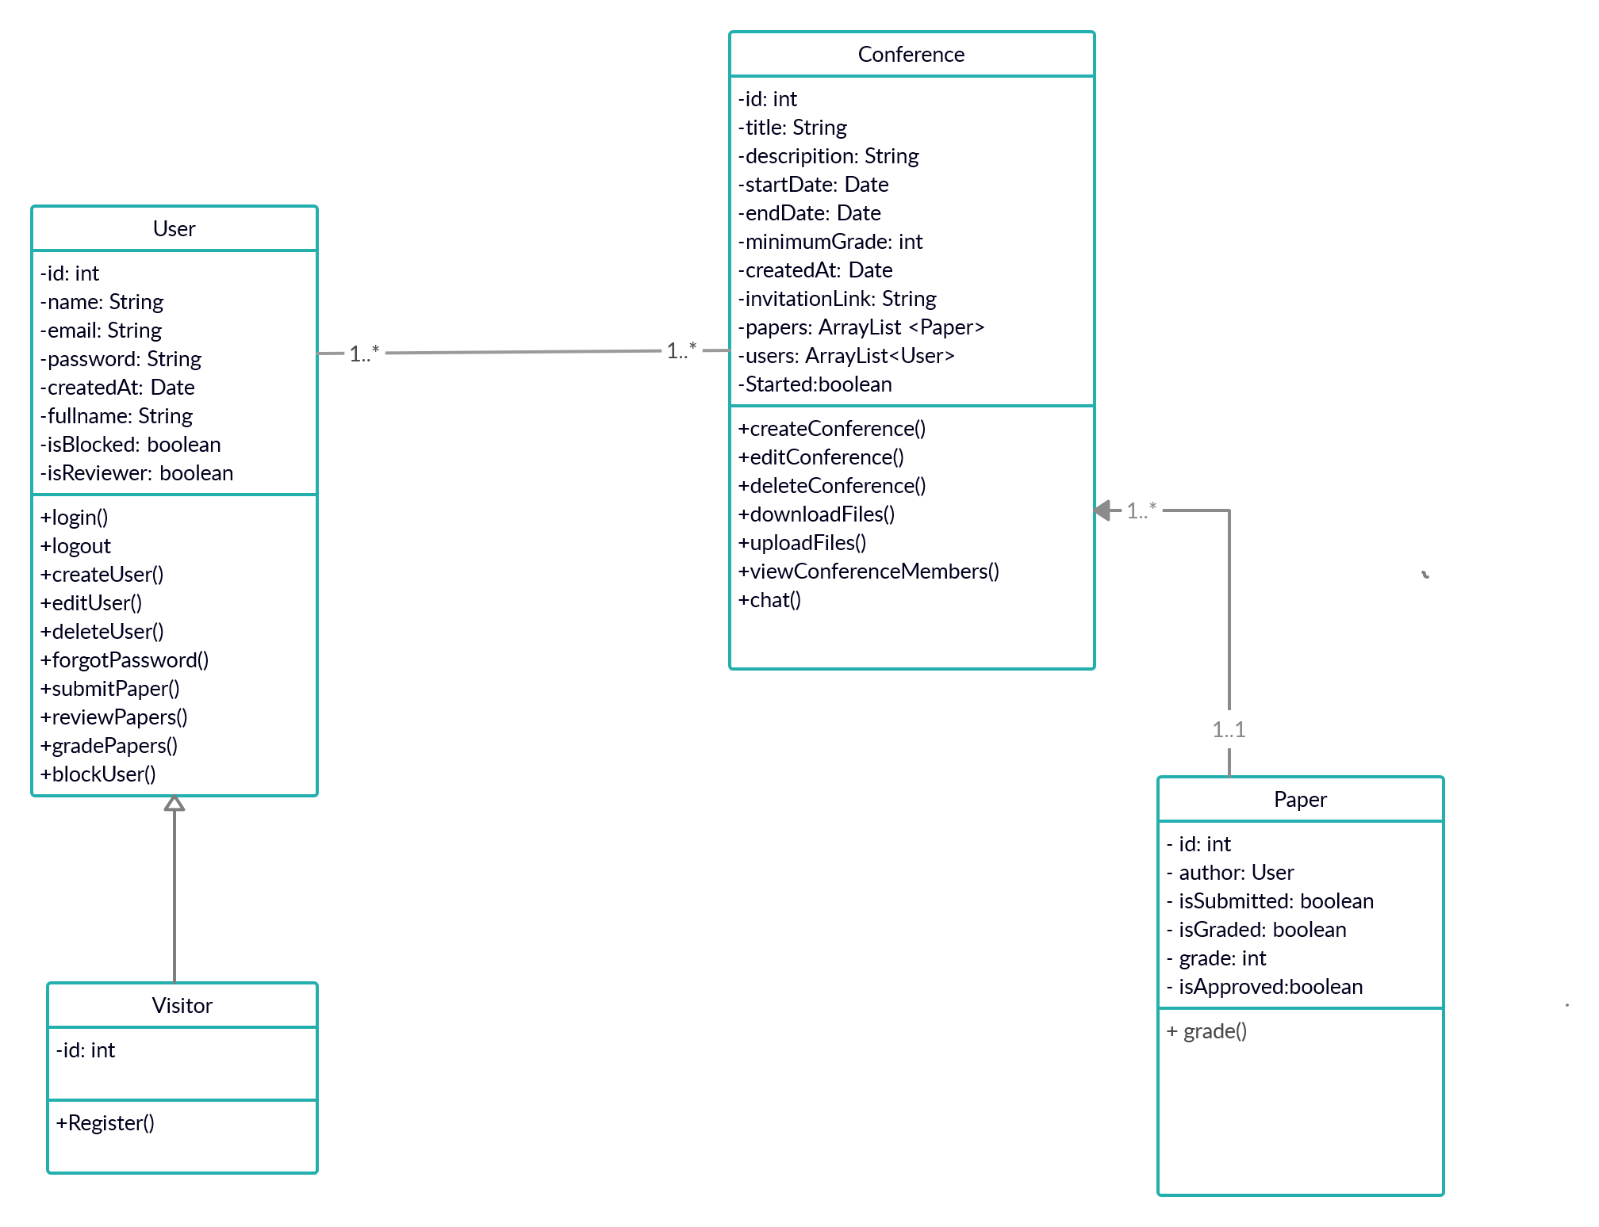

1. ***Glossary***
   * **User:** A user type that is already registered in the Confy System.
   * **Visitor:** A user type that has not registered in to the Confy System. In order to use system functions, the visitor must create an account and Sign-up first.
   * **Conference Creator:** A user type that uses the function of “Create Conference”. Conference Creators can edit the conference they created, as well as inviting other people.
   * **Reviewer:** Conference members that got invited by Conference Creator and given the role of “Reviewer” has the functions to discuss and grade the article documents sent by the author in the conference.
   * **Author:** Conference member that got invited by Conference Creator and is responsible for sending the article document he/she is responsible of before the conference begins.
   * **Conference:** A meeting initiated by Conference Creator. Purpose of a conference is the discussion and approval of an article documents sent by the Author of member of the conference.
2. ***References***
   * Timothy K. Shih, Jason C. Hung, Te-Hua Wang, Yu-Shian Chen and Sheng-En Yeh “Virtual Conference Management System”ICOIN 2001
   * Huang, M., Y. Feng, B. C. Desai. CONFSYS2: An Improved Web-based Multi-Conference Management System. Proceedings of the 2009 C3S2E conference. ACM.
   * OpenConf CMS, http://www.openconf.com/
   * The MyReview System, http://myreview.lri.fr/
3. ***Schedule Gantt Chart***

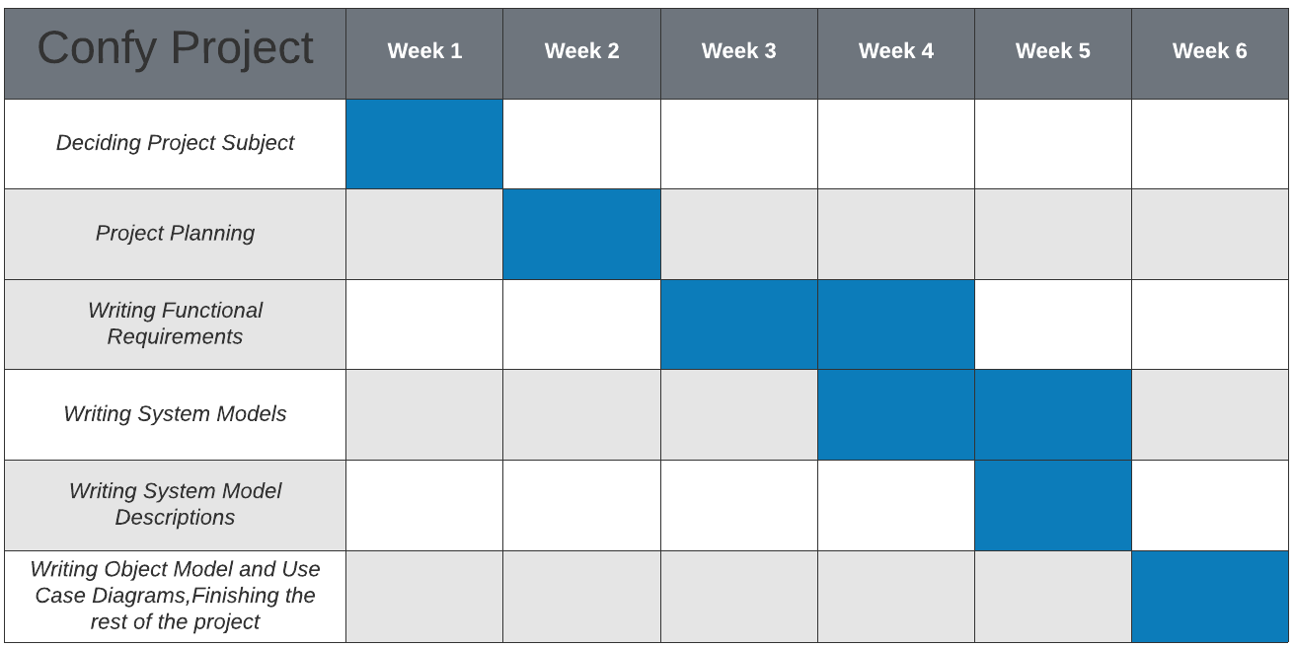

1. ***Sequence Diagrams*** 
   1. 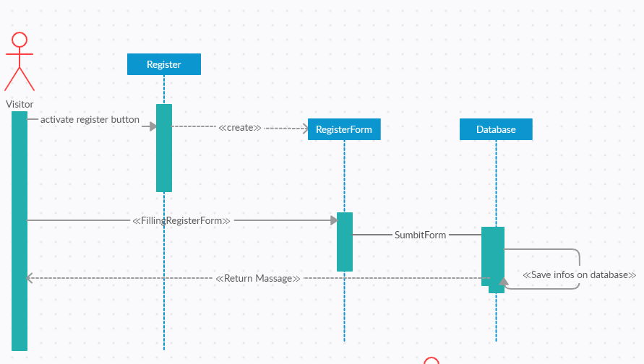***Register***
   2. ***Login***

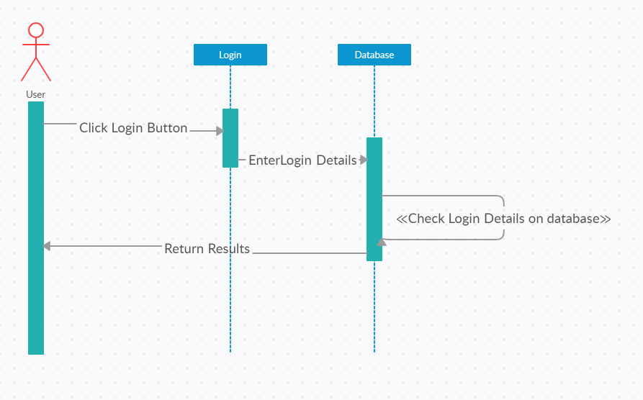

* 1. 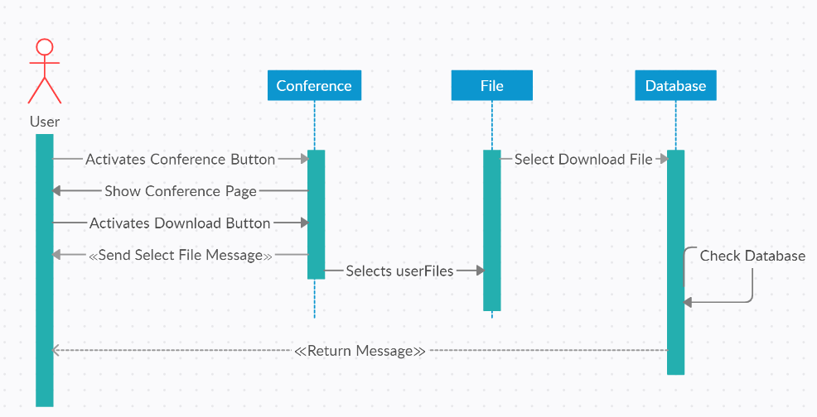***Download Files***
  2. 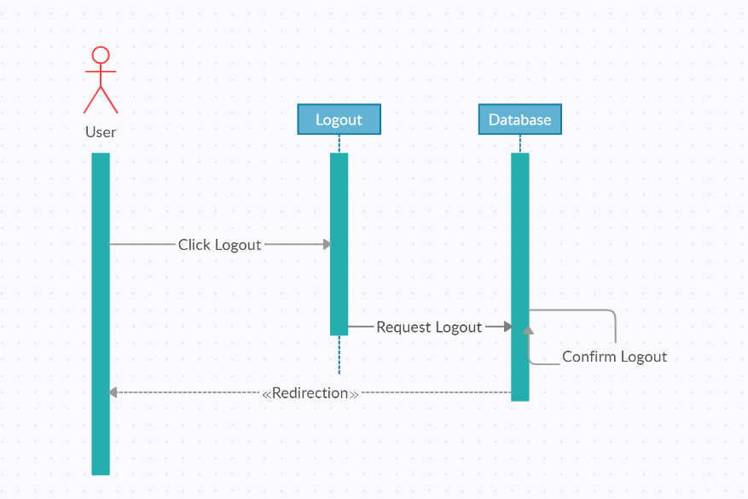***Logout***
  3. 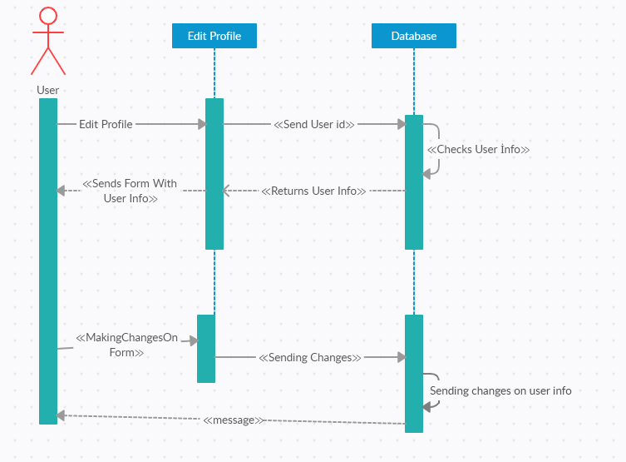***Edit Profile***
  4. 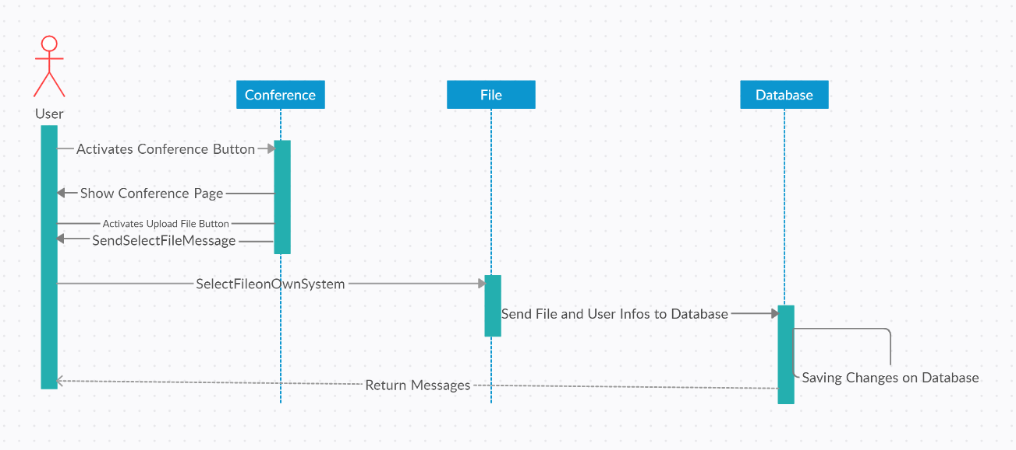***Upload Files***
  5. 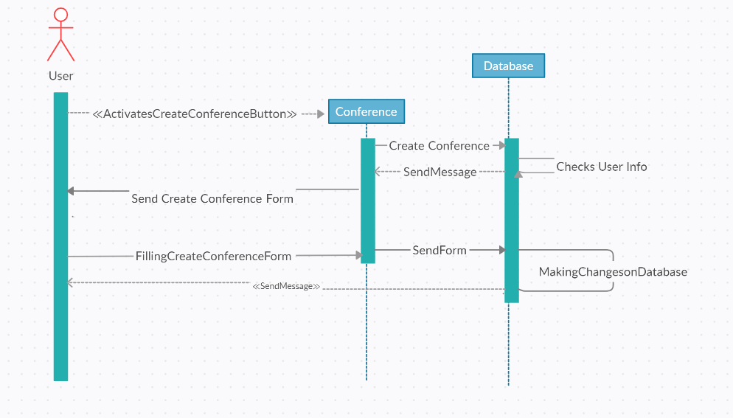***Create Conference***
  6. 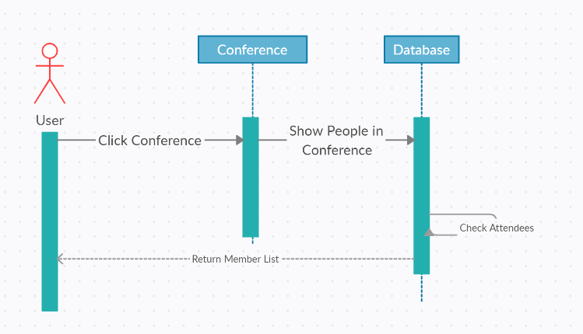***View Conference Members***
  7. ***Edit Upload***

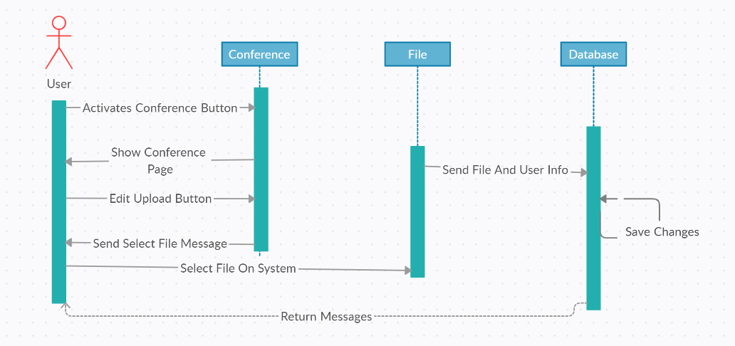

* 1. ***Notification***

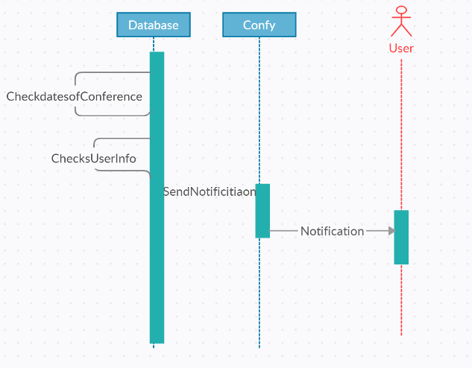

* 1. 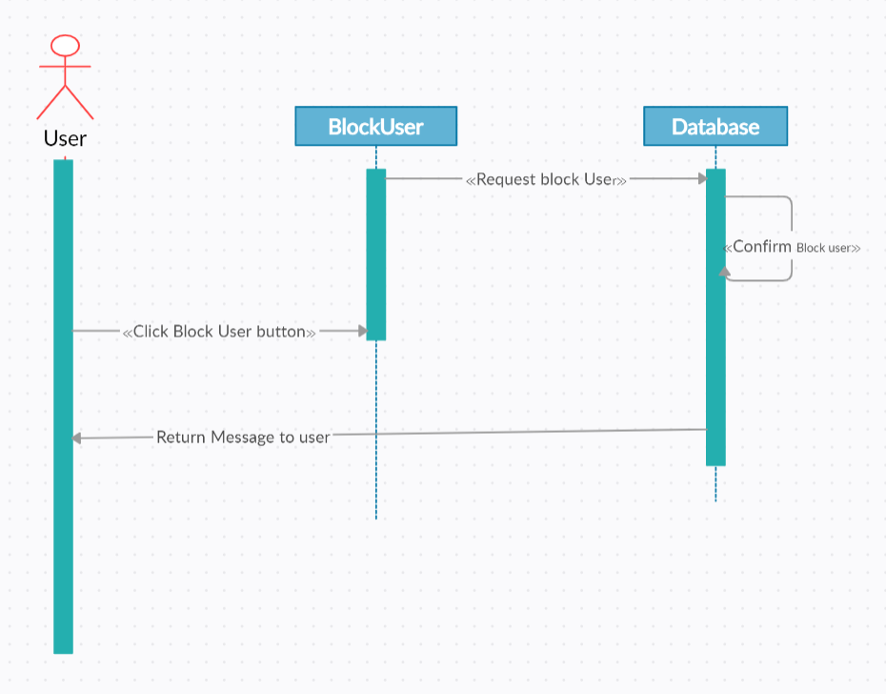 ***Block User***
  2. 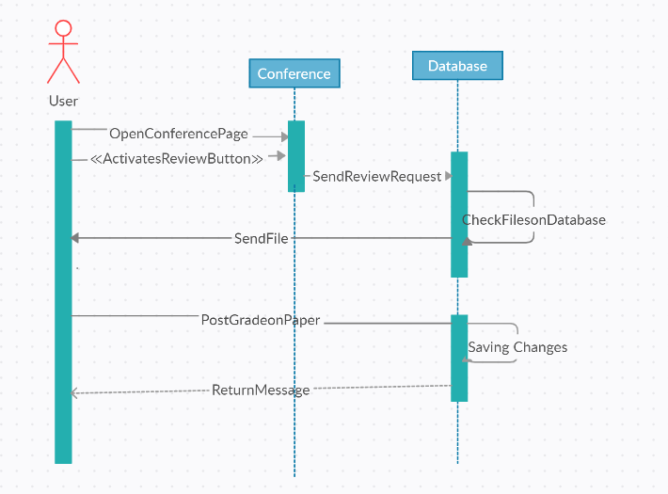***Review & Grade Paper***
  3. 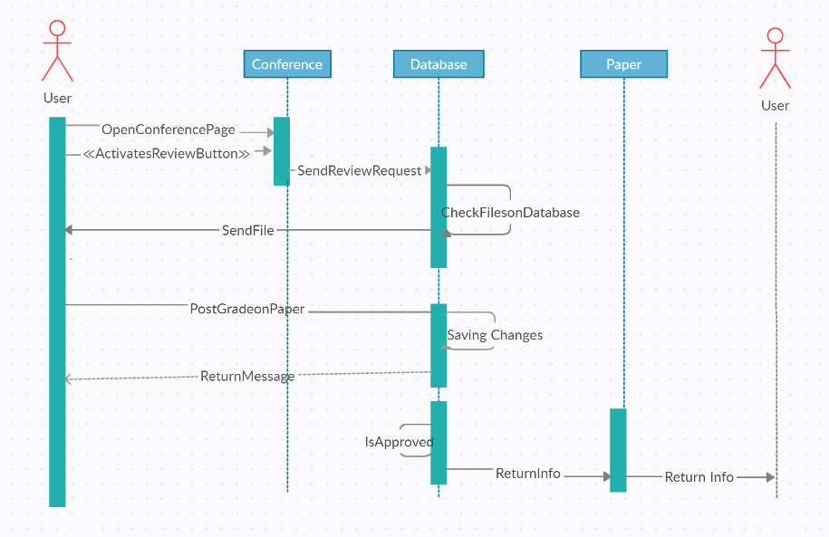 ***Review File, Assign Grade & Approve Paper***
  4. 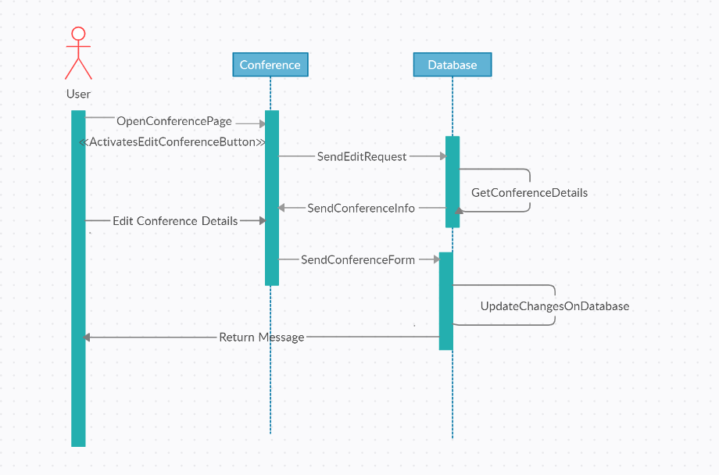 ***Edit Conference***
  5. 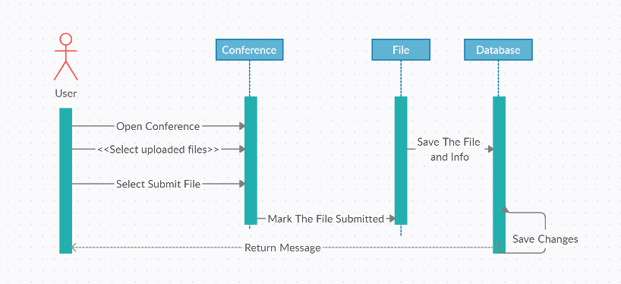 ***Submit File***