1. For adding the product, we need to have following field:
   1. Product Name / Title
   2. Product overview
   3. Key features
   4. Legal
   5. Specifications
   6. Technical Specifications

Please do the changes in the form by:

        1.  **Remove or make**the fields optional (PDF, Video)

1. Description to be renamed as “Product Overview.”
2. Features to be as “ Key Features.”
3. Add another field for “ Specifications”.
4. Add another field for “Legal.”
5. Add another field for “Technical specifications.”
6. Also add images slider for multiple images and add that field accordingly.  
  
  
**Make sure all the field title appears correctly along with their descriptions as it is. Here when you add “Description” in form it appears as “ Overview” we DO NOT want that.  
Product Overview must appear as Product overview and so on.  
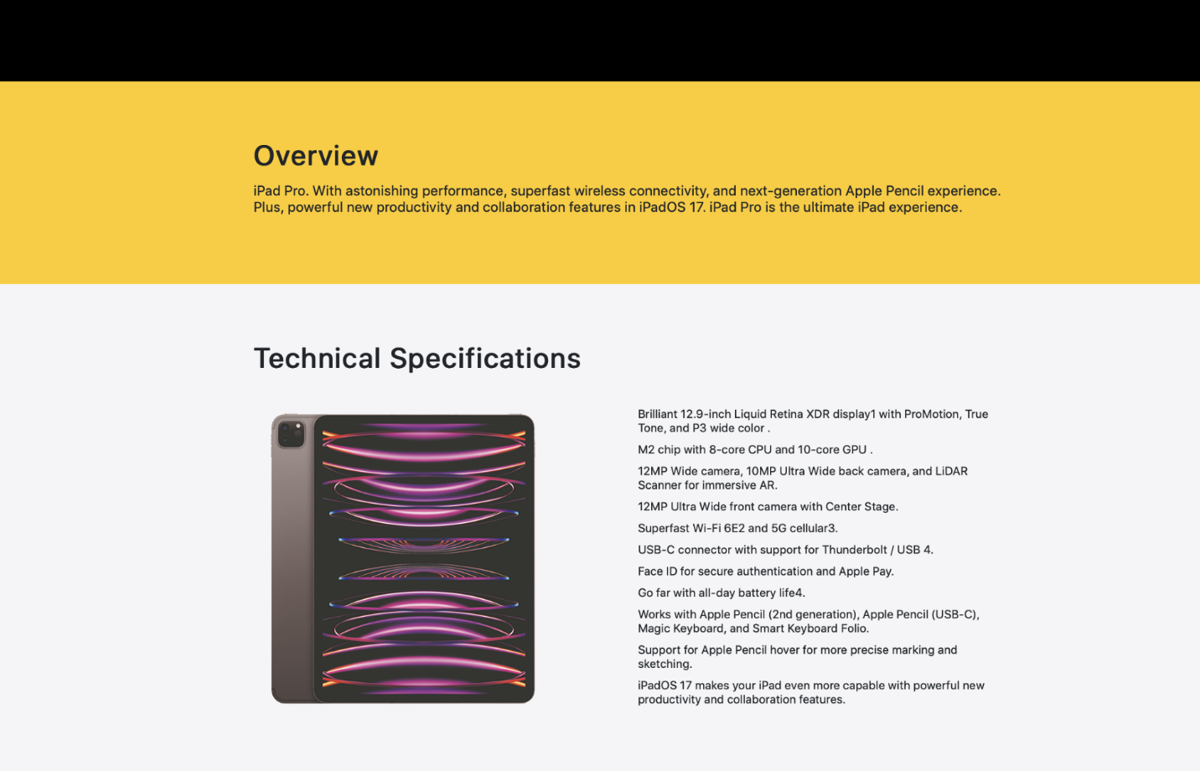**

Please keep the unified theme that is “White” for product page as well. Make sure that when images are added they must not appear zoomed or stretchy.

Again, for your reference below are the website:  
[https://edu.store.academia.co.uk/apple/ipad/education-ipad-10-2-inch-wi-fi-64gb-space-grey-mk2k3ba.html](https://eur01.safelinks.protection.outlook.com/?url=https%3A%2F%2Fedu.store.academia.co.uk%2Fapple%2Fipad%2Feducation-ipad-10-2-inch-wi-fi-64gb-space-grey-mk2k3ba.html&data=05%7C02%7Cmeshref.emam%40tharawat.tech%7C411e4536c12a43709afc08dc6465c95b%7C75638cf6c8d640bea7f89ad85b0b6eca%7C0%7C0%7C638495635578007409%7CUnknown%7CTWFpbGZsb3d8eyJWIjoiMC4wLjAwMDAiLCJQIjoiV2luMzIiLCJBTiI6Ik1haWwiLCJXVCI6Mn0%3D%7C0%7C%7C%7C&sdata=%2FPggce7FXscfopaSzBgYgxLyKzck%2FPxDQfO%2BwRn1JEc%3D&reserved=0)  
  
[https://www.krcs.co.uk/macbook-air-13-inch-m2-8-core-cpu-8-core-gpu-8gb-256gb-space-grey-30w](https://eur01.safelinks.protection.outlook.com/?url=https%3A%2F%2Fwww.krcs.co.uk%2Fmacbook-air-13-inch-m2-8-core-cpu-8-core-gpu-8gb-256gb-space-grey-30w&data=05%7C02%7Cmeshref.emam%40tharawat.tech%7C411e4536c12a43709afc08dc6465c95b%7C75638cf6c8d640bea7f89ad85b0b6eca%7C0%7C0%7C638495635578024862%7CUnknown%7CTWFpbGZsb3d8eyJWIjoiMC4wLjAwMDAiLCJQIjoiV2luMzIiLCJBTiI6Ik1haWwiLCJXVCI6Mn0%3D%7C0%7C%7C%7C&sdata=XN7xlNgRwBgHsa0USjSis48prcG9rIQih1WUcDjgxno%3D&reserved=0)

Please check with the development team to go through each and decide which approach would be feasible for them to execute.