HOMEWORK #4
MLP Implementation By SystemC
Ali Alipour Fraydani
810101233
ali.alipour98@yahoo.com

Ali
Alipour
(Fraydani)

In this homework we try to implemented MLP by VHDL. in this project we design Datapath and Controller for every Neuron.
VHDL, Datapath, Controller, State Diagram

Introduction
In this homework first we want describe Dathapath and Controller of Single Neuron in next step connected them to hidden layer, in output compare them and identify classes of iris (Setosa, Versicolor, Virginica).

datapath and controller

Datapath
Figure 2.1 show datapath of single neuron
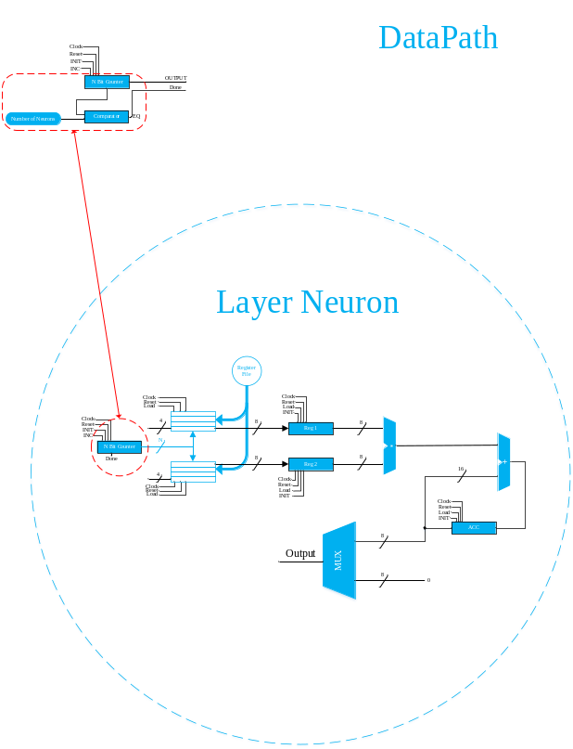
Figure ‎II:I
Datapath has two register file for store inputs and weights, next one we have two register that we called Partial register that every data that need to process goes there next one data multiply and add with bias, first one bias initial in Accumulator and after than that add with before data. Output multiplexer describe ReLu function.

Controller
In this level describe a Controller Figure 2.2 shown the controller of single neuron.

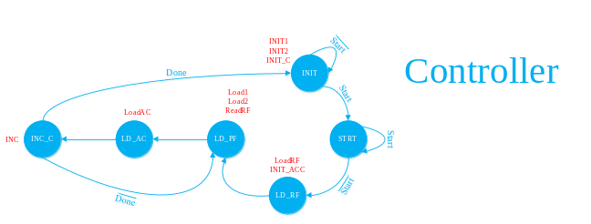
Figure ‎II:II
Controller start with Start signal, this signal have to on and off for start control, next state load data to register files and Accumulator initial with bias data first one, after than load data to Partial registers and load to Accumulator after than, increment counter if neuron doing itself duty controller issued Done, else load new value to partial register.
In this section we describe the MLP by systemC, we describe modules in VHDL into c++ file that shown in Figure 2.3.
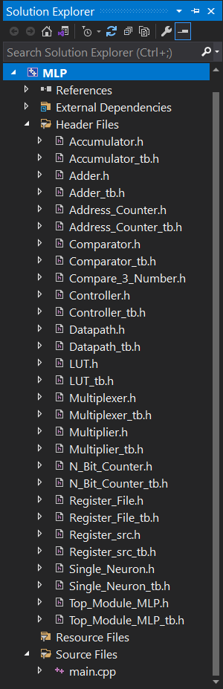
Figure ‎II:III

This module explain in represent, that capturing from desktop. Single Neuron included from datapath & controller that shown in Figure 2.4.

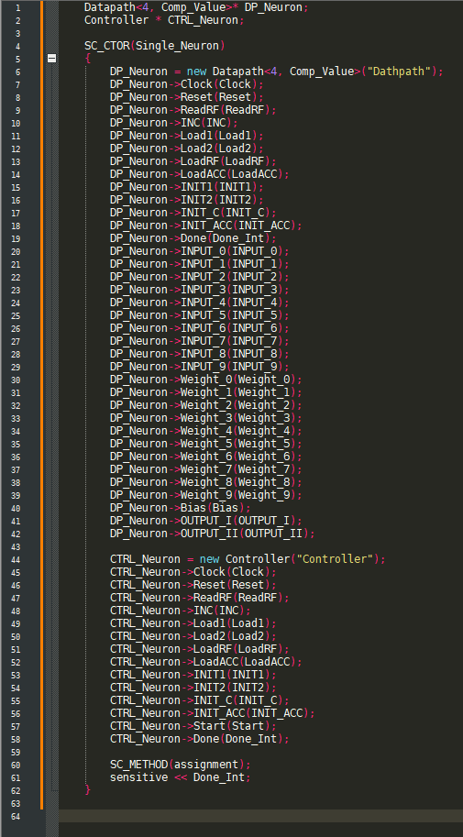
Figure ‎II:IV

Top_module_MLP include 21 Neuron, 10 Neuron for first layer, 8 Neuron for second layer and 3 Neuron for output layer, number of inputs in first layer is 4 that fully connected to Neurons of layer, therefore counter of this Neurons must be count until 4, as the same way, layer 2 count until 10 and third layer count until 3, by use of this information set parameter of Single Neurons in Top_module_mlp that first parameter shown number of bit from counter and second parameter shown maximum counting by counter. Figure 2.5 shown this.

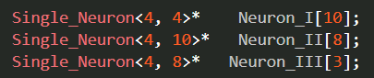
Figure ‎II:V

We use for statement in c++ for describe Neuron of layer that shown in Figure 2.6.

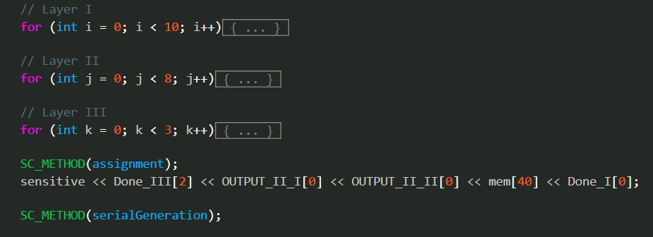
Figure ‎II:VI

First layer shown in Figure 2.6 that shown how describe it by for statement.

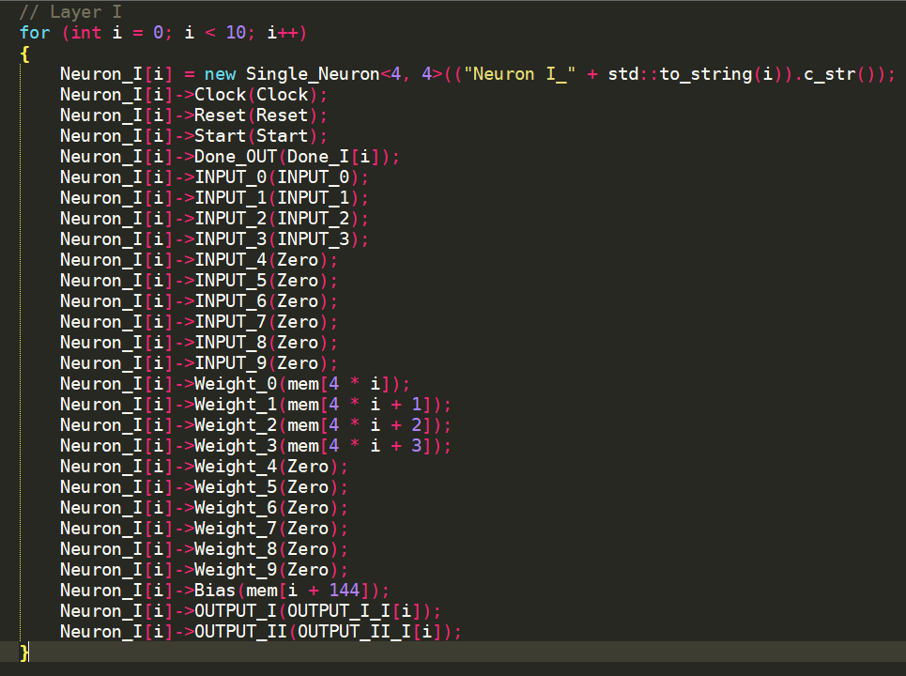
Figure ‎II:VII

mem array take by file by format text from zero time that shown in Figure 2.8.

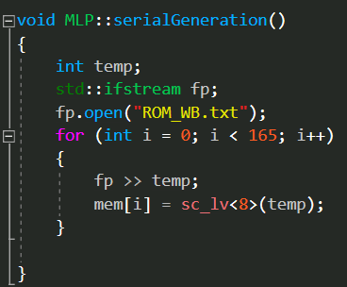
Figure ‎II:VIII

serialGeneration has a SC_METHOD member function that run from zero time after running.

In test bench of top_module_mlp give test data from file that named by X_Test_Data.txt and apply from MLP and compare by targets that exist in Y_Test_Data.txt end of run show accuracy. Inputting member function shown in Figure 2.9.
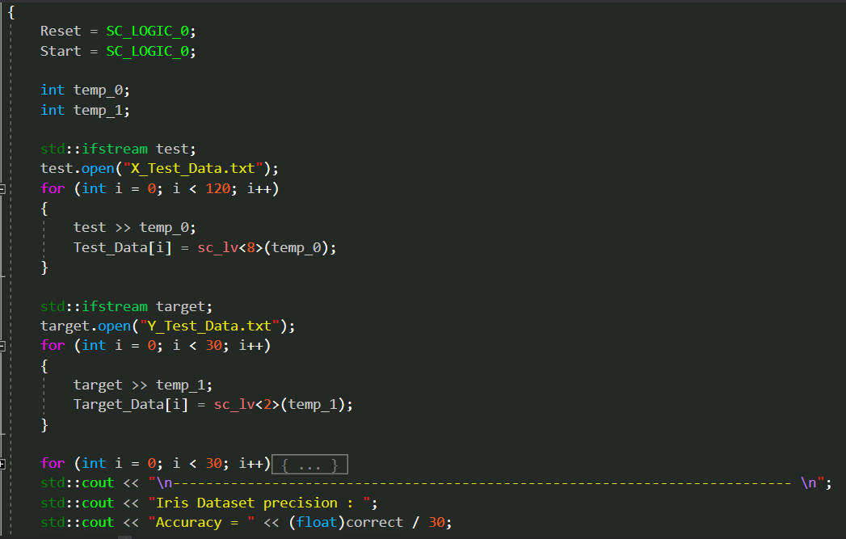
Figure ‎II:IX

Result of command line shown in Figure 2.10, accuracy get same of VHDL Homework.

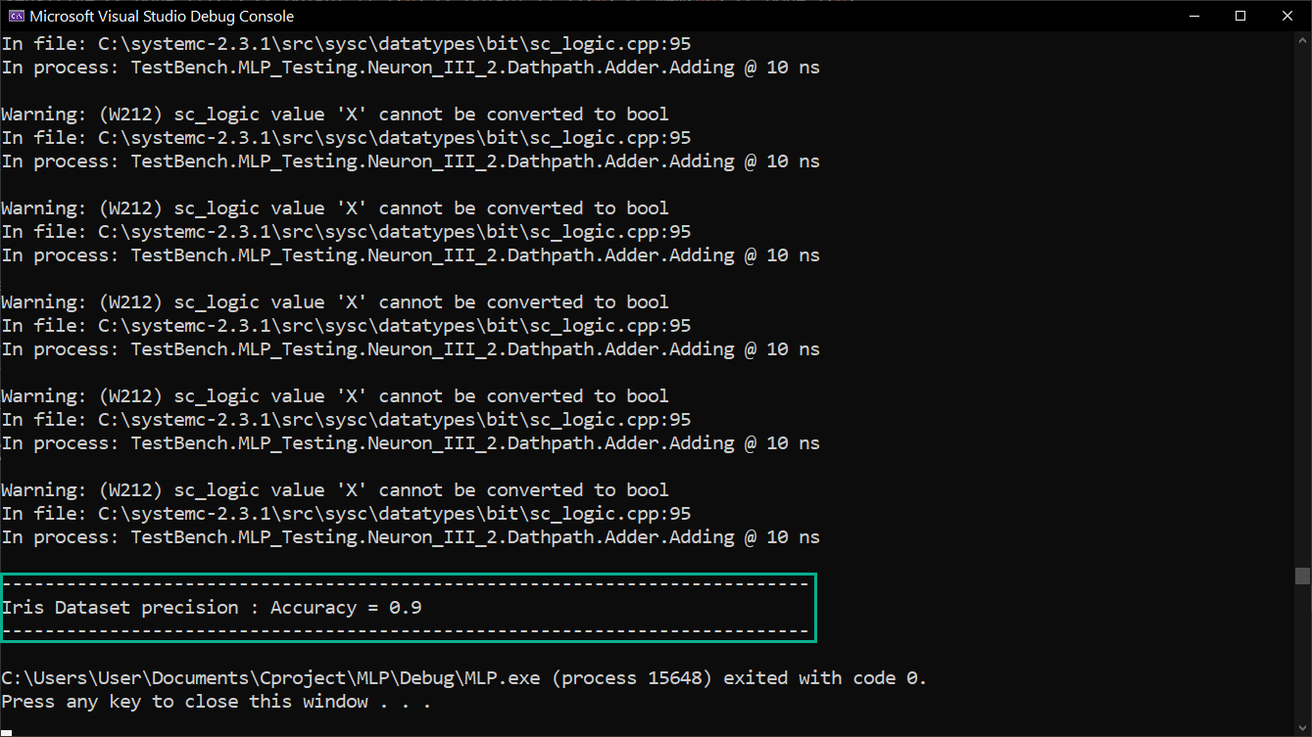
Figure ‎II:X

IEEE conference templates contain guidance text for composing and formatting conference papers. Please ensure that all template text is removed from your conference paper prior to submission to the conference. Failure to remove template text from your paper may result in your paper not being published

Waveform of this Homework shown in Figure 2.11.

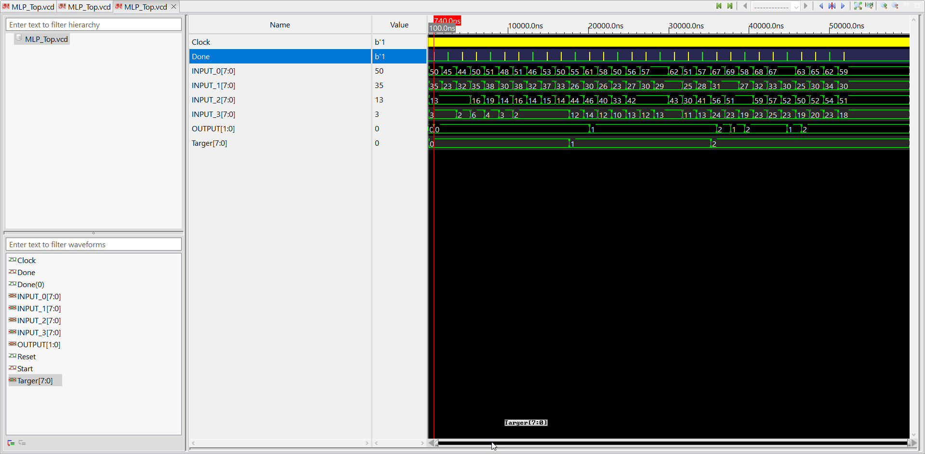
Figure ‎II:XI

