HOMEWORK #3
MLP Implementation By VHDL
Ali Alipour Fraydani
810101233
ali.alipour98@yahoo.com

Ali
Alipour
(Fraydani)

In this homework we try to implemented MLP by VHDL. in this project we design Datapath and Controller for every Neuron.
VHDL, Datapath, Controller, State Diagram

Introduction
In this homework first we want describe Dathapath and Controller of Single Neuron in next step connected them to hidden layer, in output compare them and identify classes of iris (Setosa, Versicolor, Virginica).

datapath and controller

Datapath
Figure 2.1 show datapath of single neuron
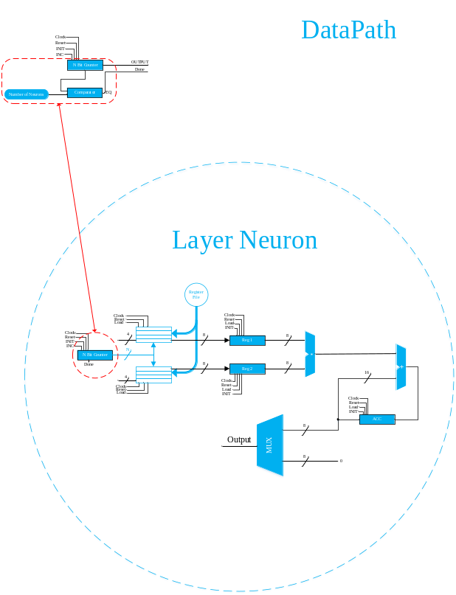
Figure ‎II:I
Datapath has two register file for store inputs and weights, next one we have two register that we called Partial register that every data that need to process goes there next one data multiply and add with bias, first one bias initial in Accumulator and after than that add with before data. Output multiplexer describe ReLu function.

Controller
In this level describe a Controller Figure 2.2 shown the controller of single neuron.

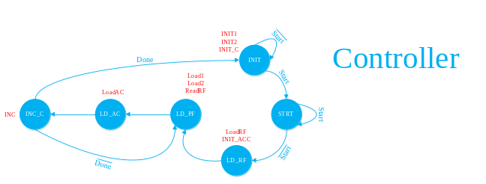
Figure ‎II:II
Controller start with Start signal, this signal have to on and off for start control, next state load data to register files and Accumulator initial with bias data first one, after than load data to Partial registers and load to Accumulator after than, increment counter if neuron doing itself duty controller issued Done, else load new value to partial register.
Counter provide address for register files, architeture of it shown in Figure 3.1
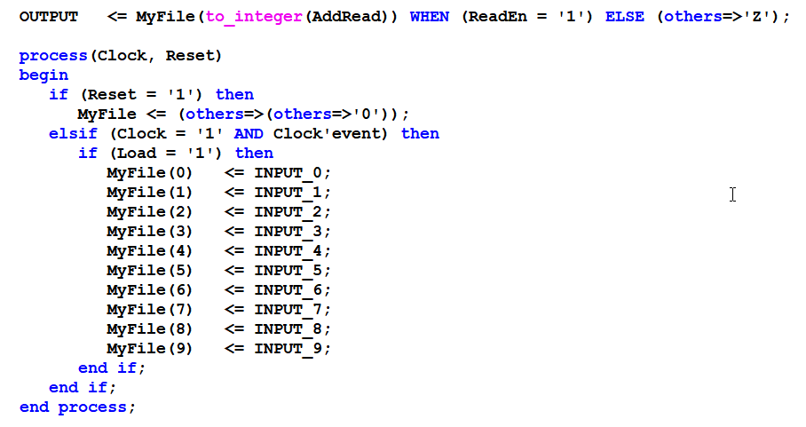
Figure ‎II:III
Figure 3.2 show Address counter that addressed register files.
Figure ‎II:IV
Partial registers shown in Figure 3.2 this registers stored values for process.
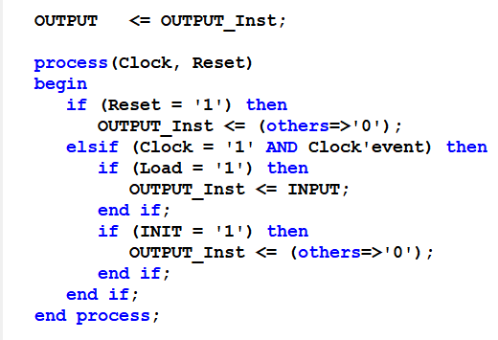
Figure ‎II:III

Figure 3.4 shown datapath that synthesizer arrived that our describe from VHDL.

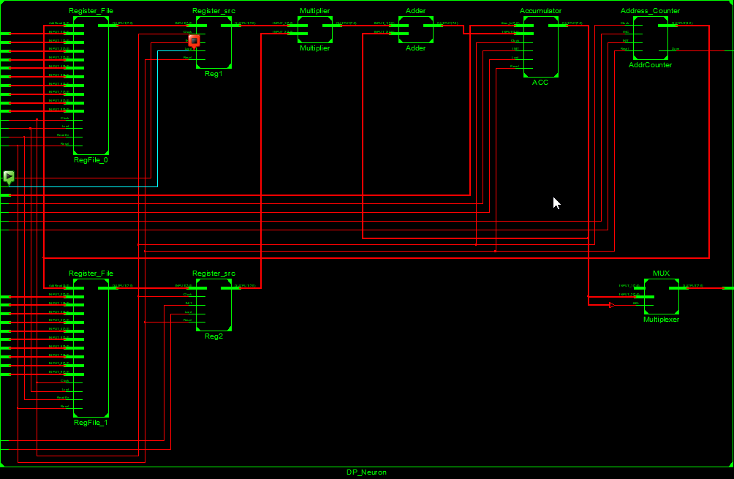
Figure ‎II:IV

Figure ‎II:V

Results
Examples shows in Figure 3.1, 3.2, 3.3, 3.4 .

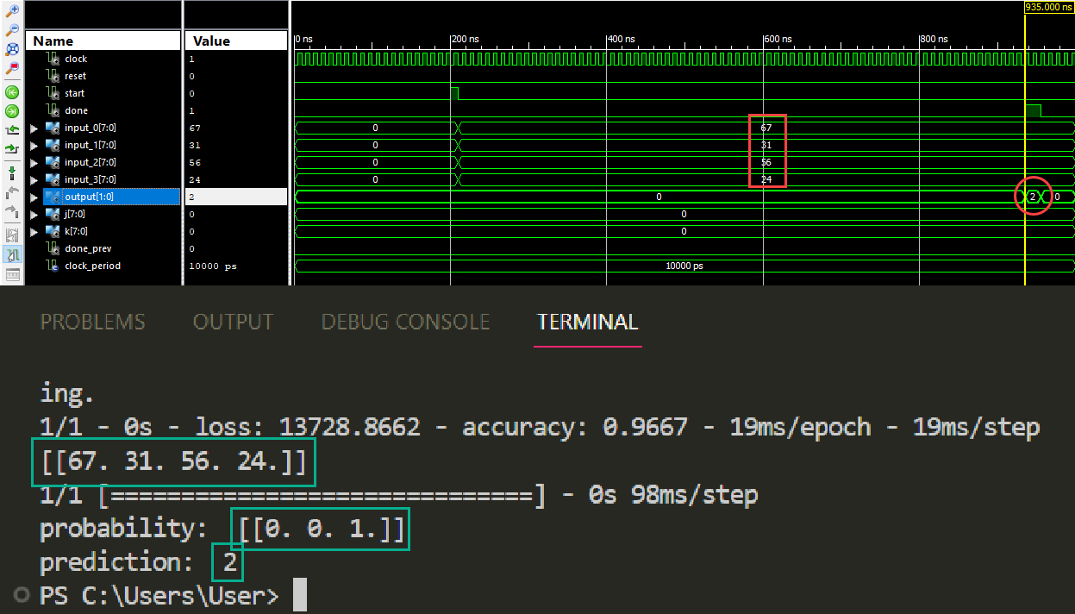
Figure ‎III:VI

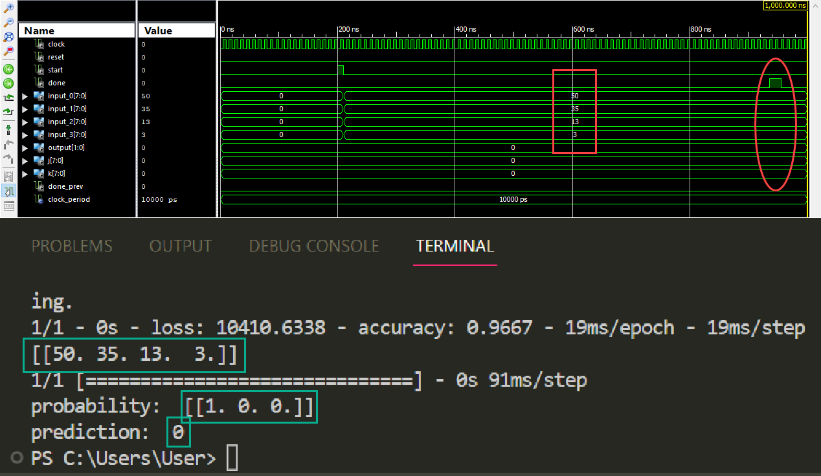
Figure ‎III:VII

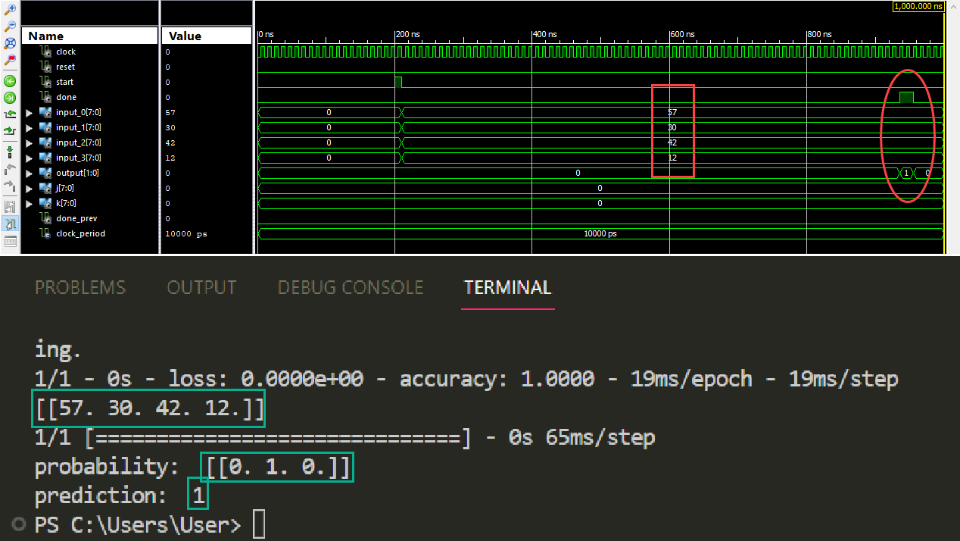
Figure ‎III:VIII

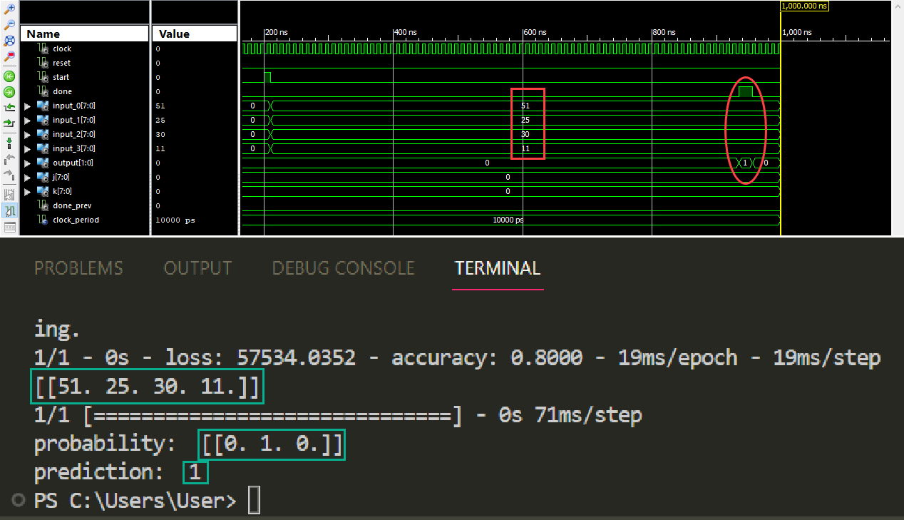
Figure ‎III:IX

Resolution of this algorithm shown in Figure 3.5.
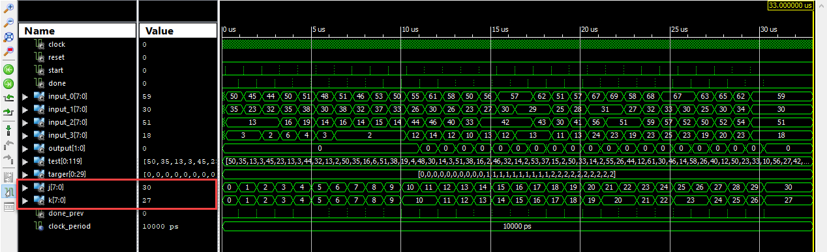
Figure ‎III:X

As you can see resolution is 0.9 (27/30) that this resolution for test data received.

IEEE conference templates contain guidance text for composing and formatting conference papers. Please ensure that all template text is removed from your conference paper prior to submission to the conference. Failure to remove template text from your paper may result in your paper not being published.

