HOMEWORK #1
RTL Design
Ali Alipour Fraydani
810101233
alipoura364@gmail.com

Ali
Alipour
(Fraydani)

We have an unsigned 8-bit multiplier (inA[7:0], inB[7:0], outW[15:0]) that we want to use for approximating multiplication of two 16-bit operands, opndA[15:0] and opndB[15:0]. The result is to become available on the 32-bit output, rsltW[31:0]. A simple and very inaccuruate way of doing the multiplication is to take eight most significant bits of opndA and opndB, multiply them using the 8-bit multiplier and use the result as the most significant 16 bits of rsltW with 16 zeros to its right.
VHDL, Datapath, Controller, VAM16, State Diagram

Introduction
In this homework we want to describe and 32 multiplier by 8 bit multiplier this multiplication is very inaccurate but the most of time we don’t want accuracy but want to approach to real result.

dathapath and controller

Datapath
First one talk about design VAM16 (A Valuable 16-bit Approximate Multiplier). My design has a datapath and controller that I want to explain it, datapath shown in Figure 2.1, that has 3 registers that have different functionality, Register A have same functionality of Register B but concatenation Register is different. Data from ABus and BBus place to Register A and Register B by load command that issued by controller, therefore 16 bit send to a combinational logic named 1’s Detector, 1’s Detector, detect first one from the left hand side then 8-bit data select the input and send to its output to addition of special slice input counting number of zeros to arrive first 1, and it count send by Count_A or Count_B to the next level.
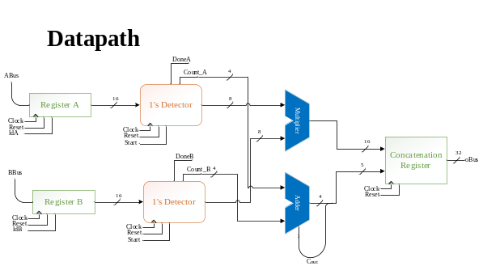
Figure ‎II:I
8-bit of output of 1’s Detector that send from Register A and Register B take to Multiplier and output of it is 16-bit that send to Concatenation Register.
Count that calculate by 1’s Detector is number of zeros that we skipped, every two count must be add, this operation perform by Adder, because of addiction of two operands perhaps have beyond that 15 and overflow concatenate output by Cout and send to Concatenation Register. In Concatenation Register place result of Multiplier to output register but distance of left hand side specified by result of Adder Unit.

Controller
Now we talk about controller that designed. Controller shown in Figure 2.2
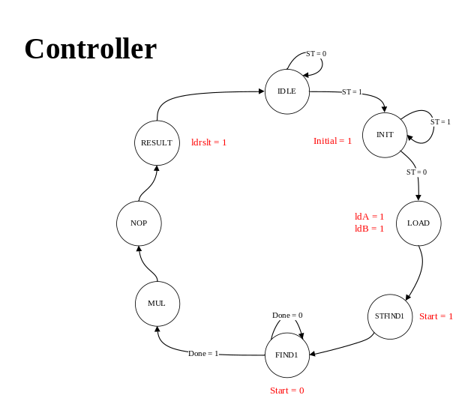
Figure ‎II:II

In this controller we are in state IDLE, ST (start) have to toggle to one and toggle to zero for 1 cycle that controller started, after ST = 1 we are go to state INIT that initial signal has issued, initial signal is reset all register that apply to Datapath, then if ST = 0 go to LOAD state in LOAD, ldA and ldB issued that mean ABus and BBus load to output of its registers. STFIND1 active start for 1’s Detector start its activity for detect 1, in state FIND1 we stay until Done = 1 that mean component find first 1 and go to state MUL that perform multiplication operation, one cycle delay for multiplication perform multiple completely that its purpose provide by NOP state that do not special operation in this state. Then result provided and we load this result in Concatenation register by state RESULT.

Code Description (Component)
First one we describe a register, Figure 3.1 shown entity of register.

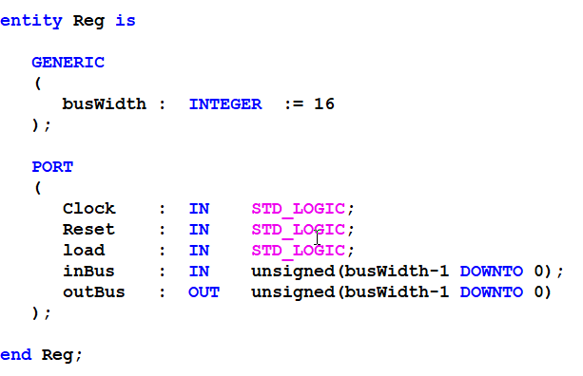
Figure ‎III:III
Architecture of register shown in Figure 3.2 if load issued then input send to output and if Reset issued output is zero.

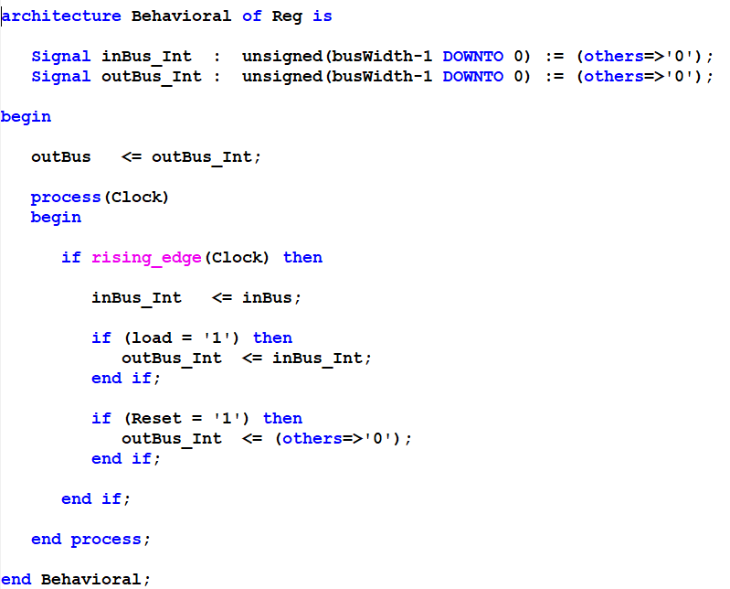
Figure ‎III:IV

Next component we describe is 1’s Detector, every 1’s Detector has four inputs Clock, Reset, Start and input and five output that names is sellower, selupper (this two port are optional remain from before my wrong design) Done, count_OUT and output, Figure 3.3 shown entity of 1’s Detector.

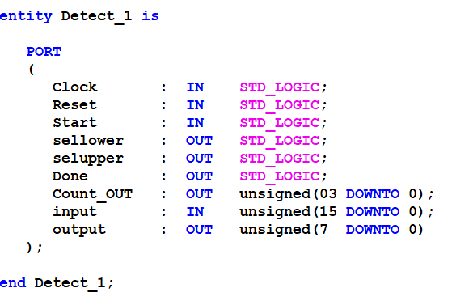
Figure ‎III:V

This module has an asynchronous Reset that by reset all signal and counter is zeros that shown in Figure 3.4.

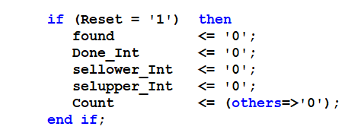
Figure ‎III:VI

If start is issued counter that show skip zeros is zero and module start to detect first 1. This state shown if Figure 3.5.

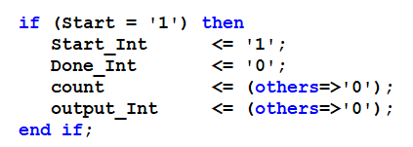
Figure ‎III:VII

From right hand side if find first 1, found signal issued and start inactive because now we can start again and issued start for another set of numbers. Figure 3.6 show how to detect 1.

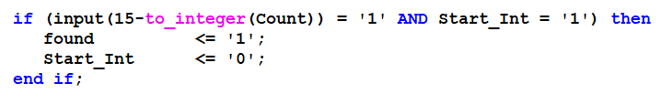
Figure ‎III:VIII

If do not found and start issued we have to walk to bits from left for this approach we have to a increment counter Figure 3.7 shown how to increment this counter.

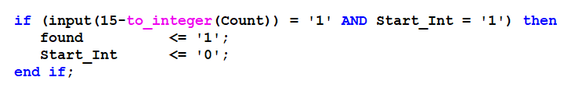
Figure ‎III:IX

If found issued, take Done means first 1 founded. If counter greater than 8 select (number of skip bit from the left is beyond 8 or first 1 is in LSB). Output take lower value 8-bit otherwise first 1 until 8 bit after assign to output. This statement shown in Figure 3.8.

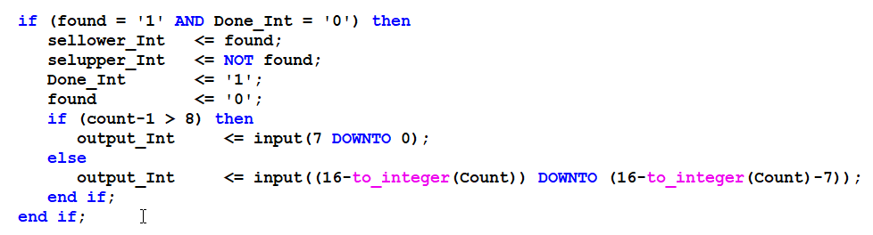
Figure ‎III:X

Multiply and Adder is very simplify that shown in Figure 3.9 and Figure 3.10.

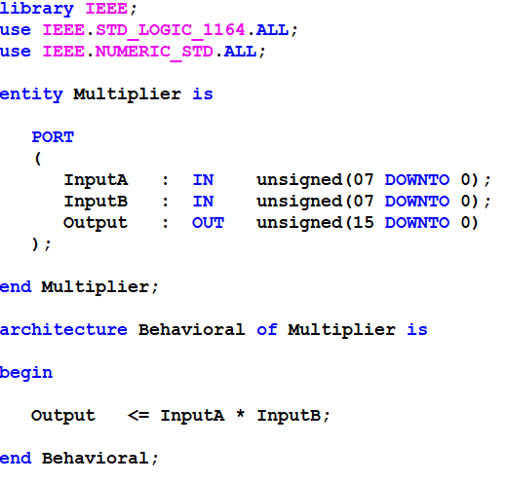
Figure ‎III:XI
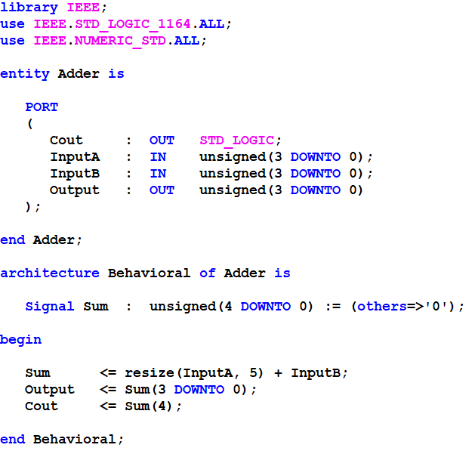
Figure ‎III:XII

In Figure 3.10 used resize function because inputA and InputB are 4-bit but we want to assign to a 5-bit signal. VHDL take error this unlike Verilog.

In Concatenation Register we take result of Multiplier and Adder (number of first one position from two operand) and concatenate between 32-bit number like than Homework Question and Python code provided. Figure 3.11 shown how to describe Concatenation Register.

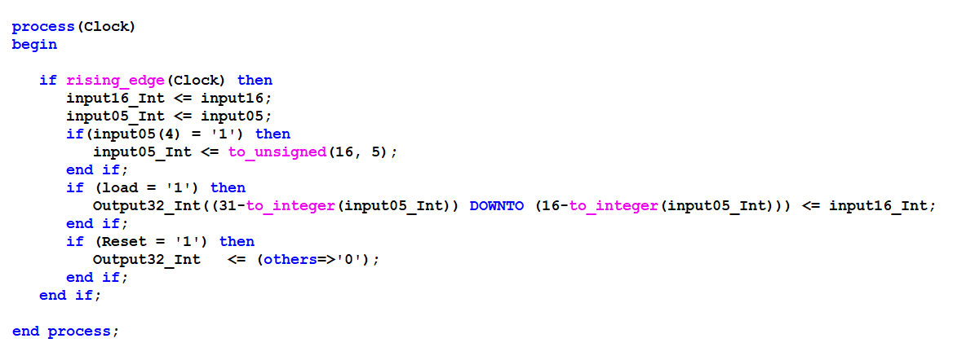
Figure ‎III:XIII

Code Description (Controller)
As you can see in Figure 4.1 we describe states by Constant in VHDL and take issued the signals by Controller design that shown in Figure 2.2.

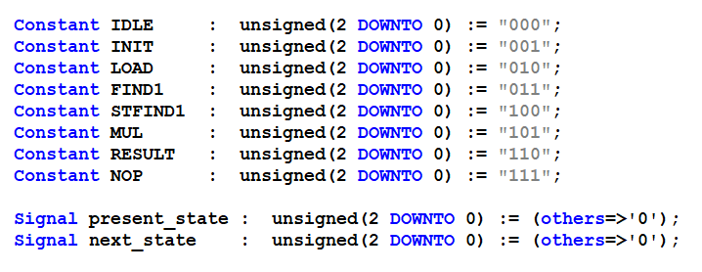
Figure ‎IV:XIV

Figure 4.2 show transition state.

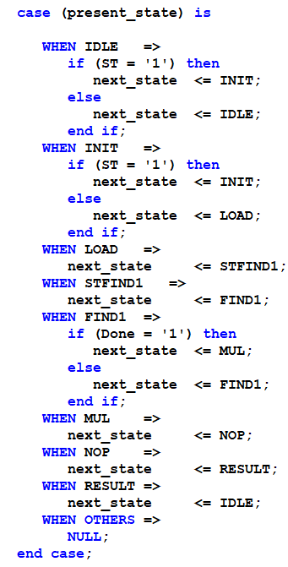
Figure ‎IV:XV

Figure 4.3 shown how to issued signals.

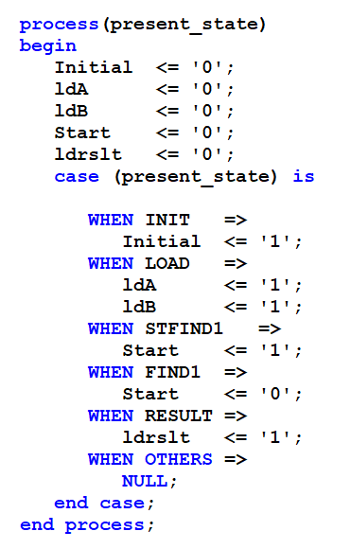
Figure ‎IV:XVI

Code Description (Datapath)

Datapath create by connected components, note this modules instants by generating instantiation for example.

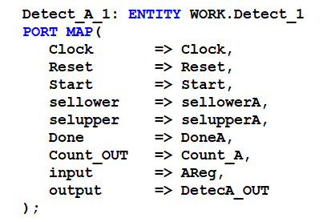
Figure ‎V:XVII

Simulation Result
We define four set of number for apply to multiplier every multiply shown by Python sample.
Four sets shown in Figure 6.1.

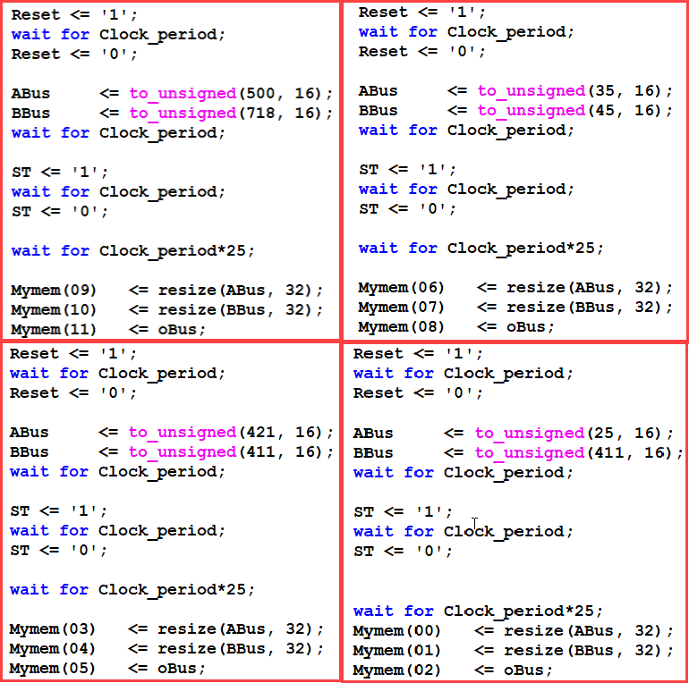
Figure ‎VI:XVIII

Simulation result by ISIM shown in Figure 6.2.

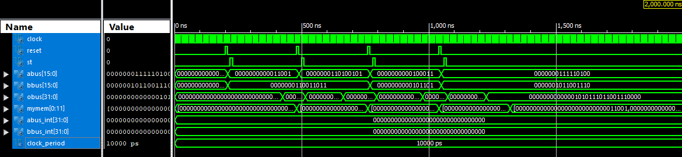
Figure ‎VI:XIX

For better comparison we store inputs and outputs in a memory and compare by Python code than show in Figure 6.3.

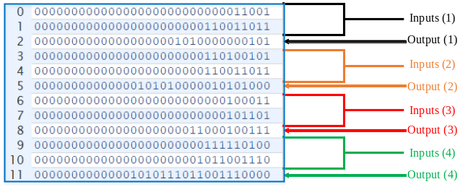
Figure ‎VI:XX

Result of Python code shown in Figure 6.4.

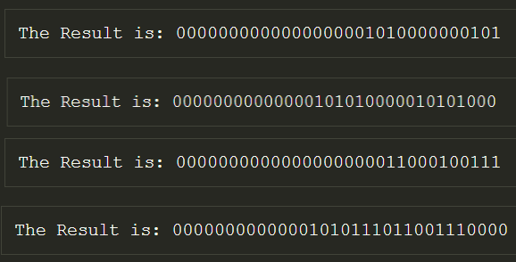
Figure ‎VI:XXI

VAM16 (Top Module)
Top Level Module include Datapath and Controller that we describe Connect intersect port between Datapath and Controller Figure 7.1 show Top Module and connection between Datapath and Controller.

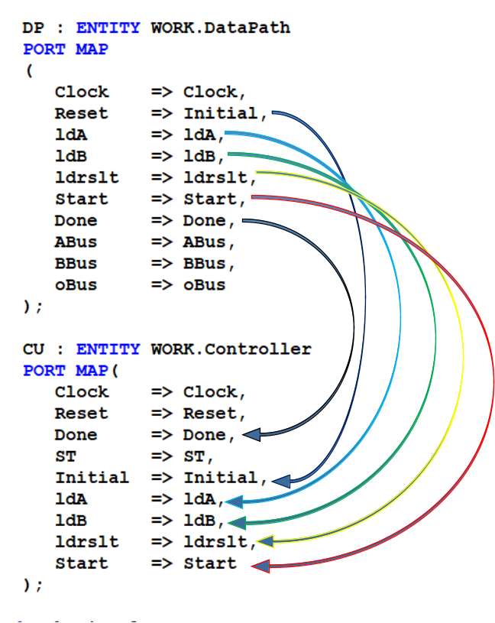
Figure ‎VII:XXII

EEE conference templates contain guidance text for composing and formatting conference papers. Please ensure that all template text is removed from your conference paper prior to submission to the conference. Failure to remove template text from your paper may result in your paper not being published.

