1. Project Description
This project implements a fully functional Data Warehouse for a large-scale retail operation using the Medallion Architecture (Bronze → Silver → Gold). The solution ingests raw data from 19 CSV source files representing an OLTP retail system, applies progressive data quality transformations across three layers, and exposes analytical star schemas for business intelligence consumption via Power BI.

The data covers all major operational areas of the retail business:
- In-store POS sales across 64 stores and 218 registers
- Online e-commerce orders fulfilled from 8 warehouses
- Inventory stock levels across stores
- Delivery and logistics performance across 8 courier providers
- Customer data for 4,000 customers across multiple US cities

2. Dataset Description
The source system is a retail OLTP database consisting of 19 CSV files exported from CRM and ERP systems. The dataset spans multiple business domains and contains a total of approximately 47,000 records across all tables.

Key dataset characteristics:
- 4,000 customers across 15 major US cities with loyalty tier segmentation (Bronze, Silver, Gold, Platinum)
- 600 products organized across 12 departments and 30 brands
- 14,962 transaction line items from 6,000 POS transactions
- 7,151 online order items from 3,000 online orders
- 1,927 delivery records linked to online orders
- 3,600 inventory snapshots across store-product combinations

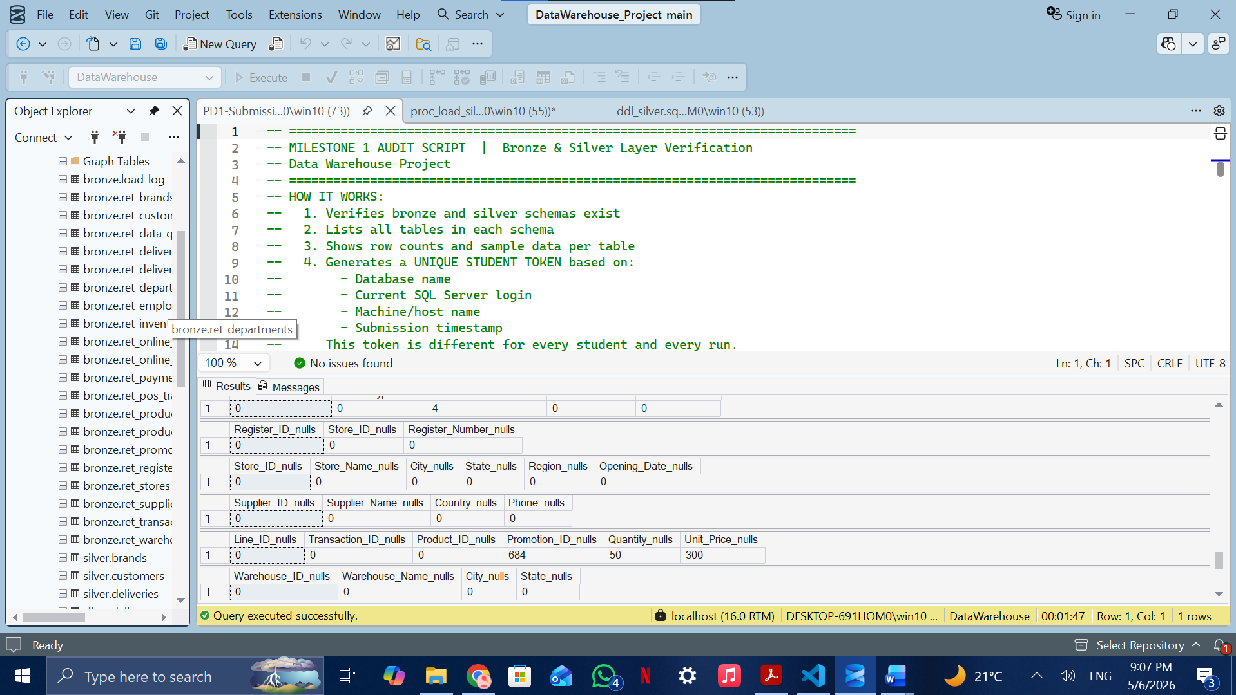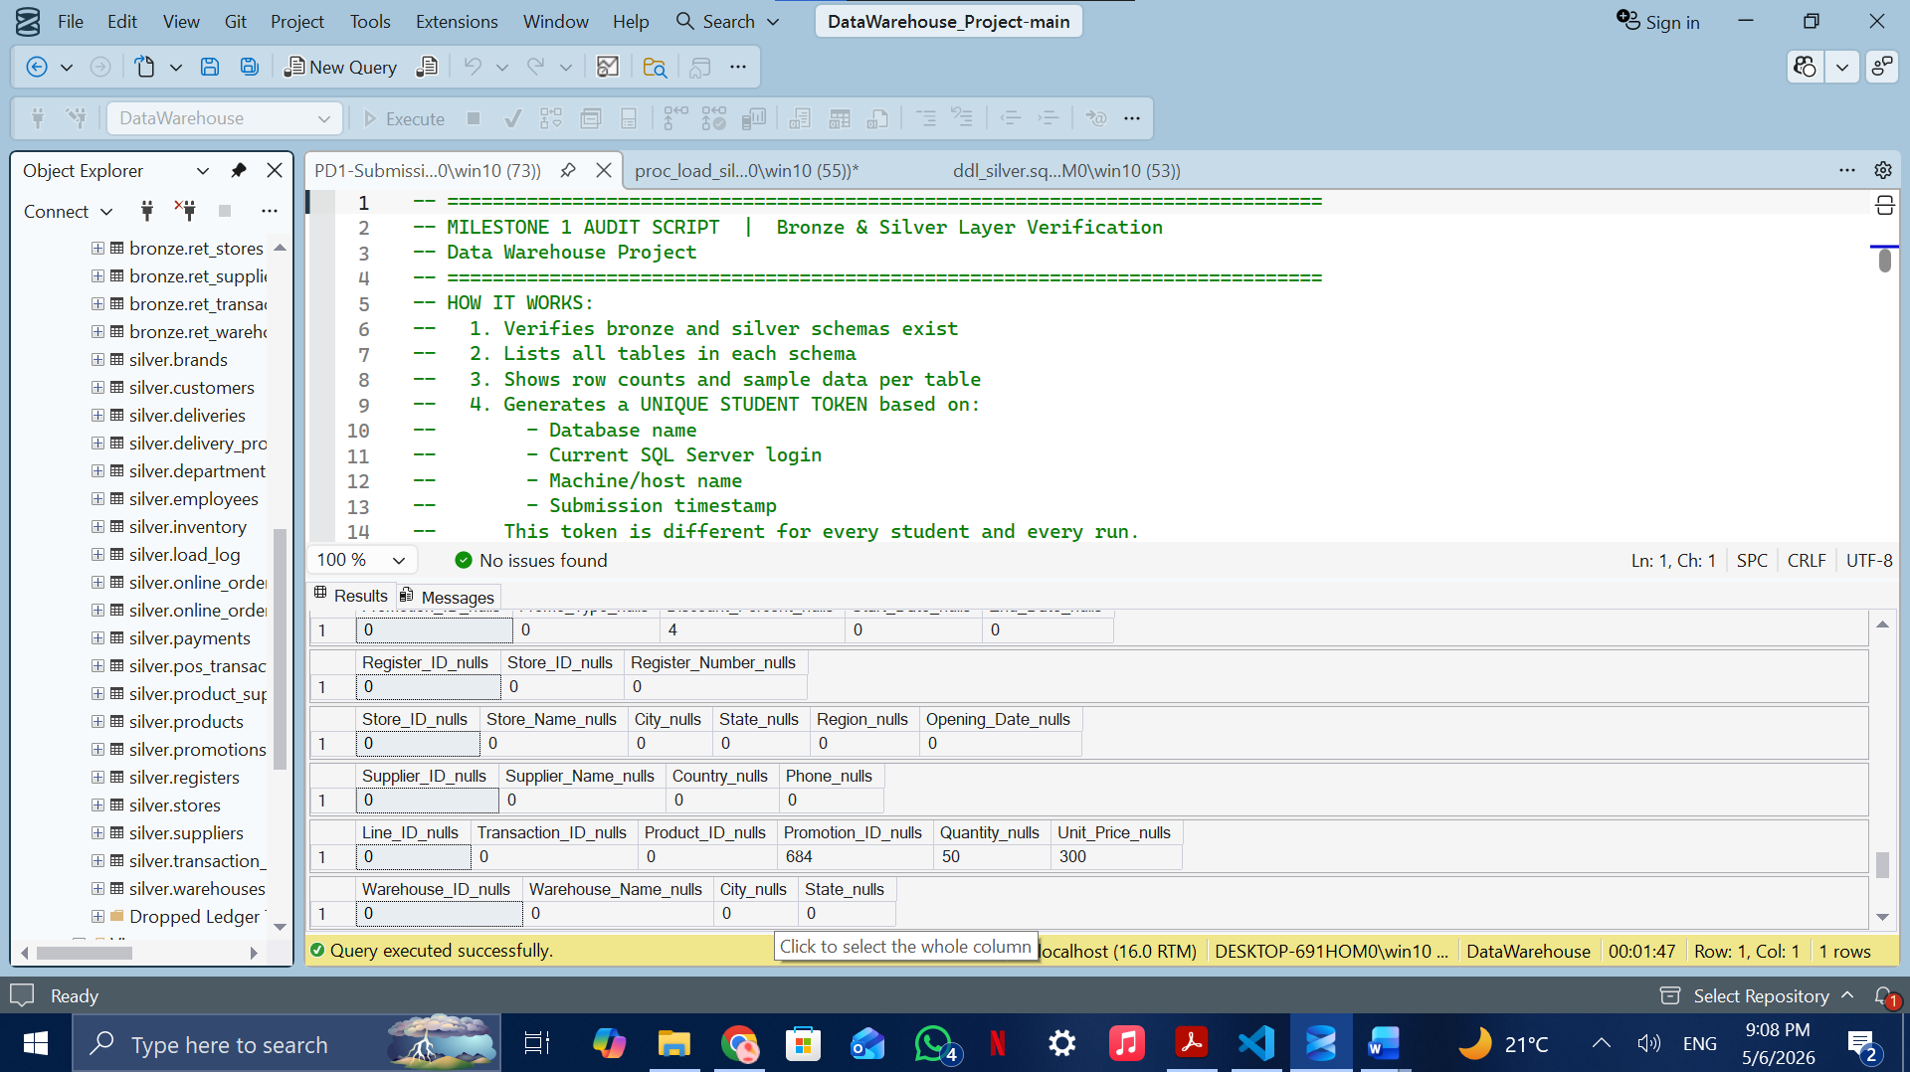

3. Bronze Layer

3.1 Overview
The Bronze layer serves as the raw data landing zone. Data is loaded exactly as received from the CSV source files — no transformations, no type casting, no cleaning. All columns are stored as NVARCHAR or INT to avoid any load failures due to data quality issues in the source.

The Bronze layer follows these specifications:
- Load method: Batch Processing, Full Load, Truncate and Insert
- Object type: Tables (one per CSV source file)
- Transformations: None — data mirrors the source structure exactly
- Automation: All loads executed through a single stored procedure bronze.load_bronze
- Auditing: Every table load is recorded in bronze.load_log with start time, end time, duration, row count, and status

3.2 Database and Schema Setup
The DataWarehouse database was created using init_database.sql, which drops and recreates the database and defines three schemas:
- bronze — raw staging tables
- silver — cleaned and transformed tables
- gold — analytical star schema tables

3.3 Bronze Tables
The following 19 Bronze tables were created to mirror each CSV source file:

Bronze Table | Source CSV | Rows | Description
bronze.ret_customers | CUSTOMERS.csv | 4,000 | Customer demographics
bronze.ret_employees | EMPLOYEES.csv | 800 | Store staff records
bronze.ret_stores | STORES.csv | 64 | Physical store locations
bronze.ret_registers | REGISTERS.csv | 218 | POS register devices
bronze.ret_products | PRODUCTS.csv | 600 | Product catalogue
bronze.ret_brands | BRANDS.csv | 30 | Brand reference
bronze.ret_departments | DEPARTMENTS.csv | 12 | Department reference
bronze.ret_promotions | PROMOTIONS.csv | 120 | Promotional campaigns
bronze.ret_pos_transactions | POS_TRANSACTIONS.csv | 6,000 | In-store POS headers
bronze.ret_transaction_items | TRANSACTION_ITEMS.csv | 14,962 | POS line items (main fact)
bronze.ret_online_orders | ONLINE_ORDERS.csv | 3,000 | E-commerce order headers
bronze.ret_online_order_items | ONLINE_ORDER_ITEMS.csv | 7,151 | Online line items (main fact)
bronze.ret_inventory | INVENTORY.csv | 3,600 | Stock level snapshots
bronze.ret_suppliers | SUPPLIERS.csv | 80 | Supplier master
bronze.ret_product_suppliers | PRODUCT_SUPPLIERS.csv | 1,214 | Product-supplier mapping
bronze.ret_warehouses | WAREHOUSES.csv | 8 | Warehouse locations
bronze.ret_deliveries | DELIVERIES.csv | 1,927 | Shipment records
bronze.ret_delivery_providers | DELIVERY_PROVIDERS.csv | 8 | Courier companies
bronze.ret_payments | PAYMENTS.csv | 3,000 | Online order payments

3.4 Load Procedure
The stored procedure bronze.load_bronze performs the following steps for each table:
- TRUNCATE TABLE to clear existing data before each load
- BULK INSERT from the corresponding CSV file using FIRSTROW=2, FIELDTERMINATOR=comma, ROWTERMINATOR=0x0d0a
- Row count capture using @@ROWCOUNT immediately after each insert
- Log entry inserted into bronze.load_log with procedure name, table name, start/end times, duration, row count, and SUCCESS/FAILED status
- Full error handling via BEGIN TRY / END CATCH — any failure is logged with the error message and the procedure continues

3.5 Load Validation
After executing the procedure, all 19 tables were validated against the DATA_QUALITY_REPORT reference file. Every table achieved an exact row count match, confirming successful load integrity.

4. Silver Layer

4.1 Overview
The Silver layer applies comprehensive data quality transformations to the raw Bronze data, producing clean, standardized, and enriched tables suitable for analytical modeling. Unlike Bronze, Silver tables use proper data types, enforce business rules, and add derived columns that support analytical queries.

The Silver layer follows these specifications:
- Load method: Batch Processing, Full Load, Truncate and Insert
- Object type: Tables with proper data types and constraints
- Transformations: Data cleansing, standardization, normalization, derived columns, and enrichment
- Automation: All transformations executed through stored procedure silver.load_silver
- Auditing: Every table transformation is recorded in silver.load_log

4.2 Transformations Applied
The following transformations were applied across all Silver tables:

Silver Table | Transformations Applied
silver.customers | TRIM all strings; Gender → Male/Female/Unknown; Loyalty_Level capitalization standardized; derived Full_Name
silver.employees | TRIM Name/Position; Gender standardized; Hire_Date cast to DATE; derived Tenure_Years
silver.stores | TRIM strings; Opening_Date cast to DATE; deduplicated on Store_ID
silver.registers | Deduplicated on Register_ID; NULL Register_Number allowed
silver.products | TRIM strings; enriched with Brand_Name and Department_Name via JOIN; NULL Package_Size → N/A
silver.brands | TRIM Brand_Name; deduplicated on Brand_ID
silver.departments | TRIM Department_Name; deduplicated on Department_ID
silver.promotions | TRIM Promo_Type; dates cast to DATE; derived Promo_Duration_Days; NULL Discount → 0
silver.pos_transactions | Transaction_Time cast to DATETIME; derived Transaction_Date; deduplicated on Transaction_ID
silver.transaction_items | NULL Promotion_ID → 0; derived Sales_Amount, Discount_Amount, Net_Sales_Amount; filtered invalid rows
silver.online_orders | Order_Time cast to DATETIME; derived Order_Date; Order_Status standardized; NULL Order_Total → 0
silver.online_order_items | NULL Promotion_ID → 0; derived Sales_Amount, Discount_Amount, Net_Sales_Amount; filtered invalid rows
silver.inventory | Last_Updated cast to DATETIME; NULL Stock_Level → 0; derived Reorder_Flag (< 50 units)
silver.deliveries | Ship/Delivery dates cast; Status standardized; derived Days_to_Ship, Days_to_Deliver, Total_Delivery_Days, On_Time_Flag (SLA 7 days)
silver.payments | Payment_Time cast to DATETIME; TRIM Payment_Method; filtered Payment_Amount <= 0
silver.warehouses | TRIM all strings; deduplicated on Warehouse_ID
silver.suppliers | TRIM all strings; deduplicated on Supplier_ID
silver.product_suppliers | Filtered Supply_Price <= 0; 20 invalid rows removed
silver.delivery_providers | TRIM all strings; deduplicated on Provider_ID

4.3 Data Quality Issues Identified and Resolved
The following data quality issues were identified in the Bronze layer and resolved during the Silver transformation:

Issue | Affected Table(s) | Resolution
NULL Promotion_ID | transaction_items, online_order_items | Replaced with 0 (no promotion)
NULL Order_Total | online_orders | Replaced with 0 using ISNULL
Invalid Supply_Price | product_suppliers | Filtered out rows where price <= 0 (20 rows removed)
Inconsistent Gender | customers, employees | Standardized to Male / Female / Unknown
Inconsistent Loyalty | customers | Standardized to Bronze / Silver / Gold / Platinum
Inconsistent Order_Status | online_orders | Standardized: Canceled → Cancelled, trimmed whitespace
Date stored as string | pos_transactions, online_orders, deliveries, inventory | Cast using TRY_CAST to DATETIME/DATE
Duplicate records | customers, products, stores, promotions | Removed using ROW_NUMBER() OVER PARTITION BY business key
Whitespace in strings | All text columns | Applied TRIM() across all NVARCHAR fields
Zero quantity/price rows | transaction_items, online_order_items | Filtered out in Silver load (350 + 150 rows)

4.4 Derived Columns Added
The following business-relevant derived columns were added in the Silver layer:
- Full_Name (silver.customers) — concatenation of First_Name and Last_Name
- Tenure_Years (silver.employees) — calculated as DATEDIFF(YEAR, Hire_Date, GETDATE())
- Transaction_Date (silver.pos_transactions) — date portion extracted from Transaction_Time
- Order_Date (silver.online_orders) — date portion extracted from Order_Time
- Sales_Amount (silver.transaction_items, silver.online_order_items) — Quantity multiplied by Unit_Price
- Discount_Amount — Sales_Amount multiplied by Discount_Percent divided by 100, looked up from silver.promotions
- Net_Sales_Amount — Sales_Amount minus Discount_Amount
- Reorder_Flag (silver.inventory) — 1 if Stock_Level is below 50 units, else 0
- Promo_Duration_Days (silver.promotions) — DATEDIFF between Start_Date and End_Date
- Days_to_Ship (silver.deliveries) — days from Order_Time to Ship_Date
- Days_to_Deliver (silver.deliveries) — days from Ship_Date to Delivery_Date
- Total_Delivery_Days (silver.deliveries) — end-to-end delivery duration
- On_Time_Flag (silver.deliveries) — 1 if Total_Delivery_Days is 7 or fewer, else 0 (SLA threshold)

4.5 Enrichment
The silver.products table was enriched by joining to silver.brands and silver.departments during the transformation, denormalizing Brand_Name and Department_Name directly into the products table. This avoids repeated joins in the Gold layer and follows Kimball dimensional modeling best practices.

The silver.transaction_items and silver.online_order_items tables were enriched by joining to silver.promotions to look up Discount_Percent for each line item, enabling accurate discount and net sales calculations at the row level.

4.6 Silver Row Count Validation
The following table compares Bronze source row counts against Silver loaded row counts. All differences are justified by intentional data quality filtering:

Silver Table | Bronze Rows | Silver Rows | Notes
customers | 4,000 | 4,000 | Exact match
employees | 800 | 800 | Exact match
stores | 64 | 64 | Exact match
registers | 218 | 218 | Exact match
products | 600 | 600 | Exact match
brands | 30 | 30 | Exact match
departments | 12 | 12 | Exact match
promotions | 120 | 120 | Exact match
pos_transactions | 6,000 | 6,000 | Exact match
transaction_items | 14,962 | 14,612 | 350 rows filtered (invalid qty/price)
online_orders | 3,000 | 3,000 | Exact match
online_order_items | 7,151 | 7,001 | 150 rows filtered (invalid qty/price)
inventory | 3,600 | 3,600 | Exact match
suppliers | 80 | 80 | Exact match
product_suppliers | 1,214 | 1,194 | 20 rows filtered (invalid supply price)
warehouses | 8 | 8 | Exact match
deliveries | 1,927 | 1,927 | Exact match
delivery_providers | 8 | 8 | Exact match
payments | 3,000 | 2,794 | 206 rows filtered (invalid payment amount)

5. Project Technical Audit
The PD_SubmissionScript was executed on the DataWarehouse database to generate a unique verification token tied to the login credentials, machine identity, and execution timestamp. The full SSMS output from both the Results tab and the Messages tab is presented in screenshots

6. Project Scripts

6.1 Bronze Layer Procedure — bronze.load_bronze

6.2 Silver Layer Procedure — silver.load_silver

4.4 Additional Data Quality Issues (Advanced Profiling)
The initial data quality assessment revealed additional issues beyond standard null handling and formatting inconsistencies. These issues were identified through detailed profiling and were addressed during the Silver transformation process.

4.4.1 Null Value Analysis
Table | Column | Null Count | Resolution
inventory | Stock_Level | 180 | Replaced with 0 using ISNULL
online_orders | Order_Total | 120 | Replaced with 0
online_order_items | Quantity | 30 | Filtered invalid rows
online_order_items | Unit_Price | 120 | Filtered invalid rows
payments | Payment_Amount | 90 | Filtered invalid or NULL
product_suppliers | Supply_Price | 20 | Removed invalid rows
promotions | Discount_Percent | 4 | Defaulted to 0
transaction_items | Quantity | 50 | Filtered invalid rows
transaction_items | Unit_Price | 300 | Filtered invalid rows

4.4.2 Data Integrity Issues
Duplicate Customer Emails (12 cases): Deduplicated using business rules to ensure unique customer identity.
Invalid Promotion Date Ranges (4 cases): End_Date earlier than Start_Date; corrected or excluded.
Delivery Date Anomalies (12 cases): Delivery_Date earlier than Ship_Date; excluded from SLA calculations.
Payment Mismatch Issues (45 cases): Payment amounts not matching order totals; flagged for auditing.

4.4.3 Granular Data Issue Tracking
All problematic records were identified at the row level using business keys, enabling precise correction, filtering, and audit traceability.

