EXECUTIVE BRIEFING
Vesta
Your work, in order.
The AI chief of staff that keeps your priorities lit — and acts on them with you.

“I no longer need to scan my inbox to know what matters today.”

Prepared for Ali Sabbagh • What it does for you, and what's next
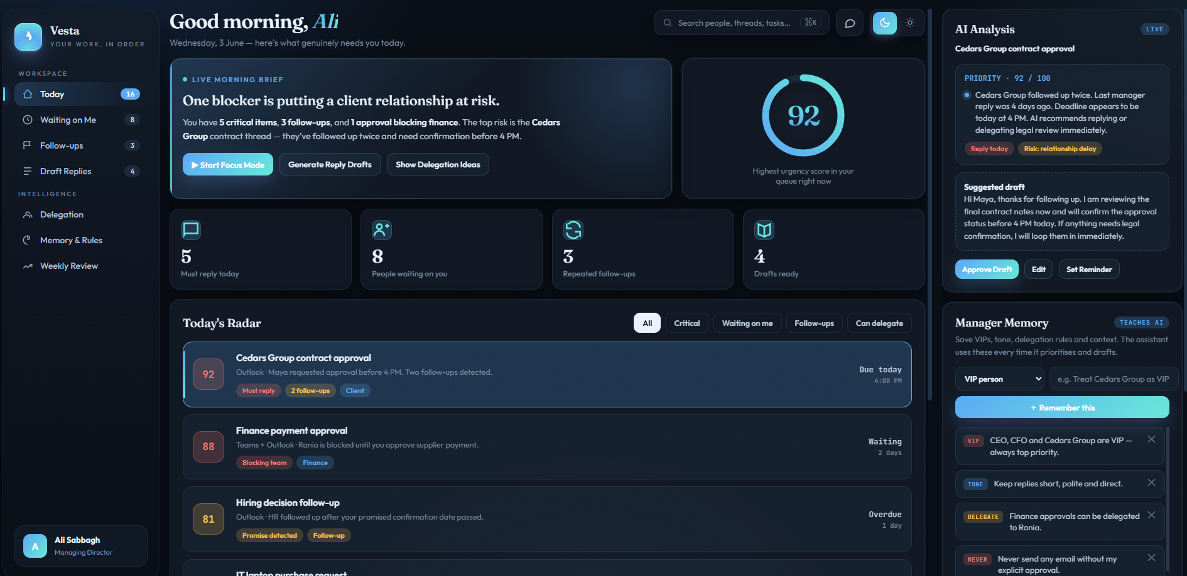

The Idea in One Line
Most of a manager's day is lost to one question: “out of everything in my inbox, chats, and tasks — what actually needs me right now?” This tool answers that question for you, every morning, automatically.
It is not another inbox. It is Vesta — a single dashboard that reads across your email, messages, and tasks like a work radar, then shows you a short, ranked list of what truly needs your attention, why it matters, and what to do about it.
In short
Vesta watches the noise so you can focus on the decisions. You stay in control — nothing is ever sent without your approval.

Why the name
Vesta was the keeper of the hearth — the one who tended the flame so the household always stayed in order. That is exactly the role here: a steady presence working quietly in the background, keeping your priorities lit and never letting the important things go dark.

What You See Every Morning
You open one screen and instantly know where the day stands:
- A morning brief — a plain-language summary: how many urgent items, who's waiting, what's at risk.
- A ranked radar — your work sorted by genuine urgency, each item scored 0–100 with the reason in one line.
- People waiting on you — so nobody is quietly stuck waiting for your reply or approval.
- Repeated follow-ups — threads where someone has chased you more than once are surfaced before they become a problem.
- Ready-to-send drafts — the assistant pre-writes replies in your tone; you review, edit, and approve.

What It Does For You
Capability | What it means for your day
Prioritises automatically | No more scanning. The most important items rise to the top with a clear reason.
Catches what slips | Unanswered emails, broken promises, and repeated follow-ups are flagged early.
Drafts your replies | Replies are written for you in your style — you simply review and approve.
Suggests delegation | Spots work that someone on your team should handle, and drafts the hand-off.
Protects relationships | Highlights clients or VIPs at risk of being left waiting too long.
Remembers your rules | Learns your priorities, tone, and the people who matter most — and applies them.
Keeps you in control | Draft-first, approve-always. Nothing leaves your name without your say-so.

It Learns How You Work
Vesta has a memory you control directly. You tell it once, and it applies that knowledge from then on:
- Who your VIPs are (key clients, the CEO, the board) so their requests always rise to the top.
- Your preferred tone — short and direct, warm and formal, whatever fits you.
- Your delegation rules — e.g. “finance approvals can go to Rania first.”
- Hard boundaries — e.g. “never send anything without my approval.”
You can add a memory in seconds, and remove any one with a single click. The more you use it, the more it sounds and decides like you.

A Day in the Life
8:30 AM You open Vesta. The brief reads: “5 critical items, 3 follow-ups, 1 approval blocking finance.” The top item is a client contract that's been chased twice.
8:32 AM You read the one-line reason, glance at the draft reply the assistant prepared, edit a word, and approve it. Done.
8:35 AM The finance approval is flagged as blocking your team. You delegate the budget check to Operations with a hand-off the assistant drafted.
8:40 AM Ten minutes in, the work that actually needs you is handled — and you never opened a cluttered inbox.

What's Coming Next
This first version focuses on getting the essentials right — email, priorities, follow-ups, drafts, and memory. From there, Vesta grows into a true chief of staff:

Phase 2 — Deeper Awareness
- Teams messages included alongside email, so nothing is missed across channels.
- Meeting prep packs — before each meeting: who's attending, recent threads, open decisions, and questions to ask.
- Commitment tracking — when you say “I'll send this by Thursday,” it quietly remembers and reminds you.

Phase 3 — Proactive Support
- Relationship heatmap — see at a glance which clients and projects are healthy, waiting, or at risk.
- Weekly executive review — a Friday summary: what got done, what slipped, and where time is being lost.
- Smart inbox cleanup — the assistant proposes how to triage the whole inbox; you approve in one pass.

Phase 4 — Scale
- Roll out to other managers once proven, each with their own private memory and rules.
- Mobile access for approvals and the morning brief on the go.

Why This Matters
Today  Hours lost scanning inboxes. Important things slip. People wait. The day runs you. | With Vesta  One glance shows what matters. Replies are ready. Nothing slips. You run the day.

The goal
Give you back the first hour of every day, and the confidence that nothing important is falling through the cracks — while you stay fully in control of every decision.

— A working prototype is ready to demo today —

