Scraper and Video Summarizer

Prepared by

Joseph Ashraf Anwar Nasr | 20p4328
Ali Amer Ibrahim Mahmoud | 1900881

Project Report

Table of Contents
Project Report 2
Overview 2
Repository Details 2
Instructions for Replication 3
Key Metrics 3
Scraper Performance 3
Video Summarizer Performance 3
Results and Discussion 4
Achievements 4
Challenges 4
Repository Link 4
Conclusion 4

Overview
This report documents the development of two Python applications and their associated performance evaluation scripts:
- Scraper Application
  - Automates the extraction of movie data from IMDb.
  - Stores the data in a MySQL database.
- Video Summarizer Application
  - Analyzes movie trailers to detect engaging scenes.
  - Generates summary videos with captions based on detected scenes.

Repository Details
A GitHub repository hosts all related code, scripts, and instructions. The repository structure includes:
- Scripts:
  - Scraper.py: Scrapes movie data and populates the database.
  - video_summarizer.py: Summarizes trailers by detecting key scenes and adding captions.
  - performance_evaluation.py: Evaluates the performance of the scraper.
  - video_summarizer_evaluation.py: Evaluates the performance of the video summarizer.
- Documentation:
  - README.md: Provides setup instructions and details for replicating the work.
- Dependencies:
  - requirements.txt: Lists required Python packages.

Instructions for Replication
- Clone the Repository:
git clone <repository_url>
cd <repository_directory>
- Install Dependencies:
pip install -r requirements.txt
- Set Up Database:
  - Create a MySQL database.
  - Update database credentials in Scraper.py and video_summarizer.py.
  - Initialize the movies table using the schema in Scraper.py.
- Run Applications:
  - Execute Scraper.py to populate the database.
  - Run video_summarizer.py to generate trailer summaries.
- Evaluate Performance:
  - Execute video_summarizer_evaluation.py to log performance metrics.

Key Metrics

Scraper Performance
- Execution time for various scraping tasks.
- Memory and CPU usage during data extraction.

Video Summarizer Performance
- Time taken to detect scenes and generate summaries.
- Resource usage during video processing.

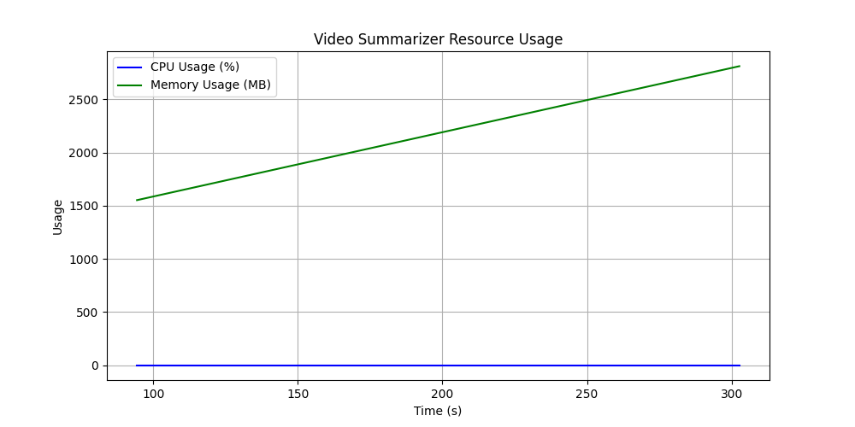
Logger
2025-01-09 17:40:15,332 - INFO - Scene detection completed: 26 scenes found
2025-01-09 17:40:15,333 - INFO - Time taken: 94.39 seconds
2025-01-09 17:40:15,333 - INFO - Memory usage: 1552.50 MB
2025-01-09 17:40:15,333 - INFO - CPU usage: 0.00%
2025-01-09 17:40:15,333 - INFO - Starting video summarization
2025-01-09 17:45:19,005 - INFO - Video summarization completed
2025-01-09 17:45:19,006 - INFO - Time taken: 302.67 seconds
2025-01-09 17:45:19,006 - INFO - Memory usage: 2813.30 MB
2025-01-09 17:45:19,006 - INFO - CPU usage: 0.00%

Results and Discussion

Achievements
- Efficiently scraped and stored movie data, including titles, release dates, ratings, and trailers.
- Generated concise and engaging video summaries with captions.

Challenges
- Optimizing resource usage for large-scale video processing.
- Handling diverse video formats and metadata extraction.

Repository Link
Access the GitHub repository here: https://github.com/aliamer0/SPE

Conclusion
This project demonstrates the integration of web scraping and video summarization using Python. Future improvements could include advanced error handling and support for additional data sources

