**Libraries Used :**

* from skimage import color,data
* import numpy as np
* import matplotlib.pyplot as plt (Used to Plot Image)
* from skimage.transform import rescale,resize, downscale_local_mean

**Task 1:**

**Code:**

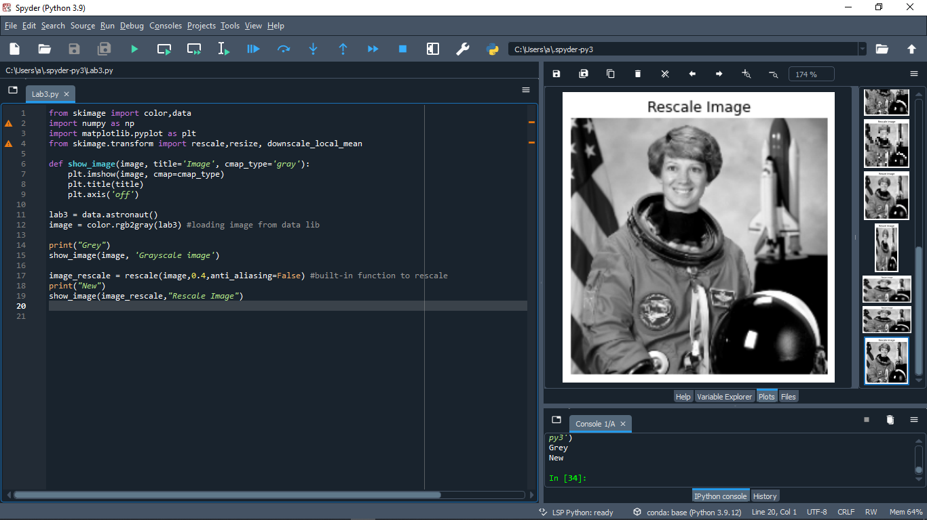

**Screenshot Orginal Grey:**

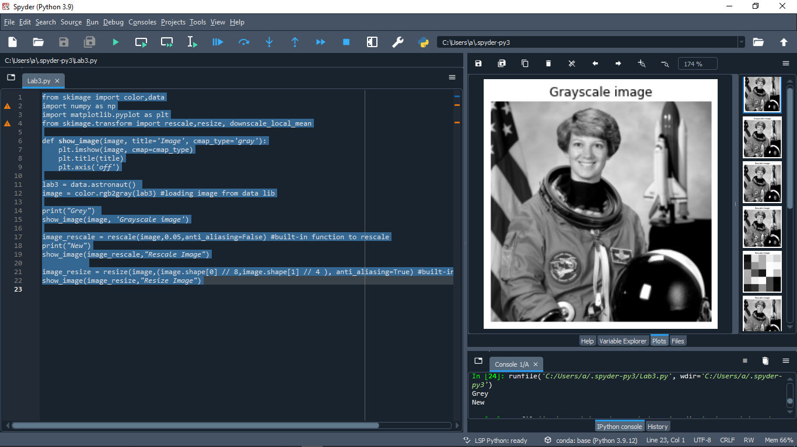

**ScreenShot Rescale Image:**



**Task 2**

**Code:**

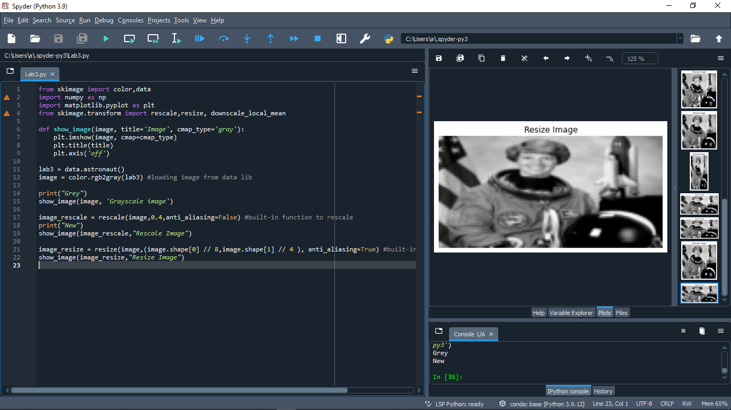

**Screenshot Resize:**



**Task 3**

**Code:**

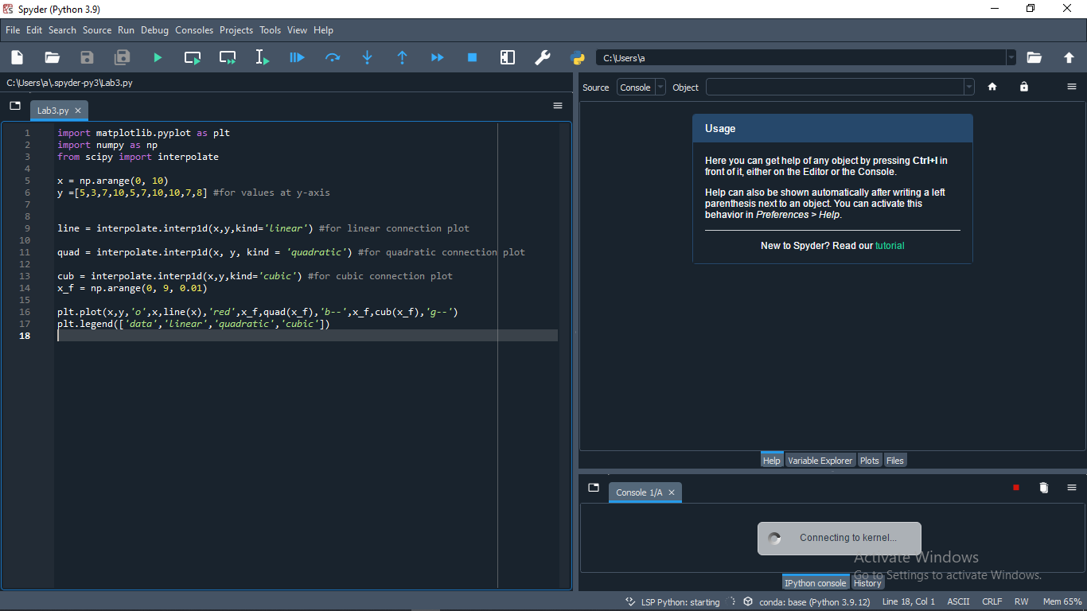

**Screenshot:**

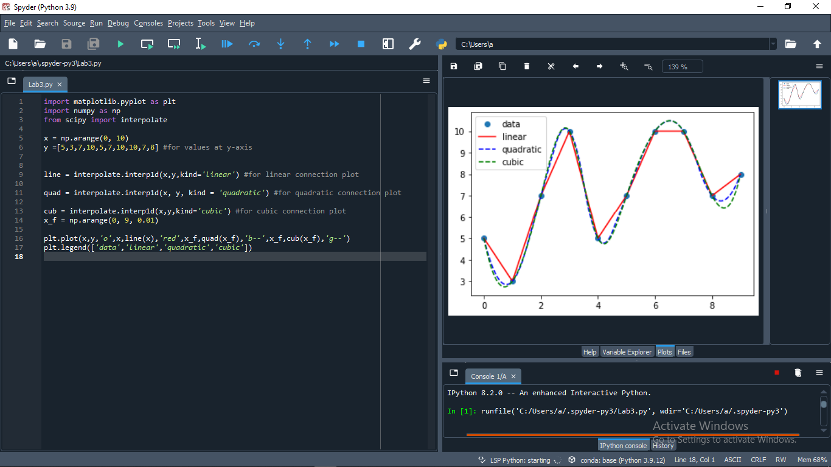

**Task 4**

**Code:**

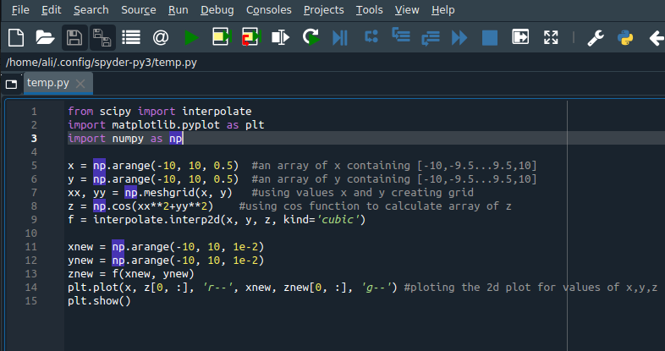

**Screenshot:**

