**Lab Final**

**Ali Amir Khawaja 344200**

**Muhammad Suleman 242709**

**10-B**

**Task 1**

**Code:**

**import cv2**

**import matplotlib.pyplot as plt**

**image= cv2.imread("task1.jpg")**

**original_image= image**

**plt.subplot(111),plt.imshow(image),plt.title('Original Image')**

**plt.xticks([]), plt.yticks([])**

**plt.show()**

**gray = cv2.cvtColor(image,cv2.COLOR_BGR2GRAY)**

**edges = cv2.Canny(gray, 80,200)**

**contours, hierarchy= cv2.findContours(edges.copy(), cv2.RETR_EXTERNAL, cv2.CHAIN_APPROX_NONE)**

**sorted_contours= sorted(contours, key=cv2.contourArea, reverse= True)**

**for (i,c) in enumerate(sorted_contours):**

**M= cv2.moments(c)**

**cx= int(M['m10']/M['m00'])**

**cy= int(M['m01']/M['m00'])**

**cv2.putText(image, text= 'Object '+str(i+1), org=(cx,cy),**

**fontFace= cv2.FONT_HERSHEY_SIMPLEX, fontScale=1, color=(0,0,0),**

**thickness=2, lineType=cv2.LINE_AA)**

**plt.subplot(111),plt.imshow(image),plt.title('Labelled Image')**

**plt.xticks([]), plt.yticks([])**

**plt.show()**

**Screenshot:**

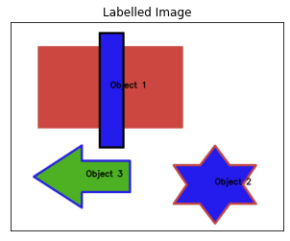

**Task 2**

**Code:**

**#Libraries Used**

**import cv2**

**import numpy as np**

**from google.colab.patches import cv2_imshow**

**im=cv2.imread("/content/task2.PNG")**

**cv2_imshow(im)**

**def invert(img, name):**

**img = (255-img)**

**cv2_imshow(img)**

**invert(im,"Inverted Image")**

**ScreenShot:**

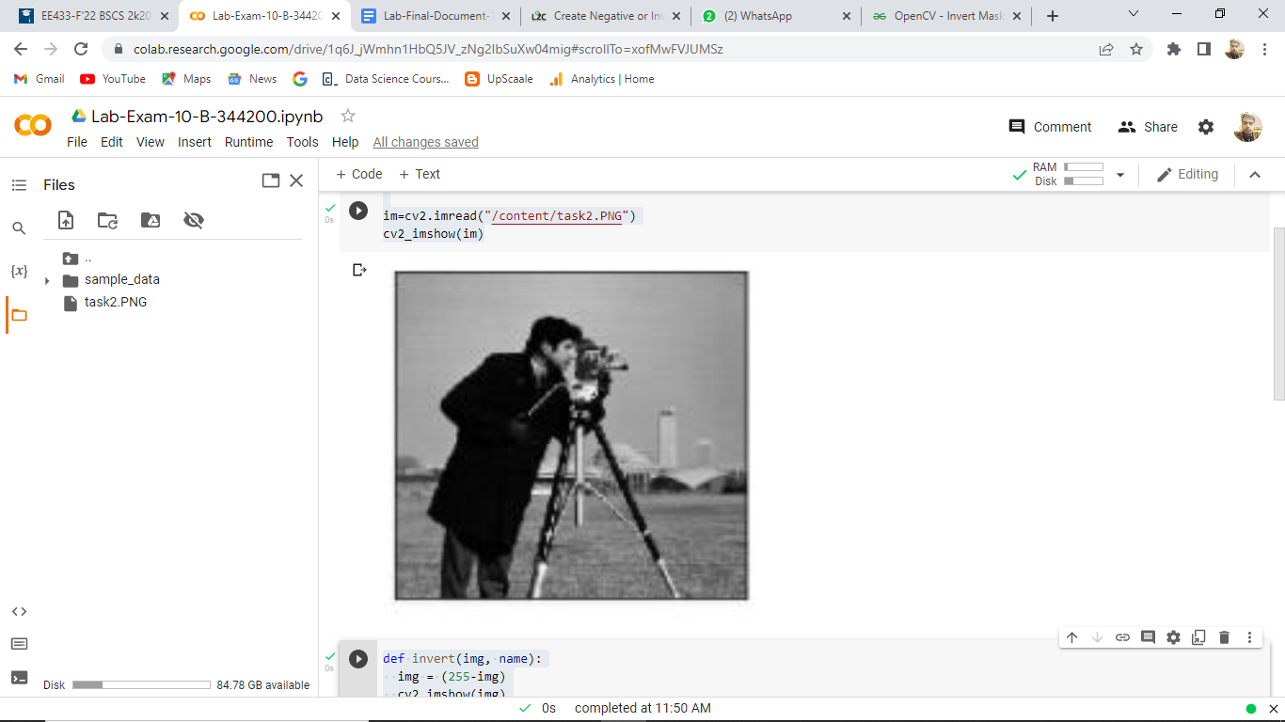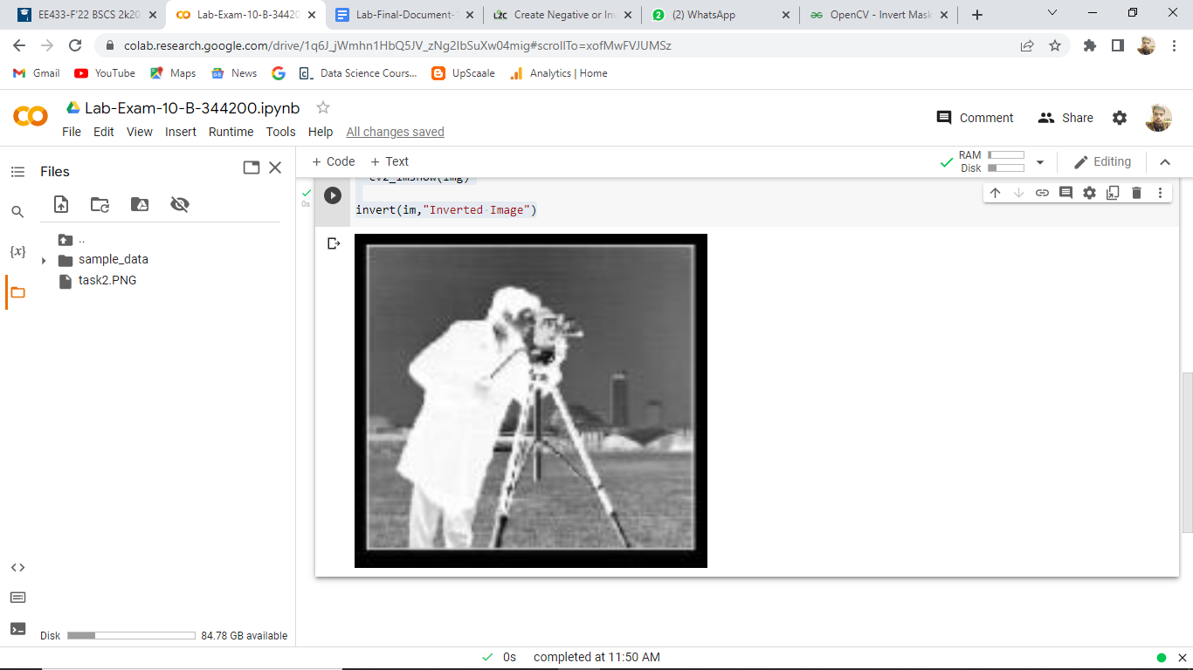

The colours of the original images were inverted.

**Task 3**

**import numpy as np**

**import cv2 as cv**

**from matplotlib import pyplot as plt**

**img = cv.imread('task3.tif',0)**

**img = cv.GaussianBlur(img, (7, 7), 0)**

**edges = cv.Canny(img,100,200)**

**plt.subplot(121),plt.imshow(img,cmap = 'gray')**

**plt.title('Original Image'), plt.xticks([]), plt.yticks([])**

**plt.subplot(122),plt.imshow(edges,cmap = 'gray')**

**plt.title('Edge Image'), plt.xticks([]), plt.yticks([])**

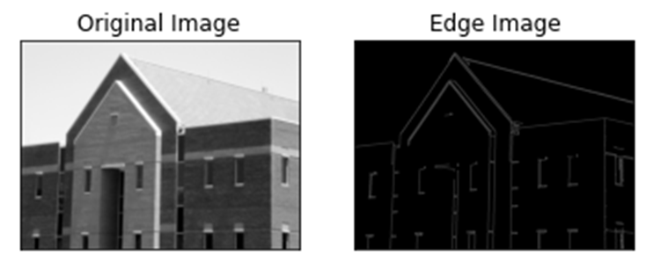

**Output Image:**

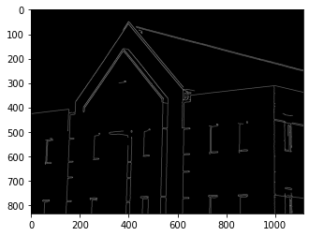

**Colab Link:** [**https://colab.research.google.com/drive/1q6J_jWmhn1HbQ5JV_zNg2IbSuXw04mig?usp=sharing**](https://colab.research.google.com/drive/1q6J_jWmhn1HbQ5JV_zNg2IbSuXw04mig?usp=sharing)