**Task 1**

Libraries:

* from PIL import Image
* import NumPy as np

**Code**

from PIL import Image

import numpy as np

im = Image.open("/content/lab05.tif")

im #to show original image

resolution = im.size

original_image = np.array(im)

word = ""

bin0 = np.array(im) #for bit position 1

bin1 = np.array(im) #for bit position 2

bin2 = np.array(im) #for bit position 3

bin3 = np.array(im) #for bit position 4

bin4 = np.array(im) #for bit position 5

bin5 = np.array(im) #for bit position 6

bin6 = np.array(im) #for bit position 7

bin7 = np.array(im) #for bit position 8

binary_value = "" #stores current binary value

point = 0

for x in range(0,resolution[1]-1):

for y in range(0,resolution[0]-1):

point = original_image[x][y]

binary_value = bin(point)

binary_value = binary_value[2:len(binary_value)]

while len(binary_value) < 8:

binary_value = "0" + binary_value

bin7[x][y] = int(binary_value[0]) * 128

bin6[x][y] = int(binary_value[1]) * 64

bin5[x][y] = int(binary_value[2]) * 32

bin4[x][y] = int(binary_value[3]) * 16

bin3[x][y] = int(binary_value[4]) * 8

bin2[x][y] = int(binary_value[5]) * 4

bin1[x][y] = int(binary_value[6]) * 2

bin0[x][y] = int(binary_value[7]) * 1

im_new = Image.fromarray(bin0)

im_new.save("dollar0.tif")

im_new = Image.fromarray(bin1)

im_new.save("dollar1.tif")

im_new = Image.fromarray(bin2)

im_new.save("dollar2.tif")

im_new = Image.fromarray(bin3)

im_new.save("dollar3.tif")

im_new = Image.fromarray(bin4)

im_new.save("dollar4.tif")

im_new = Image.fromarray(bin5)

im_new.save("dollar5.tif")

im_new = Image.fromarray(bin6)

im_new.save("dollar6.tif")

im_new = Image.fromarray(bin7)

im_new.save("dollar7.tif")

im_new = Image.open("dollar0.tif")

Im_new

**Screenshot**

* Image Slice Bit 8

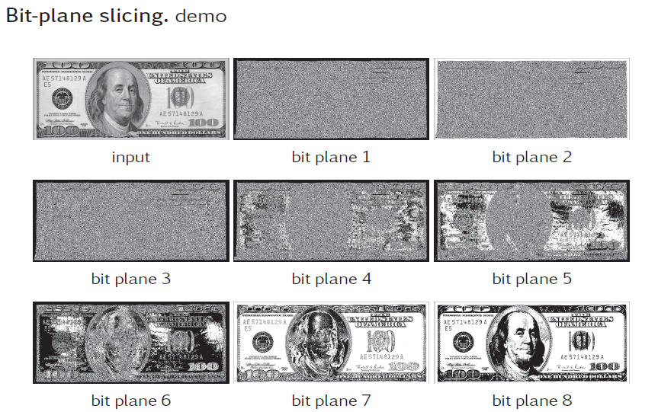

* Image Slice Bit 7



* Image Slice Bit 6



* Image Slice Bit 5



* Image Slice Bit 4



* Image Slice Bit 3



* Image Slice Bit 2



* Image Slice Bit 1

