**Lab10-DIP-Morphological Operations**

**AliAmirKhawaja-344200**

**Mueed Hassan-347391**

**10-B**

**Libraries Used**

* **#Libraries Used**
* **import cv2**
* **from PIL import Image, ImageChops**
* **import numpy as np**
* **from google.colab.patches import cv2_imshow**

**Lab Task 1**

**Erode the image “fp.tif” using a suitable structural element so that all the noise is removed**

**from the image. Apply erosion on Fig01.tif with structuring elements of different sizes.**

**Code**

#Reading Image File

im=cv2.imread("/content/fp.tif")

#gray = cv2.cvtColor(image, cv2.COLOR_BGR2GRAY)

cv2_imshow(im)

#Making Various Size Structuring Element

struct_element_rect5=cv2.getStructuringElement(cv2.MORPH_RECT,(5,5))

struct_element_rect3=cv2.getStructuringElement(cv2.MORPH_RECT,(3,3))

struct_element_rect7=cv2.getStructuringElement(cv2.MORPH_RECT,(7,7))

#Different size element structures

#Applying erosions

erosion_im_rect3=cv2.erode(im,struct_element_rect3,iterations=1)

erosion_im_rect5=cv2.erode(im,struct_element_rect5,iterations=1)

erosion_im_rect7=cv2.erode(im,struct_element_rect7,iterations=1)

cv2_imshow(erosion_im_rect3)

cv2_imshow(erosion_im_rect5)

cv2_imshow(erosion_im_rect7)

**Screenshot**

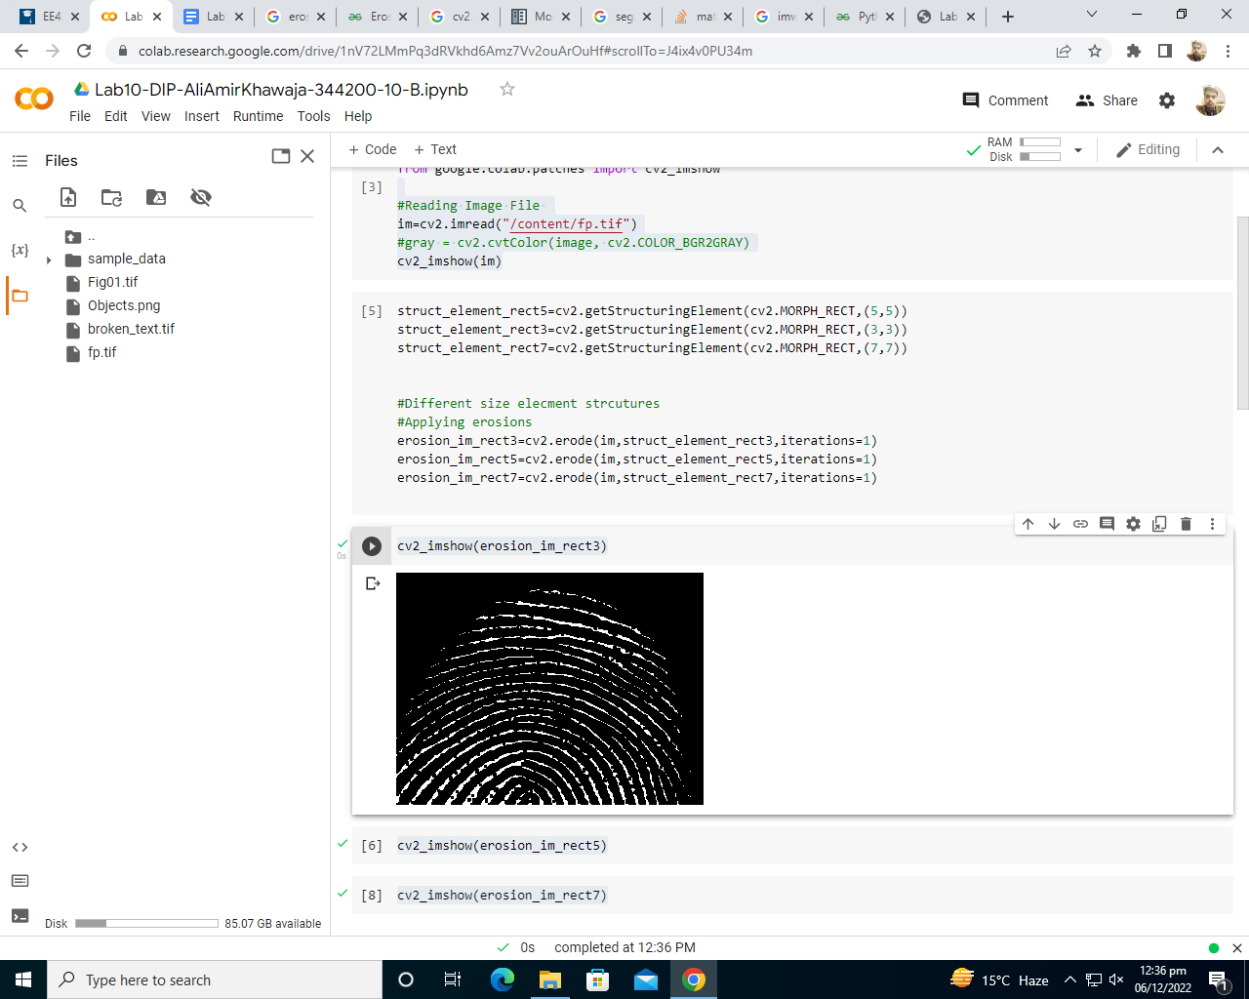

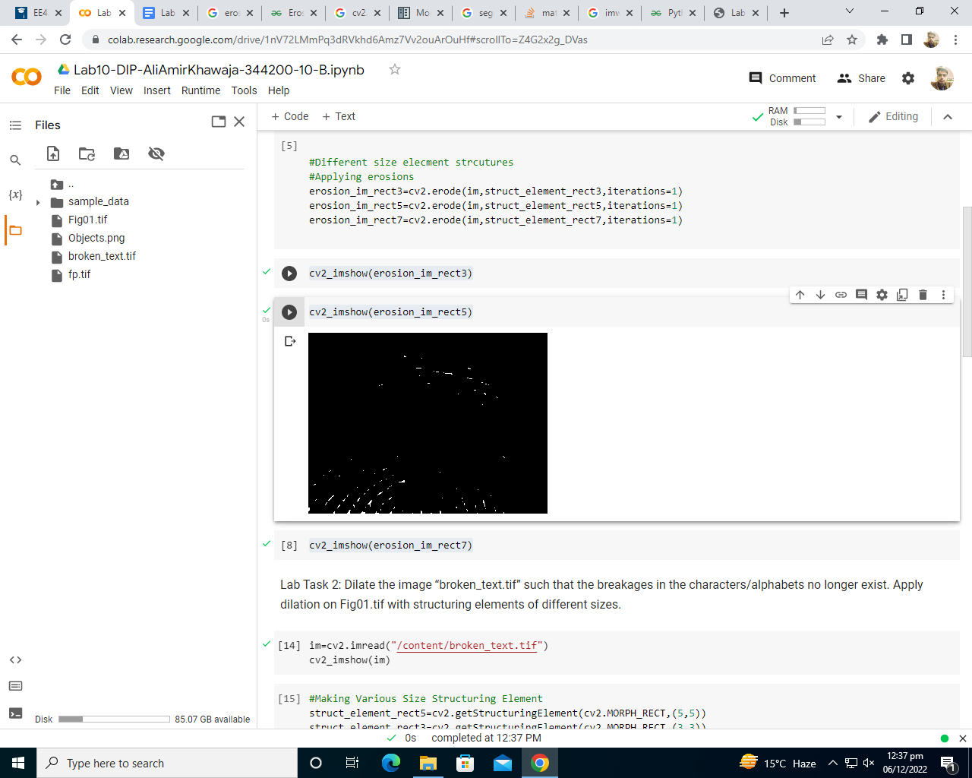

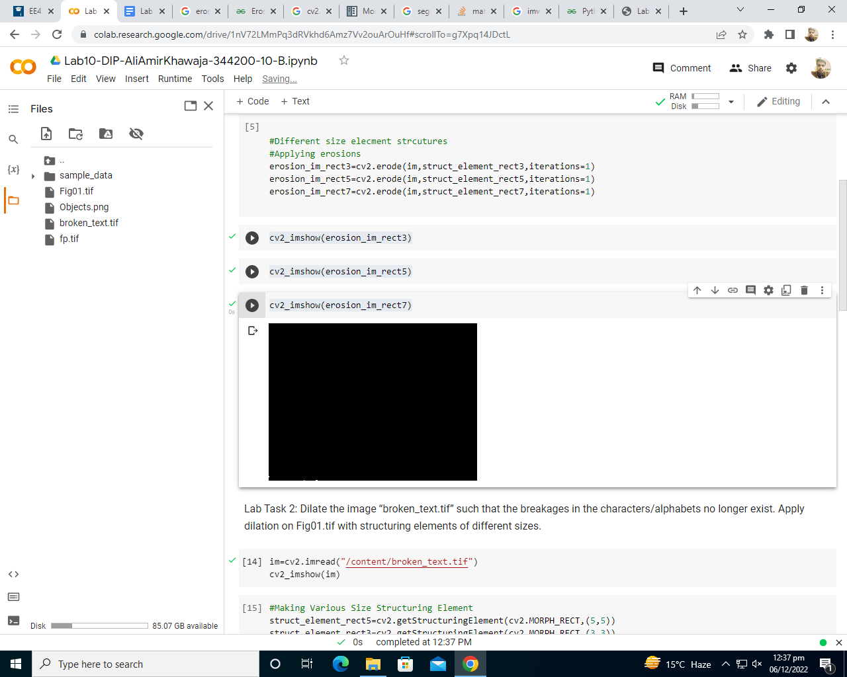

**Lab Task 2**

**Dilate the image “broken_text.tif” such that the breakages in the characters/alphabets no longer exist. Apply dilation on Fig01.tif with structuring elements of different sizes.**

**Code**

im=cv2.imread("/content/broken_text.tif")

cv2_imshow(im)

#Making Various Size Structuring Element

struct_element_rect5=cv2.getStructuringElement(cv2.MORPH_RECT,(5,5))

struct_element_rect3=cv2.getStructuringElement(cv2.MORPH_RECT,(3,3))

struct_element_rect7=cv2.getStructuringElement(cv2.MORPH_RECT,(7,7))

#Different size element structures

#Applying Dilations

dilate_im_rect3=cv2.dilate(im,struct_element_rect3,iterations=1)

dilate_im_rect5=cv2.dilate(im,struct_element_rect5,iterations=1)

dilate_im_rect7=cv2.dilate(im,struct_element_rect7,iterations=1)

**Screenshot**

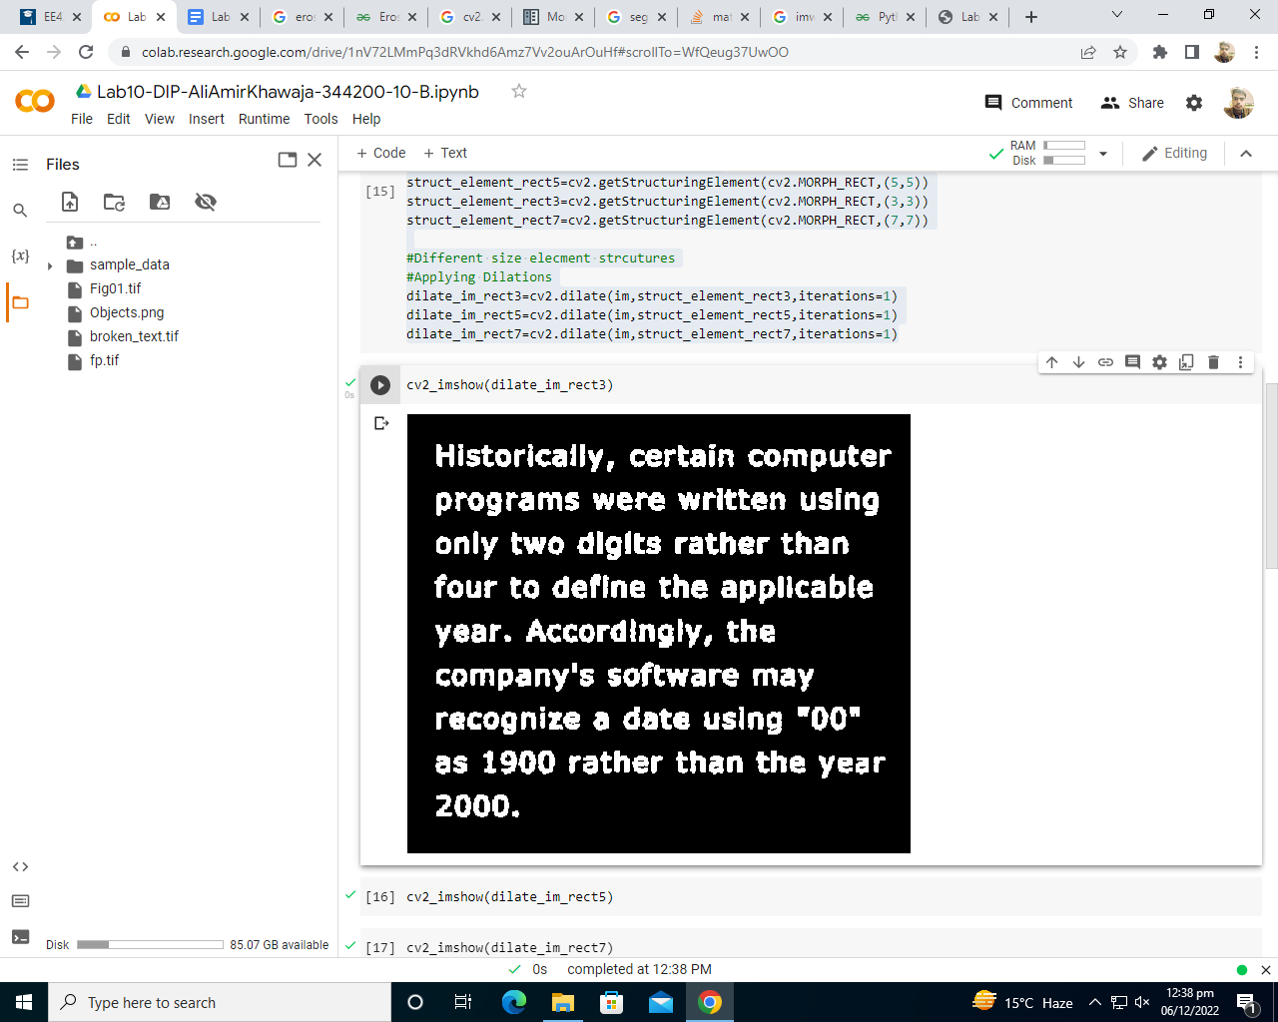

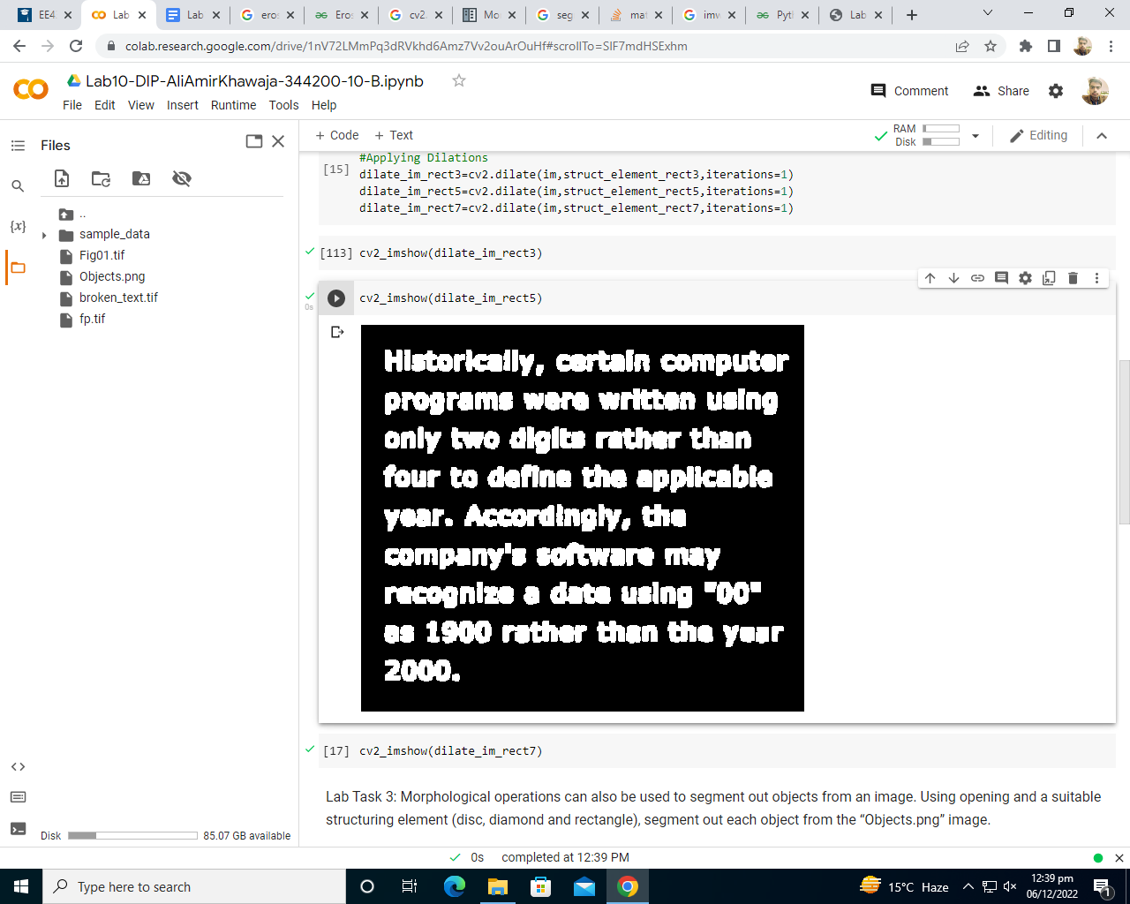

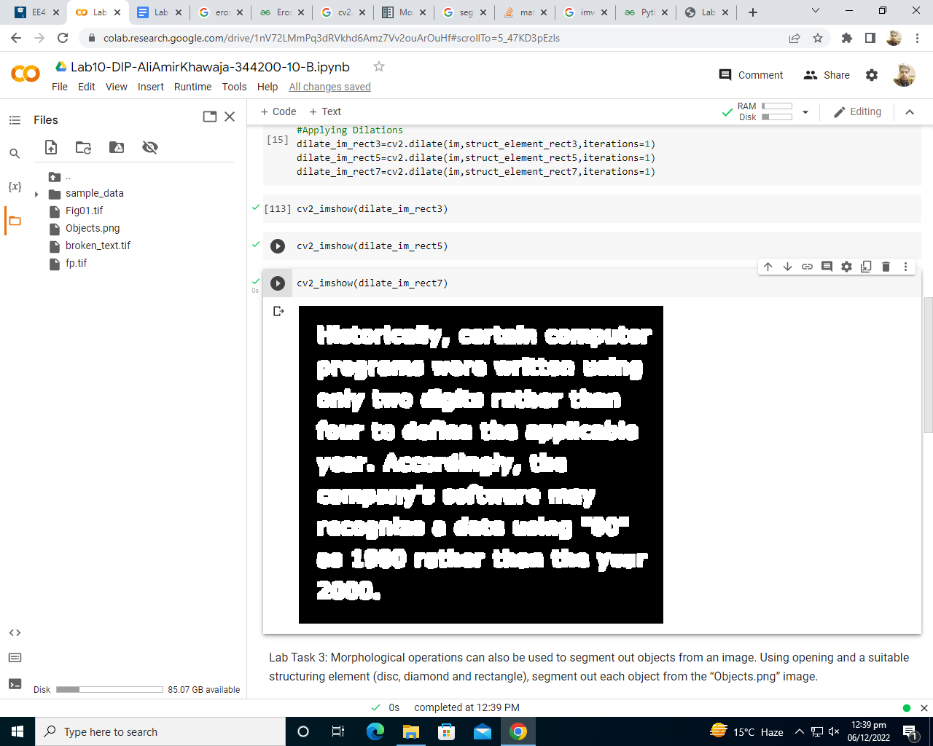

**Lab Task 3**

**Morphological operations can also be used to segment out objects from an image. Using opening and a suitable structuring element (disc, diamond and rectangle), segment out each object from the “Objects.png” image.**

Code:

im=cv2.imread("/content/Objects.png")

cv2_imshow(im)

struct_element_recte=cv2.getStructuringElement(cv2.MORPH_RECT,(11,11))

struct_element_rectd=cv2.getStructuringElement(cv2.MORPH_RECT,(65,65))

struct_element_ellie=cv2.getStructuringElement(cv2.MORPH_ELLIPSE,(13,13))

struct_element_ellid=cv2.getStructuringElement(cv2.MORPH_ELLIPSE,(45,45))

struct_element_crosse=cv2.getStructuringElement(cv2.MORPH_CROSS,(9,9))

struct_element_crossd=cv2.getStructuringElement(cv2.MORPH_CROSS,(3,3))

#Different 5X5 elecment strcutures

#Applying Erosions and Dilation (Rectangule)

'''

array([[1, 1, 1, 1, 1],

[1, 1, 1, 1, 1],

[1, 1, 1, 1, 1],

[1, 1, 1, 1, 1],

[1, 1, 1, 1, 1]]

'''

erosion_im_rect=cv2.erode(im,struct_element_recte,iterations=7)

erosion_im_rect=cv2.dilate(erosion_im_rect,struct_element_rectd,iterations=1)

#Applying Erosions and Dilation (Elliptical)

'''

array([[0, 0, 1, 0, 0],

[1, 1, 1, 1, 1],

[1, 1, 1, 1, 1],

[1, 1, 1, 1, 1],

[0, 0, 1, 0, 0]]

'''

erosion_im_elli=cv2.erode(im,struct_element_ellie,iterations=7)

erosion_im_elli=cv2.dilate(erosion_im_elli,struct_element_ellid,iterations=2)

#Applying Erosions and Dilation (Cross-shaped)

'''

array([[0, 0, 1, 0, 0],

[0, 0, 1, 0, 0],

[1, 1, 1, 1, 1],

[0, 0, 1, 0, 0],

[0, 0, 1, 0, 0]]

'''

erosion_im_cross=cv2.erode(im,struct_element_crosse,iterations=12)

erosion_im_cross=cv2.dilate(erosion_im_cross,struct_element_crossd,iterations=50)

**Screenshot**

