Lab 12

Digital Image Processing for color images

**Today’s tasks**

Task 1:

 **Your goal is to isolate only “green” smarties from the image**

 Read “smarties.jpg” image.

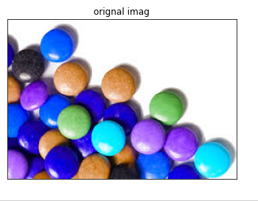

 Change color space to HSV (i.e. RGB->HSV) using cv2.cvtColor()

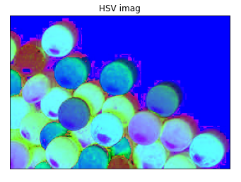

 Create 6 tracbars using opencv’s cv2.createtrackbar() function for controlling lower and upper limits for each channel of HSV. (let’s rename these trackbars to LowH HighH, LowS HighS and LowV HighV)

 By using an infinite for loop take the values from each trackbar and use cv2.inRange() function and detect “green” color smarties.

**Code:**

The output for track bars look somewhat like this :-

By changing the values of all of above 6 parameters (by changing the positions of track bars) you can isolate any object of your desirous color.

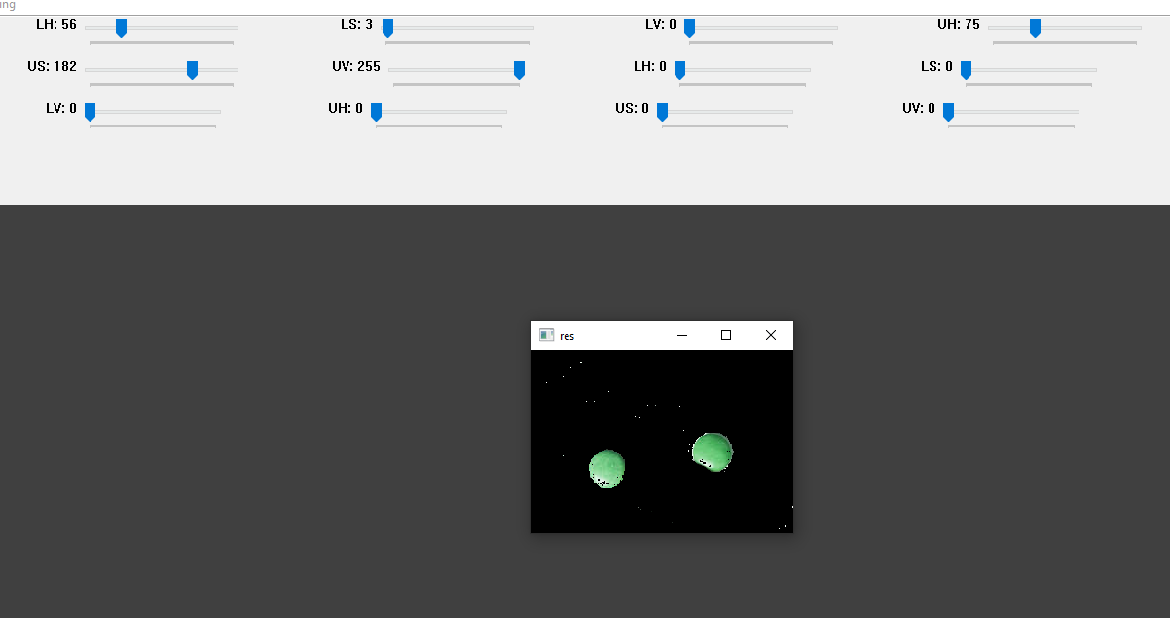

# Task 2: Your goal in this task is to read webcam from your computer and detect and track some object of your choice

* Make sure that the object (of your choice) is distinct from background.
* Use all steps from above and apply them on live feed of your webcam. (i.e. read documentation at cv2::VideoCapture class.
* You may notice that in real-time feed, there exist noise in both chromatic and achromatic channels. Which result in very small patches of binary thresholded image after applying cv2.inRange.

***Live feed of webcam***

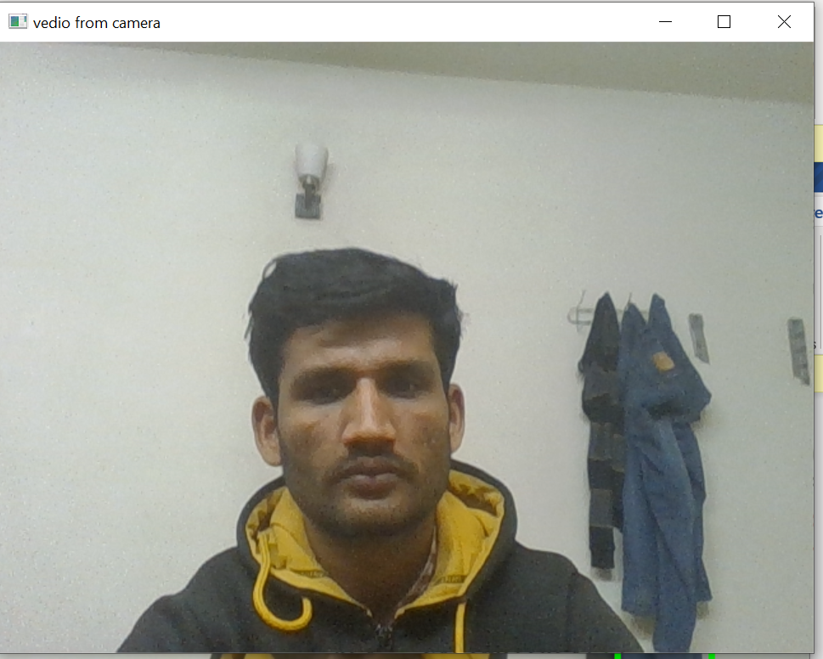

***object before filtering /morphological operation***

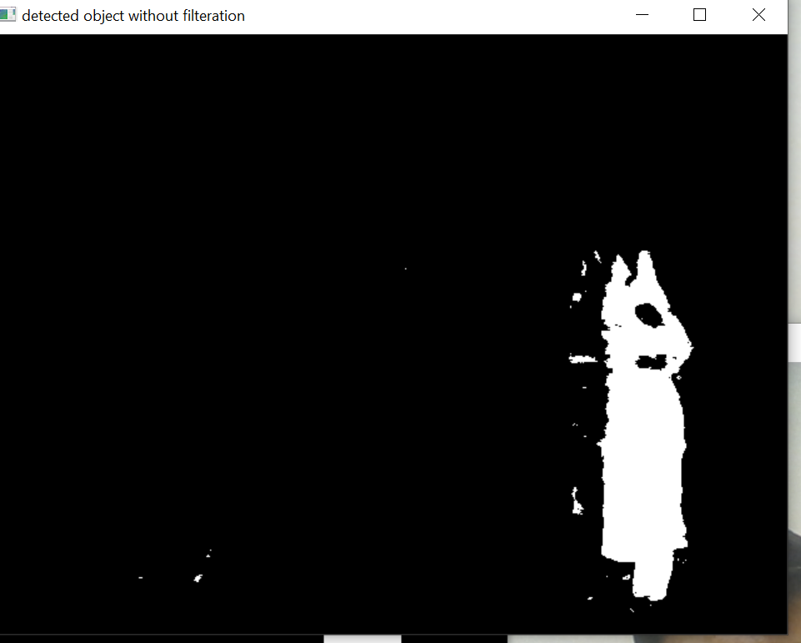

* Therefore some mechanism either pre-processing (i.e. Filtering) or post-processing (i.e. Morphological operations) are needed to cater this problem

***Detected object after filtering /morphological operation***

* At the end you have to draw bounding box around the detected objects.

***Bounding box around detected object***

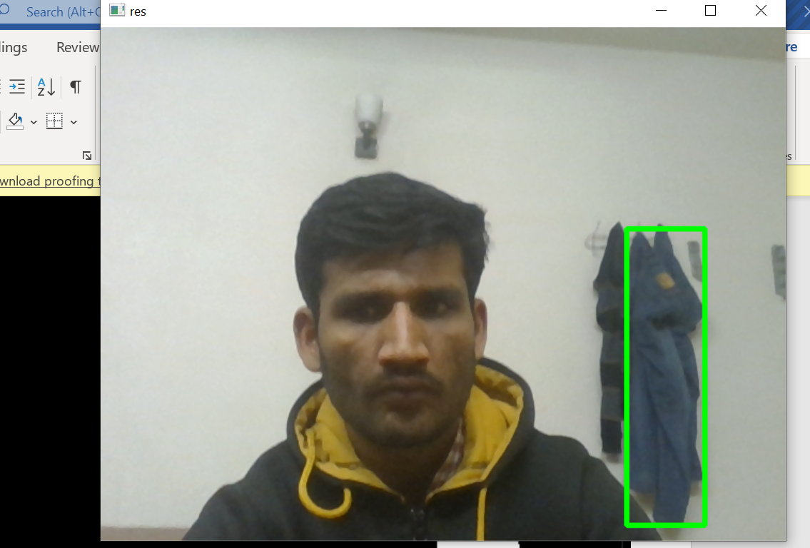

***Overall window***

