Sorting Algorithms on Real-World Big Data
Bubble Sort, Selection Sort & Insertion Sort — Assignment Report
Name: Ali Amir
Section: BCS - 5B
Roll No: 24F - 0622
Dataset: Airline Delay and Cancellation Data, 2009-2018 (Kaggle)— 2011.csv, ~6.37 million rows

1. Dataset and Column Choices
- Dataset amount used: one full yearly file (2011.csv, ~6.37 million rows), loaded with chunked reading (chunksize=1,000,000) so the file is never fully loaded into RAM at once.
- Numeric column chosen: ARR_DELAY (arrival delay in minutes) — a continuous, real-valued measurement with meaningful spread (negative for early arrivals, large positive for badly delayed flights), which makes it a good candidate for sorting and statistics.
- Text column chosen: OP_CARRIER (two-letter airline code) — short strings with a manageable number of unique values, useful for directly comparing numeric vs. string comparison cost.

2. Sample Size Reasoning
- Sample sizes used: 100, 500, 1000, 2000, 4000.
- Chosen by starting small, confirming correctness, then scaling up until Bubble Sort's worst case (reverse-sorted input) still finished within a reasonable time — large enough to see the O(n²) growth curve clearly, small enough to avoid long waits or locking up the Kaggle session.
- A safety limit (30 seconds per run) was built into the benchmarking code so any run exceeding this is skipped and reported honestly, rather than left to run indefinitely.

3. Benchmark Results
Full results are in sort_benchmark_results.csv. Random-order timings across all three algorithms:
Size | Bubble Sort (s) | Selection Sort (s) | Insertion Sort (s)
100 | 0.000435 | 0.000226 | 0.000154
500 | 0.010851 | 0.005207 | 0.004580
1000 | 0.046950 | 0.024012 | 0.021512
2000 | 0.191768 | 0.091103 | 0.083483
4000 | 0.784376 | 0.350620 | 0.335968

Insertion Sort's timings across the three orderings, showing its best/average/worst-case spread:
Size | Random (s) | Sorted (s) | Reversed (s)
100 | 0.000154 | 0.000009 | 0.000411
500 | 0.004580 | 0.000049 | 0.008492
1000 | 0.021512 | 0.000124 | 0.038227
2000 | 0.083483 | 0.000236 | 0.163317
4000 | 0.335968 | 0.000451 | 0.670715

3.1 Runtime vs n (random order)
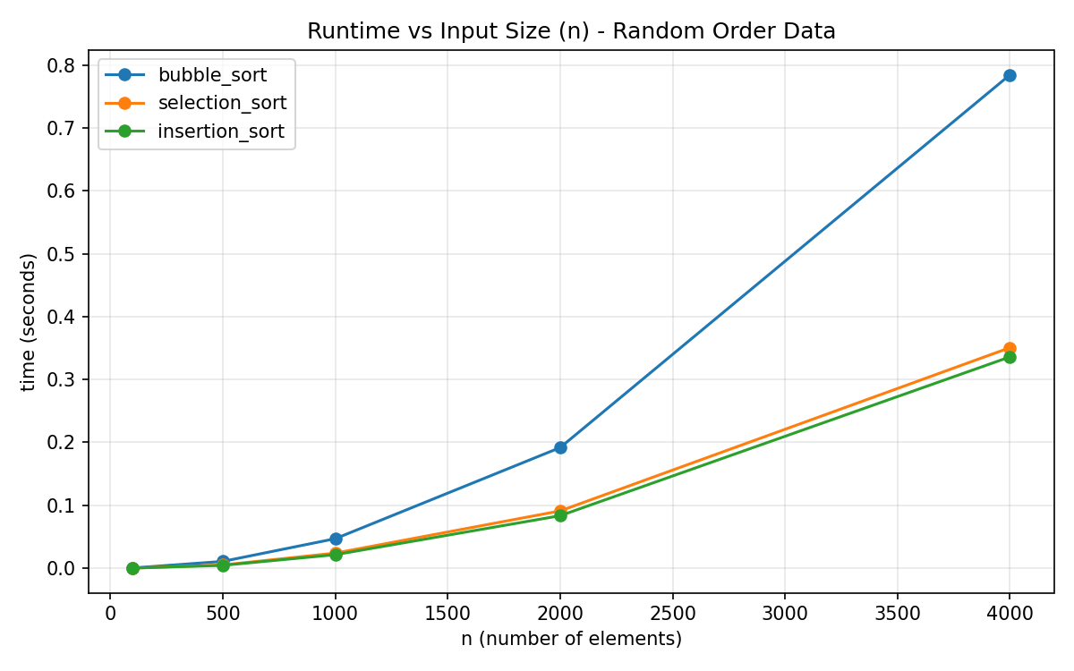

3.2 Insertion Sort: random vs sorted vs reversed
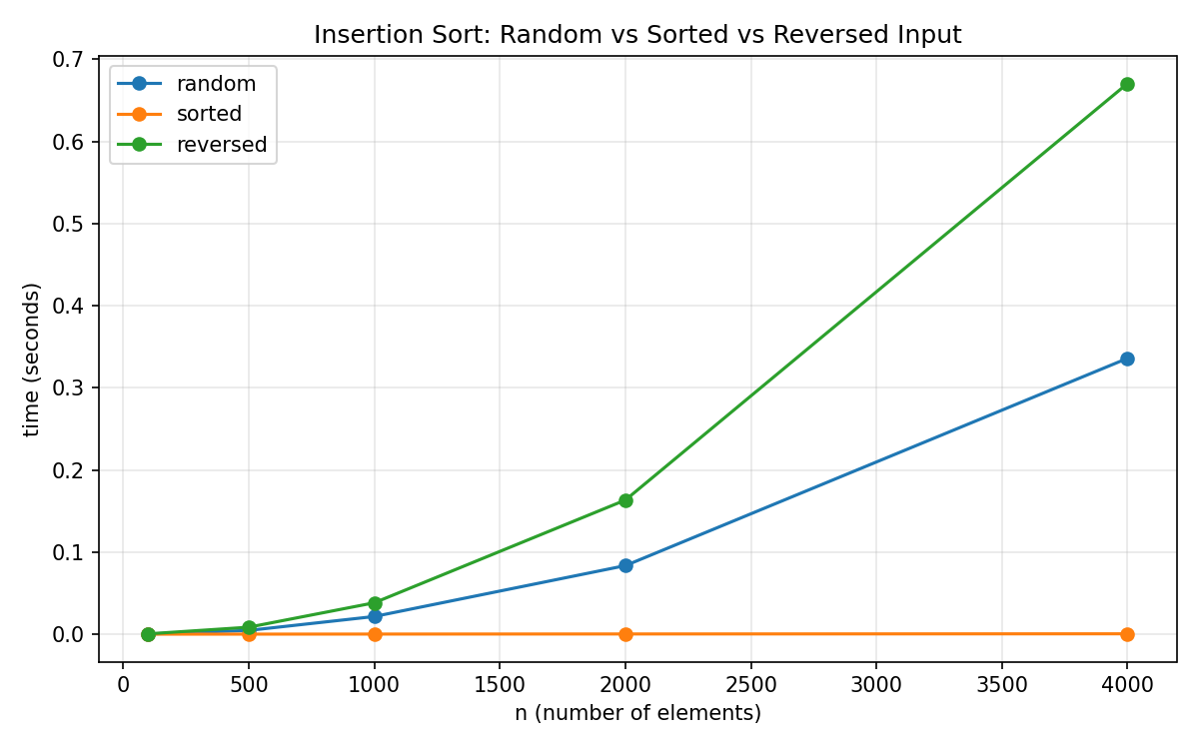

4. Text vs Numeric Column Comparison (n = 2000)
Ordering | Algorithm | Numeric (ARR_DELAY) | Text (OP_CARRIER)
random | bubble_sort | 0.191768 | 0.225442
random | selection_sort | 0.091103 | 0.124271
random | insertion_sort | 0.083483 | 0.092536
sorted | bubble_sort | 0.000143 | 0.000208
sorted | selection_sort | 0.089719 | 0.118649
sorted | insertion_sort | 0.000236 | 0.000303
reversed | bubble_sort | 0.255222 | 0.271188
reversed | selection_sort | 0.092774 | 0.119682
reversed | insertion_sort | 0.163317 | 0.186069

- Text (OP_CARRIER) sorting was slower than numeric (ARR_DELAY) sorting in every single case at n=2000, across all three algorithms and all three orderings.
- Largest gap: selection_sort on random data — 0.124s (text) vs 0.091s (numeric), about 36% slower.
- Smallest gap: insertion_sort on sorted data — both near-instant, but text still consistently a bit higher.
- Reason: comparing two strings means Python checks characters one at a time until it finds a difference, while comparing two numbers is a single direct operation — so every comparison inside the sort costs a little more with text.

5. Full-Scale Extrapolation (Part E)
Using time = c × n² fitted from the largest sample (n=4000, random order), each algorithm's timing was projected to the full dataset size (~6.37 million rows), compared against a measured-and-extrapolated Timsort baseline:
Algorithm | Estimated full-scale time | Speedup factor vs Timsort
Bubble Sort | ≈ 23.02 days | ≈ 1,133,404x slower
Selection Sort | ≈ 10.29 days | ≈ 506,637x slower
Insertion Sort | ≈ 9.86 days | ≈ 485,465x slower
Python sorted() (Timsort) | ≈ 1.75 seconds | baseline

- These are theoretical estimates from the n² growth model, not actual measured full-scale runs — actually sorting 6.37 million rows with these algorithms would be impractical, which is exactly what the extrapolation demonstrates.

6. Written Analysis (Part F)

Fastest/slowest on random data, and does it match theory?
- Insertion Sort was fastest at every size (0.336s at n=4000), Selection Sort close behind (0.351s), Bubble Sort clearly slowest (0.784s — more than double).
- This matches theory: all three are O(n²) on average, so all three curves bend upward the same way, exactly as seen in the runtime-vs-n chart.
- Bubble Sort being slowest also matches theory — it performs more element swaps per pass than the other two for the same amount of disorder.

How did Insertion Sort's runtime change across orderings, and why?
- Sorted input (n=4000): ~0.00045s — essentially instant. The inner while-loop barely runs because each new element is already larger than everything before it. This is its O(n) best case.
- Reversed input (n=4000): ~0.671s — about 1,400x slower than sorted, and roughly double the random case. Every element must shift all the way to the front. This is its O(n²) worst case.
- Random input (n=4000): ~0.336s — sits between the two extremes, matching its O(n²) average case exactly as theory predicts.
- By contrast, Selection Sort barely changed at all between sorted (0.342s) and random (0.351s) at n=4000 — it always scans the entire remaining array for the minimum regardless of order, which is why its best, average, and worst cases are all O(n²).

Did text sorting take longer than numeric sorting? Why?
- Yes — text (OP_CARRIER) was slower than numeric (ARR_DELAY) in every ordering and every algorithm tested at n=2000 (see Section 4 table).
- String comparison costs more than numeric comparison because Python compares strings character-by-character until it finds a difference, while comparing two numbers is one direct, cheap operation.
- The gap was clearest on Selection Sort with random data (~36% slower for text), since that algorithm makes the most total comparisons regardless of ordering.

Is it ever practical to use these algorithms at this scale? When should you switch to O(n log n)?
- Based on the Part E extrapolation: no, not at the scale of the full dataset. Even Insertion Sort (fastest of the three) would take ~9.86 days on 6.37 million rows, versus ~1.75 seconds for Timsort — a gap of about 485,000x.
- Rough personal rule: anywhere from a few tens of thousands of rows upward is where an O(n log n) algorithm (Timsort, Merge Sort, Quick Sort) should be preferred, since the gap between O(n²) and O(n log n) widens extremely fast as n grows into the millions.

What real-world conditions would make these simple algorithms acceptable?
- Genuinely small datasets (a few hundred to a few thousand items), where the difference from Timsort is milliseconds and not worth extra code complexity.
- Nearly-sorted data — Insertion Sort in particular handles this very well, as shown by its near-zero time on sorted input above.
- Contexts where simplicity, low memory overhead, or code readability matter more than raw speed — teaching, embedded systems, or small one-off scripts.
- For a dataset the size of the full Airline Delay records, these algorithms remain useful here only as a learning exercise in what Big-O complexity costs in practice, not as a real sorting strategy.

