FAST – National University of
Computer and Emerging Sciences
Department of Data Science

CRICKLYTICS
Context-Aware Cricket Analytics & Probability Platform
Iteration 1 Document

Subject | Fundamentals of Software Engineering
Team Member | Muhammad Ali Aamir | Roll No. 24L-2558
Team Member | Muhammad Mahad Mahmood | Roll No. 24L-2548
Deliverable | Iteration 1 / Sprint 1
Date | March 2026

1. Project Title & Introduction
1.1 Project Title
Cricklytics — Context-Aware Cricket Analytics & Probability Platform
1.2 Introduction
Cricklytics is a multi-page, data-driven cricket analytics web application that transforms historical ball-by-ball match data into contextual, probability-based insights. Unlike conventional cricket websites that display isolated statistics, Cricklytics answers questions such as:
- How likely is a batsman to score 50+ at this venue against this opposition?
- Which team historically dominates in day-night Tests at a specific ground?
- How does a bowler's economy vary by opponent and format?

The platform covers all three major international formats — T20I, ODI, and Test — with dedicated sections for Players, Teams, Venues, Matches, Rankings, Records, Compare, and Search. A built-in Machine Learning probability engine trained on Logistic Regression powers the insight layer, accompanied by mandatory disclaimers clarifying that all outputs are statistical observations, not outcome predictions.
1.3 Tech Stack
Layer | Technology
Backend | Python 3.11 · Flask · pandas · scikit-learn (Logistic Regression) · JSON/CSV cache
Frontend | HTML5 · CSS3 (custom design system) · Vanilla JavaScript · Font Awesome 6
Data Sources | Cricsheet (CC BY-SA 4.0) · Cricbuzz via RapidAPI · CricAPI · ICC Rankings scraper
ML | scikit-learn Logistic Regression · .pkl model persistence · offline training pipeline
Tooling | Git · GitHub · Trello · VS Code

2. Sprint Backlog — Iteration 1

2.1 Modules Developed in Sprint 1
# | Module | Description
M1 | UI Shell & Navigation | Global navigation bar, responsive layout, page routing across all 13 HTML pages.
M2 | Home Page | Live match cards, upcoming fixtures strip, trending players section, recent results.
M3 | Matches Module | Matches listing page with live/upcoming/completed groups, pagination, format filters.
M4 | Players Module | Players listing page with search, role/country/format filters, player cards with photos.
M5 | Teams Module | Teams listing with rankings, win-rate sidebar, format switching.
M6 | Venues Module | Venues listing with cards, country/region filters, venue sidebar stats.
M7 | Data Pipeline | process_cricsheet.py (ball-by-ball → analytics JSON), scrape_matches.py (Cricbuzz), scrape_rankings.py (ICC), fetch_live.py (CricAPI live + scorecards).
M8 | Flask REST API | All backend API endpoints: /api/players, /api/teams, /api/venues, /api/matches, /api/live, /api/rankings, /api/h2h, /api/search, and others.
M9 | Match Detail | match-detail.html with Overview / Scorecard / Context Insights tabs.
M10 | Utility Pages | About, Data Sources, Disclaimer pages.

2.2 User Stories — Sprint 1
The following user stories were selected for Sprint 1 and are written in the standard Connextra format:
As a [role], I want [goal], so that [reason/benefit].

US-01 — Navigation & Page Routing
User Story ID | US-01
Title | Navigation & Page Routing
User Story | As a cricket fan, I want a persistent navigation bar with links to all sections, so that I can quickly jump to any part of the platform from anywhere.
Sub-stories | - US-01a: As a user, I want to click on Players in the navbar, so that I am taken to the players listing page.  - US-01b: As a user, I want the navbar to highlight the current active page, so that I always know where I am.  - US-01c: As a mobile user, I want a hamburger menu on small screens, so that navigation is usable on my phone.  - US-01d: As a user, I want a persistent search bar in the header, so that I can search from any page.

US-02 — Home Page — Live & Upcoming Matches
User Story ID | US-02
Title | Home Page — Live & Upcoming Matches
User Story | As a cricket fan, I want to see live and upcoming matches on the home page, so that I immediately know what is happening right now and what to look forward to.
Sub-stories | - US-02a: As a user, I want a 'Live' badge on ongoing matches, so that I can identify them at a glance.  - US-02b: As a user, I want to see team flags, scores, and venue for each match card, so that I get the full picture quickly.  - US-02c: As a user, I want to click a match card and reach its detail page, so that I can read the full scorecard.  - US-02d: As a user, I want the section title to change to 'Up Next' when no live matches exist, so that the UI is always informative.

US-03 — Matches Listing Page
User Story ID | US-03
Title | Matches Listing Page
User Story | As a cricket analyst, I want to browse all matches grouped by live/upcoming/completed, so that I can find any match at a glance.
Sub-stories | - US-03a: As a user, I want matches grouped under Live Now, Upcoming, and Recent Results headers, so that the timeline is clear.  - US-03b: As a user, I want paginated results (10 per group), so that the page does not become overwhelming.  - US-03c: As a user, I want to click an upcoming match and see a fixture detail page, so that I can view venue and H2H context before it starts.  - US-03d: As a user, I want to click a completed match and see the full scorecard page, so that I can analyse the result.

US-04 — Players Listing & Search
User Story ID | US-04
Title | Players Listing & Search
User Story | As a cricket fan, I want to browse and search all international players with their career stats, so that I can find and compare any player quickly.
Sub-stories | - US-04a: As a user, I want to filter players by role (Batsman/Bowler/All-Rounder/Wicketkeeper), so that I see only relevant players.  - US-04b: As a user, I want to filter by format (T20I/ODI/Test), so that format-specific averages are displayed.  - US-04c: As a user, I want to filter by country using a country sidebar, so that I can see my national team's players.  - US-04d: As a user, I want each player card to show an avatar photo, country flag, batting average, strike rate, and centuries, so that I get an immediate performance snapshot.

US-05 — Teams Page — Rankings & Win Rates
User Story ID | US-05
Title | Teams Page — Rankings & Win Rates
User Story | As a cricket analyst, I want to view ICC-style team rankings alongside T20I win rates, so that I can compare team strengths across formats.
Sub-stories | - US-05a: As a user, I want to switch between T20I, ODI, and Test rankings, so that I see format-specific standings.  - US-05b: As a user, I want each ranking row to show team flag, ranking position, rating, points, and win percentage, so that the data is complete.  - US-05c: As a user, I want a sidebar showing top T20I win rates with bar indicators, so that I can compare teams visually.  - US-05d: As a user, I want to filter teams by region (Asia/Oceania/Europe/Americas/Africa), so that I can narrow my focus.

US-06 — Venues Listing
User Story ID | US-06
Title | Venues Listing
User Story | As a cricket analyst, I want to browse all international venues with their key statistics, so that I can understand ground characteristics before a match.
Sub-stories | - US-06a: As a user, I want each venue card to show a batting/bowling bias indicator, average score, and country flag, so that I instantly understand the pitch character.  - US-06b: As a user, I want to filter venues by country or region, so that I find grounds in a specific area.  - US-06c: As a user, I want a 'Most Active' sidebar listing high-match-volume grounds, so that I can identify major cricket centres.  - US-06d: As a user, I want to click a venue card and reach its full profile page, so that I see detailed stats, top scorers, and historical records.

US-07 — Data Pipeline — Fetch, Process & Cache
User Story ID | US-07
Title | Data Pipeline — Fetch, Process & Cache
User Story | As a developer, I want a robust data pipeline that fetches live data from APIs and processes Cricsheet ball-by-ball records into analytics-ready JSON, so that all platform pages are backed by real data.
Sub-stories | - US-07a: As a developer, I want process_cricsheet.py to parse all historical matches and produce players_index.json, venue_stats.json, and h2h.json, so that the frontend has queryable data.  - US-07b: As a developer, I want scrape_matches.py to fetch recent and upcoming matches from Cricbuzz weekly, so that the Matches page reflects current fixtures.  - US-07c: As a developer, I want fetch_live.py to fetch live scores and scorecards from CricAPI when VPN is active, so that completed match scorecards are cached for offline use.  - US-07d: As a developer, I want all API fallbacks to use locally cached JSON, so that the app works without a network connection during demos.

US-08 — Match Detail — Scorecard & Overview
User Story ID | US-08
Title | Match Detail — Scorecard & Overview
User Story | As a cricket fan, I want to view a completed match's full scorecard with batting and bowling breakdowns, so that I can analyse individual and team performances.
Sub-stories | - US-08a: As a user, I want to see the result summary (teams, final scores, result line) at the top of the match detail page, so that I get the outcome immediately.  - US-08b: As a user, I want a Scorecard tab showing innings-wise batting table (batter, dismissal, R, B, 4s, 6s, SR) and bowling table (bowler, O, M, R, W, Econ), so that I can read the full game.  - US-08c: As a user, I want Live Snapshot and At-the-Crease sections hidden for completed matches, so that the UI does not show irrelevant live widgets.  - US-08d: As a user, I want to see 'Match not started' with a clock icon on the Scorecard tab for upcoming matches, so that the absence of data is clearly explained.

3. Structured Specifications
Four full structured specifications are provided below, covering the most architecturally significant user stories of Sprint 1.

SS-01 — Home Page — Live & Upcoming Match Cards
Related User Story: US-02
Actors | Cricket fan, System (Flask API)
Pre-conditions | User opens the Cricklytics home page. Flask server is running. data/live/matches.json and live.json are present.
Post-conditions | Up to 2 live or upcoming match cards are rendered in the data-live-matches grid with correct team names, flags, scores, dates, and status badges.
Trigger | DOMContentLoaded event fires on index.html.
Main Flow | 1. System calls loadLiveMatches() in index-api.js.  2. index-api.js sends GET /api/live to the Flask backend.  3. Flask reads data/live/live.json and filters for matchStarted=true AND matchEnded=false.  4. If live matches exist, they are returned as JSON.  5. index-api.js sets isLive = true and renders up to 2 match cards with a pulsing Live badge.  6. Each card links to match-detail.html?id=<match_id>.  7. Section title is updated to 'Live Matches'.
Alternative Flows | - 3a. /api/live returns empty → index-api.js calls GET /api/matches, filters for !matchEnded, renders first 2 upcoming matches with an Upcoming badge, section title becomes 'Up Next'.  - 3b. /api/matches also returns empty → liveGrid shows 'No live or upcoming matches' with a calendar icon.
NFR | Response must render within 2 seconds on localhost. Flag images load from jsDelivr CDN with onerror fallback.

SS-02 — Players Listing — Filter by Format and Role
Related User Story: US-04
Actors | Cricket fan, System (Flask API, Cricsheet data)
Pre-conditions | User is on players.html. /api/players returns player data from players_index.json. players_meta.json is present with image URLs.
Post-conditions | The players grid shows only players matching the selected role and format filters. Player cards display photo, flag, name, avg, SR, and centuries.
Trigger | User clicks a Role or Format filter chip.
Main Flow | 1. DOMContentLoaded fires loadPlayers() in players-api.js.  2. GET /api/players?limit=500&sort=runs is called.  3. GET /api/meta/players is called to fetch photo URLs and country ISO codes.  4. renderPage() renders the first 24 players as cards in a responsive grid.  5. User clicks 'Bowler' role chip → activeRole is set → renderPage() re-runs.  6. Only players with role='Bowler' are shown.  7. avatarHtml() builds each card's photo using image_url from playersMeta; if absent, initials + flag badge are shown.  8. Clicking a player card navigates to player-profile.html?name=<name>.
Alternative Flows | - 3a. /api/players returns error → a styled error state is displayed with a 'Try again' message.  - 6a. No players match the combined filters → empty state is shown with a filter hint.
NFR | Filter re-render must complete in under 100ms (client-side). All 500 players loaded once at init to avoid repeated API calls.

SS-03 — Data Pipeline — Cricsheet Processing
Related User Story: US-07
Actors | Developer / Admin
Pre-conditions | Cricsheet ZIP files have been downloaded to data/raw/t20s_male_json/, data/raw/odis_male_json/, data/raw/tests_male_json/. Python 3.11 and required packages installed.
Post-conditions | data/processed/ contains players_index.json, venue_stats.json, h2h.json, team_format_stats.json, and related analytics files.
Trigger | Developer runs: python process_cricsheet.py
Main Flow | 1. Script iterates over all JSON files in each Cricsheet format folder.  2. For each match file: teams, dates, venue, and innings are read from info block.  3. Ball-by-ball deliveries are iterated using iter_deliveries(); per-batter and per-bowler stats are accumulated.  4. Player career stats (runs, balls, 4s, 6s, wickets, economy) are aggregated by format.  5. Venue stats (avg first innings, chase win %, toss advantage) are computed.  6. Head-to-head records per team pair and format are built.  7. All output dicts are serialised to JSON and written to data/processed/.
Alternative Flows | - 1a. A JSON file is malformed → exception is caught, file is skipped with a warning, processing continues.  - 7a. data/processed/ does not exist → it is created automatically before writing.
NFR | Full processing of ~15,000 Cricsheet files completes in under 10 minutes on a standard laptop. Each output file is valid JSON.

SS-04 — Match Detail — Scorecard Tab Rendering
Related User Story: US-08
Actors | Cricket fan, System (Flask API)
Pre-conditions | User navigated to match-detail.html?id=<match_id>. Match exists in /api/matches with matchEnded=true. Match has a score field containing innings batting and bowling arrays.
Post-conditions | The Scorecard tab shows a full batting table and bowling table for each innings. Live Snapshot, At the Crease, and Current Bowlers sections are hidden.
Trigger | Page load with a valid match ID in the URL query string.
Main Flow | 1. match-detail-api.js reads id= from the URL via getParam('id').  2. GET /api/matches is called; the match is found by comparing match.id to the URL param.  3. updateScoreboard(match) fills team names, final scores, venue, date, and result in the hero area.  4. Since matchEnded=true: Live Snapshot, At the Crease, Current Bowlers, and Recent Deliveries cards are hidden via display:none.  5. All status-badge.status-live elements are changed to 'Completed' with the completed style.  6. match.score[0].batting is passed to updateBattingScorecard('innings1-batting').  7. match.score[0].bowling is passed to updateBowlingScorecard('innings1-bowling').  8. Steps 6–7 repeat for the second innings using match.score[1].
Alternative Flows | - 2a. No match found → 'No match selected' state shown with a Browse Matches button.  - 1a. matchStarted=false → scorecard panel shows 'Match not started' with a clock icon; live sections hidden.
NFR | Scorecard tables must render within 500ms of the API response. Tables are accessible (proper th/td structure).

4. Scrum Board (Trello)
The Sprint 1 Trello board tracked all user stories and sub-tasks across four columns: Backlog, In Progress, Review/Testing, and Done. Three snapshots were taken at key milestones.

Snapshot 1 — Sprint Start (Backlog Uploaded)
Taken at the beginning of the sprint when all user stories were placed in the Backlog column. No tasks had been started yet.
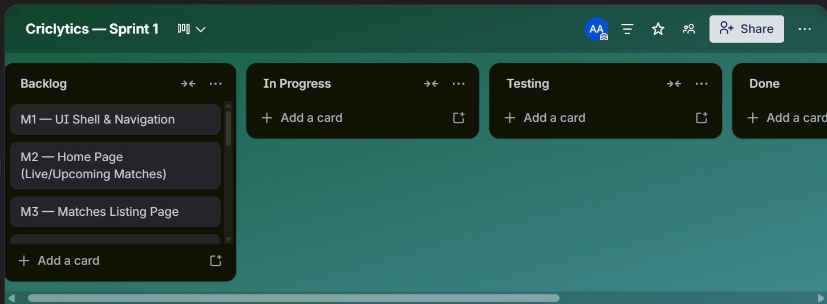

Snapshot 2 — Mid-Sprint (50% Complete)
Taken at the mid-point of Sprint 1. UI Shell, Home Page, and Data Pipeline modules were complete and moved to Done. Matches, Players, and Teams modules were In Progress.
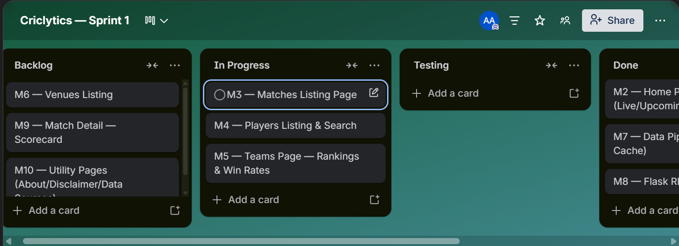

Snapshot 3 — Sprint End
Taken at the conclusion of Sprint 1. All planned user stories were completed and moved to Done. No leftovers were carried to Sprint 2.
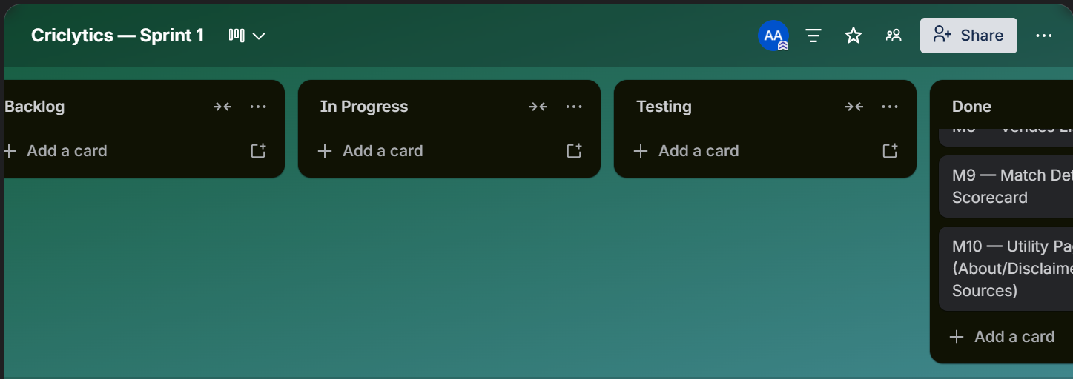

4.1 Product Burn-Down Chart
The burn-down chart below plots planned story points versus completed story points across the two-week Sprint 1 timeline.
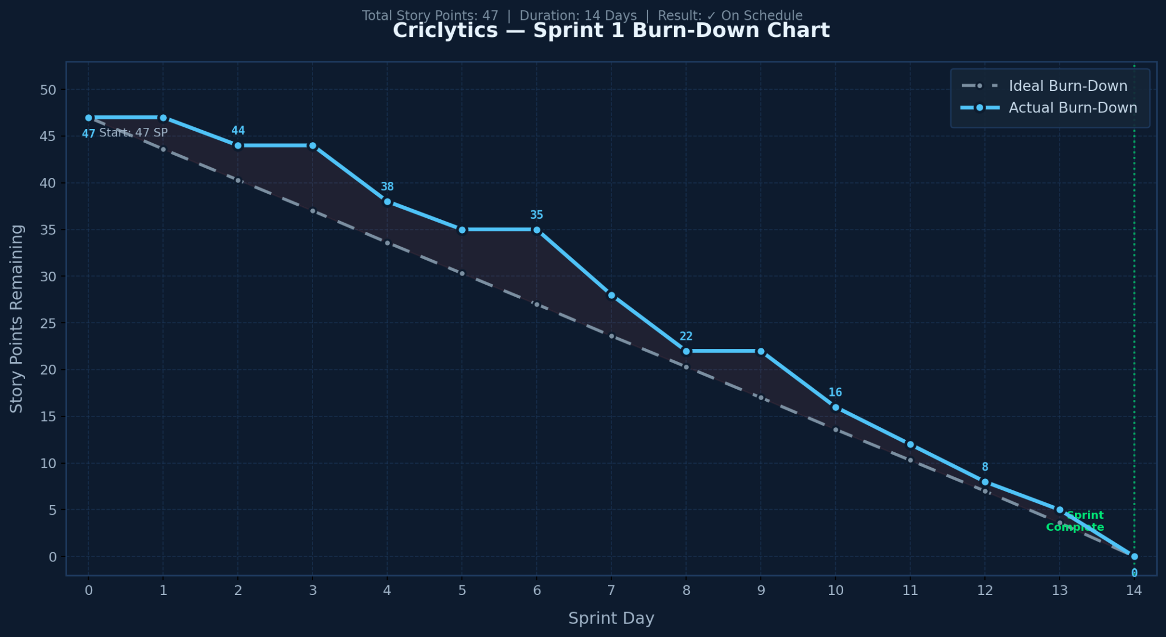
Story point summary:
Module | Planned SP | Completed SP
UI Shell & Navigation | 3 | 3
Home Page | 5 | 5
Matches Module | 5 | 5
Players Module | 5 | 5
Teams Module | 4 | 4
Venues Module | 4 | 4
Data Pipeline | 8 | 8
Flask REST API | 6 | 6
Match Detail | 5 | 5
Utility Pages | 2 | 2
TOTAL | 47 | 47

5. Non-Functional Requirements (NFR) Specification
All NFRs are specified using natural language specification format.

ID | Category | NFR-01 — Performance
Specification |  | The platform shall render any page within 3 seconds on a standard desktop browser over a localhost connection. API responses from Flask endpoints shall return within 500 milliseconds for cached data.

ID | Category | NFR-02 — Usability
Specification |  | The platform shall be usable without any training. All navigation, filters, and interactive elements shall be self-explanatory. A first-time user shall be able to locate a player's career statistics within 3 clicks from the home page.

ID | Category | NFR-03 — Responsiveness
Specification |  | All pages shall be responsive and usable on screen widths from 375px (mobile) to 1920px (desktop). The navigation bar shall collapse into a hamburger menu on screens narrower than 768px.

ID | Category | NFR-04 — Reliability
Specification |  | The platform shall function correctly in the absence of a live internet connection by serving all data from locally cached JSON files in data/live/ and data/processed/. No page shall show an unhandled JavaScript error when an API call fails.

ID | Category | NFR-05 — Accuracy & Disclaimer
Specification |  | All probability figures and statistical estimates displayed on the platform shall be accompanied by a visible disclaimer label indicating they are based on historical data and do not constitute predictions. The Disclaimer page shall be reachable from the footer of every page.

ID | Category | NFR-06 — Maintainability
Specification |  | The codebase shall be organised into clear modules (frontend pages, API JS files, Flask endpoints, data pipeline scripts). Each page shall have a dedicated <page>-api.js file. The Flask app shall use a single app.py entry point.

ID | Category | NFR-07 — Security
Specification |  | No API keys or credentials shall be committed to the public GitHub repository. All sensitive values shall be stored in a .env file which is listed in .gitignore. A .env.example file with placeholder values shall be provided.

ID | Category | NFR-08 — Data Freshness
Specification |  | Match schedule and live data shall be refreshable on demand by running fetch_live.py (with VPN) or scrape_matches.py. Rankings data shall be refreshable by running scrape_rankings.py. The system shall continue to function with stale cached data if refresh is not run.

6. Iteration 1 — Implementation Screenshots
The following placeholders indicate where screenshots of the running implementation should be inserted. Replace each placeholder with an actual screenshot from the localhost application.

SS-IMG-01
Home Page — Live / Upcoming matches section with team flags and match cards.
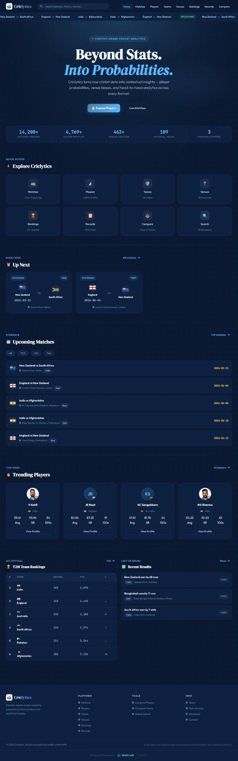

SS-IMG-02
Matches Page — Three groups (Live Now, Upcoming, Recent Results) populated with real Cricbuzz data.
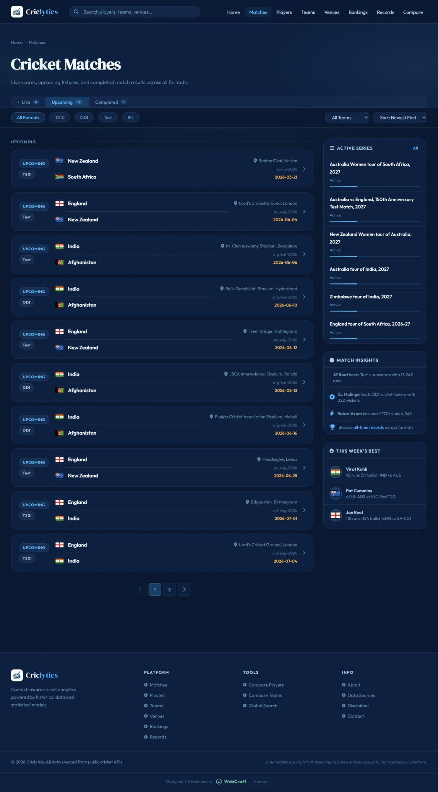

SS-IMG-03
Players Page — Player cards with photos, flags, format filters, and role sidebar.
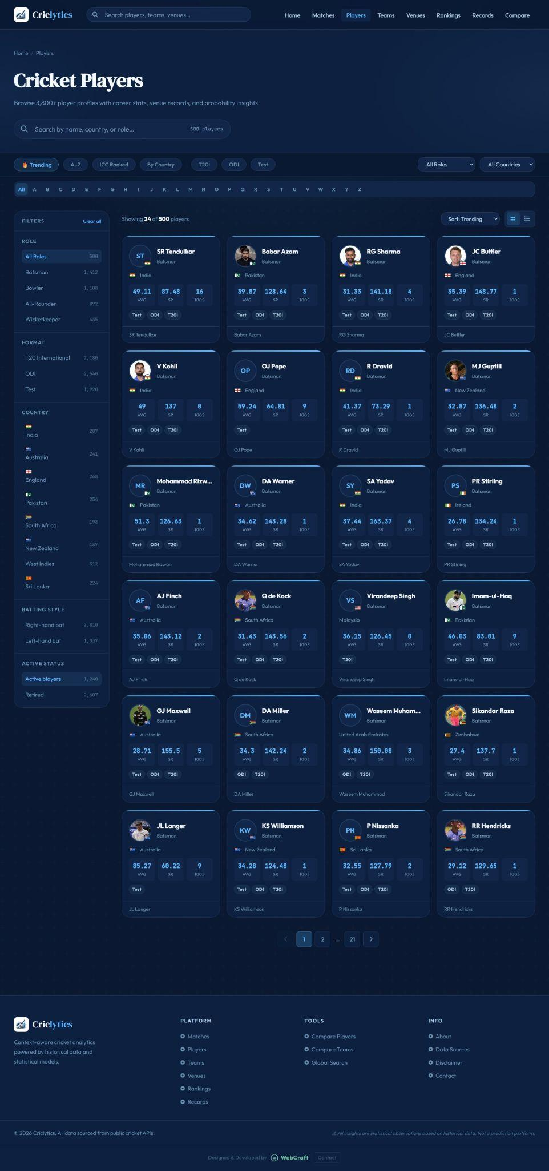

SS-IMG-04
Teams Page — Rankings table with win-rate sidebar populated from Cricsheet data.
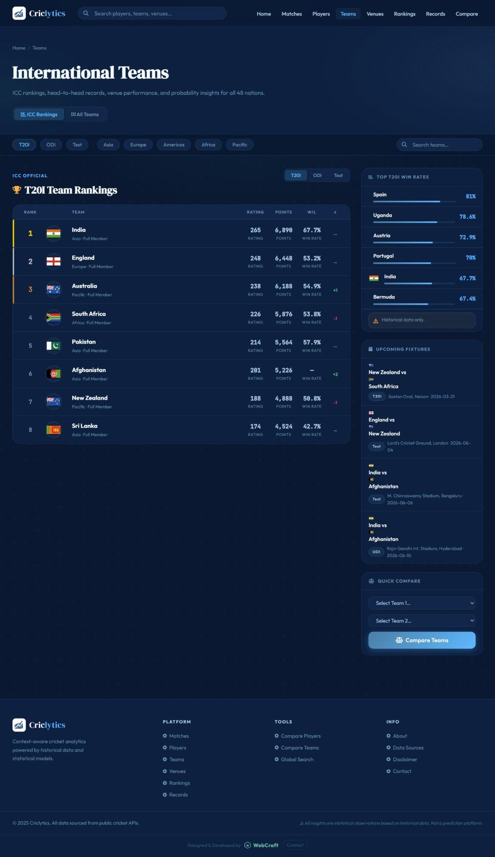

SS-IMG-05
Venues Page — Venue cards with bat/bowl bias indicators and country flags.
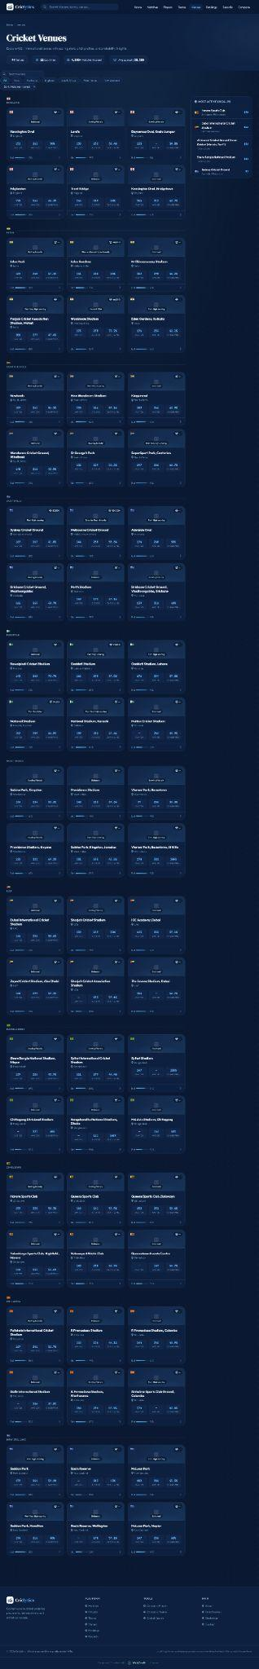

SS-IMG-06
Match Upcoming Page — Fixture detail with Head-to-Head and Venue Context sections.
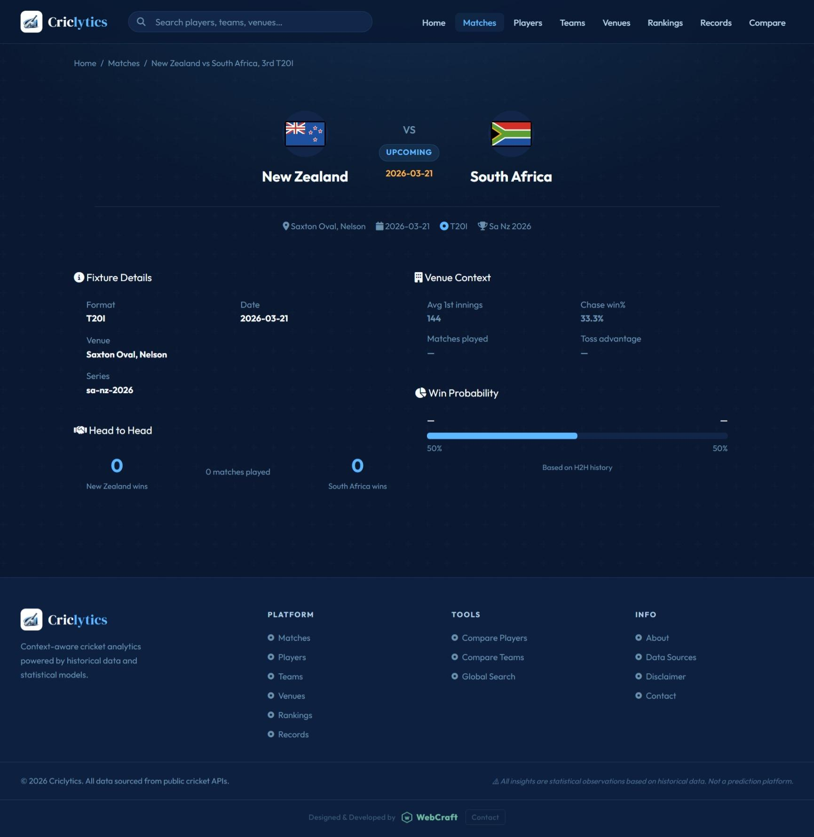

SS-IMG-07
About / Disclaimer pages — Informational pages confirming statutory disclaimers.
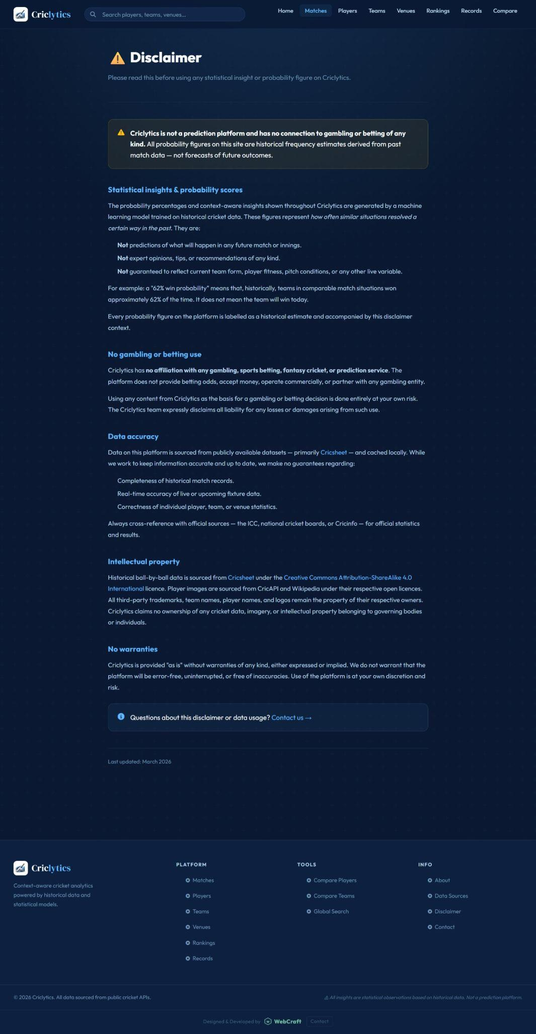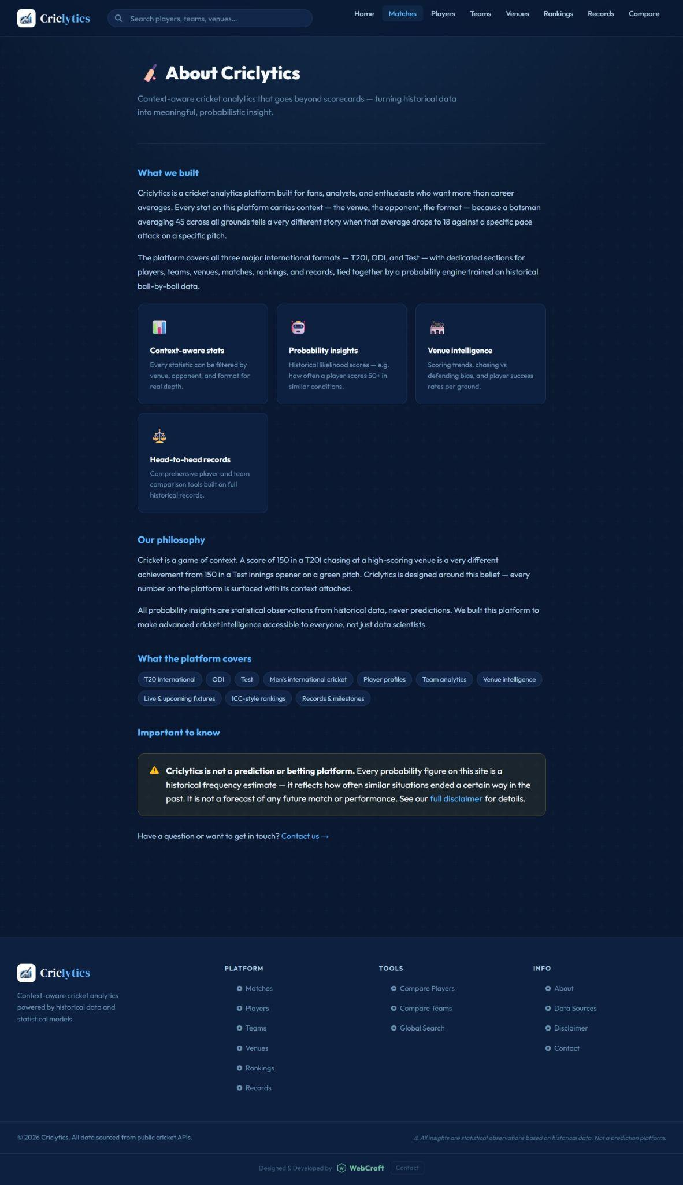

7. Work Division
The following table details the task distribution between both team members for Sprint 1.

Muhammad Ali Aamir (24L-2558) | Muhammad Mahad Mahmood (24L-2548)
- Flask backend setup and all REST API endpoints (app.py)  - Cricsheet data processing pipeline (process_cricsheet.py)  - Live data fetcher (fetch_live.py) with CricAPI integration  - Rankings scraper (scrape_rankings.py)  - Match schedule scraper (scrape_matches.py with Cricbuzz)  - players_meta.json and photo URL management  - ML model training pipeline (scikit-learn Logistic Regression)  - Project coordination, GitHub repository setup | - All 13 HTML page designs (UI shell, layout, CSS design system)  - All 14 API-wiring JS files (*-api.js) for frontend integration  - cricklytics.js shared utility library (flags, search, routing)  - Home page (index.html + index-api.js) with live/upcoming sections  - Matches, Players, Teams, Venues listing pages  - Match Detail and Match Upcoming pages  - About, Data Sources, Disclaimer pages  - Functional & integration testing across all pages

Cricklytics — Iteration 1 Document | Spring 2026 | FAST-NUCES
Muhammad Ali Aamir (24L-2558) · Muhammad Mahad Mahmood (24L-2548)

