**Programming Fundamentals**

**Lab – 5**

**Muhammad Ali / 24K-3103**

**BS. Software Eng. - 01B**

**Q1 – Traffic Light Sytem.**

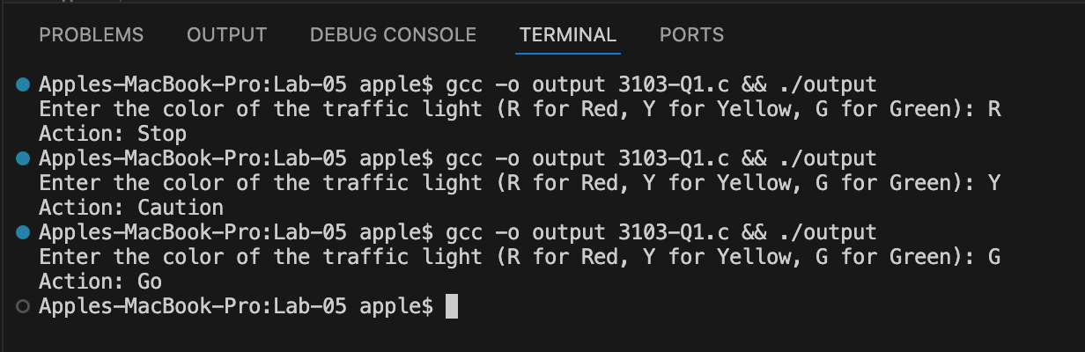

**Q2 – Movie Rating.**

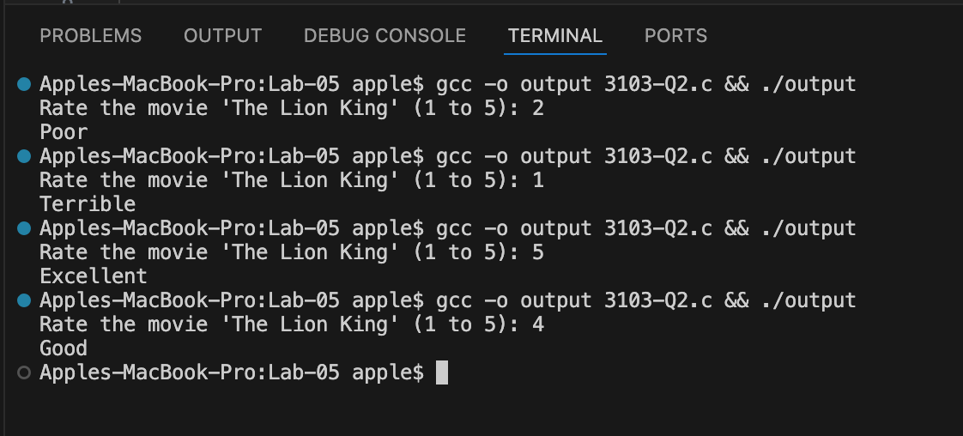

**Q3 – Grade Feedback.**

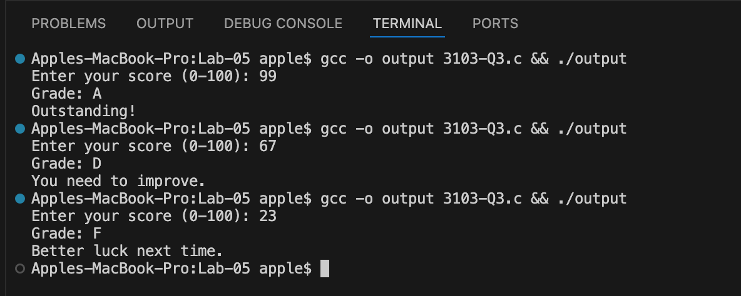

**Q4 – Age Life Stage.**

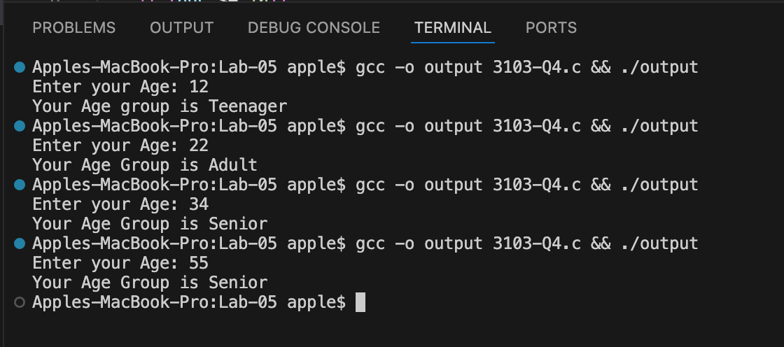

**Q5 – Positive/Negative Number.**

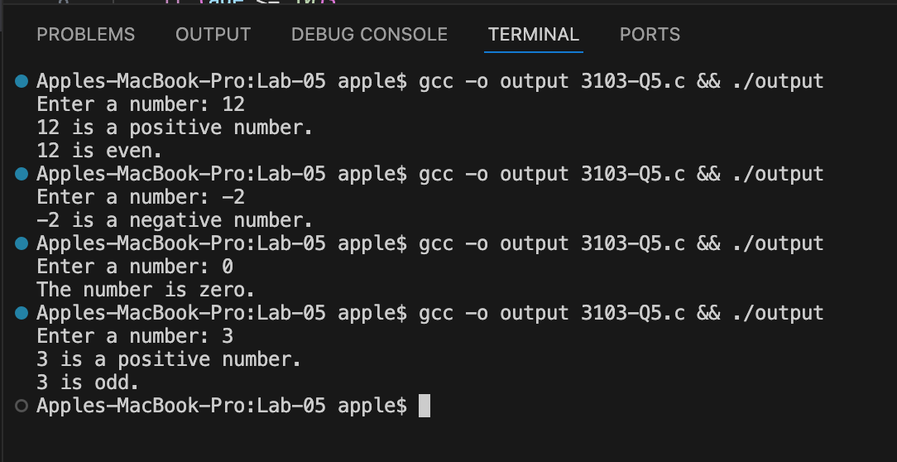

**Q6 – ATM.**

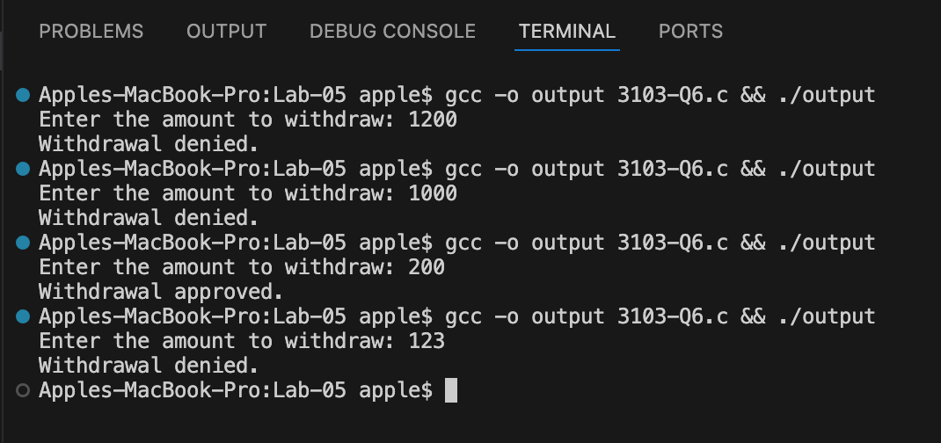

**Q7 – Divisible by both 3 and 5.**

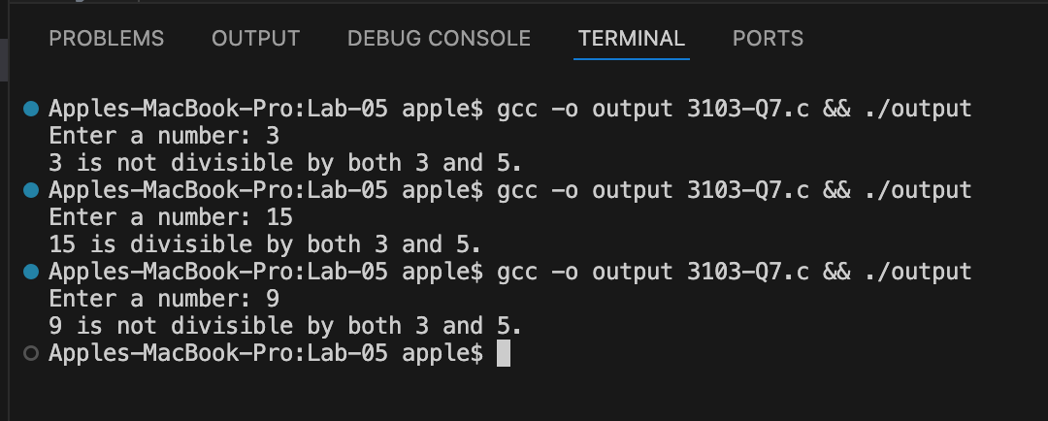

**Q8 – Max of two Numbers.**

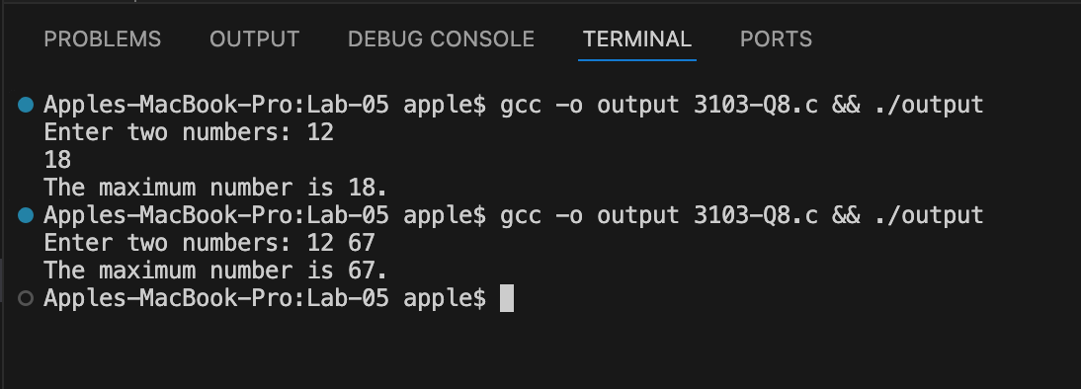

**Q9 –Ticket Pricing.**

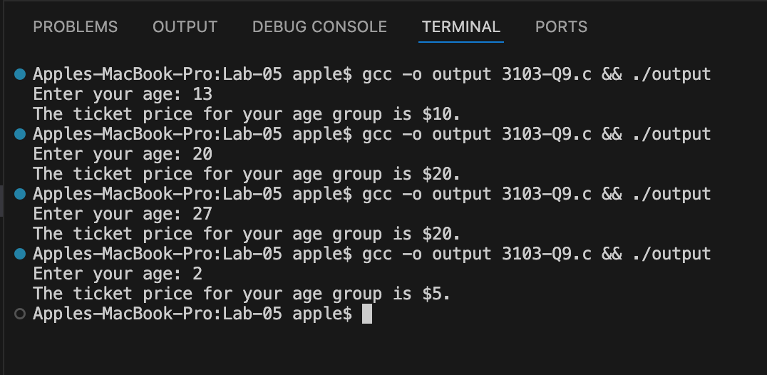

**Q10 – Number is Positive, Negative or Zero.**

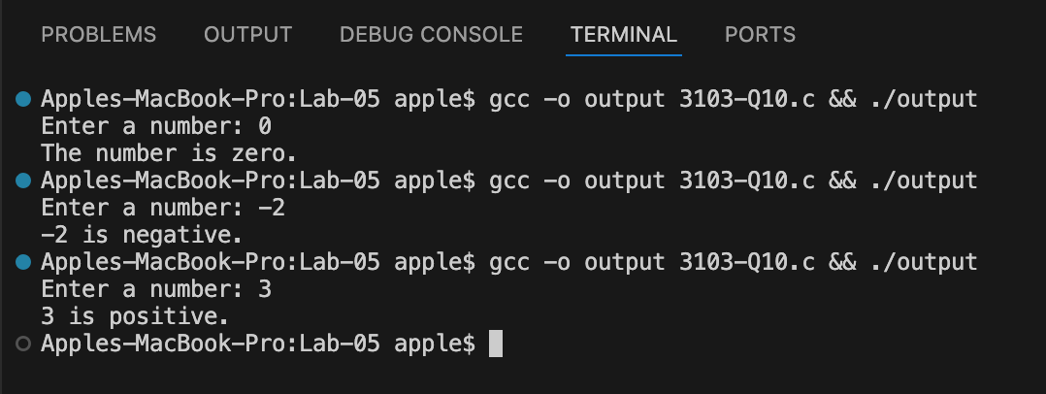

**Q11 – Check Leap Year.**

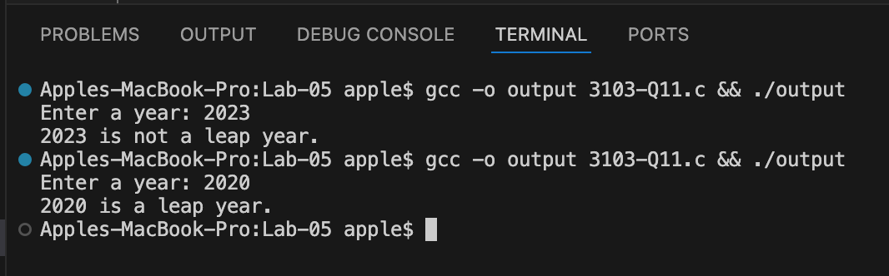

**Q12 – Speeding Test.**

