**Programming Fundamentals**

**Lab – 9**

**Muhammad Ali / 24K-3103**

**BS. Software Eng. - 01B**

**Q1 – Concatenate String.**

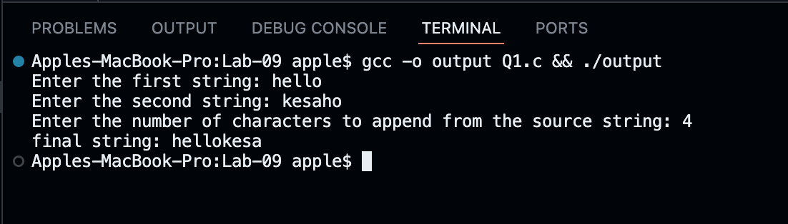

**Q2 – Search Word in Array.**

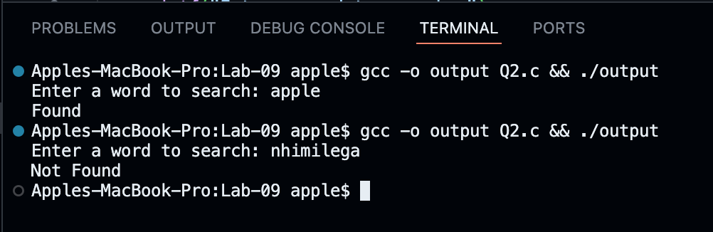

**Q3 – Palindrome Check.**

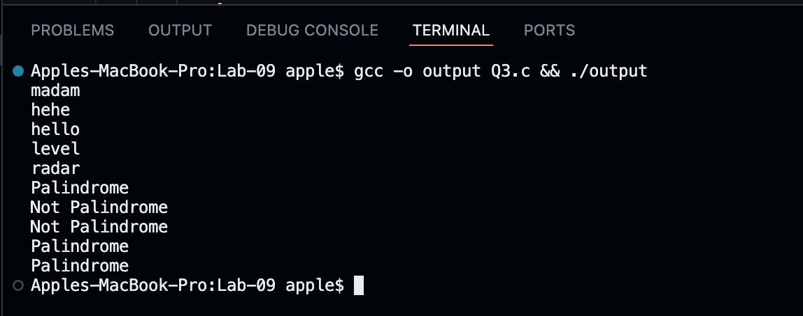

**Q4 – Swap Two Integers.**

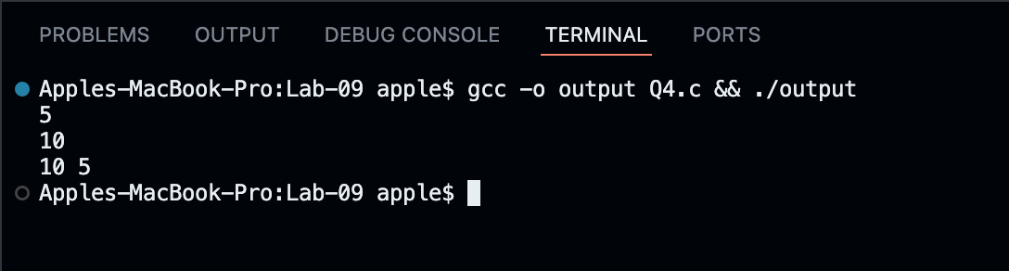

**Q5 – Prime Number Check.**

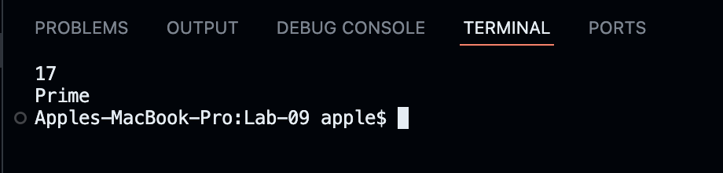

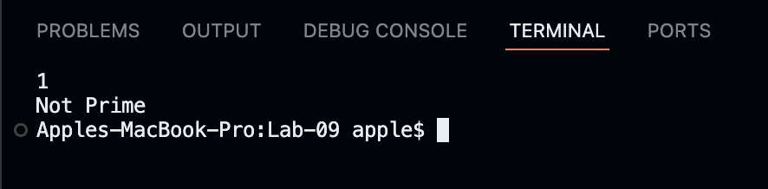

**Q6 – Arithmetic Operations.**

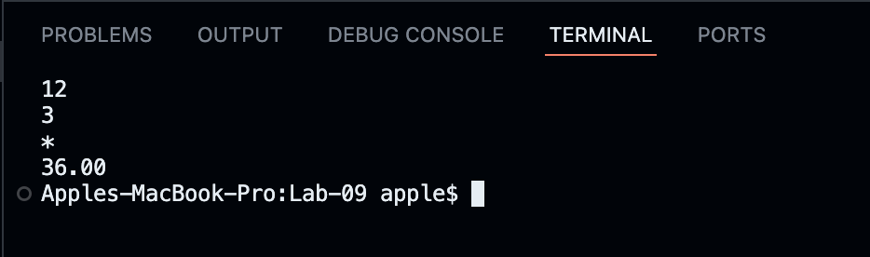

**Q7 – Reverse String.**

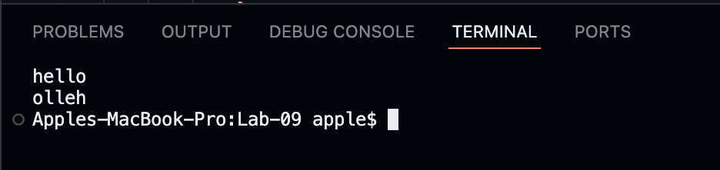

**Q8 – Replace Vowels.**

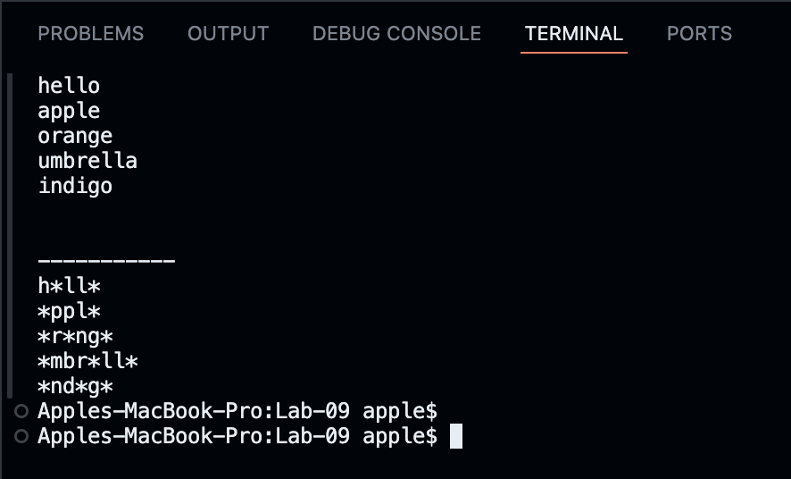

**Q9 – Calculate Power.**

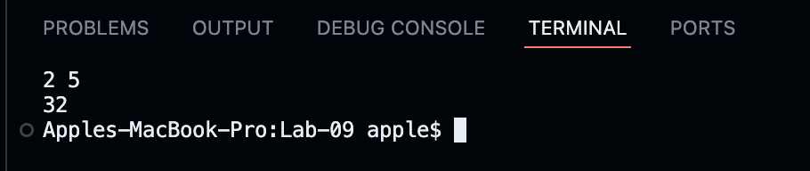

**Q10 - Convert String to Uppercase.**

