**Installing VirtualBox and pfSense 2.7.2**

**1. Install VirtualBox**

* I go to the official VirtualBox download page.
* I choose the correct version for my operating system (macOS).
* I downloaded the installer and ran the downloaded installer.
* I followed the on-screen instructions to complete the installation.

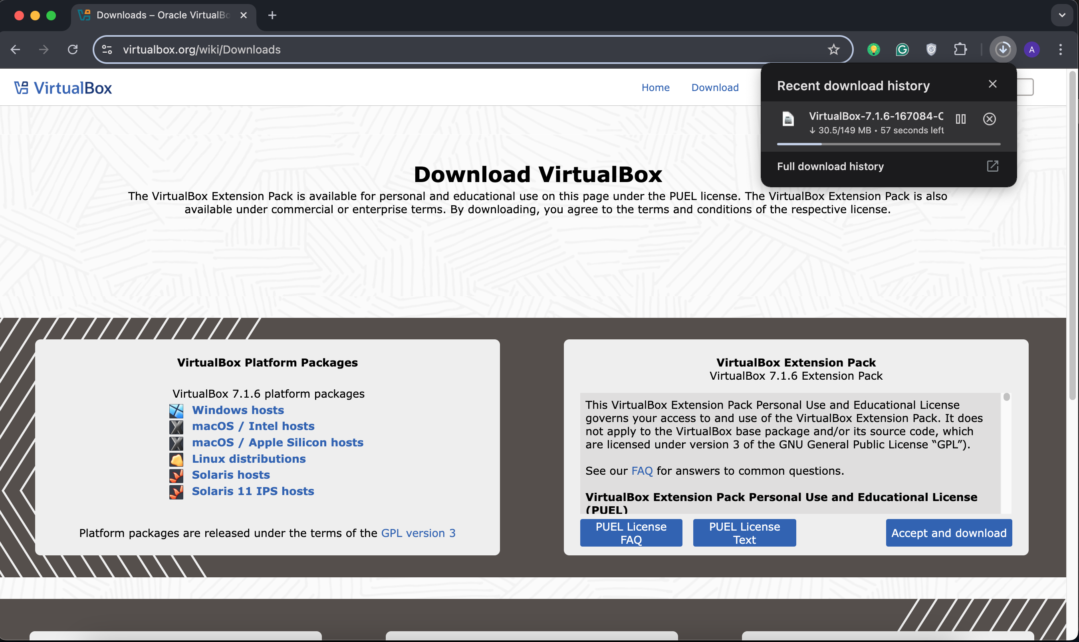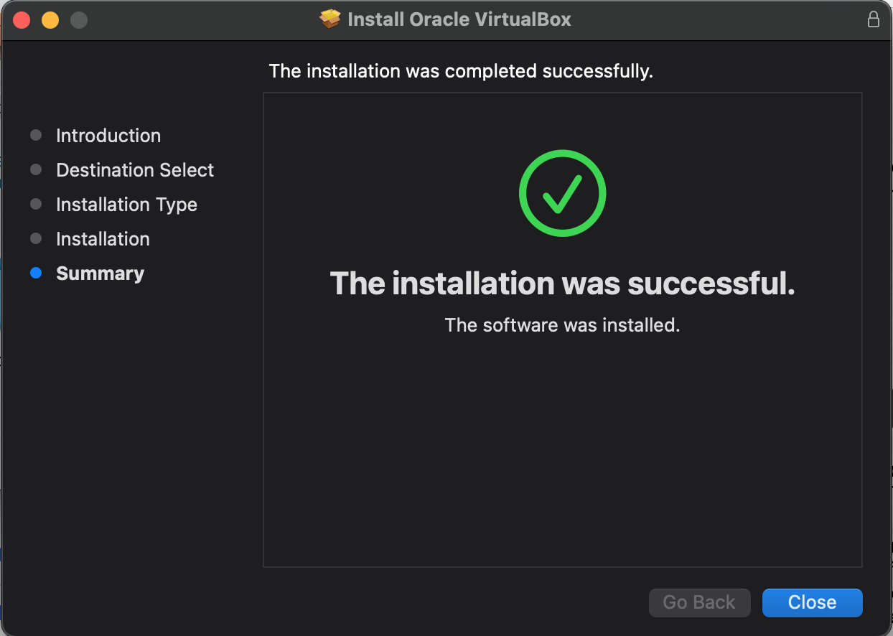

**2. Download pfSense 2.7.2 ISO**

* I visit the pfSense Downloads page.
* I select the correct architecture (AMD64).
* I choose the Installer type as ISO and picked the mirror closest to my location and click Download.

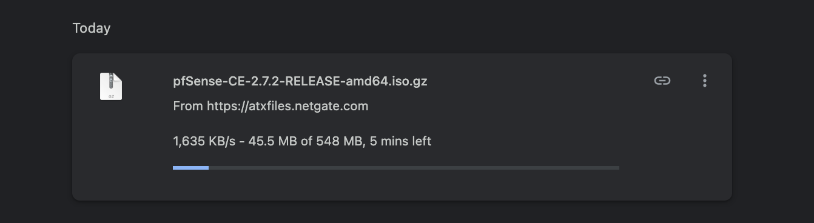

**3. Setting Up VirtualBox for pfSense**

* I open VirtualBox and click **New**.
* I name the virtual machine (pfSense).
* I set the **Type** to BSD and **Version** to FreeBSD (64-bit) and assigned 1 GB of RAM.
* Next I select **Create a virtual hard disk now** and choosed **VDI (VirtualBox Disk Image)** as the disk type.
* I set the disk size to 10 GB.

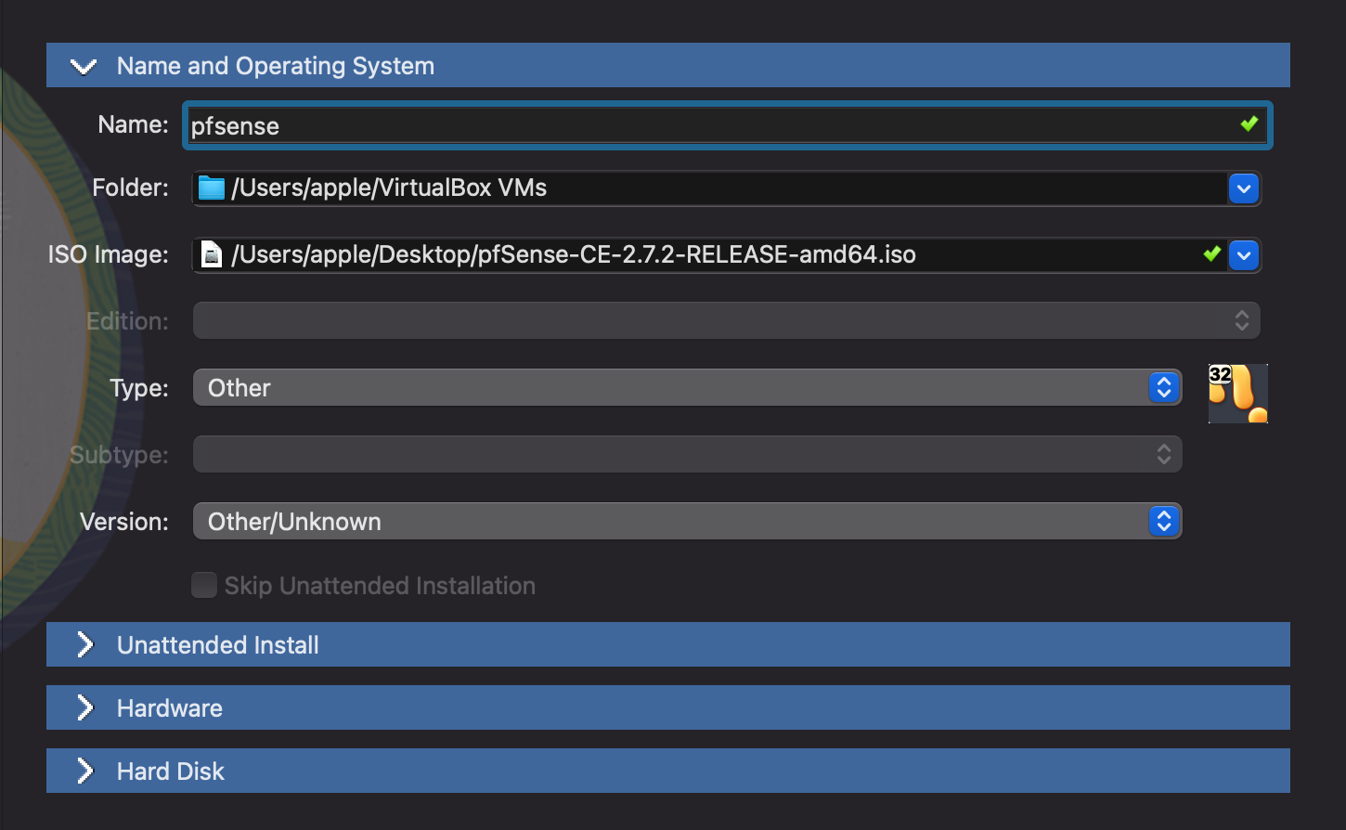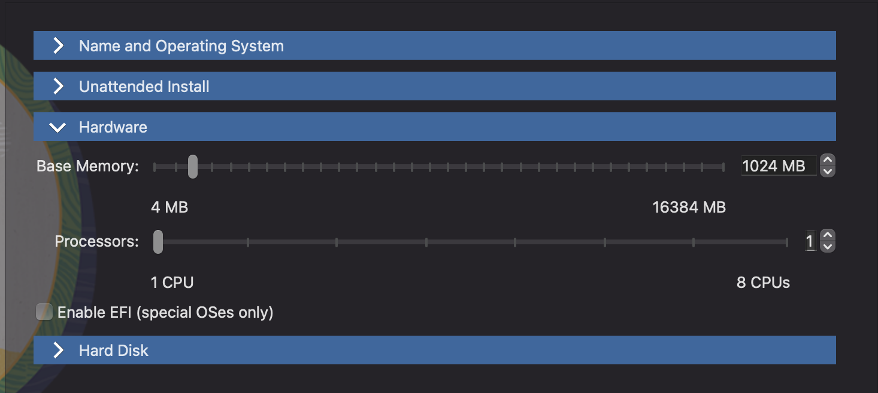

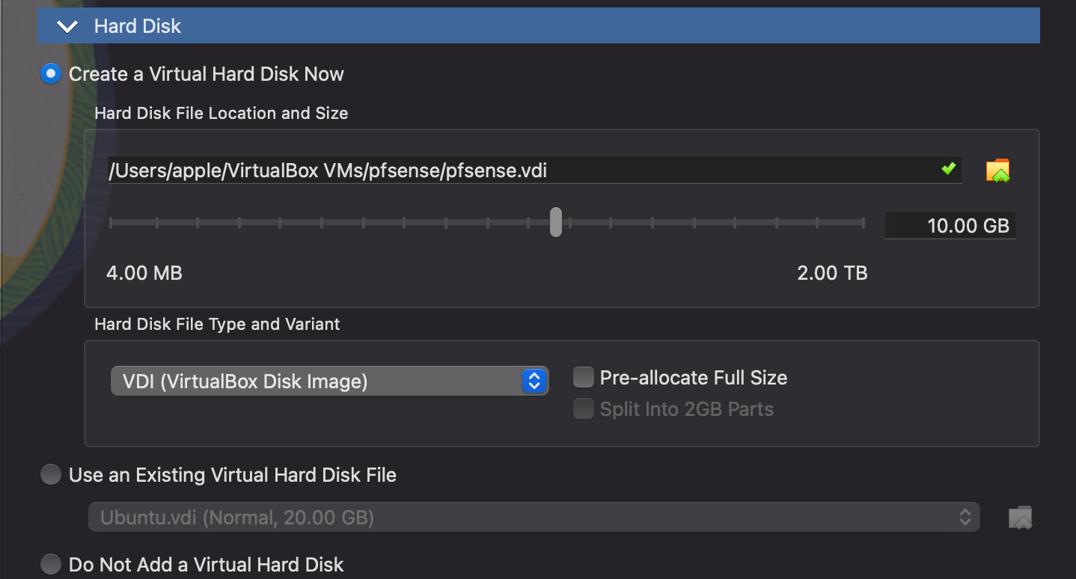

**Configuring Network**

* I select the new VM and click on **Settings**.
* I go to the **Network** tab.
* For **Adapter 1**, I set **Attached to: NAT**.
* For **Adapter 2**, I set **Attached to: Internal Network**.

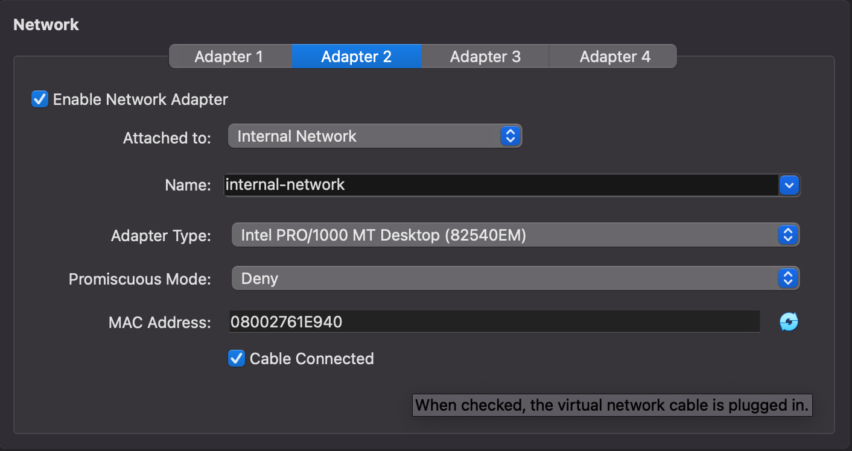

**Starting the Virtual Machine**

* Since the VM is now created, I click **Start** to boot the VM from the pfSense ISO.
* When the pfSense installer menu appears, I choose **Install pfSense** and press Enter.
* I follow the on-screen instructions, including selecting the installation drive.
* The installation process begins.

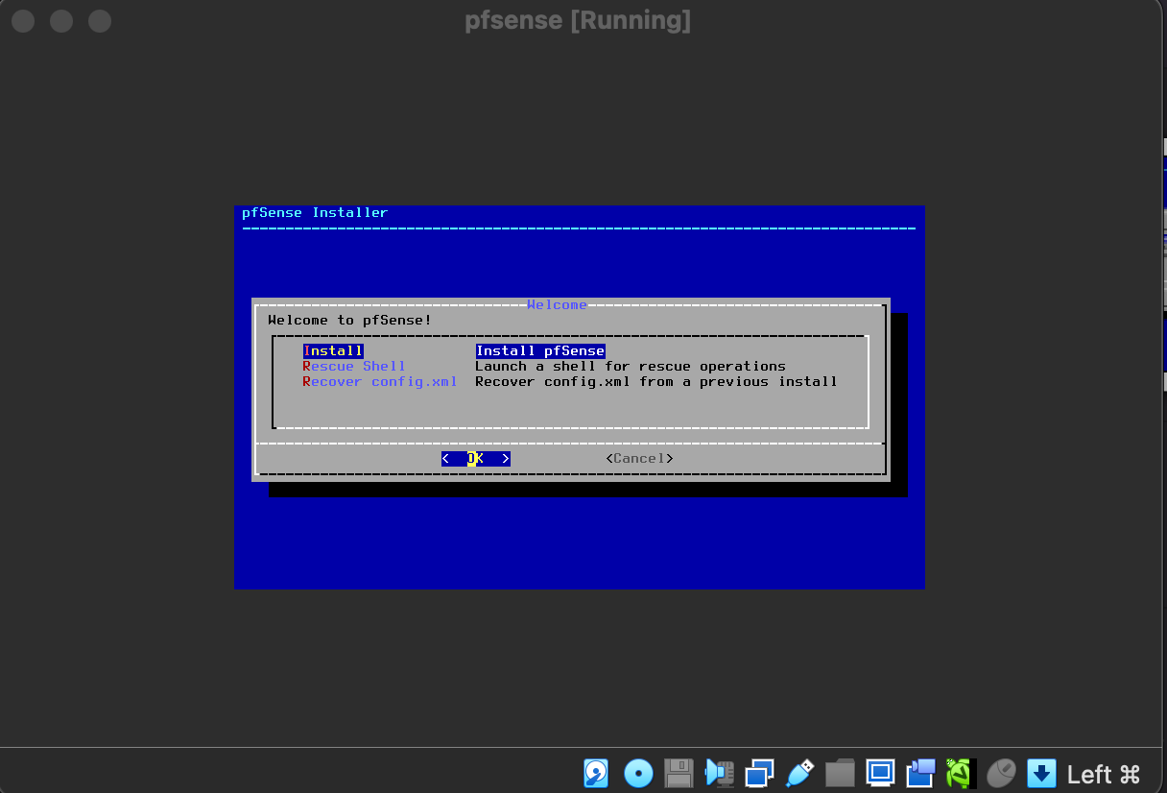

**Reboot and Remove the ISO**

* Once installation is complete, the system asks me to reboot.
* Before rebooting, I go to **Storage settings** and remove the ISO file from the virtual CD drive.
* I then reboot the VM.
* After rebooting, pfSense starts and shows a console menu and sets up the network interfaces (WAN, LAN).
* The default setting assigns LAN to DHCP and WAN as needed.

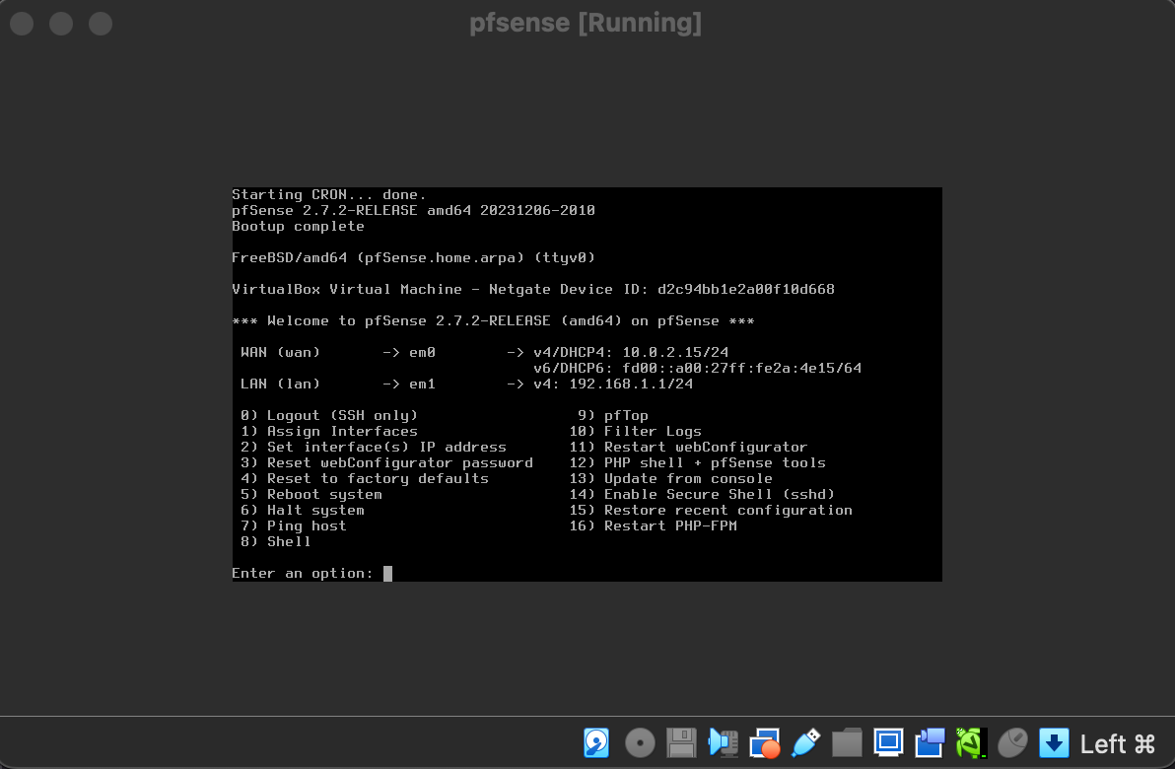

**Accessing the pfSense Web Interface**

* Once pfSense has finished booting, I open a web browser.
* I go to https://192.168.1.1
* I enter the default login credentials and followed the setup wizard to configure my network, firewall rules, and other settings.

Now, pfSense is installed and ready to use!

