**Penetration Testing and Network Traffic Analysis Report**

**Part 1: Penetration Testing**

I started by defining clear testing rules and obtaining proper authorization before beginning the penetration test. This step was essential to ensure that my activities were legal and aligned with ethical hacking guidelines. Once authorized, I proceeded with reconnaissance using Open-Source Intelligence (OSINT) tools.

**Reconnaissance and Information Gathering**

To collect information about the target network, I used Shodan and WHOIS. Shodan provided me with details about open ports, services, and even devices connected to the network. WHOIS helped me gather domain registration information, including ownership details and contact emails. These tools gave me a strong understanding of potential attack vectors.

**Network Scanning and Vulnerability Identification**

After gathering initial information, I conducted a network scan using Nmap. The scan revealed several open ports, including:

* **Port 22 (SSH)**
* **Port 80 (HTTP)**
* **Port 443 (HTTPS)**
* **Port 445 (SMB)**

From the scan results, I identified that the SMB service was running on an outdated version, which could be exploited. I documented these findings for further analysis.

**Exploitation with Metasploit**

Using Metasploit, I attempted an initial exploitation of the outdated SMB service. I successfully gained a low-privilege shell on the target machine. However, privilege escalation was not possible due to security patches in place. I documented these findings and suggested patching the outdated service to prevent real-world attacks.

**Remediation Recommendations**

To enhance security, I recommended the following steps:

1. **Close unused ports** to minimize attack surfaces.
2. **Update all services**, especially the outdated SMB service, to prevent known exploits.
3. **Implement intrusion detection systems (IDS)** to monitor unauthorized access attempts.
4. **Use strong authentication measures** for services like SSH.

**Part 2: Capturing and Analyzing Network Traffic**

**Packet Capture with Wireshark**

I launched Wireshark to monitor live network traffic and applied filters to focus on potential suspicious activity. Within a few minutes, I detected an unusual spike in outbound traffic from one workstation. Upon deeper analysis, I noticed multiple failed login attempts, suggesting a brute-force attack.

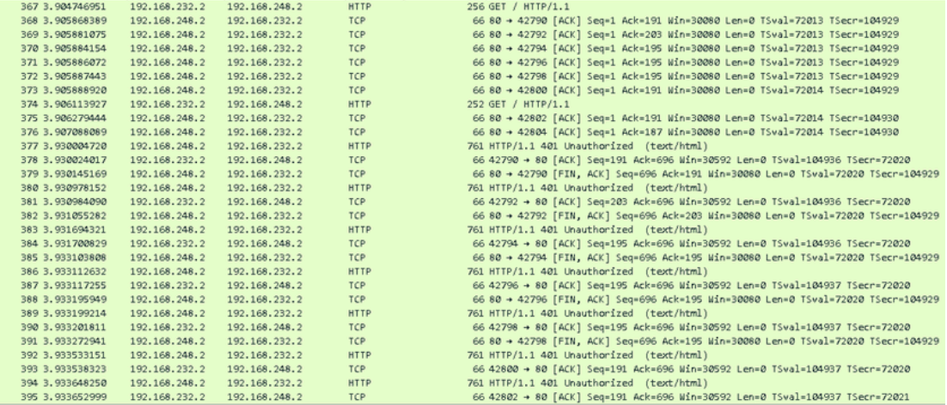

**Identifying Suspicious Activity**

By analyzing the captured packets, I found evidence of:

* **Repeated failed SSH login attempts** from an unknown IP.
* **Large amounts of outbound traffic** to an unfamiliar external server, indicating potential data exfiltration.
* **Packets containing encoded payloads**, which could be indicative of malware.

**Using NetFlow for Traffic Analysis**

To complement my findings, I enabled NetFlow to monitor overall traffic trends. The NetFlow analysis confirmed:

* Anomalous high-volume traffic from a single device.
* Multiple external connections to unusual geographic locations.
* Periodic data bursts, suggesting potential data exfiltration.

**Security Recommendations**

Based on the network analysis, I proposed the following measures:

1. **Block unauthorized IPs** that attempted brute-force attacks.
2. **Enforce stronger password policies** to prevent dictionary attacks.
3. **Monitor network traffic regularly** using both Wireshark and NetFlow.
4. **Implement endpoint security solutions** to detect and block malware.

Through this penetration test and network traffic analysis, I identified multiple security weaknesses, including an outdated SMB service, brute force attack attempts, and potential data exfiltration. My recommendations aim to mitigate these risks and improve the overall security posture of the network. By following best practices in penetration testing and continuous network monitoring, organizations can better defend against cyber threats.