Ali Swing Suite:
Bullish Weekly Participation v5 Training Manual
System: SwingSuiteScreener
Strategy profile: Bullish Weekly Participation v5
Validation state: research_default
Document date: July 16, 2026
Scope: Read-only bullish stock and long-call research

Important Notice
This manual describes a research process. It does not provide investment advice, personalized suitability analysis, an expected return, a probability of success, or an instruction to trade.
Long calls can lose the full premium paid. Short-duration options can change value rapidly because of price movement, time decay, implied volatility, liquidity, and changes in delta. Before trading exchange-listed options, review the current Characteristics and Risks of Standardized Options.
The software is intentionally read-only. It does not connect to a brokerage account, inspect positions, place orders, exercise contracts, or manage money.

Quick Reference

Index Weekly
Rule | Value
Symbols | SPY, QQQ
Preferred DTE | 10-16
Hard DTE | 7-21
Preferred delta | 0.60-0.75
Hard delta | 0.50-0.85
Intended hold | 1-4 sessions
Requalify | 5 DTE
Maximum spread | 3%
Minimum OI / volume | 2,000 / 500
Minimum bid / ask size | 10 / 10
Maximum daily theta / ask | 5%

Leader Weekly
Rule | Value
Minimum price | $20
Minimum 20-session average dollar volume | $100 million
Preferred DTE | 14-21
Hard DTE | 10-24
Preferred delta | 0.55-0.70
Hard delta | 0.45-0.80
Intended hold | 1-5 sessions
Requalify | 7 DTE
Maximum spread | 5%
Minimum OI / volume | 1,000 / 200
Minimum bid / ask size | 5 / 5
Maximum daily theta / ask | 6%

Entry Timing
- daily thesis qualified
- completed 60-minute bar
- 10:30 AM through 2:45 PM ET
- EMA9 above EMA21
- price above EMA9 and session VWAP
- RSI at or above 50
- MACD histogram positive
- higher low or reclaim
- intraday SPY/QQQ confirmation

Management
- tactical warning: reassess momentum
- tactical failure: hourly timing failed
- structural invalidation: daily thesis failed
- reassess after two sessions without meaningful progress
- enforce the lane maximum hold
- do not hold through earnings
- exit or fully requalify at the lane DTE boundary

1. Strategy Doctrine
Bullish Weekly Participation v5 looks for liquid bullish continuation structures that can reasonably resolve within a short holding window. The strategy is not designed to predict every market advance. It narrows attention to situations where:
- the broad market is not hostile
- the underlying is in a durable daily uptrend
- a promoted bullish pattern has clear geometry
- the setup is near its trigger and not extended
- the completed hourly chart confirms timing
- event risk is known and acceptable
- a live call contract passes strict liquidity and decay controls
The strategy prefers evidence agreement over any single indicator. A high score in one category cannot repair a failed hard protection in another category.

1.1 Why Weekly-Duration Calls
"Weekly" means controlled short-duration calls, not same-day or near-expiration lottery contracts. V5 excludes zero through six DTE.
The Options Industry Council explains that theta is not linear and tends to accelerate as expiration approaches. It also explains that gamma is generally higher for near-term, at-the-money options, making delta more sensitive to underlying movement. See:
- OIC Theta
- OIC Gamma
V5 uses 7-24 DTE hard bounds to retain short-duration responsiveness while avoiding the most concentrated expiration window.

1.2 Research Default
V5 starts in research_default.
This means:
- a perfect technical setup does not become Ready
- a perfect candidate is labeled Ready - Verify
- historical results cannot edit configuration
- shadow evidence cannot edit configuration
- promotion requires a documented manual review
The validation state is a safety control, not a commentary on any individual setup.

1.3 Evidence Is Not Probability
Scores answer:
How much configured evidence does this candidate currently satisfy?
Scores do not answer:
- What is the probability of profit?
- What return should be expected?
- How certain is this trade?
- How much capital should be allocated?

2. Chart Ownership

2.1 Daily Chart
The daily chart owns:
- primary trend
- weekly alignment
- leadership
- production pattern
- trigger
- structural invalidation
- confirmed pivot
- 2R planning objective
- pattern lifecycle
The daily thesis cannot be overridden by an attractive hourly candle.

2.2 Completed 60-Minute Chart
The hourly chart owns:
- entry timing
- EMA9 / EMA21 alignment
- session VWAP
- RSI
- MACD histogram
- relative volume
- higher-low / reclaim structure
- intraday index confirmation
- tactical warning
- tactical failure
An incomplete hourly bar does not count.

2.3 Market Confirmation
The system evaluates SPY and QQQ on daily and hourly timeframes. The goal is to avoid isolated bullish signals when the broad environment is hostile or intraday participation is absent.

3. Strategy Lanes

3.1 Index Weekly Lane
The Index Weekly lane applies only to SPY and QQQ.
Why it differs from individual leaders:
- index options generally have deeper liquidity
- event risk is macro rather than company-specific
- intended holds are shorter
- the preferred delta is higher
- spread and depth requirements are stricter

Index Contract Rules
- preferred 10-16 DTE
- hard 7-21 DTE
- preferred delta 0.60-0.75
- hard delta 0.50-0.85
- spread no wider than 3%
- open interest at least 2,000
- volume at least 500
- bid and ask size at least 10
- theta / ask no more than 5%

Index Management Rules
- intended hold: one to four sessions
- no-progress review: two sessions
- exit or fully requalify at 5 DTE
- protect FOMC, CPI, and Employment Situation windows

3.2 Leader Weekly Lane
The Leader Weekly lane applies to liquid individual stocks with eligible options.
Universe minimums:
- price at least $20
- 20-session average dollar volume at least $100 million
- options required
- eligible expiration required inside the lane hard window

Leader Contract Rules
- preferred 14-21 DTE
- hard 10-24 DTE
- preferred delta 0.55-0.70
- hard delta 0.45-0.80
- spread no wider than 5%
- open interest at least 1,000
- volume at least 200
- bid and ask size at least 5
- theta / ask no more than 6%

Leader Management Rules
- intended hold: one to five sessions
- no-progress review: two sessions
- exit or fully requalify at 7 DTE
- no entry when earnings fall inside maximum hold plus two trading sessions
- no holding through earnings

3.3 Weekly Versus Standard Monthly Expiration
The system prefers a nonstandard weekly expiration. A standard monthly can become primary only when:
- it falls inside the same hard DTE window
- it passes every hard contract gate
- its combined open interest, volume, and displayed depth are materially stronger
- the liquidity advantage is at least 25%
The label "weekly strategy" describes the duration and workflow. It does not require selecting a nonstandard expiration when a monthly contract is clearly more liquid.

4. End-To-End Operating Workflow
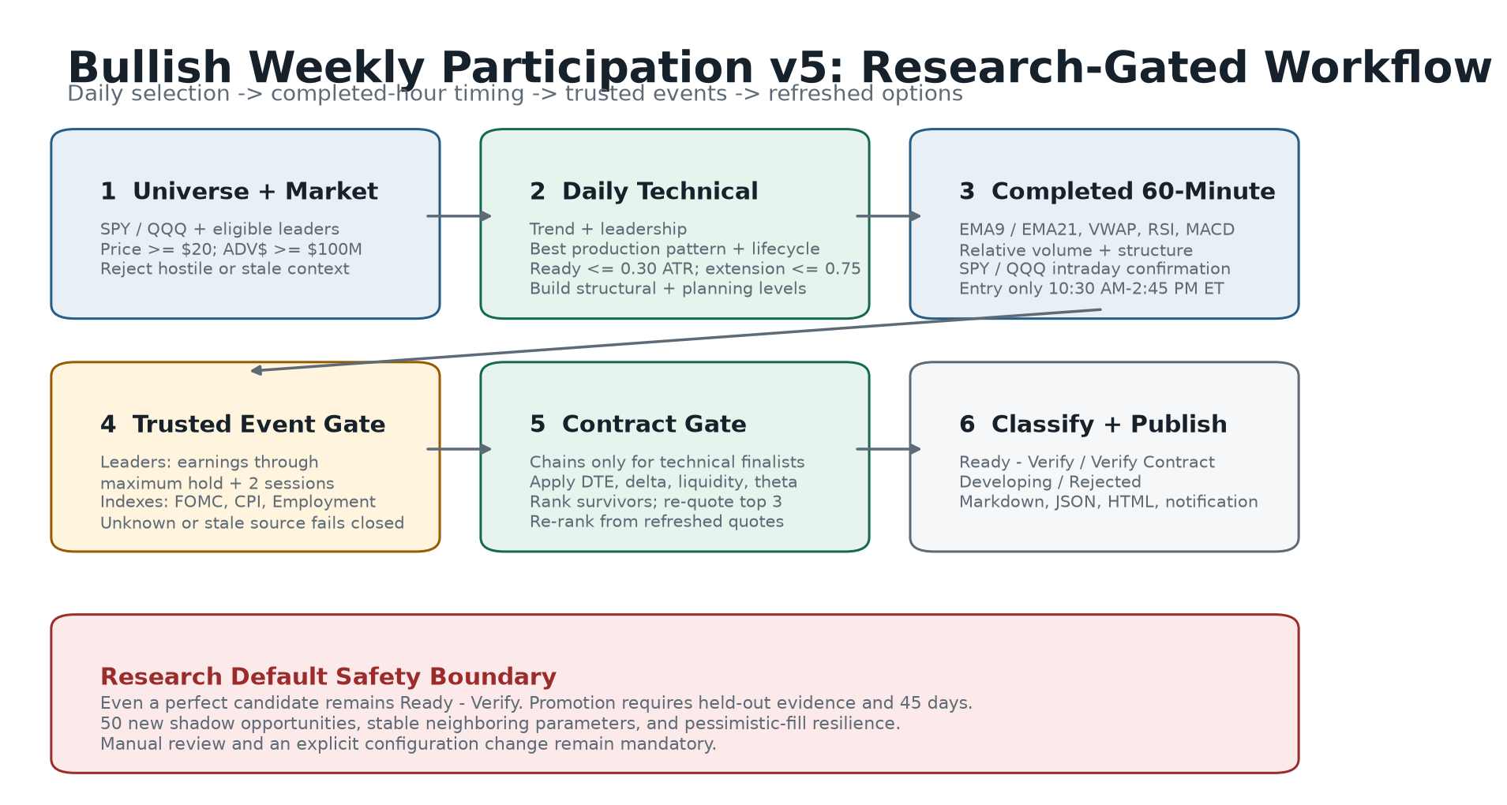
V5 workflow

Stage 1: Universe And Market
- Load configured symbols.
- Calculate SPY/QQQ market context.
- Apply leader price and average dollar-volume minimums.
- Reject stale or incomplete market data.

Stage 2: Daily Technical Evaluation
- Calculate trend.
- Calculate leadership for individual leaders.
- Detect the best production pattern.
- Apply lifecycle and extension limits.
- Build structural levels.

Stage 3: Hourly Timing
- Use completed 60-minute candles only.
- Calculate EMA9, EMA21, session VWAP, RSI, MACD histogram, and relative volume.
- Evaluate higher-low or reclaim structure.
- Confirm intraday SPY/QQQ participation.
- Check the entry window.

Stage 4: Event Gate
Only technical finalists reach the event adapter.
- leaders: earnings
- indexes: FOMC, CPI, Employment Situation
- unknown, missing, or stale source: fail closed

Stage 5: Contract Gate
Only event-clear technical finalists receive an option-chain request.
- Fetch contracts inside the lane DTE window.
- Reject hard failures.
- Rank survivors.
- Re-quote the top three.
- Re-rank from refreshed quotes.
- Assess SIP, OPRA, event, quote-age, and quote-stability trust.

Stage 6: Classification And Output
The candidate becomes:
- Ready - Verify
- Verify Contract
- Developing
- Rejected
The result is written to:
- Markdown
- JSON
- HTML workspace
- notification summary
- research ledger

5. Daily Trend Qualification

5.1 Long-Term Protection
Price must be above SMA200. The long-term trend boundary is a hard protection.
The trend score also considers:
- close above EMA21
- EMA21 above SMA50
- close above SMA50
- SMA50 above SMA200
- rising SMA200
- weekly alignment

5.2 Extension
Extension is measured from the selected pattern trigger using ATR.
Maximum confirmed extension:
0.75 ATR
Why this matters:
- late entries have less room to the nearest pivot
- the underlying invalidation becomes less efficient
- short-duration calls may be purchased after volatility expands
- theta continues while the setup consolidates

5.3 Leadership
Individual leaders are compared with:
- their peer ETF
- SPY
- their own prior performance
Index candidates do not need an individual-stock leadership score.

5.4 Controlled Pullback Preference
Controlled pullbacks receive a ranking advantage when other evidence is comparable. They often offer:
- clearer support
- closer invalidation
- lower extension
- less breakout-volatility inflation
This is a preference, not a guarantee.

6. Pattern Lifecycle
All patterns share the same states.

Forming
The geometry exists, but price is not yet inside the ready zone.

Ready
Price is no more than 0.30 ATR below the trigger.

Confirmed
Price crossed the trigger on a completed daily bar and:
- the confirmation is no older than one daily bar
- price is no more than 0.75 ATR beyond the trigger

Stale
The setup is stale when:
- confirmed age exceeds one daily bar
- extension exceeds 0.75 ATR
- price remains above an old trigger without fresh geometry

Failed
The completed daily close is below structural invalidation.

7. Production Pattern Playbook
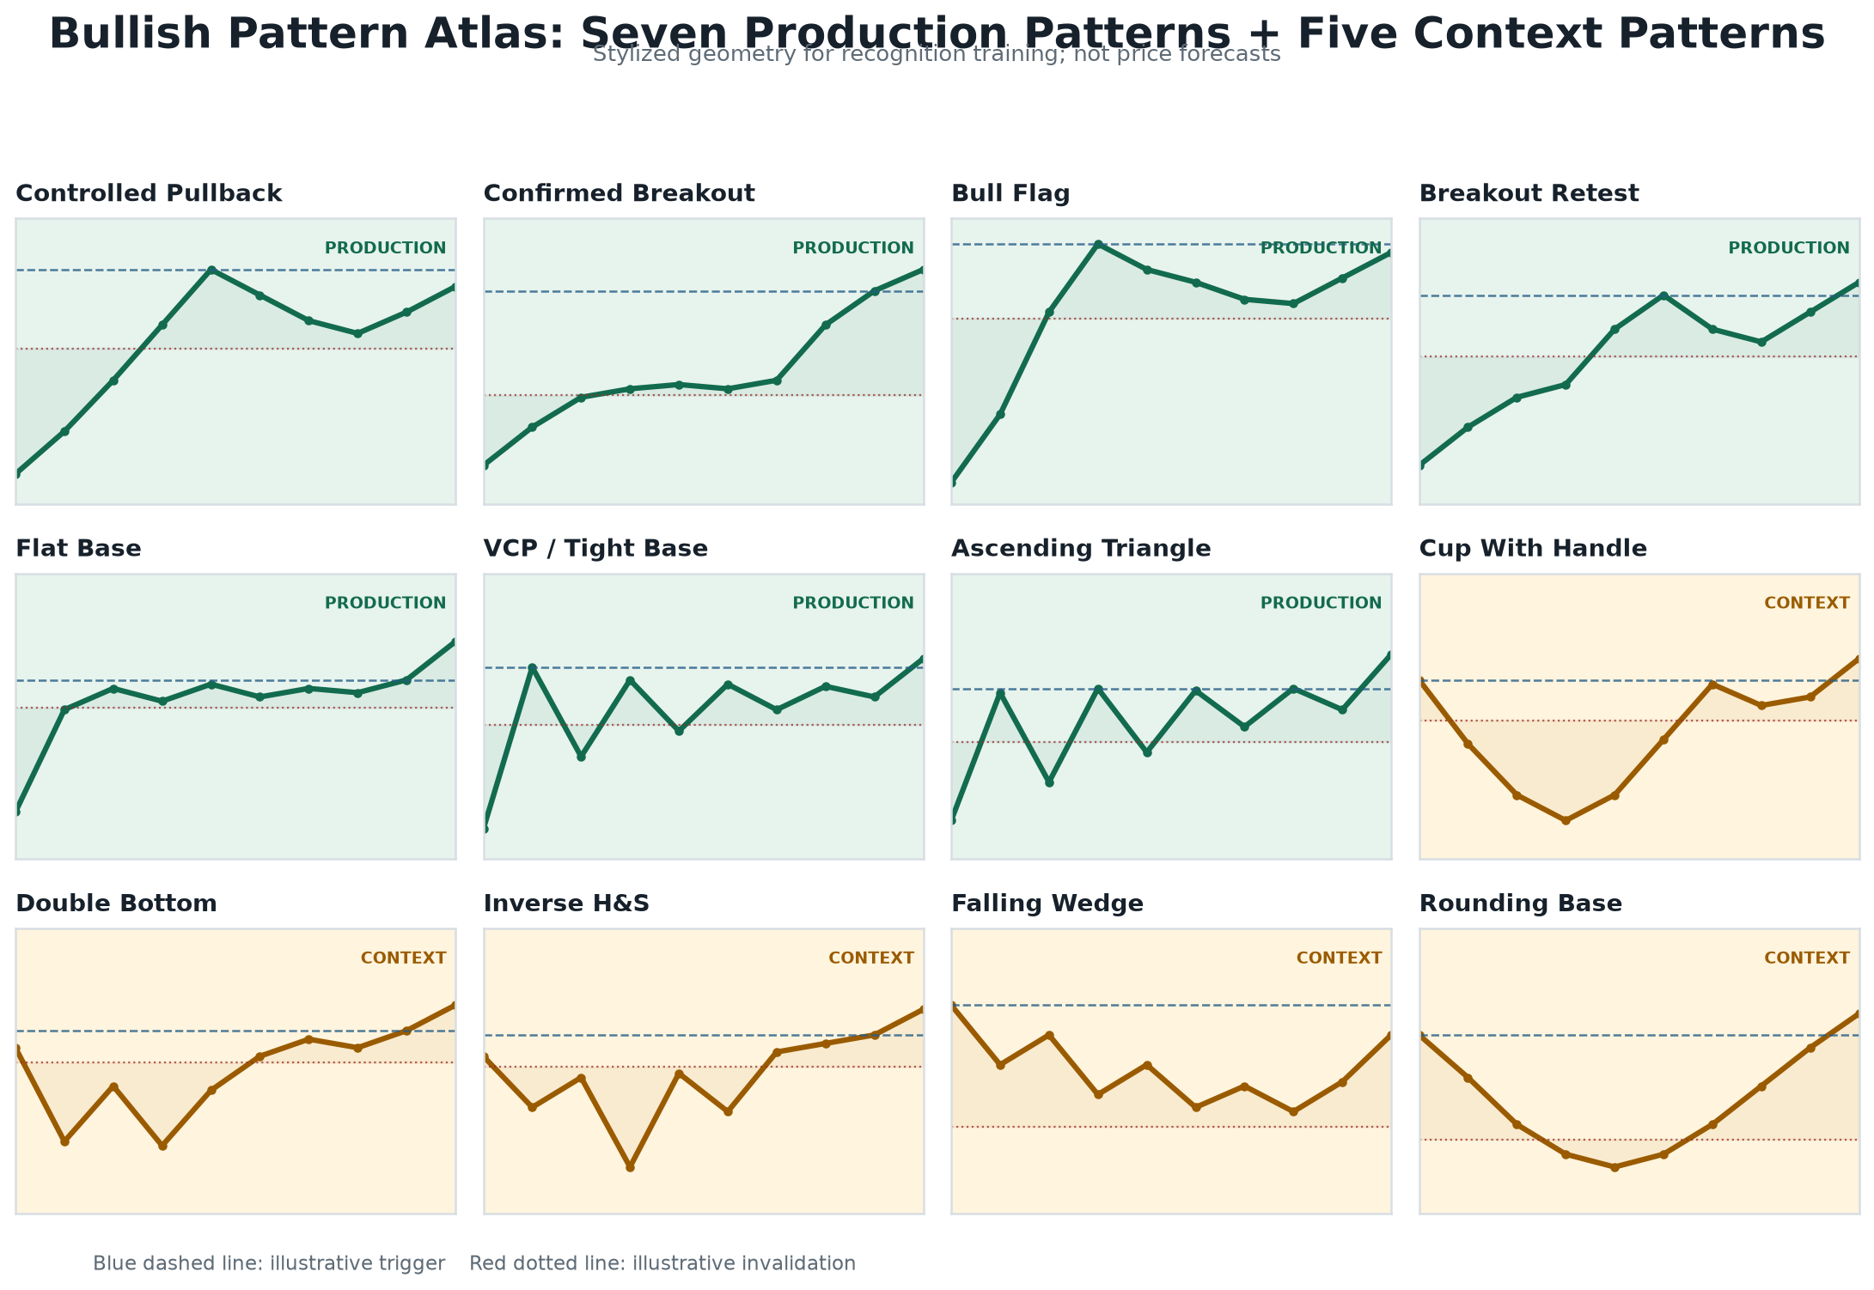
V5 pattern map

7.1 Controlled Pullback
Purpose: Join an established uptrend after an orderly retracement.
Required evidence:
- qualified daily uptrend
- pullback into EMA21, anchored value, or confirmed pivot support
- support held
- constructive close
- no excessive extension
Trigger:
- near-term reaction high
Structural invalidation:
- below the defended daily support with ATR allowance
Failure signs:
- close below support
- expanding downside volume
- hourly rally unable to reclaim EMA9/VWAP
Common error:
- treating a steep selloff as a controlled pullback

7.2 Confirmed Breakout
Purpose: Participate after a completed close through established resistance.
Required evidence:
- qualified daily trend
- close through the prior breakout level
- prior bar at or below the level
- relative volume confirmation
- extension inside the configured maximum
Trigger:
- confirmed breakout level
Structural invalidation:
- breakout level minus ATR allowance or stronger daily support
Failure signs:
- immediate close back below the breakout
- weak hourly reclaim
- low participation
Common error:
- buying an intraday poke before the daily bar completes

7.3 Bull Flag
Purpose: Participate after a strong impulse followed by a controlled, shallow consolidation.
Required evidence:
- meaningful flagpole
- retracement roughly 10%-50% of the pole
- contracting or controlled volume
- preserved daily trend
Trigger:
- top of the flag
Structural invalidation:
- flag low
Failure signs:
- retracement becomes too deep
- volume expands on downside bars
- flag loses its descending or sideways containment
Common error:
- calling any short pullback a bull flag without a valid flagpole

7.4 Breakout Retest
Purpose: Enter after a breakout proves it can hold as support.
Required evidence:
- prior completed breakout
- retest within the allowed age
- low reaches the breakout area without structural failure
- close back above the breakout level
Trigger:
- reclaimed breakout level or reaction high
Structural invalidation:
- retest low
Failure signs:
- close below the prior breakout
- repeated failed reclaims
- increasing downside volume
Common error:
- confusing a failed breakout with a valid retest

7.5 Flat Base
Purpose: Participate when a strong stock consolidates in a shallow horizontal range.
Required evidence:
- base depth no greater than configured geometry
- stable upper boundary
- controlled volume
- trend maintained above long-term support
Trigger:
- highest confirmed base resistance
Structural invalidation:
- base low
Failure signs:
- base widens
- lower lows appear
- trend averages roll over
Common error:
- accepting a broad volatile range as a flat base

7.6 VCP / Tight Base
Purpose: Participate after successive contractions reduce available supply.
Required evidence:
- 60-bar range contracts into 40-bar range
- 40-bar range contracts into 20-bar range
- volume contracts
- daily trend remains qualified
Trigger:
- top of the tightest contraction
Structural invalidation:
- low of the final contraction
Failure signs:
- late range expands
- volume expands without progress
- repeated closes below EMA21
Common error:
- identifying one quiet week as a full volatility contraction pattern

7.7 Ascending Triangle
Purpose: Participate when repeated tests of resistance are supported by rising lows.
Required evidence:
- stable upper boundary
- recent swing low above prior swing low
- price inside the ready zone
- trend qualified
Trigger:
- triangle top
Structural invalidation:
- recent rising low
Failure signs:
- rising-low sequence breaks
- resistance becomes unstable or slopes sharply
- price extends before confirmation
Common error:
- drawing a triangle from arbitrary points without repeated resistance tests

8. Context-Only Pattern Atlas
Context-only patterns are visible for education and research. They cannot qualify a production entry.

8.1 Cup With Handle
Geometry:
- rounded cup
- comparable left and right rims
- controlled handle
- limited handle depth
Research trigger:
- right-rim / handle resistance
Research invalidation:
- handle low
Why context-only:
- longer formation
- more geometric ambiguity
- slower resolution may not fit the weekly holding window

8.2 Double Bottom
Geometry:
- two confirmed lows
- acceptable similarity
- adequate spacing
- neckline
Research trigger:
- neckline
Research invalidation:
- lower bottom
Why context-only:
- reversal behavior can conflict with the continuation focus

8.3 Inverse Head And Shoulders
Geometry:
- left shoulder
- lower head
- comparable right shoulder
- confirmed neckline
Research trigger:
- neckline
Research invalidation:
- head low
Why context-only:
- subjective neckline and shoulder geometry
- reversal structure may resolve slowly

8.4 Falling Wedge
Geometry:
- descending upper and lower boundaries
- upper boundary falls faster
- range contracts
Research trigger:
- upper wedge boundary
Research invalidation:
- recent wedge low
Why context-only:
- regression geometry can be unstable across symbols and time windows

8.5 Rounding Base
Geometry:
- gradual left-side decline
- broad bottom
- gradual right-side recovery
- comparable rim area
Research trigger:
- right-rim resistance
Research invalidation:
- base low
Why context-only:
- long duration
- weak fit with fast one-to-five-session resolution

9. Completed-Hour Timing

9.1 EMA9 And EMA21
Preferred structure:
price > EMA9 > EMA21
EMA9 provides short-term reaction speed. EMA21 provides the more stable hourly trend boundary.

9.2 Session VWAP
The system calculates VWAP from the latest regular trading session.
Preferred evidence:
- price above VWAP
- reclaim of VWAP after a pullback
- VWAP aligned with EMA support
VWAP is not used as a universal stop.

9.3 RSI
V5 looks for constructive, not necessarily extreme, momentum.
- below 50: timing concern
- 50-72: preferred constructive zone
- above the preferred zone: review extension rather than assuming strength

9.4 MACD Histogram
Preferred evidence:
- histogram above zero
- histogram stable or rising
A positive histogram is one component. It cannot override failed daily structure.

9.5 Relative Volume
Hourly relative volume compares the current completed bar with its recent average.
Volume helps answer:
- Is the move attracting participation?
- Is a reclaim occurring on weak activity?
- Is a failure occurring on expanding activity?

9.6 Higher Low Or Reclaim
At least one is required:
- recent low above prior short-term lows
- EMA9 reclaim
- session VWAP reclaim
- price holding above both EMA9 and VWAP after a controlled reaction

9.7 Intraday Market Confirmation
SPY and QQQ are evaluated on completed hourly bars. An individual leader should not receive full timing confirmation when both indexes fail intraday alignment.

9.8 Entry Window
New-entry eligibility:
10:30 AM ET through 2:45 PM ET
The 2:45 PM boundary is inclusive. At 2:46 PM, timing becomes management-only.
The scheduled 3:35 PM scan exists for:
- warning review
- failure review
- event changes
- DTE review
- next-session preparation
It is not a new-entry scan.

10. Event Risk

10.1 Leader Earnings
Leaders are blocked when earnings occur inside:
maximum intended hold + two trading sessions
This protects against:
- gap risk
- implied-volatility repricing
- uncertain announcement timing
- inability to rely on the daily invalidation through a gap
The system uses Massive Benzinga earnings when the entitlement is available. The endpoint is documented in the Massive Partners API.
No leader position should be held through earnings under this process.

10.2 FOMC
Index entries are blocked from the protected morning window through the first completed hour after the scheduled FOMC statement time.
Source:
- Federal Reserve FOMC calendars

10.3 CPI And Employment Situation
For premarket releases, entries remain blocked until the first completed regular session hour.
Source:
- U.S. BLS release calendar

10.4 Freshness
Event evidence requires:
- known status
- source timestamp
- source age no more than 24 hours
Missing or stale evidence is rejected before option-chain retrieval.

11. Contract Research

11.1 The Live Chain Is Authoritative
The screener proposes a primary contract and up to two alternatives. The current live chain remains authoritative.
Before any decision, verify:
- expiration
- strike
- DTE
- delta
- bid and ask
- spread
- bid and ask size
- volume
- open interest
- implied volatility
- theta
- gamma
- earnings or macro events

11.2 Delta
Delta is used as a responsiveness and moneyness control.
Index preferred range:
0.60-0.75
Leader preferred range:
0.55-0.70
A higher delta generally makes the contract respond more like the underlying, but it also changes premium, intrinsic value, and capital at risk. Delta is not a probability label in this system.

11.3 Gamma
Gamma estimates how delta may change for a one-dollar move in the underlying. OIC notes that gamma tends to be higher near the money and closer to expiration.
V5 records and scores gamma because a short-duration contract can change sensitivity quickly. Gamma is not used alone to select a contract.
Reference:
- OIC Gamma

11.4 Theta
Theta estimates daily premium decay with other variables held constant. OIC notes that time decay is not linear and tends to accelerate as expiration approaches.
V5 calculates:
absolute theta / ask * 100
Hard maximum:
- Index Weekly: 5%
- Leader Weekly: 6%
Reference:
- OIC Theta

11.5 Implied Versus Realized Volatility
The screener compares implied volatility with realized volatility.
Purpose:
- identify unusually expensive volatility
- avoid treating elevated option premium as free leverage
- compare contracts consistently
The ratio is a ranking component, not a standalone rejection.

11.6 Extrinsic Value Percentage
Extrinsic value is estimated as:
ask - intrinsic value
The percentage of ask helps distinguish:
- contracts dominated by time/volatility value
- contracts with more intrinsic participation

11.7 Spread
Spread percentage uses the midpoint:
(ask - bid) / midpoint * 100
Hard maximum:
- index: 3%
- leader: 5%
A tight quoted spread does not guarantee a fill.

11.8 Open Interest, Volume, And Depth
Open interest and volume describe activity. Bid and ask size describe currently displayed depth.
V5 requires all three because:
- open interest can be high while current trading is inactive
- volume can be high while the current quote is shallow
- displayed size can disappear

11.9 Quote Age And Stability
The top three contracts are refreshed before classification.
Requirements:
- quote age at or below two minutes
- refreshed midpoint change no more than 10% for full stability
- OPRA feed for full trust
Alpaca documents official OPRA and indicative data differences in Historical Option Data and its Latest Option Quotes endpoint.

11.10 SIP And OPRA
SIP consolidates activity across U.S. exchanges, while IEX represents a single exchange. Alpaca documents the distinction in Historical Stock Data.
V5 requires:
- SIP for stock trust
- OPRA for option trust
An indicative option feed can support chart research, but the candidate remains Verify Contract.

12. Levels And Management

12.1 Tactical Warning
Owner:
- hourly chart
Meaning:
- momentum deterioration
- reassess, do not automatically assume structural failure
Typical inputs:
- EMA9
- session VWAP
- recent hourly lows

12.2 Tactical Failure
Owner:
- hourly chart
Meaning:
- entry timing thesis failed
- stronger than a warning
Typical inputs:
- EMA21
- recent hourly structure low

12.3 Structural Invalidation
Owner:
- daily chart
Meaning:
- the underlying pattern thesis failed
This is the authoritative thesis invalidation.

12.4 Nearest Confirmed Pivot
The pivot is a verified daily structure point. It is not synthesized.
Use:
- assess overhead path
- identify congestion
- decide whether the 2R objective has a credible path

12.5 2R Planning Objective
The planning objective is:
trigger + 2 * underlying risk
It is a planning reference, not guaranteed resistance and not a universal profit target.

12.6 Target Selection
Use the confirmed pivot as the displayed target only when it offers at least 1.5R of room. Otherwise:
- display the 2R planning objective
- display the confirmed pivot separately
- require path review

12.7 No Progress
After two sessions without meaningful progress:
- reassess daily pattern status
- reassess hourly timing
- reassess event calendar
- reassess DTE and theta
- reassess contract spread and depth
No-progress review is not an automatic premium stop.

12.8 Maximum Hold
- Index Weekly: four sessions maximum
- Leader Weekly: five sessions maximum
At the boundary, exit or complete a full requalification.

12.9 DTE Requalification
- Index Weekly: 5 DTE
- Leader Weekly: 7 DTE
Requalification means repeating:
- daily thesis
- hourly timing
- event check
- current chain
- current Greeks
- current spread/depth
- current quote trust

13. Review States

13.1 Ready - Verify
Meaning:
- technical evidence passed
- event evidence passed
- contract evidence passed
- data trust passed
- research validation gate still applies
Required user action:
- verify the live chart and live contract
- confirm no event update
- confirm the alert occurred on a completed bar

13.2 Verify Contract
Meaning:
- chart evidence passed
- contract or feed evidence cannot support a trustworthy selection
Common reasons:
- non-OPRA feed
- no eligible contract
- stale quote
- unstable refreshed quote
- missing depth

13.3 Developing
Meaning:
- bullish geometry exists
- one or more non-hard chart gates remain incomplete
Common reasons:
- pattern forming
- timing improving but not confirmed
- score below a review threshold
- outside the new-entry window

13.4 Rejected
Meaning:
- hard protection failed
Common reasons:
- below SMA200
- hostile market
- excessive extension
- stale or failed pattern
- event blocked
- event unknown or stale
- universe minimum failed
- contract hard gate failed

14. Using The HTML Screener
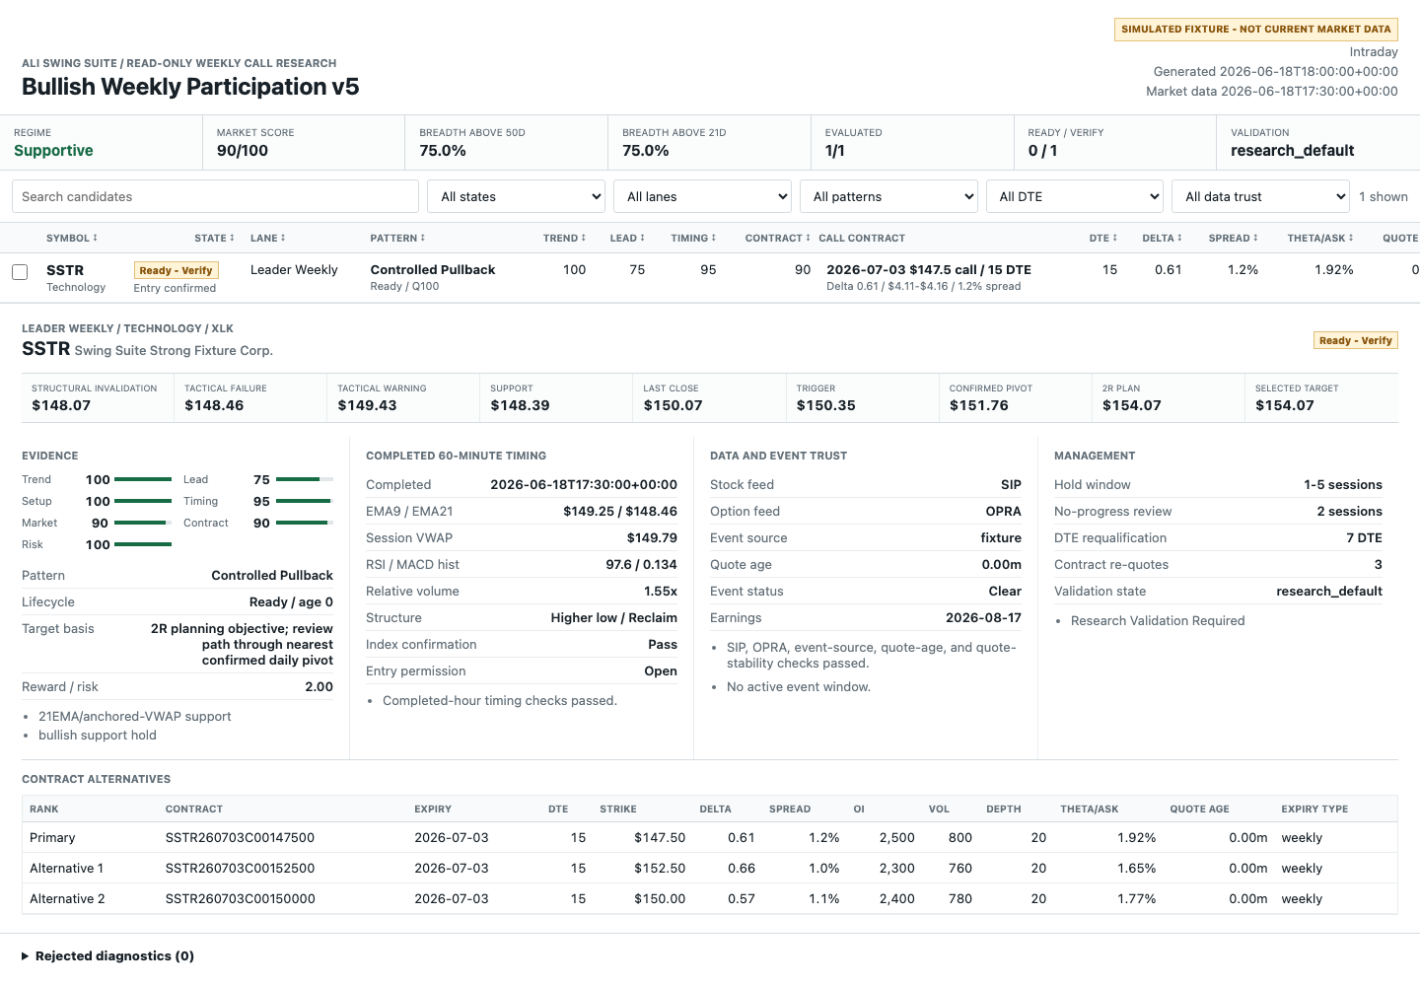
V5 dashboard desktop

14.1 Summary Bar
Review:
- scan type
- validation state
- generated time
- market-data time
- market regime
- breadth
- state counts
If the report is a fixture, it is simulated and not current market data.

14.2 Sorting
Click a column header to sort.
Useful first sorts:
- state
- total evidence
- setup
- timing
- contract
- DTE
- quote age
- theta / ask
- spread

14.3 Filters
Available filters:
- text search
- state
- lane
- pattern
- DTE range
- data trust
Recommended review sequence:
- state = Ready - Verify
- trust = trusted
- lane
- pattern
- DTE
- quote age

14.4 Candidate Comparison
Select up to three candidates.
Compare:
- pattern lifecycle
- distance to trigger
- extension
- timing score
- event window
- contract DTE/delta
- spread
- depth
- theta / ask
- confirmed pivot path
The comparison tool is for evidence review, not position allocation.

14.5 Candidate Detail
Each detail pane contains:
- doctrine and state reason
- market and trend evidence
- hourly timing
- event source
- data trust
- primary contract
- alternatives
- tactical and structural levels
- rejection or verification diagnostics

14.6 Contract Alternatives
Alternatives are not automatically interchangeable.
Review why the primary ranked first:
- weekly/monthly preference
- DTE
- delta
- spread
- depth
- theta
- volatility
- quote stability

14.7 Rejection Diagnostics
Every rejected record includes:
- symbol
- stage
- reason codes
- supporting details
Stages:
- universe or data quality
- technical
- event
- contract
Use reason codes to fix data or understand qualification. Do not weaken a hard gate just to increase candidate count.

15. Pine v6 Installation
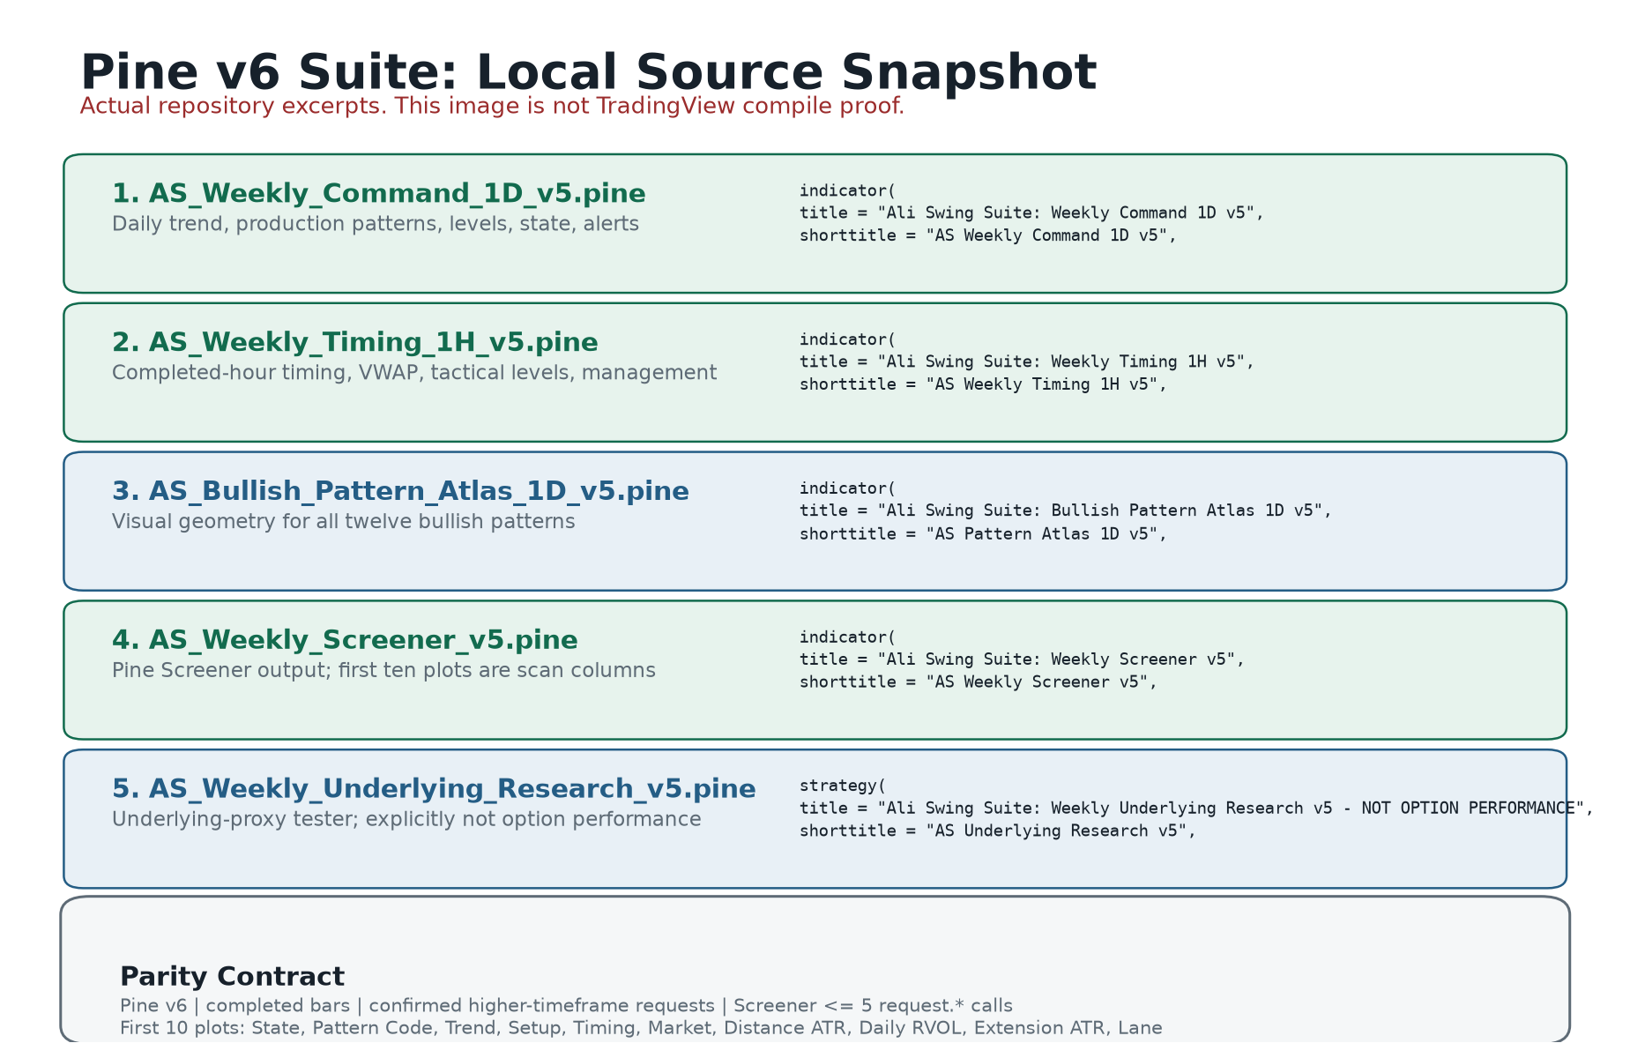
V5 Pine suite
TradingView documents Pine Screener behavior and limits in Pine Screener requirements.

15.1 Daily Command
File:
AS_Weekly_Command_1D_v5.pine
Installation:
- Open TradingView Pine Editor.
- Create a new indicator.
- Replace the editor contents with the script.
- Save.
- Add to chart.
- Set the chart to one day.
- Confirm the table shows Research default.
- Confirm the state never displays a validated Ready while the profile is research default.
Review:
- EMA21, SMA50, SMA200
- selected production pattern
- trigger
- structural invalidation
- confirmed pivot
- 2R objective
- market and leadership

15.2 Hourly Timing
File:
AS_Weekly_Timing_1H_v5.pine
Installation:
- Add the script to the same symbol.
- Set chart to 60 minutes.
- Confirm EMA9, EMA21, and VWAP.
- Confirm the timing table recognizes the timeframe.
- Confirm entry timing appears only inside the entry window.
- Confirm the final scheduled hour is management-only.

15.3 Pattern Atlas
File:
AS_Bullish_Pattern_Atlas_1D_v5.pine
Use:
- study all twelve patterns
- distinguish green production labels from context labels
- inspect selected trigger and invalidation
- compare chart geometry with the Python report
The atlas does not promote context patterns.

15.4 Pine Screener
File:
AS_Weekly_Screener_v5.pine
First ten columns:
- State
- Pattern Code
- Trend
- Setup
- Timing
- Market
- Distance ATR
- Daily Relative Volume
- Extension ATR
- Lane
Pattern codes:
Code | Pattern
0 | no production setup
1 | controlled pullback
2 | confirmed breakout
3 | bull flag
4 | breakout retest
5 | flat base
6 | VCP / tight base
7 | ascending triangle
Lane codes:
Code | Lane
1 | Index Weekly
2 | Leader Weekly
TradingView uses the first ten plots as Screener columns and permits no more than five request.* calls in the scanned script. The v5 script is designed around those limits.

15.5 Underlying Research Tester
File:
AS_Weekly_Underlying_Research_v5.pine
The tester is labeled:
NOT OPTION PERFORMANCE
It does not model:
- option bid/ask
- theta
- gamma
- implied volatility
- contract selection
- assignment or exercise
Use it only to inspect underlying signal behavior.

16. Alerts

16.1 Daily Alerts
Available:
- setup ready for verification
- daily trigger confirmed
- structural invalidation
- extension warning
Alert rule:
- once per bar close

16.2 Hourly Alerts
Available:
- completed-hour entry confirmation
- tactical warning
- tactical failure
- management-only window
Alert rule:
- once per bar close

16.3 Atlas Alerts
Available:
- production pattern ready
- context-only pattern observed
The context alert is educational and not a production entry alert.

16.4 Screener Alert
Available:
- technical finalist
The alert message explicitly requires live event, feed, and contract verification.

16.5 Alert QA
Before relying on an alert:
- confirm chart timeframe
- confirm script version
- confirm once-per-bar-close setting
- confirm symbol
- confirm exchange
- confirm timezone
- compare with Python report
- test on SPY, QQQ, and a representative leader

17. Worked Research Examples
All examples are hypothetical and do not imply expected results.

17.1 Index Controlled Pullback
Situation:
- SPY above rising SMA200
- weekly alignment positive
- pullback holds EMA21
- price 0.18 ATR below trigger
- hourly EMA9 above EMA21
- hourly close above VWAP
- no active CPI, Employment Situation, or FOMC window
Contract research:
- 13 DTE
- 0.67 delta
- 2.2% spread
- OI 8,000
- volume 1,400
- displayed depth 30
- theta / ask 3.8%
- OPRA quote age 0.4 minutes
Classification:
Ready - Verify
Why not Ready:
validation_state = research_default

17.2 Leader Bull Flag
Situation:
- liquid leader above SMA200
- 20-session average dollar volume above minimum
- strong flagpole
- 35% retracement
- declining flag volume
- price 0.22 ATR below flag trigger
- earnings 20 trading sessions away
- hourly reclaim above EMA9 and VWAP
Contract research:
- best weekly: 18 DTE, 0.62 delta
- standard monthly: 16 DTE, similar delta
- monthly liquidity only 10% stronger
Selection:
- weekly remains primary because the monthly advantage is below 25%

17.3 Rejected Leader Near Earnings
Situation:
- daily pattern and hourly timing both pass
- earnings in four trading sessions
- lane maximum hold is five sessions
- event buffer is two sessions
Result:
- event blocked
- no option chain fetched
- rejection stage = event
This is intentional. A high-quality chart does not override the event protection.

17.4 Verify Contract From Indicative Data
Situation:
- chart and event gates pass
- option feed is indicative
Result:
Verify Contract
Required action:
- inspect a current OPRA chain or another trustworthy live source
The indicative quote cannot produce full contract trust.

17.5 2R Objective With Pivot In The Path
Situation:
- trigger = 100
- structural invalidation = 97
- 2R objective = 106
- nearest confirmed pivot = 103
The pivot offers only 1R of room, so it is not adopted as the main target. The report shows:
- confirmed pivot = 103
- 2R planning objective = 106
- target basis = path review through confirmed pivot
The objective is not labeled resistance.

18. Historical Research Standard

18.1 Point-In-Time Requirement
Historical contracts must have existed at the signal date. Historical quotes must be timestamped.
Entry quote:
quote timestamp >= completed hourly trigger timestamp
Pre-trigger quotes are prohibited.

18.2 Underlying Sequencing
Use minute-level underlying bars to determine:
- trigger first
- invalidation first
- same-minute ambiguity
Same-minute trigger and invalidation are handled pessimistically.

18.3 Fill Model
Default research fill assumptions:
- enter at ask
- exit at bid
- include commission
- reject quote age above two minutes
No unrecorded price improvement is assumed.

18.4 Session Counting
Multiple minute quotes on one date count as one trading session for:
- no-progress review
- maximum hold

18.5 Walk-Forward Folds
The process:
- sort experiments chronologically
- train on past observations only
- purge observations near the boundary
- embargo the first test interval
- choose policy from training data
- evaluate untouched held-out data

18.6 Overlap
Report:
- raw entered count
- non-overlapping adjusted count
- maximum concurrent positions
- largest pattern concentration
This prevents many simultaneous signals from being interpreted as independent evidence.

18.7 Promotion Gates
Required historical evidence:
- 150 held-out contracts per lane
- 40 per promoted pattern
- positive median in at least 60% of folds
- improvement over frozen baseline
- acceptable drawdown
- acceptable concentration
- neighboring-parameter stability
- pessimistic-fill resilience
Required forward evidence:
- 45 calendar days
- 50 new eligible shadow opportunities
Passing creates:
eligible_for_promotion_review
It does not change the strategy automatically.

19. Daily Operating Checklists

19.1 Premarket
- [ ] Confirm market calendar and session status
- [ ] Review FOMC, CPI, and Employment Situation schedule
- [ ] Review leader earnings calendar
- [ ] Confirm SIP entitlement
- [ ] Confirm OPRA entitlement
- [ ] Confirm Massive entitlement when used
- [ ] Review prior Ready - Verify candidates
- [ ] Remove candidates with event or structural changes
- [ ] Confirm report timestamps

19.2 Daily Chart
- [ ] Close above SMA200
- [ ] Weekly alignment positive
- [ ] Market not hostile
- [ ] Leader universe minimums pass
- [ ] Leadership passes when required
- [ ] Production pattern selected
- [ ] Pattern ready or freshly confirmed
- [ ] Distance no more than 0.30 ATR when ready
- [ ] Extension no more than 0.75 ATR when confirmed
- [ ] Confirmed age no more than one daily bar
- [ ] Structural invalidation visible
- [ ] Confirmed pivot visible
- [ ] 2R objective visible

19.3 Hourly Timing
- [ ] Completed 60-minute bar
- [ ] Time between 10:30 AM and 2:45 PM ET
- [ ] Price above EMA9
- [ ] EMA9 above EMA21
- [ ] Price above session VWAP
- [ ] RSI at or above 50
- [ ] MACD histogram positive
- [ ] Relative volume acceptable
- [ ] Higher low or reclaim present
- [ ] SPY/QQQ intraday confirmation
- [ ] Tactical warning visible
- [ ] Tactical failure visible

19.4 Event
- [ ] Event status known
- [ ] Source timestamp present
- [ ] Source age no more than 24 hours
- [ ] Leader earnings outside protected horizon
- [ ] Index macro window clear

19.5 Contract
- [ ] DTE inside hard range
- [ ] DTE outside 0-6 exclusion
- [ ] Delta inside hard range
- [ ] Spread inside lane maximum
- [ ] OI at or above minimum
- [ ] Volume at or above minimum
- [ ] Bid and ask size at or above minimum
- [ ] Theta / ask inside lane maximum
- [ ] Quote age no more than two minutes
- [ ] OPRA feed
- [ ] Re-quote stable
- [ ] Weekly/monthly preference reviewed
- [ ] Alternatives reviewed

19.6 Management
- [ ] Tactical warning status
- [ ] Tactical failure status
- [ ] Structural invalidation status
- [ ] Sessions held
- [ ] Progress after two sessions
- [ ] DTE boundary
- [ ] Earnings or macro update
- [ ] Current spread and depth
- [ ] Full premium loss remains possible

19.7 Post Close
- [ ] No incomplete daily bar used
- [ ] Pattern lifecycle updated
- [ ] Stale confirmations removed
- [ ] Structural levels updated
- [ ] Event calendar refreshed
- [ ] Research ledger written
- [ ] Rejection reasons reviewed
- [ ] Next-session watchlist prepared

20. Troubleshooting

20.1 No Candidates
Check:
- market regime
- incomplete candles
- entry window
- leader liquidity minimums
- production pattern list
- event source freshness
- option entitlement
Do not weaken thresholds solely to produce candidates.

20.2 Every Leader Is Event-Rejected
Likely causes:
- MASSIVE_API_KEY missing
- entitlement unavailable
- configured fallback is unknown
- source timestamp missing
- source older than 24 hours
Expected behavior:
- fail closed
- no chain fetch

20.3 Every Contract Is Verify Contract
Check:
- ALPACA_OPTION_FEED=opra
- OPRA subscription
- quote timestamps
- bid/ask size
- re-quote stability
- spread
- theta availability

20.4 Stock Feed Not Trusted
Check:
ALPACA_FEED=sip
Alpaca may reject recent SIP requests without the required subscription.

20.5 Quote Stale
Check:
- system clock
- provider timestamp parsing
- API response timestamp
- scan delay
- network retries
The maximum is two minutes.

20.6 Timing Is Management-Only
Expected causes:
- scan before 10:30 AM ET
- scan after 2:45 PM ET
- post-close or premarket command
- final 3:35 PM scan

20.7 Pattern Shows In Atlas But Not Screener
The pattern may be context-only:
- cup with handle
- double bottom
- inverse head and shoulders
- falling wedge
- rounding base
This is intentional.

20.8 Pine Screener Missing Columns
Check:
- correct script favorited
- correct v5 Screener script selected
- first ten plots unchanged
- script compiled
- supported timeframe
TradingView exposes only plots from the selected indicator.

20.9 Pine Screener Request Error
The scanned script must use no more than five request.* calls. The v5 Screener uses five.

20.10 Dashboard Layout Problem
Check the generated file in:
reports/intraday/latest.html
Review:
- browser zoom at 100%
- desktop, tablet, and mobile widths
- print preview
- long rejection strings
- long contract symbols

20.11 Research Sample Says Validated
The maturity label describes sample count only.
It does not mean:
- profitable
- promoted
- production-ready
- suitable for a specific user
Promotion requires every historical and shadow gate.

21. Technical Commands

Run Tests
python -m pytest

Run Ruff
python -m ruff check scanner tests scripts

Run Mypy
python -m mypy scanner

Validate Pine Parity
python scripts/check_pine_parity.py

Run Release Audit
python scripts/release_audit.py

Run Fixture Intraday Scan
python -m scanner.run_scan intraday --fixture --scenario ready

Run Fixture Post-Close Scan
python -m scanner.run_scan post_close --fixture

Open Dashboard
open reports/intraday/latest.html

22. Glossary
ATR: Average True Range, used to normalize distance and extension.
Confirmed pivot: Verified daily swing high used as real structure.
Context-only pattern: Visible for research but unable to qualify production.
Delta: Estimated option-price sensitivity to a one-unit underlying move.
DTE: Calendar days to expiration.
Extrinsic value: Option premium above intrinsic value.
Gamma: Estimated rate of change of delta.
Management-only: Scan state that cannot authorize a new entry.
OPRA: Consolidated U.S. listed-options quote feed.
Production pattern: Pattern eligible to contribute to candidate qualification.
Research default: Validation state that caps candidates at Ready - Verify.
SIP: Consolidated U.S. equity market feed.
Structural invalidation: Daily level that fails the underlying thesis.
Tactical failure: Hourly level that fails timing without redefining daily geometry.
Tactical warning: Hourly level that calls for reassessment.
Theta / ask: Absolute daily theta divided by current ask.
VCP: Volatility contraction pattern.
VWAP: Volume-weighted average price for the current session.

23. Official References
Options:
- OCC Characteristics and Risks of Standardized Options
- OIC Theta
- OIC Gamma
Market data:
- Alpaca Historical Stock Data
- Alpaca Historical Option Data
- Alpaca Latest Option Quotes
- Alpaca Option Chain
Events:
- Massive Partners API
- Federal Reserve FOMC Calendars
- U.S. BLS Release Calendar
Pine:
- TradingView Pine Screener Requirements

24. Final Operating Principle
The purpose of V5 is not to produce more signals. It is to produce a smaller number of well-documented research candidates whose daily thesis, hourly timing, event status, contract quality, and data provenance can be inspected independently.
When evidence is incomplete, the correct system behavior is to wait, verify, or reject.

