COVID-19 IMPACT & RECOVERY ANALYTICS
Data Cleaning, Statistical Analysis, Power BI Dashboard & Insights
Prepared for project submission

Dataset period: 22 January 2020 – 27 July 2020 | 187 countries

1. Requirements & Direct Answers
The report follows the supplied COVID-19 Data Analysis Report Requirements. The requirements ask for overall statistics for Active, Confirmed, Deaths and Recovered, then country-level values and identification of countries above the overall average. The supplied note states that “above average” and “overactive” are the same condition unless a separate threshold is provided.
ID | Requirement | Implemented / Answer | Output
R1 | Calculate Total, Average, Maximum for Active, Confirmed, Deaths, Recovered | Calculated from country_wise_latest (187 countries). | Statistics sheet
R2 | Display Active cases for every country | Full 187-country table included. | Country Results sheet
R3 | Identify Active countries above overall average | 24 countries above average. | Above Average sheet
R4 | Highlight overactive countries if threshold exists | No separate threshold provided; per requirement note, above average = overactive. | Above Average sheet
R5 | Display Confirmed cases for every country | Full 187-country table included. | Country Results sheet
R6 | Identify Confirmed countries above overall average | 25 countries above average. | Above Average sheet
R7 | Display Deaths for every country | Full 187-country table included. | Country Results sheet
R8 | Identify Deaths above overall average | 26 countries above average. | Above Average sheet
R9 | Display Recovered cases for every country | Full 187-country table included. | Country Results sheet
R10 | Identify Recovered above overall average | 28 countries above average. | Above Average sheet
R11 | Present results in clear organized tables | Requirements matrix, statistics, country results, above-average tables and dashboard screenshots prepared. | All sheets / report

2. Data Preparation & Cleaning
The analysis was performed on the provided workbook using Python/Pandas. The three supplied sheets were inspected before analysis. The country_wise_latest sheet was used for the required country-level snapshot statistics, while full_grouped was used for daily trend analysis and the Power BI-ready model.
Sheet | Rows | Columns | Missing Cells | Duplicates | Purpose / Note
country_wise_latest | 187 | 15 | 0 | 0 | 187-country latest snapshot; used for overall/country-level requirements
clean_complete | 49,068 | 10 | 34,404 | 0 | Province/State detail; missing location detail retained where source was blank
full_grouped | 35,156 | 10 | 0 | 0 | Daily country-level series from 2020-01-22 to 2020-07-27; used for time analysis

Cleaning validation
- country_wise_latest contains 187 country records with no missing cells and no duplicate rows.
- full_grouped contains 35,156 daily country records covering 2020-01-22 to 2020-07-27, with 187 countries.
- clean_complete contains 49,068 rows; 34,404 missing cells are concentrated in the Province/State detail field in the supplied source.
- Active was validated using Confirmed − Deaths − Recovered; 0 mismatches were found.
- Source revision values were retained: 2 negative Active values, 38 negative New deaths values, and 77 negative New recovered values occur in the source.

3. Part 1 — Overall Statistical Analysis
The required statistics are calculated across the 187-country latest snapshot. Average values represent the mean across countries.
Metric | Total | Average | Maximum | Above Average Countries
Active | 6,358,362 | 34,001.94 | 2,816,444 | 24
Confirmed | 16,480,485 | 88,130.94 | 4,290,259 | 25
Deaths | 654,036 | 3,497.52 | 148,011 | 26
Recovered | 9,468,087 | 50,631.48 | 1,846,641 | 28

Direct answers
Active: Total = 6,358,362; Average = 34,001.94; Maximum = 2,816,444. 24 countries are above the overall average.
Confirmed: Total = 16,480,485; Average = 88,130.94; Maximum = 4,290,259. 25 countries are above the overall average.
Deaths: Total = 654,036; Average = 3,497.52; Maximum = 148,011. 26 countries are above the overall average.
Recovered: Total = 9,468,087; Average = 50,631.48; Maximum = 1,846,641. 28 countries are above the overall average.

4. Part 2 — Country-Level Analysis
For each required category, every country is included in the accompanying workbook. The tables below show the countries above the overall average, sorted from highest to lowest.

4.1 Active Cases
Overall average: 34,001.94. Countries above average: 24.
Country | Value | WHO Region
US | 2,816,444 | Americas
Brazil | 508,116 | Americas
India | 495,499 | South-East Asia
United Kingdom | 254,427 | Europe
Russia | 201,097 | Europe
South Africa | 170,537 | Africa
Colombia | 117,163 | Americas
France | 108,928 | Europe
Canada | 107,514 | Americas
Peru | 98,752 | Americas
Bangladesh | 97,577 | South-East Asia
Spain | 93,613 | Europe
Argentina | 91,782 | Americas
Sweden | 73,695 | Europe
Philippines | 53,649 | Western Pacific
Egypt | 52,992 | Eastern Mediterranean
Mexico | 47,657 | Americas
Netherlands | 47,064 | Europe
Bolivia | 47,056 | Americas
Saudi Arabia | 43,238 | Eastern Mediterranean
Ecuador | 40,733 | Americas
Belgium | 39,154 | Europe
Indonesia | 37,292 | South-East Asia
Israel | 36,378 | Europe

4.2 Confirmed Cases
Overall average: 88,130.94. Countries above average: 25.
Country | Value | WHO Region
US | 4,290,259 | Americas
Brazil | 2,442,375 | Americas
India | 1,480,073 | South-East Asia
Russia | 816,680 | Europe
South Africa | 452,529 | Africa
Mexico | 395,489 | Americas
Peru | 389,717 | Americas
Chile | 347,923 | Americas
United Kingdom | 301,708 | Europe
Iran | 293,606 | Eastern Mediterranean
Pakistan | 274,289 | Eastern Mediterranean
Spain | 272,421 | Europe
Saudi Arabia | 268,934 | Eastern Mediterranean
Colombia | 257,101 | Americas
Italy | 246,286 | Europe
Turkey | 227,019 | Europe
Bangladesh | 226,225 | South-East Asia
France | 220,352 | Europe
Germany | 207,112 | Europe
Argentina | 167,416 | Americas
Canada | 116,458 | Americas
Iraq | 112,585 | Eastern Mediterranean
Qatar | 109,597 | Eastern Mediterranean
Indonesia | 100,303 | South-East Asia
Egypt | 92,482 | Eastern Mediterranean

4.3 Deaths Cases
Overall average: 3,497.52. Countries above average: 26.
Country | Value | WHO Region
US | 148,011 | Americas
Brazil | 87,618 | Americas
United Kingdom | 45,844 | Europe
Mexico | 44,022 | Americas
Italy | 35,112 | Europe
India | 33,408 | South-East Asia
France | 30,212 | Europe
Spain | 28,432 | Europe
Peru | 18,418 | Americas
Iran | 15,912 | Eastern Mediterranean
Russia | 13,334 | Europe
Belgium | 9,822 | Europe
Chile | 9,187 | Americas
Germany | 9,125 | Europe
Canada | 8,944 | Americas
Colombia | 8,777 | Americas
South Africa | 7,067 | Africa
Netherlands | 6,160 | Europe
Pakistan | 5,842 | Eastern Mediterranean
Sweden | 5,700 | Europe
Turkey | 5,630 | Europe
Ecuador | 5,532 | Americas
Indonesia | 4,838 | South-East Asia
China | 4,656 | Western Pacific
Egypt | 4,652 | Eastern Mediterranean
Iraq | 4,458 | Eastern Mediterranean

4.4 Recovered Cases
Overall average: 50,631.48. Countries above average: 28.
Country | Value | WHO Region
Brazil | 1,846,641 | Americas
US | 1,325,804 | Americas
India | 951,166 | South-East Asia
Russia | 602,249 | Europe
Chile | 319,954 | Americas
Mexico | 303,810 | Americas
South Africa | 274,925 | Africa
Peru | 272,547 | Americas
Iran | 255,144 | Eastern Mediterranean
Pakistan | 241,026 | Eastern Mediterranean
Saudi Arabia | 222,936 | Eastern Mediterranean
Turkey | 210,469 | Europe
Italy | 198,593 | Europe
Germany | 190,314 | Europe
Spain | 150,376 | Europe
Colombia | 131,161 | Americas
Bangladesh | 125,683 | South-East Asia
Qatar | 106,328 | Eastern Mediterranean
France | 81,212 | Europe
China | 78,869 | Western Pacific
Iraq | 77,144 | Eastern Mediterranean
Argentina | 72,575 | Americas
Belarus | 60,492 | Europe
Indonesia | 58,173 | South-East Asia
Oman | 57,028 | Eastern Mediterranean
Kuwait | 55,057 | Eastern Mediterranean
Kazakhstan | 54,404 | Europe
United Arab Emirates | 52,510 | Eastern Mediterranean

5. Statistical Interpretation
The overall totals show a large global burden by the end of the observed snapshot. Confirmed cases reached 16.48 million, while recoveries reached 9.47 million. Deaths reached 654,036 and active cases were 6.36 million.
The largest confirmed-case concentration was in the Americas, with 8,839,286 confirmed cases, representing 53.63% of the country-level confirmed total.
The highest daily new-case total occurred on 2020-07-23, with 282,756 new cases. The highest daily death total also occurred on 2020-07-23, with 9,966 deaths. The highest daily recovered total occurred on 2020-07-02, with 284,394 recoveries.

Confirmed Cases by WHO Region
WHO Region | Confirmed | Share of Confirmed
Americas | 8,839,286 | 53.63
Europe | 3,299,523 | 20.02
South-East Asia | 1,835,297 | 11.14
Eastern Mediterranean | 1,490,744 | 9.05
Africa | 723,207 | 4.39
Western Pacific | 292,428 | 1.77

6. Dashboard & Visual Analysis
The Power BI report translates the statistical analysis into two pages: Executive Overview and Insights. The dashboard uses KPI cards, a daily-case trend with a 7-day moving average, a dynamic Top 10 country chart, a cumulative trend, a global map, metric selectors and a date-range slicer.
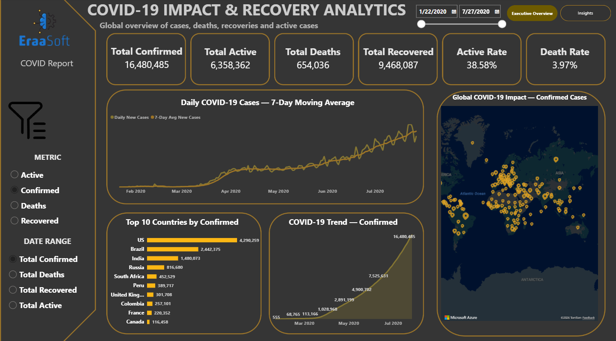
Figure 1. Executive Overview dashboard.

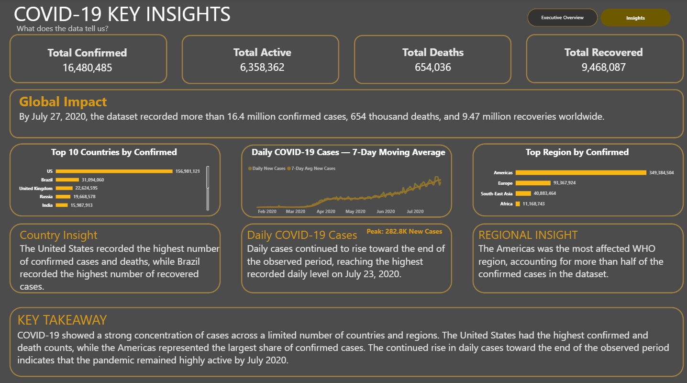
Figure 2. Insights dashboard with statistical interpretation and regional analysis.

7. Key Findings
- The United States had the highest confirmed count in the latest snapshot: 4,290,259.
- Brazil had the highest recovered count: 1,846,641.
- The United States also had the highest death count: 148,011.
- The Americas represented 53.63% of confirmed cases in the country-level snapshot.
- Daily new cases peaked at 282,756 on 2020-07-23.
- The number of countries above average was 24 for Active, 25 for Confirmed, 26 for Deaths and 28 for Recovered.

8. Analyst Recommendations
- Prioritize monitoring and resource planning around countries and regions with confirmed, active and death counts substantially above the overall country average.
- Use daily new cases together with a 7-day moving average for operational monitoring because daily values can fluctuate while the moving average makes the underlying direction easier to interpret.
- Maintain separate reporting logic for cumulative metrics and daily metrics: cumulative measures should use the latest snapshot within a selected period, while daily deltas can be summed across the selected period.
- Use country and WHO-region segmentation as a standard drill-down so decision makers can move from the global picture to the locations contributing most to the burden.
- For future iterations, automate the refresh pipeline from source ingestion through Python cleaning and Power BI refresh so the analysis can be repeated with newer snapshots.
- Because this dataset covers January–July 2020, recommendations are analytical and historical rather than statements about the current COVID-19 situation.

9. Methodology & Power BI Logic
- Python/Pandas was used to inspect, validate and prepare the supplied workbook.
- The latest country snapshot was used for the required overall and country-level statistics.
- The daily full_grouped table was used for time-trend analysis.
- Power BI uses a DateTable related one-to-many to FactCOVID.
- Cumulative KPI measures use the latest date within the selected range to avoid double-counting historical cumulative values.
- Daily New Cases, New Deaths and New Recovered are treated as daily delta metrics.
- Field Parameters provide dynamic metric selection for the dashboard visuals.

10. Appendix — Full Country-Level Results
The following table contains the four required country-level measures for all 187 countries. This appendix satisfies the requirement to present the number of Active, Confirmed, Deaths and Recovered cases for every country.

Country | Active | Confirmed | Deaths | Recovered | WHO Region
Afghanistan | 9,796 | 36,263 | 1,269 | 25,198 | Eastern Mediterranean
Albania | 1,991 | 4,880 | 144 | 2,745 | Europe
Algeria | 7,973 | 27,973 | 1,163 | 18,837 | Africa
Andorra | 52 | 907 | 52 | 803 | Europe
Angola | 667 | 950 | 41 | 242 | Africa
Antigua and Barbuda | 18 | 86 | 3 | 65 | Americas
Argentina | 91,782 | 167,416 | 3,059 | 72,575 | Americas
Armenia | 10,014 | 37,390 | 711 | 26,665 | Europe
Australia | 5,825 | 15,303 | 167 | 9,311 | Western Pacific
Austria | 1,599 | 20,558 | 713 | 18,246 | Europe
Azerbaijan | 6,781 | 30,446 | 423 | 23,242 | Europe
Bahamas | 280 | 382 | 11 | 91 | Americas
Bahrain | 3,231 | 39,482 | 141 | 36,110 | Eastern Mediterranean
Bangladesh | 97,577 | 226,225 | 2,965 | 125,683 | South-East Asia
Barbados | 9 | 110 | 7 | 94 | Americas
Belarus | 6,221 | 67,251 | 538 | 60,492 | Europe
Belgium | 39,154 | 66,428 | 9,822 | 17,452 | Europe
Belize | 20 | 48 | 2 | 26 | Americas
Benin | 699 | 1,770 | 35 | 1,036 | Africa
Bhutan | 13 | 99 | 0 | 86 | South-East Asia
Bolivia | 47,056 | 71,181 | 2,647 | 21,478 | Americas
Bosnia and Herzegovina | 5,274 | 10,498 | 294 | 4,930 | Europe
Botswana | 674 | 739 | 2 | 63 | Africa
Brazil | 508,116 | 2,442,375 | 87,618 | 1,846,641 | Americas
Brunei | 0 | 141 | 3 | 138 | Western Pacific
Bulgaria | 4,689 | 10,621 | 347 | 5,585 | Europe
Burkina Faso | 121 | 1,100 | 53 | 926 | Africa
Burma | 52 | 350 | 6 | 292 | South-East Asia
Burundi | 76 | 378 | 1 | 301 | Africa
Cabo Verde | 756 | 2,328 | 22 | 1,550 | Africa
Cambodia | 79 | 226 | 0 | 147 | Western Pacific
Cameroon | 2,180 | 17,110 | 391 | 14,539 | Africa
Canada | 107,514 | 116,458 | 8,944 | 0 | Americas
Central African Republic | 2,994 | 4,599 | 59 | 1,546 | Africa
Chad | 37 | 922 | 75 | 810 | Africa
Chile | 18,782 | 347,923 | 9,187 | 319,954 | Americas
China | 3,258 | 86,783 | 4,656 | 78,869 | Western Pacific
Colombia | 117,163 | 257,101 | 8,777 | 131,161 | Americas
Comoros | 19 | 354 | 7 | 328 | Africa
Congo (Brazzaville) | 2,317 | 3,200 | 54 | 829 | Africa
Congo (Kinshasa) | 2,936 | 8,844 | 208 | 5,700 | Africa
Costa Rica | 11,902 | 15,841 | 115 | 3,824 | Americas
Cote d'Ivoire | 5,198 | 15,655 | 96 | 10,361 | Africa
Croatia | 806 | 4,881 | 139 | 3,936 | Europe
Cuba | 94 | 2,532 | 87 | 2,351 | Americas
Cyprus | 189 | 1,060 | 19 | 852 | Europe
Czechia | 3,715 | 15,516 | 373 | 11,428 | Europe
Denmark | 543 | 13,761 | 613 | 12,605 | Europe
Djibouti | 24 | 5,059 | 58 | 4,977 | Eastern Mediterranean
Dominica | 0 | 18 | 0 | 18 | Americas
Dominican Republic | 32,869 | 64,156 | 1,083 | 30,204 | Americas
Ecuador | 40,733 | 81,161 | 5,532 | 34,896 | Americas
Egypt | 52,992 | 92,482 | 4,652 | 34,838 | Eastern Mediterranean
El Salvador | 6,849 | 15,035 | 408 | 7,778 | Americas
Equatorial Guinea | 2,178 | 3,071 | 51 | 842 | Africa
Eritrea | 74 | 265 | 0 | 191 | Africa
Estonia | 42 | 2,034 | 69 | 1,923 | Europe
Eswatini | 1,257 | 2,316 | 34 | 1,025 | Africa
Ethiopia | 7,933 | 14,547 | 228 | 6,386 | Africa
Fiji | 9 | 27 | 0 | 18 | Western Pacific
Finland | 149 | 7,398 | 329 | 6,920 | Europe
France | 108,928 | 220,352 | 30,212 | 81,212 | Europe
Gabon | 2,458 | 7,189 | 49 | 4,682 | Africa
Gambia | 252 | 326 | 8 | 66 | Africa
Georgia | 199 | 1,137 | 16 | 922 | Europe
Germany | 7,673 | 207,112 | 9,125 | 190,314 | Europe
Ghana | 3,655 | 33,624 | 168 | 29,801 | Africa
Greece | 2,651 | 4,227 | 202 | 1,374 | Europe
Greenland | 1 | 14 | 0 | 13 | Europe
Grenada | 0 | 23 | 0 | 23 | Americas
Guatemala | 11,093 | 45,309 | 1,761 | 32,455 | Americas
Guinea | 753 | 7,055 | 45 | 6,257 | Africa
Guinea-Bissau | 1,125 | 1,954 | 26 | 803 | Africa
Guyana | 188 | 389 | 20 | 181 | Americas
Haiti | 2,817 | 7,340 | 158 | 4,365 | Americas
Holy See | 0 | 12 | 0 | 12 | Europe
Honduras | 33,536 | 39,741 | 1,166 | 5,039 | Americas
Hungary | 523 | 4,448 | 596 | 3,329 | Europe
Iceland | 21 | 1,854 | 10 | 1,823 | Europe
India | 495,499 | 1,480,073 | 33,408 | 951,166 | South-East Asia
Indonesia | 37,292 | 100,303 | 4,838 | 58,173 | South-East Asia
Iran | 22,550 | 293,606 | 15,912 | 255,144 | Eastern Mediterranean
Iraq | 30,983 | 112,585 | 4,458 | 77,144 | Eastern Mediterranean
Ireland | 764 | 25,892 | 1,764 | 23,364 | Europe
Israel | 36,378 | 63,985 | 474 | 27,133 | Europe
Italy | 12,581 | 246,286 | 35,112 | 198,593 | Europe
Jamaica | 129 | 853 | 10 | 714 | Americas
Japan | 8,174 | 31,142 | 998 | 21,970 | Western Pacific
Jordan | 124 | 1,176 | 11 | 1,041 | Eastern Mediterranean
Kazakhstan | 29,659 | 84,648 | 585 | 54,404 | Europe
Kenya | 9,857 | 17,975 | 285 | 7,833 | Africa
Kosovo | 3,201 | 7,413 | 185 | 4,027 | Europe
Kuwait | 8,884 | 64,379 | 438 | 55,057 | Eastern Mediterranean
Kyrgyzstan | 10,790 | 33,296 | 1,301 | 21,205 | Europe
Laos | 1 | 20 | 0 | 19 | Western Pacific
Latvia | 143 | 1,219 | 31 | 1,045 | Europe
Lebanon | 2,122 | 3,882 | 51 | 1,709 | Eastern Mediterranean
Lesotho | 365 | 505 | 12 | 128 | Africa
Liberia | 449 | 1,167 | 72 | 646 | Africa
Libya | 2,186 | 2,827 | 64 | 577 | Eastern Mediterranean
Liechtenstein | 4 | 86 | 1 | 81 | Europe
Lithuania | 319 | 2,019 | 80 | 1,620 | Europe
Luxembourg | 1,384 | 6,321 | 112 | 4,825 | Europe
Madagascar | 3,339 | 9,690 | 91 | 6,260 | Africa
Malawi | 1,920 | 3,664 | 99 | 1,645 | Africa
Malaysia | 179 | 8,904 | 124 | 8,601 | Western Pacific
Maldives | 807 | 3,369 | 15 | 2,547 | South-East Asia
Mali | 476 | 2,513 | 124 | 1,913 | Africa
Malta | 27 | 701 | 9 | 665 | Europe
Mauritania | 1,399 | 6,208 | 156 | 4,653 | Africa
Mauritius | 2 | 344 | 10 | 332 | Africa
Mexico | 47,657 | 395,489 | 44,022 | 303,810 | Americas
Moldova | 6,252 | 23,154 | 748 | 16,154 | Europe
Monaco | 8 | 116 | 4 | 104 | Europe
Mongolia | 67 | 289 | 0 | 222 | Western Pacific
Montenegro | 2,039 | 2,893 | 45 | 809 | Europe
Morocco | 4,018 | 20,887 | 316 | 16,553 | Eastern Mediterranean
Mozambique | 1,690 | 1,701 | 11 | 0 | Africa
Namibia | 1,734 | 1,843 | 8 | 101 | Africa
Nepal | 4,950 | 18,752 | 48 | 13,754 | South-East Asia
Netherlands | 47,064 | 53,413 | 6,160 | 189 | Europe
New Zealand | 21 | 1,557 | 22 | 1,514 | Western Pacific
Nicaragua | 839 | 3,439 | 108 | 2,492 | Americas
Niger | 36 | 1,132 | 69 | 1,027 | Africa
Nigeria | 22,117 | 41,180 | 860 | 18,203 | Africa
North Macedonia | 4,183 | 10,213 | 466 | 5,564 | Europe
Norway | 125 | 9,132 | 255 | 8,752 | Europe
Oman | 19,637 | 77,058 | 393 | 57,028 | Eastern Mediterranean
Pakistan | 27,421 | 274,289 | 5,842 | 241,026 | Eastern Mediterranean
Panama | 25,034 | 61,442 | 1,322 | 35,086 | Americas
Papua New Guinea | 51 | 62 | 0 | 11 | Western Pacific
Paraguay | 1,600 | 4,548 | 43 | 2,905 | Americas
Peru | 98,752 | 389,717 | 18,418 | 272,547 | Americas
Philippines | 53,649 | 82,040 | 1,945 | 26,446 | Western Pacific
Poland | 8,870 | 43,402 | 1,676 | 32,856 | Europe
Portugal | 13,205 | 50,299 | 1,719 | 35,375 | Europe
Qatar | 3,104 | 109,597 | 165 | 106,328 | Eastern Mediterranean
Romania | 17,902 | 45,902 | 2,206 | 25,794 | Europe
Russia | 201,097 | 816,680 | 13,334 | 602,249 | Europe
Rwanda | 899 | 1,879 | 5 | 975 | Africa
Saint Kitts and Nevis | 2 | 17 | 0 | 15 | Americas
Saint Lucia | 2 | 24 | 0 | 22 | Americas
Saint Vincent and the Grenadines | 13 | 52 | 0 | 39 | Americas
San Marino | 0 | 699 | 42 | 657 | Europe
Sao Tome and Principe | 117 | 865 | 14 | 734 | Africa
Saudi Arabia | 43,238 | 268,934 | 2,760 | 222,936 | Eastern Mediterranean
Senegal | 3,093 | 9,764 | 194 | 6,477 | Africa
Serbia | 23,598 | 24,141 | 543 | 0 | Europe
Seychelles | 75 | 114 | 0 | 39 | Africa
Sierra Leone | 400 | 1,783 | 66 | 1,317 | Africa
Singapore | 5,119 | 50,838 | 27 | 45,692 | Western Pacific
Slovakia | 537 | 2,181 | 28 | 1,616 | Europe
Slovenia | 238 | 2,087 | 116 | 1,733 | Europe
Somalia | 1,560 | 3,196 | 93 | 1,543 | Eastern Mediterranean
South Africa | 170,537 | 452,529 | 7,067 | 274,925 | Africa
South Korea | 896 | 14,203 | 300 | 13,007 | Western Pacific
South Sudan | 1,084 | 2,305 | 46 | 1,175 | Africa
Spain | 93,613 | 272,421 | 28,432 | 150,376 | Europe
Sri Lanka | 673 | 2,805 | 11 | 2,121 | South-East Asia
Sudan | 4,765 | 11,424 | 720 | 5,939 | Eastern Mediterranean
Suriname | 534 | 1,483 | 24 | 925 | Americas
Sweden | 73,695 | 79,395 | 5,700 | 0 | Europe
Switzerland | 1,599 | 34,477 | 1,978 | 30,900 | Europe
Syria | 634 | 674 | 40 | 0 | Eastern Mediterranean
Taiwan* | 15 | 462 | 7 | 440 | Western Pacific
Tajikistan | 1,147 | 7,235 | 60 | 6,028 | Europe
Tanzania | 305 | 509 | 21 | 183 | Africa
Thailand | 128 | 3,297 | 58 | 3,111 | South-East Asia
Timor-Leste | 24 | 24 | 0 | 0 | South-East Asia
Togo | 249 | 874 | 18 | 607 | Africa
Trinidad and Tobago | 12 | 148 | 8 | 128 | Americas
Tunisia | 248 | 1,455 | 50 | 1,157 | Eastern Mediterranean
Turkey | 10,920 | 227,019 | 5,630 | 210,469 | Europe
US | 2,816,444 | 4,290,259 | 148,011 | 1,325,804 | Americas
Uganda | 140 | 1,128 | 2 | 986 | Africa
Ukraine | 28,258 | 67,096 | 1,636 | 37,202 | Europe
United Arab Emirates | 6,322 | 59,177 | 345 | 52,510 | Eastern Mediterranean
United Kingdom | 254,427 | 301,708 | 45,844 | 1,437 | Europe
Uruguay | 216 | 1,202 | 35 | 951 | Americas
Uzbekistan | 9,414 | 21,209 | 121 | 11,674 | Europe
Venezuela | 5,883 | 15,988 | 146 | 9,959 | Americas
Vietnam | 66 | 431 | 0 | 365 | Western Pacific
West Bank and Gaza | 6,791 | 10,621 | 78 | 3,752 | Eastern Mediterranean
Western Sahara | 1 | 10 | 1 | 8 | Africa
Yemen | 375 | 1,691 | 483 | 833 | Eastern Mediterranean
Zambia | 1,597 | 4,552 | 140 | 2,815 | Africa
Zimbabwe | 2,126 | 2,704 | 36 | 542 | Africa

