Global Event Management System

G.E.M.S

USER MANUAL

Contents

1.0 Document Foreword 2

# Document Foreword

This document is designed as a guide for the user to be able to navigate the Global Event Management System, or known as G.E.M.S for short. This document will provide screenshots of the relevant webpages and how the guest will navigate it.

# 2.0 Initial Webpage

To interact with the website the user of the website, referred to as the guest from henceforth, will need to navigate to the following website URL in a browser of their choice:

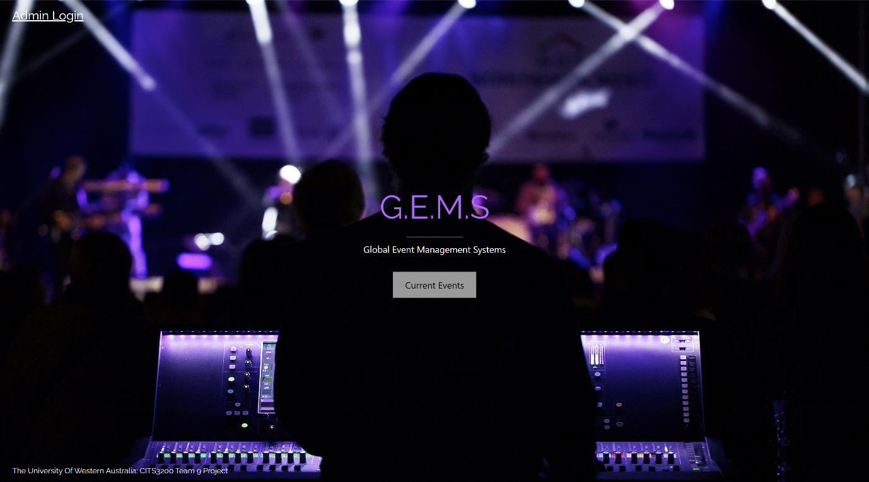Once at the URL, the user will be presented the home page (or landing page) as seen below in figure 1. From here the user can either navigate to the hyperlink “Admin Login” or the button “Current Events.” If the user clicks on the “Admin Login” link, they will be redirected to the admin login page which for further information can be seen in section 3.0. It is intended that the user will click on the Current Events button and as such has been positioned in the centre of the webpage for this exact effect. Once the user clicks on the “Current Events” they will be redirected to a webpage that

Figure 1: G.E.M.S Landing/Home page

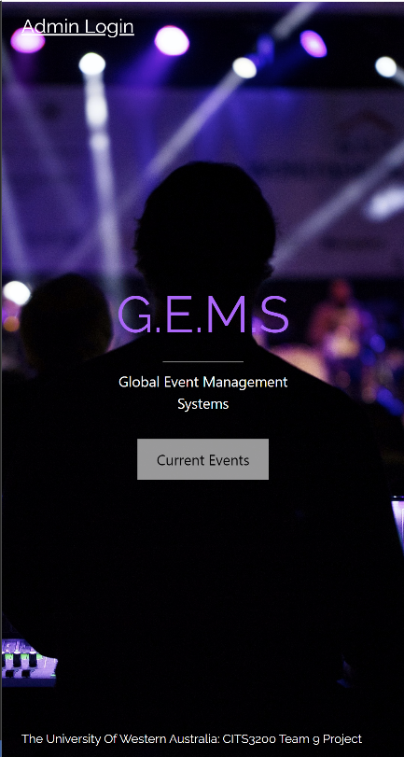Figure 2: Mobile view of G.E.M.S landing/home page

# 3.0 Admin Portal