# Result

A bidirectional, two-sample MR analysis was used to investigate the causative link between MDD levels and the risk of migraine and its subtypes. Our MR findings demonstrated a link between genetic vulnerability to MDD and an elevated risk of migraine and its subtypes; however, a link between migraine risk and MDD levels could not be established.

## Causal effects of MDD on AN

### Selection of instrumental variables

The publicly accessible MDD GWAS dataset was retrieved using the R programming language. We included 50 SNPs that were both substantially (p < 5E-08) linked with exposure (MDD) and independent (r2 < 0.001 and KB > 10,000). Some SNPs not detected in the result dataset were eliminated when utilizing these SNPs to correlate with the concluding GWAS dataset. One SNP was lost in the three MDD-migraine, MDD-MA, and MDD-MO analysis groups (rs35469634). After that, we removed two palindromic SNPs with intermediate allele frequencies from all three investigations (rs2876520 and rs4730387). It is worth noting that the OR direction of the MR-Egger transformation was inconsistent with other approaches when assessing MDD and MO; thus, we decreased P 10E-09 and repeated the MR study. Finally, 47 SNPs were identified as IVs in the MDD versus migraine and MA analysis (Supplementary Table 1), and 27 SNPs were identified as IVs in the MDD versus MO analysis (Supplementary Table S1). All F-statistics for the instrumental variables utilized in the final analysis were more extensive than 10 (MDD-Migraine and MDD-MA: mean value of 30–78, range of 39; MDD-MO: mean value of 34–78, range of 44). It was suggested that these are robust IVs and satisfy the strong correlation assumption of MR.

### Two-sample Mendelian randomization analysis

IVW was used as the primary method of analysis, which revealed a causal relationship between genetic susceptibility to MDD and increased risk of AN (OR:1.520, 95% CI:1.190-1.950, p<0.001). Secondary analysis methods included MR-Egger OR: 1.722, 95% CI:0.437-6.785, p<0.442), weighted median (OR, 1.474, 95% CI:1.122-1.936,p = 0.004), weighted mode (OR, 1.371, 95% CI:0.738-2.546,p = 0.325). The resulting OR values were all greater than 1 after transforming the relative risk ratios (Figures 2, ​,33s).

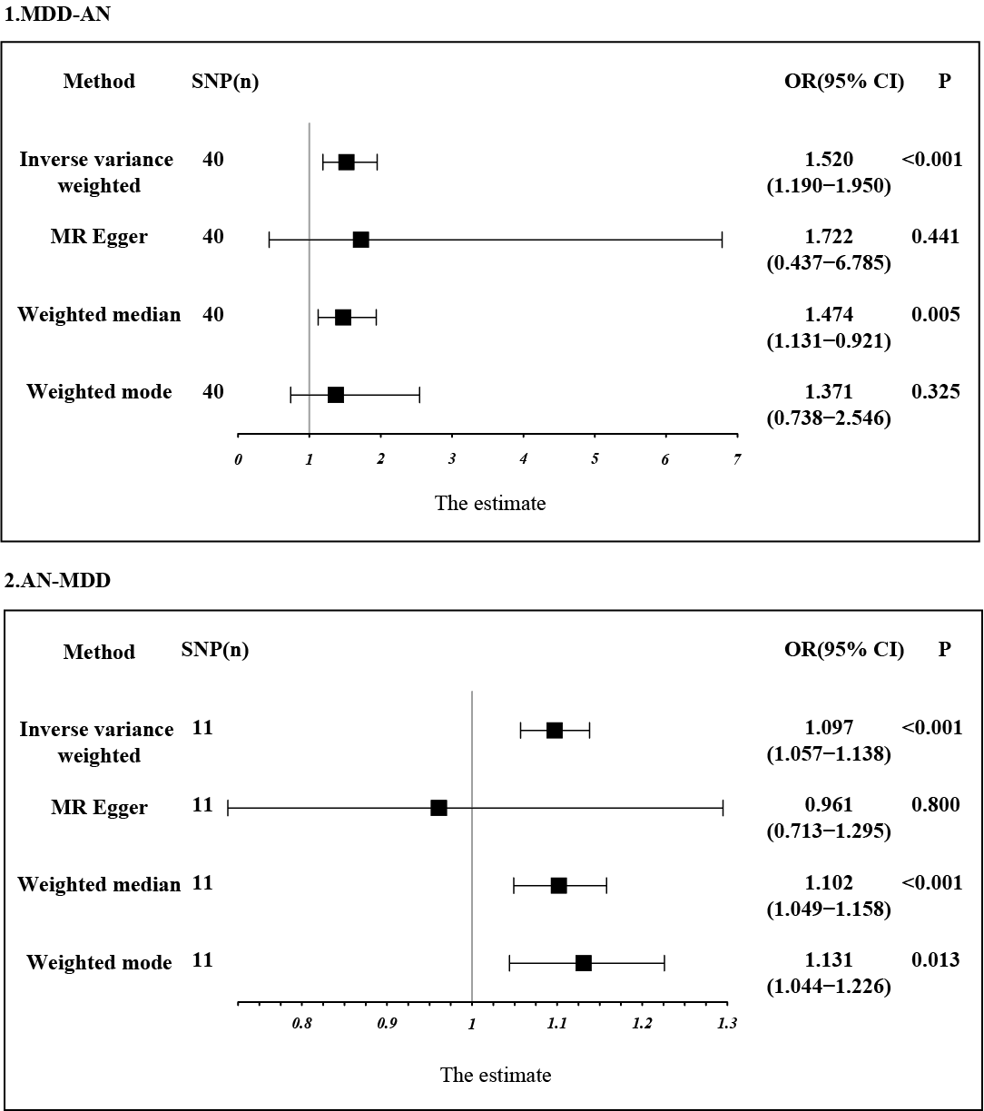

Fig2 Estimation of the causal relationship between MDD and AN using different MR methods. An OR value greater than 1 suggests that the exposure indicator is a risk factor while the opposite is a protective factor.

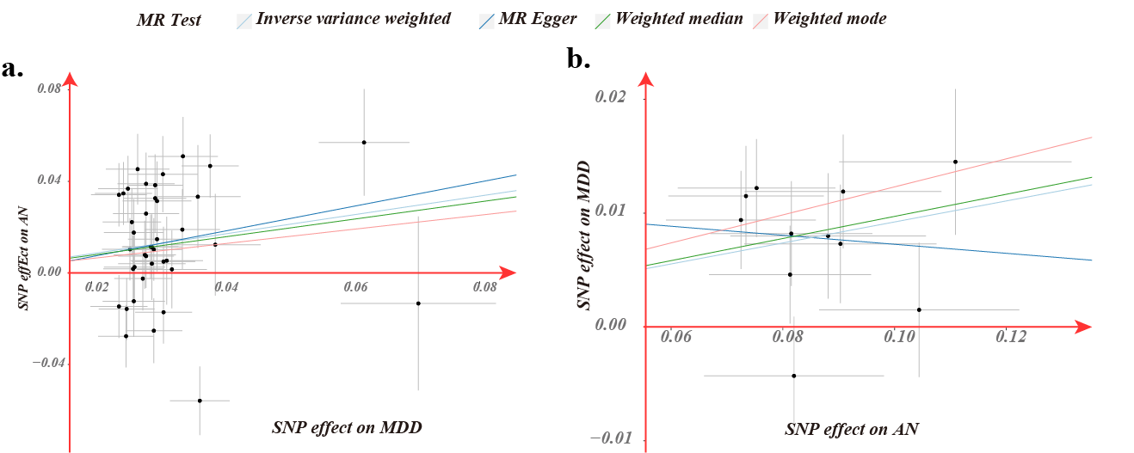

Fig3 Scatter plot of genetic correlation between MDD and migraine by different MR analysis methods.

### Sensitivity analysis and visualization

MR-Egger regression and IVW analyses were used to detect heterogeneity.MR-Egger regression (MDD-migraine: Cochran's Q = 98.036, p = 3*10-7) and IVW (Cochran's Q = 98.119, p = 5*10-7) showed significant heterogeneity in the studies, so we emphasize weighted median as our primary outcome (OR, 1.474, 95% CI: 1.122-1.936, p = 0.004). The funnel plot used to show heterogeneity is shown in Supplementary Figure S1.The MR-Egger intercept did not show horizontal multidirectionality (Egger intercept, -0.003, p = 0.858). We used a culling method to remove SNPs one by one to determine whether causal associations were caused by a single IV, and the final results showed that the results of the TSMR analysis were robust (Fig. 4).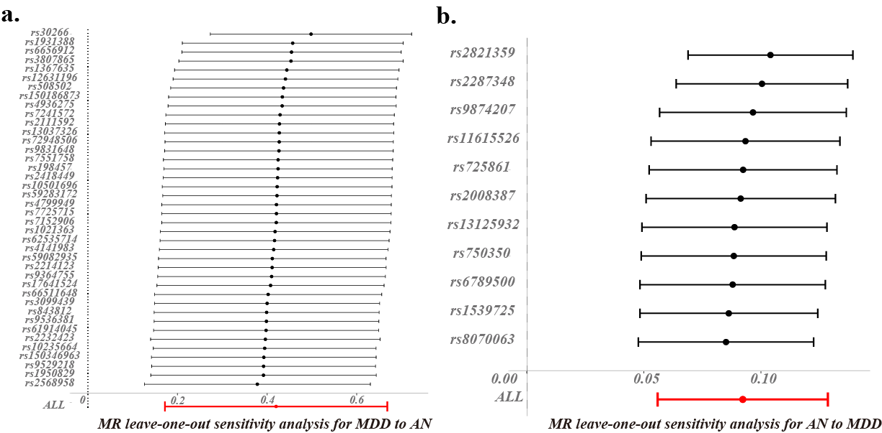

Fig4 Bidirectional leave-one-out sensitivity analysis between MDD and AN. Red lines represent estimates from IVW tests. IVW: inverse variance weighted.

## Reverse TSMR analysis

In contrast, in TSMR, AN was the exposure factor, and MDD was the outcome factor. To obtain more IVs, we set the value of p to less than 5 × 10–7.  In addition, after the setting of chain imbalance (r2 < 0.001 and KB > 10,000), we ensured that the included IVs were following the core assumptions of MR and removing SNPs not present in the outcome dataset, and removing palindromic SNPs with intermediate allele frequencies. Finally, for the exposure datasets of AN, 11 SNPs were included for MR analysis, respectively ([Supplementary Table S1](https://www.ncbi.nlm.nih.gov/pmc/articles/PMC10140565/#SM1)). The F-statistics were all greater than 20 (mean: 23, range: 21–31). The MR results did support a relationship between genetic AN susceptibility and an increased risk of MDD causality (IVW: OR, 1.096, 95% CI, 0.975–1.029, p = 9*10-7). The heterogeneity test revealed that heterogeneity existed in the MA-MDD analysis (MR-Egger: Cochran’s Q, 10.7, 0.296; IVW: Cochran’s Q = 11.6, p = 0.312). For the horizontal pleiotropy test, the MR-Egger intercept did not detect any abnormalities in the analysis between AN levels and MDD risk (Egger intercept= 0.011, p= 0.405).

Steiger-MR