Efficacy of binaural auditory beats in anxiety and anxiety : a meta-analysis

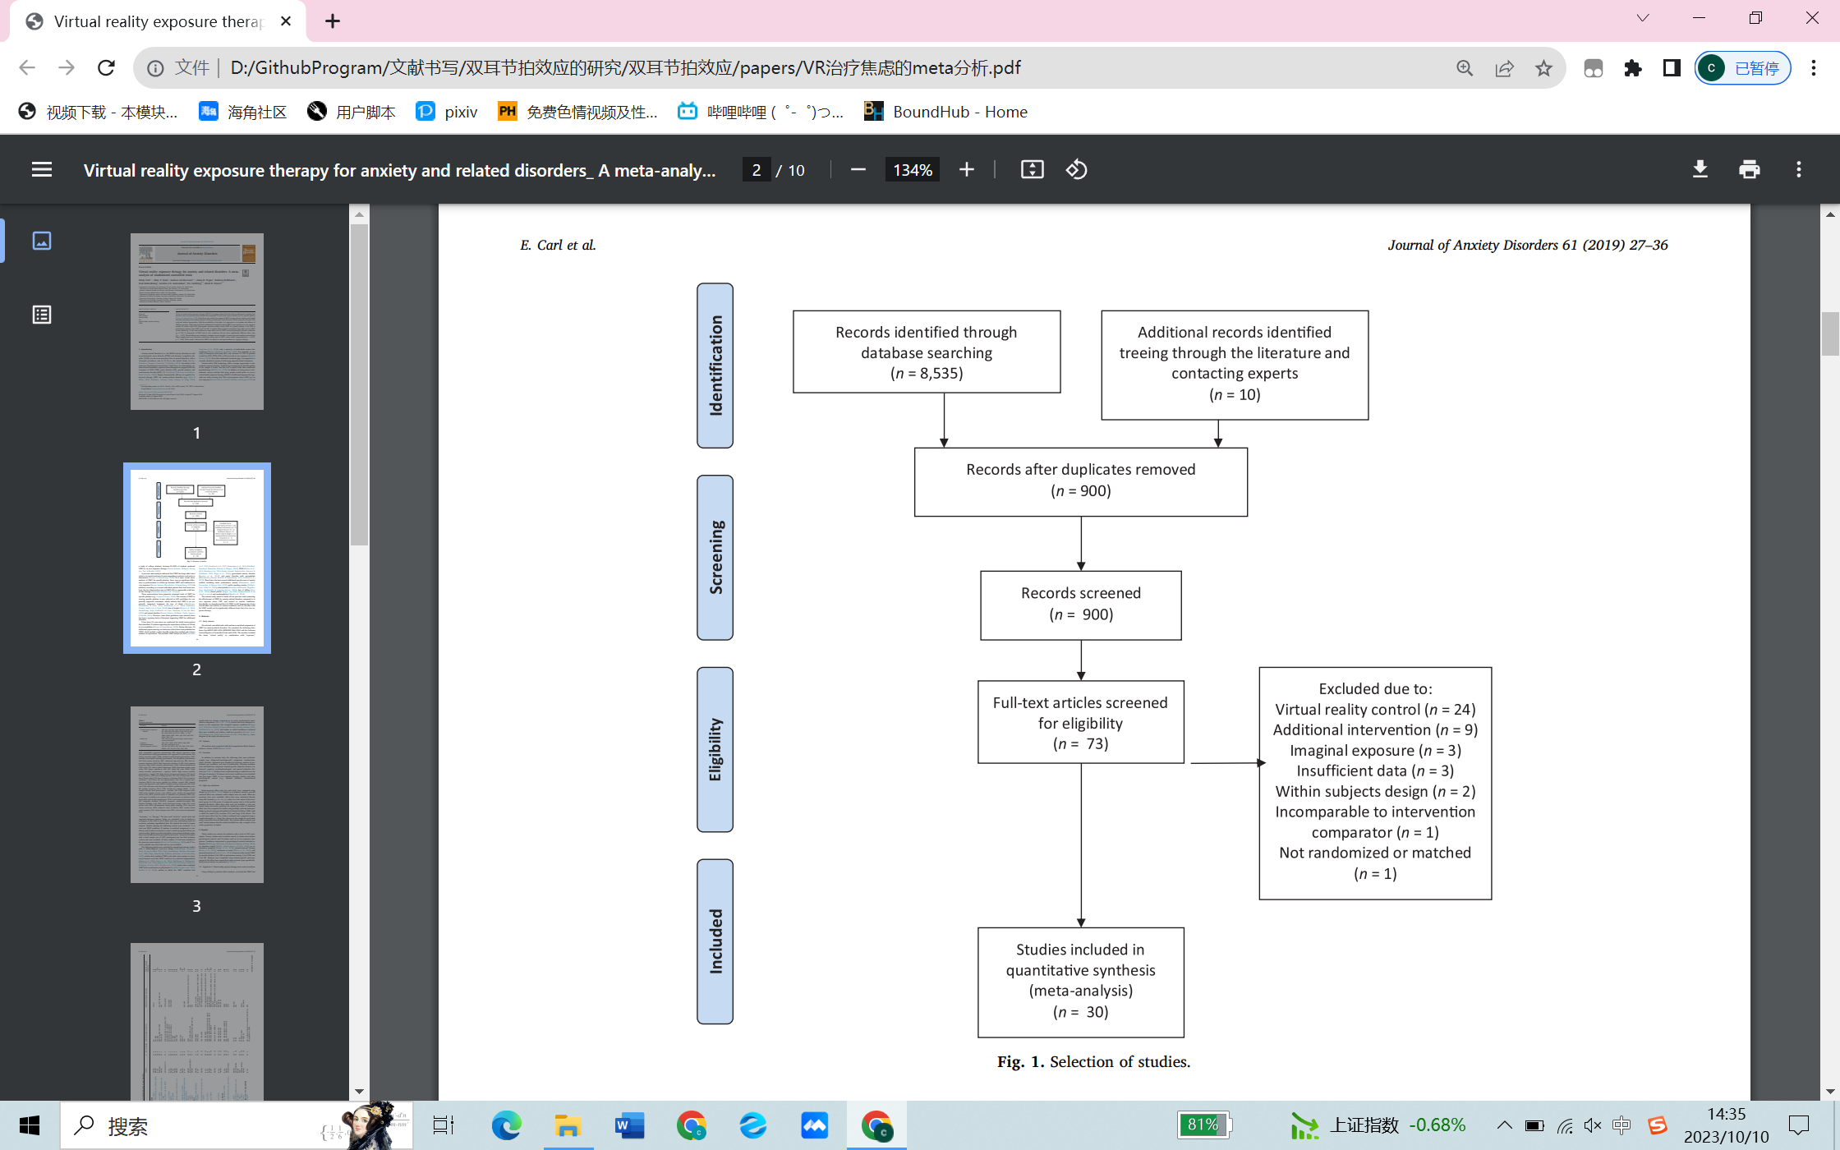

Methods

Literature search and selection criteria

We performed a systematic search on PubMed22 (Medline), Cochrane Library62, Web of Science20 and Embase75 databases to identify relevant studies on the subject. The search was limited to English language papers, using the keywords ”auditory beats”, ”binaural beats” , ”binaural auditory beats”,“brainwave entrainment”,”binaural lstimulation”,”hemispheric synchronization”and were searched in these databases up to June 2023. The flowchart of the meta-analysis is displayed in Fig. 1.

Two authors (Lian Cheng and reng qingqing) independently reviewed the retrieved studies, rating results were compared, and where differences were noted, they were discussed and reconciled. The methodology, design, features, and results of each study were described and coded by the first author.

To be included in the meta-analysis, studies had to fulfill four criteria: (1) use of binaural auditory beats as treatment or experimental manipulated factor; (2) experimental studies; (3) application of binaural beats in practical areas and where the number of studies in each area is at least three; and (4) the studies provided sufficient information to extract effect sizes (ES) from descriptive or inferential statistics.

Risk of bias

The risk of bias for each included study was assessed using the criteria suggested in the Cochrane Handbook for Systematic Reviews of Interventions.16 This guideline uses the following 7 domains to evaluate the risk of bias: (1) random sequence generation; (2) allocation concealment; (3) blinding of participants and personnel; (4) blinding of outcome assessment; (5) incomplete outcome data; (6) selective reporting; and (7) other bias. The 2 reviewers (S.J.W. and A.T.L.) individually assessed the risk of bias and categorized each study's risk of bias as “low,” “high,” or “unclear.” Any disagreements between the reviewers were resolved with discussion involving the third author (Dingyang).

**Data extraction**

The following information was extracted from the studies that met the inclusion criteria: surname of the first author, year of publication, study design, type of participant, binaural-beat frequency used, time under exposure, moment of exposure, comparison group, type of sound used to mask the binaural beat (if any), number of participants in each condition, and outcome measurement.

The literature search yielded 68 studies of which 43 were excluded since the studies did not meet the inclusion criteria for the meta-analysis. Three additional studies could not be included as the reported data were insufficient for the calculation of effect sizes. This resulted in a total of 22 studies (k = 35 ESs) that were included in the present analysis.

Statistical analysis

Data from each study was analyzed using Review Manager 5.3.5 (The Nordic Cochrane Center, 2014, Copenhagen, Denmark). Baseline demographics and procedure characteristics were combined and described using descriptive statistics according to the algorithm described in the Cochrane Handbook for Systematic Reviews.16 Differences between intervention and control groups at baseline were assessed using chi-square or t tests for categorical or continuous data, respectively. A P value of <.05 was considered statistically significant.

A meta-analysis was performed when at least 2 studies were available. The random-effects model of DerSimonian and Laird was used to produce summary treatment effects in terms of mean difference (MD) with 95% confidence intervals (CIs). Study heterogeneity was measured using Higgins I2 statistics. It was planned that possible publication biases would be assessed statistically with Begg and Egger tests and graphically using funnel plots if >10 studies were included in the analysis of any 1 outcome.

Quality assessment

The first author conducted a quality assessment for each potentially relevant study before including them for the final analysis. The quality assessment was based on the following methodological questions: (a) randomization or double blinding; (b) sample characteristics; (c) presence of control or a comparison group or a baseline measurement; (d) detailed process of the BB intervention; and (e) validity of assessments to measure the outcome variables (Garcia-Argibay et al., 2019b). Only those studies that reported the information mentioned above were included for the final meta-analysis.

((binaural beats) OR (auditory beats) OR (brainwave entrainment) OR (binaural therapy) OR (binaural tones) OR (binaural therapy) OR (binaural stimulation) OR (hemispheric synchronization))AND ((mental disorders) OR (psychiatric disorders) OR (psychological disorders) OR (mental illness) OR (psychiatric conditions) OR (Post-traumatic stress disorder) OR (Schizophrenia) OR (Depression OR Anxiety disorders) OR (Bipolar disorder) OR (Attention-deficit/hyperactivity disorder))

双耳节拍

10HZ缓解抑郁[1]

256 Hz的声学频率和另一只耳朵的260 Hz[2]减轻结肠镜检查的不适感。

[1] P. Daengruan, R. Chairat, R. Jenraumjit, D. Chinwong, A. Oon-Arom, J. Klaphajone, P. Arunmanakul, Effectiveness of Receptive Music Therapy with Imbedded 10 Hz Binaural Beats Compared with Standard Care for Patients with Major Depressive Disorder: A Randomized Controlled Trial, Complement Ther Med 61 (2021) 102765.

[2] A. Tani, G. Tartarisco, G. Vagheggini, C. Vaccaro, S. Campana, F. Tomaiuolo, Binaural beats reduce feeling of pain and discomfort during colonoscopy procedure in not-sedated patients: A randomized control trial, Complement Ther Clin Pract 48 (2022) 101605.