

Advanced Networks (420-521-VA)

# Group Project

## Project-B Network Simulation-VLANS- Routing

Hussain Amin, Ali Ilyas, Fruan Tabamo Jr

Due Date: Thursday, November 28, 2024

Requirements

1,2,3,4:

5.

6.

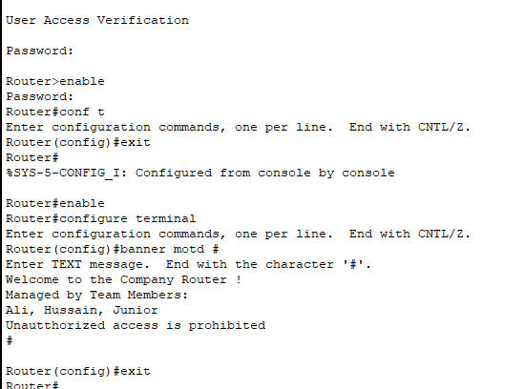

7.

8. Assigned all the IPs for all routers in packet tracker (pkt file in the submission)

9.

10.

11.

Admin -> departments PCs

Manufacture:



Human Resources:

Administration:

Departments PCs-> company servers

Manufacture:



Human Resources:

Administration:

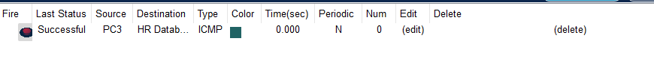

Departments PCs-> HeadQuarters.ca

Manufacture:

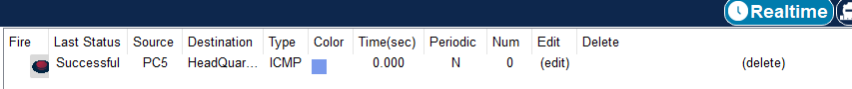

Human Resources:



Administration:



Troubleshooting the network:

Steps:

1. #do show vlan brief (under the switch (1,2) global configuration mode)
   1. Switch 1

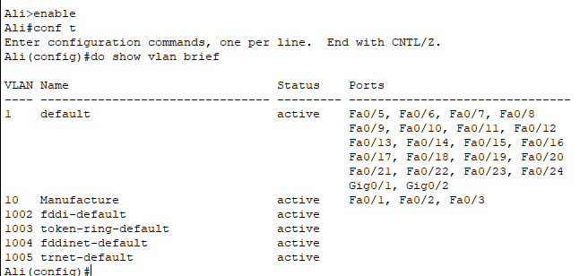

* 1. Switch 2

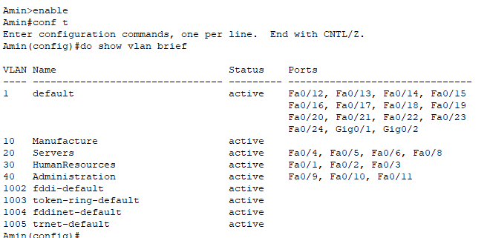

1. #do show ip interface brief (switch(1,2)/router)
   1. Switch 1

* 1. Switch 2

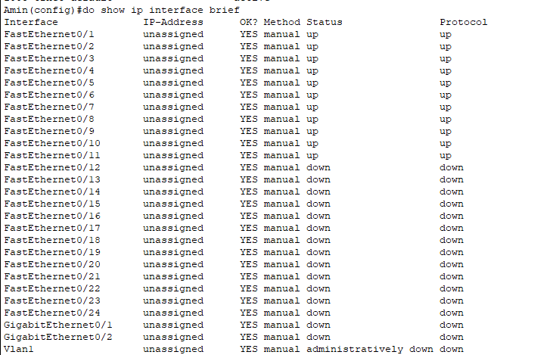

* 1. Router

1. #do show int trunk (switch1,2)
   1. Switch 1

* 1. Switch 2

1. #do show ip route (router)

1. #sh ip protocols

1. #sh ip route

