

Advanced Networks (420-521-VA)

# Group Project

## Project-B Network Simulation-VLANS- Routing

Hussain Amin, Ali Ilyas, Fruan Tabamo Jr

Due Date: Thursday, November 28, 2024

Requirements

1,2,3,4:

5.

6.

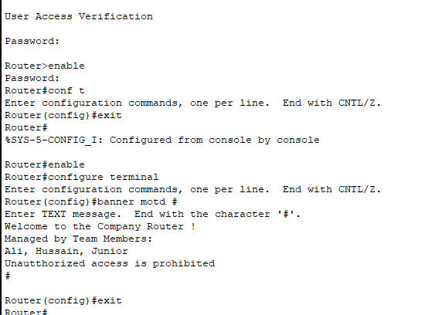

7.

8. Assigned all the IPs for all routers in packet tracker (pkt file in the submission)

9.

10.

11.

Troubleshooting the network:

Notes: