**Vanier College**

**Computer Science Department**

**Cinema Web application**

**CineWeb**

**Ali Ilyas**

**420‐331‐VA : Application Development (Sec‐03)**

**Teacher: Syed Naseem Afzal**

**Friday, December 10, 2023**

**Table of Contents**

Introduction...................................................................................................................................................................3

Project BackGround…….................................................................................................................................................3

Interactive Features.......................................................................................................................................................3

Application Features......................................................................................................................................................4

Graphical User Interface ...............................................................................................................................................4

Home Page…………………………………………………………………………………………………………………………………………………4

Log In Page…………………………………………………………………………………………………………………………………………………5

Sign Up Page………………………………………………………………………………………………………………………………………………5

Menu Page…………………………………………………………………………………………………………………………………..……………6

Personnel Details Page…………………………………………………………………………………………………………………………….…6

Reservations Page………………………………………………………………………………………………………………………..……………7

All Movies Page…………………………………………………….……………………………………………………………………..……………7

Selected Movie Page………………………………………….………………………………………………………………………..……………8

Date Choosing Page…………………………………….…………………………………………………………………….………..……………8

Seat Choosing Page…..……………………………………….………………………………………………………………………..……………9

Payment Page…………..………………………………….…………………………………………………………………….………..……………9

Receipt Page…..……………………………………….………………………………………………………………………..……………………10

Exception handling .....................................................................................................................................................11

**Introduction**

Welcome to CineWeb, your ultimate web application for hassle-free cinema seat reservations and movie ticket bookings. CineWeb aims to revolutionize your movie-going experience, allowing you to effortlessly browse, select, and reserve your preferred movies and showtimes right from your computer or smartphone. Let's explore how CineWeb can elevate your cinema experience.

**Project Background**

The cinema industry is rapidly evolving, emphasizing touch-less and user-friendly ticket booking services. CineWeb has been designed to meet this demand, simplifying the cinema reservation process while ensuring a safe and enjoyable experience for movie enthusiasts.

**Interactive Features**

* **Seeing your Personal Details:** Have access to all of your details such as id, name, phone, address, etc..
* **Seeing your Reservations Details:** Have access to all of your Reservations with their details such as Reservation ID, your Name, Movie name, Seat Number, etc..
* **Movie Selection:** Explore an array of movies categorized into genres such as Horror, Action, Romance, Comedy, Drama, Science Fiction, and others.
* **Showtime Selection:** Choose the showtime that suits your schedule best.
* **Seat Reservation:** Select your preferred seats for your chosen showtime with ease.
* **Payment:** Make secure payments for your reservations within the app.
* **Confirmation:** Receive a confirmation code and an e-ticket after completing your reservation

**Application Features**:

* **Log In:** If you already have an account with us, you simply have to provide your Email Address and Password and you’ll be log in to your account.
* **Sign In:** If you don’t have an account with us, you can provide us your information and well create an account for you. Later you can Log in with the email and password.

**Graphical User Interface (GUI)**:

**\*You have to unblock the Home.resx file in CineWeb\CineWeb folder Before runnimg the application.**

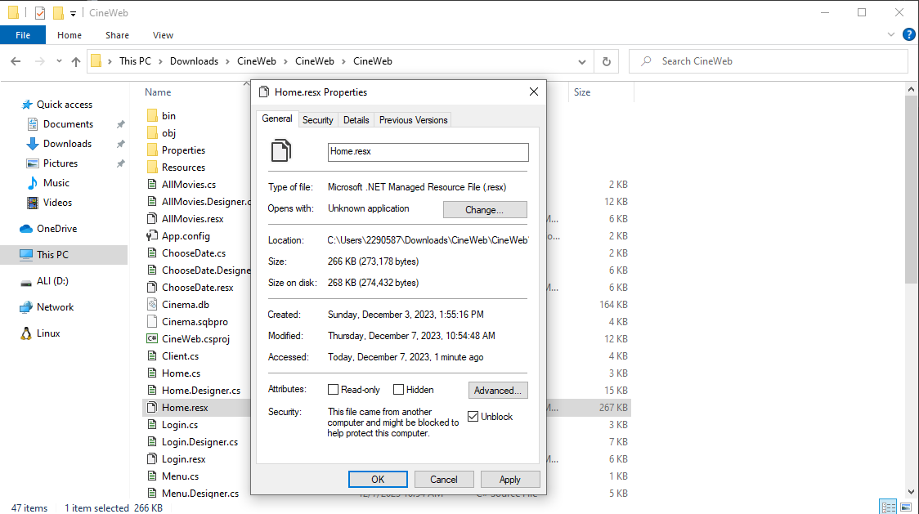

**Home Page**

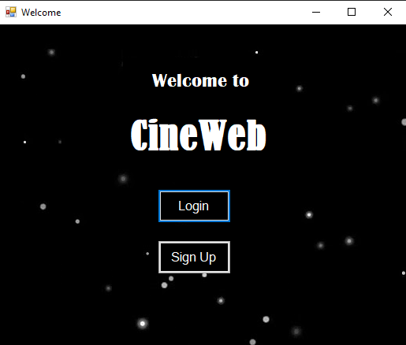

*You can choose Either log in or Sign In depending on your situation

**Log In Page:**

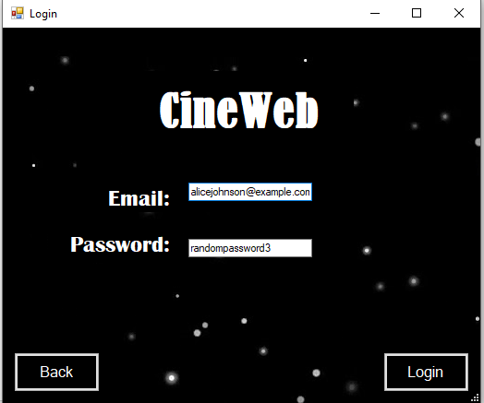

*You can Click Back to go back in the Home Page or Click log in after having entered your email and password.

**Sign up Page:**

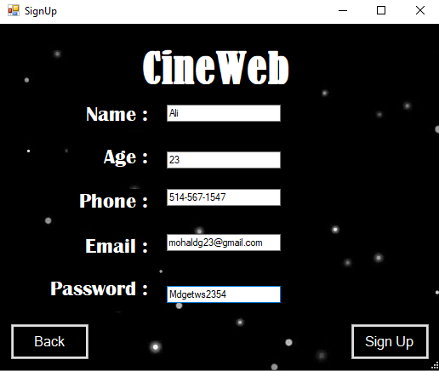

*You can Click Back to go back in the Home Page or Click Sign in after having entered your Information.

**Menu Page :**

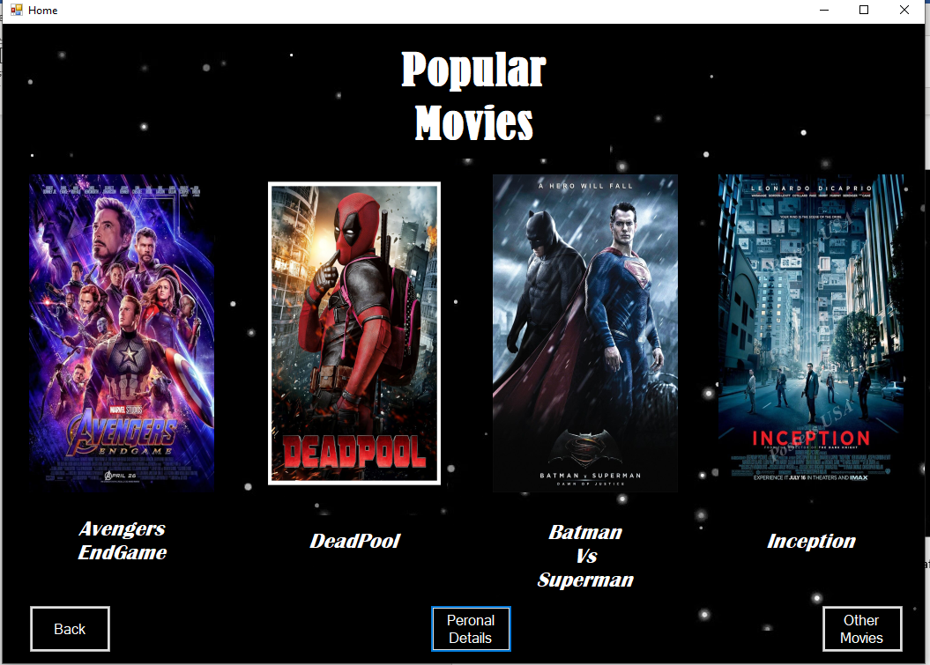

1- You can Click Back to go back in the Log In/Sing Up Page.

2- Click Personal details to have access all of your information as well as information about all of your reservations.

3- You can click on any of the four movies if you’re interested in reserving them.

4- You can also Click Other Movies to select any other movies you would want to watch

**Personnel Details Page :**

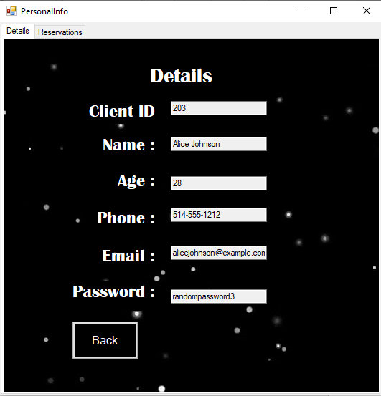

*You can Click Back to go back in the Menu Page or Click Reservations Tab to See all of your Reservations.

**Reservations Page :**

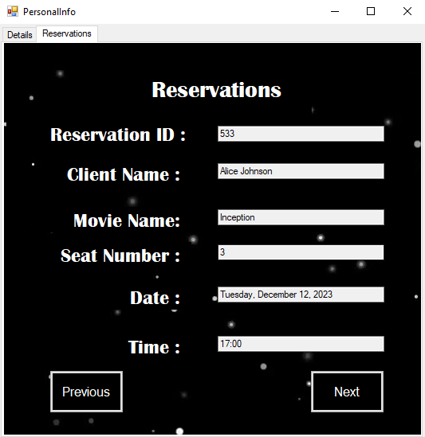

*You can Click Previous and next to iterate through all of your Reservations

**All Movies Page :**

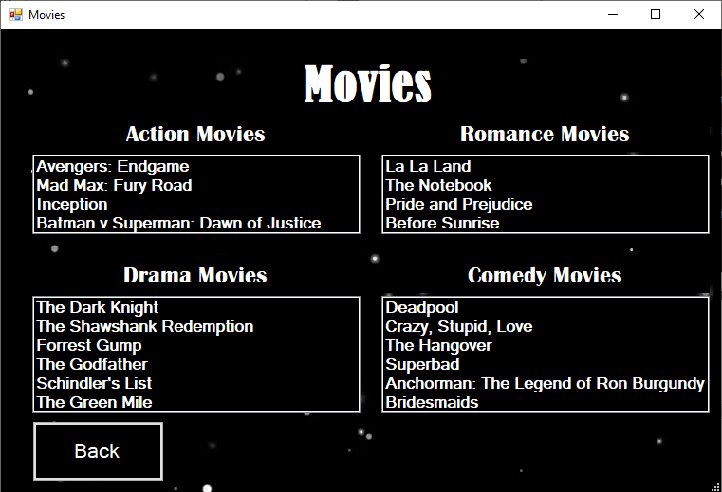

*Movies are divided into 4 categories

You can click on any of them to see their details or you could click back to get to the Menu Page

**Selected Movie Page :**

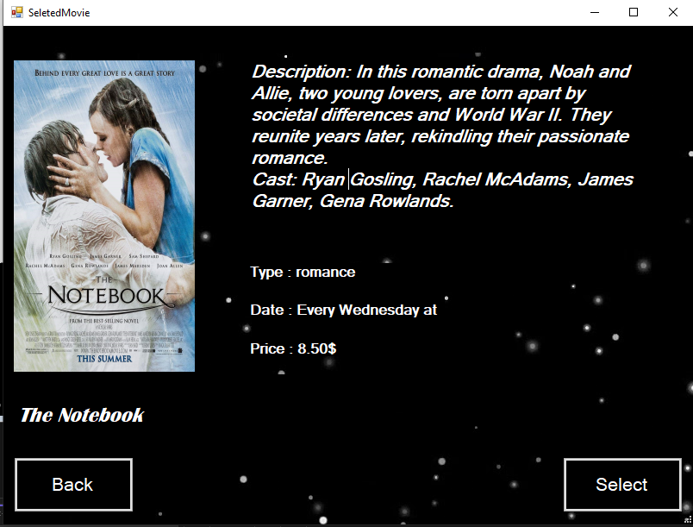

*You can Click Back to go the Movies Page or Select to select the Movie

**Date Chosing Page :**

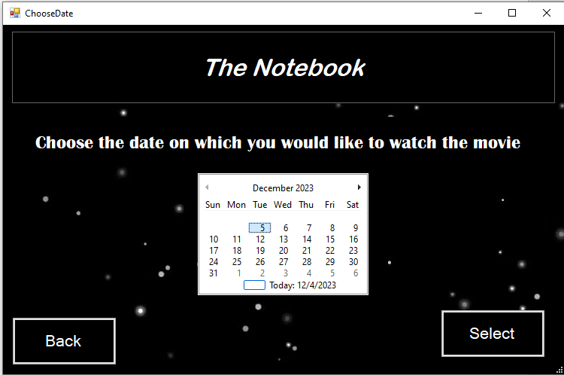

*You can Click Back to go the Selected Movie Page or Click Select after having chosen the date you want to reserver on.In this case since the The notebook on Wednesdays, if you choose any other date itll give you an error.

**Seat Chosing Page :**

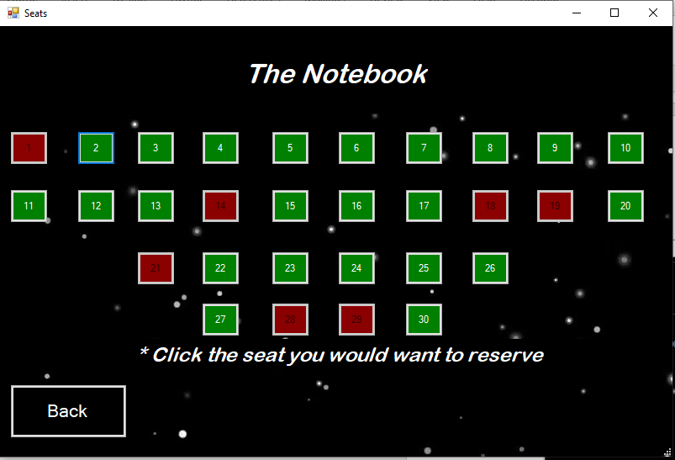

*You can click Back to go to the the date Chosing Page or simply click any of the availble Seat(Green Seats).The read ones are reserved.Lets Choose Seat 15 For this example.

**Payment Page :**

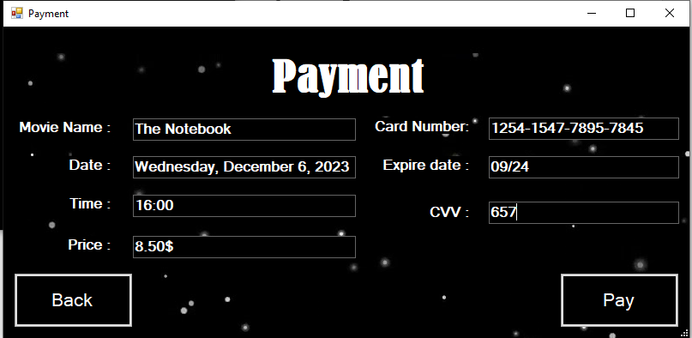

*You can click Back to go to the the Seat Chosing Page or simply click pay after Having entered your Card Information.

**Receipt Page :**

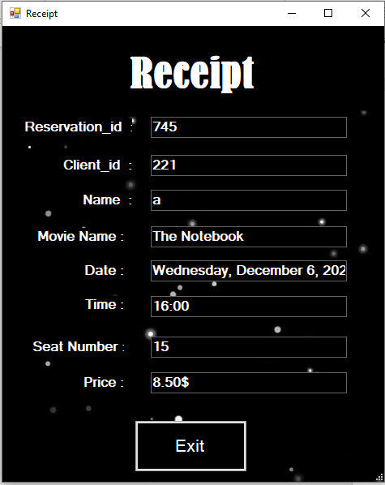

*Here is your receipt with all how the information. Simply Click Exist.

**Now If we Go to the movie The Notebook on decembre 6th well notice that the seat number 15 is not available anymore.**

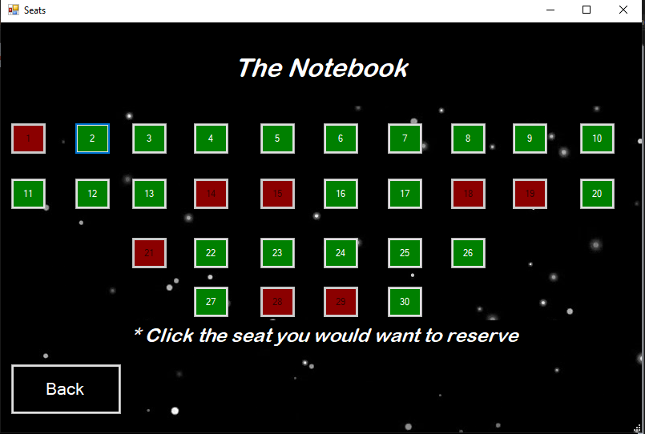

**Exception Handling**:

1. Log in exception:

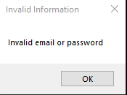

2-sign in exception

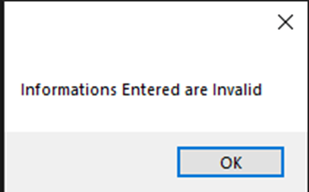

1. You choose the wrong date for a movie (every movie has a fixed day on which it is shown)

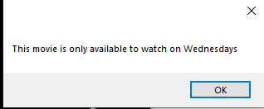

1. You enter the wrong information while paying :

* Card Numebr should have a total of 16 digits and every 4 digits there has to be a dash(‘-’).
* Exprie date shoulf have the month and year in this format XX/XX
* CVV consist of a 3 digit number.

