**Lab04**

**Date Submitted: 9/28/2019**

**Task 00: Execute provided code**

**Youtube Link: No submition required**

**------------------------------------------------------------------------------------**

**Task 01:**

Youtube Link: N/A

**Modified Schematic (if applicable): N/A**

The following screenshots are the verification of %43 duty cycle at 10 Hz using Timer0.

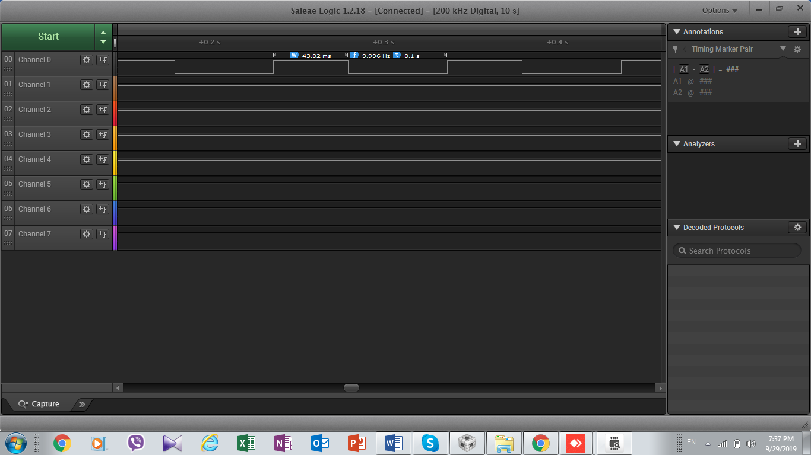



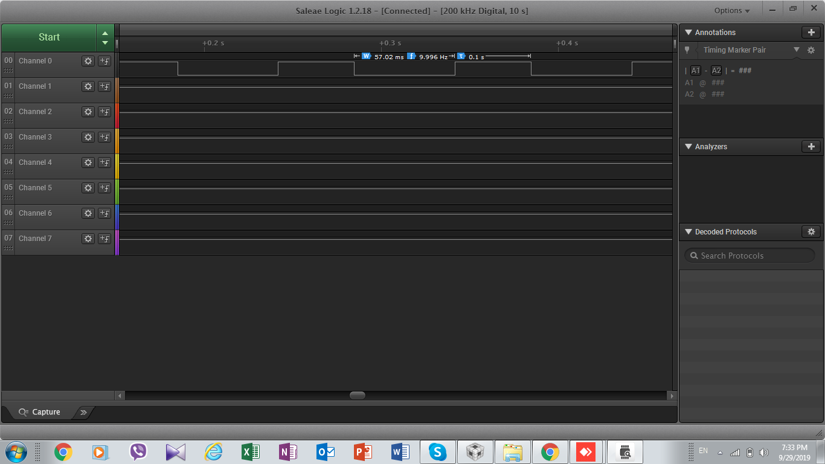

Code for Task 01:

**Modified Code:**

**// Insert code here**

**#include** <stdint.h>

**#include** <stdbool.h>

**#include** "inc/tm4c123gh6pm.h"

**#include** "inc/hw_memmap.h"

**#include** "inc/hw_types.h"

**#include** "driverlib/sysctl.h"

**#include** "driverlib/interrupt.h"

**#include** "driverlib/gpio.h"

**#include** "driverlib/timer.h"

**int** **main**(**void**)

{

uint32_t ui32Period;

**SysCtlClockSet**(SYSCTL_SYSDIV_5|SYSCTL_USE_PLL|SYSCTL_XTAL_16MHZ|SYSCTL_OSC_MAIN);

**SysCtlPeripheralEnable**(SYSCTL_PERIPH_GPIOF);

**GPIOPinTypeGPIOOutput**(GPIO_PORTF_BASE, GPIO_PIN_1|GPIO_PIN_2|GPIO_PIN_3);

**SysCtlPeripheralEnable**(SYSCTL_PERIPH_TIMER0);

**TimerConfigure**(TIMER0_BASE, TIMER_CFG_PERIODIC);

ui32Period = ((**SysCtlClockGet**() / 10)*43) /100;

**TimerLoadSet**(TIMER0_BASE, TIMER_A, ui32Period -1);

**IntEnable**(INT_TIMER0A);

**TimerIntEnable**(TIMER0_BASE, TIMER_TIMA_TIMEOUT);

**IntMasterEnable**();

**TimerEnable**(TIMER0_BASE, TIMER_A);

**while**(1)

{

}

}

**void** **Timer0IntHandler**(**void**)

{

// Clear the timer interrupt

**TimerIntClear**(TIMER0_BASE, TIMER_TIMA_TIMEOUT);

// Read the current state of the GPIO pin and

// write back the opposite state

**if**(**GPIOPinRead**(GPIO_PORTF_BASE, GPIO_PIN_2))

{

**GPIOPinWrite**(GPIO_PORTF_BASE, GPIO_PIN_1|GPIO_PIN_2|GPIO_PIN_3, 0);

uint32_t ui32Period = ((**SysCtlClockGet**() / 10)*57) /100;

**TimerLoadSet**(TIMER0_BASE, TIMER_A, ui32Period -1);

}

**else**

{

**GPIOPinWrite**(GPIO_PORTF_BASE, GPIO_PIN_2, 4);

uint32_t ui32Period = ((**SysCtlClockGet**() / 10)*43) /100;

**TimerLoadSet**(TIMER0_BASE, TIMER_A, ui32Period -1);

}

}

**------------------------------------------------------------------------------------**

**Task 02:**

Youtube Link: <https://www.youtube.com/watch?v=mclfv-lnJM8>

**Modified Schematic (if applicable): N/A**

**Code for task02**

**Modified Code:**

**// Insert code here**

**#include** <stdint.h>

**#include** <stdbool.h>

**#include** "inc/tm4c123gh6pm.h"

**#include** "inc/hw_memmap.h"

**#include** "inc/hw_types.h"

**#include** "driverlib/sysctl.h"

**#include** "driverlib/interrupt.h"

**#include** "driverlib/gpio.h"

**#include** "driverlib/timer.h"

**int** **main**(**void**)

{

uint32_t ui32Period;

**SysCtlClockSet**(SYSCTL_SYSDIV_5|SYSCTL_USE_PLL|SYSCTL_XTAL_16MHZ|SYSCTL_OSC_MAIN);

**SysCtlPeripheralEnable**(SYSCTL_PERIPH_GPIOF);

**GPIOPinTypeGPIOOutput**(GPIO_PORTF_BASE, GPIO_PIN_1|GPIO_PIN_2|GPIO_PIN_3);

GPIO_PORTF_LOCK_R = 0x4C4F434B;

GPIO_PORTF_CR_R = 1;

**GPIOPadConfigSet**(GPIO_PORTF_BASE, GPIO_PIN_0, GPIO_STRENGTH_4MA,GPIO_PIN_TYPE_STD_WPU);

GPIO_PORTF_LOCK_R = 0x4C4F434B;

**SysCtlPeripheralEnable**(SYSCTL_PERIPH_TIMER0);

**SysCtlPeripheralEnable**(SYSCTL_PERIPH_TIMER1);

**TimerConfigure**(TIMER0_BASE, TIMER_CFG_PERIODIC);

**TimerConfigure**(TIMER1_BASE, TIMER_CFG_ONE_SHOT);

ui32Period = ((**SysCtlClockGet**() / 10)*43) /100;

**TimerLoadSet**(TIMER0_BASE, TIMER_A, ui32Period -1);

ui32Period = **SysCtlClockGet**();

**TimerLoadSet**(TIMER1_BASE, TIMER_A, ui32Period -1);

**IntEnable**(INT_TIMER0A);

**IntEnable**(INT_TIMER1A);

**TimerIntEnable**(TIMER0_BASE, TIMER_TIMA_TIMEOUT);

**TimerIntEnable**(TIMER1_BASE, TIMER_TIMA_TIMEOUT);

**IntMasterEnable**();

**TimerEnable**(TIMER0_BASE, TIMER_A);

**while**(1)

{

uint32_t value = **GPIOPinRead**(GPIO_PORTF_BASE, GPIO_PIN_0);

**if**(!value)

{

**while**(!**GPIOPinRead**(GPIO_PORTF_BASE, GPIO_PIN_0));

**TimerDisable**(TIMER0_BASE, TIMER_A);

**GPIOPinWrite**(GPIO_PORTF_BASE, GPIO_PIN_2, 0x04);

ui32Period = **SysCtlClockGet**();

**TimerLoadSet**(TIMER1_BASE, TIMER_A, ui32Period -1);

**TimerEnable**(TIMER1_BASE, TIMER_A);

}

}

}

**void** **Timer1IntHandler**(**void**)

{

**TimerIntClear**(TIMER1_BASE, TIMER_TIMA_TIMEOUT);

**GPIOPinWrite**(GPIO_PORTF_BASE, GPIO_PIN_1|GPIO_PIN_2|GPIO_PIN_3, 0);

**TimerEnable**(TIMER0_BASE, TIMER_A);

}

**void** **Timer0IntHandler**(**void**)

{

// Clear the timer interrupt

**TimerIntClear**(TIMER0_BASE, TIMER_TIMA_TIMEOUT);

// Read the current state of the GPIO pin and

// write back the opposite state

**if**(**GPIOPinRead**(GPIO_PORTF_BASE, GPIO_PIN_2))

{

**GPIOPinWrite**(GPIO_PORTF_BASE, GPIO_PIN_1|GPIO_PIN_2|GPIO_PIN_3, 0);

uint32_t ui32Period = ((**SysCtlClockGet**() / 10)*57) /100;

**TimerLoadSet**(TIMER0_BASE, TIMER_A, ui32Period -1);

}

**else**

{

**GPIOPinWrite**(GPIO_PORTF_BASE, GPIO_PIN_2, 4);

uint32_t ui32Period = ((**SysCtlClockGet**() / 10)*43) /100;

**TimerLoadSet**(TIMER0_BASE, TIMER_A, ui32Period -1);

}

}

**------------------------------------------------------------------------------------**