In this design assignment, we are doing indirect addressing. I used macro directive to load pointers, instead of using extra instructions.

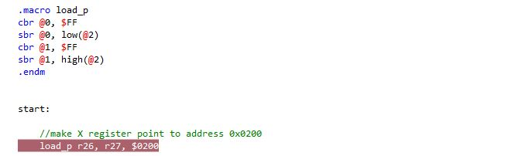

After setting R24 and R23 as counter and counter limit respectively, I stored numbers 11 to 110 starting at address 0x0200 by pointing register X to that address (screenshot above). Then I generated a loop to populate the addresses from starting address to the last (99th) address.

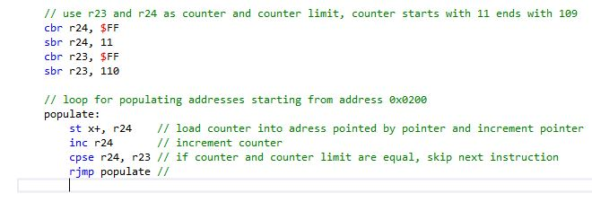

X pointer has been incremented every time that loop has been executed and each time I compare R24 and R23 to see if they are equal to skip the rjmp instruction.

For the second part of the code, I loaded X/Y/Z pointers to required addresses. In a main loop, I generate two loops to check if the number is divisible by 3 or not. If it is, it is stored in the addresses pointing by Y pointer, otherwise is stored in the addresses pointing by Z pointer .

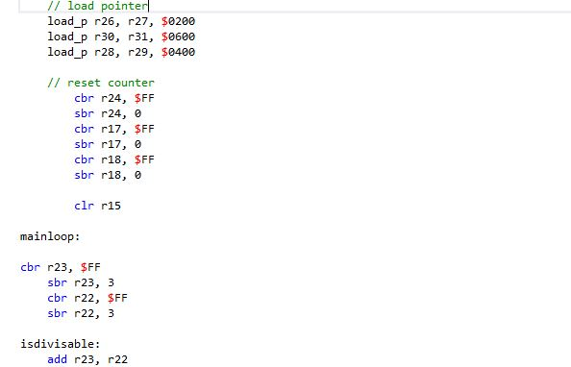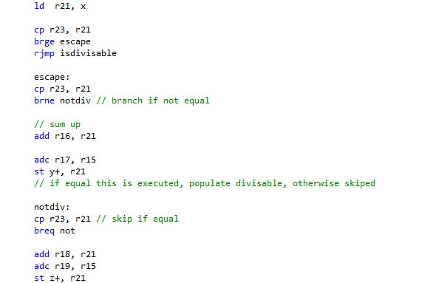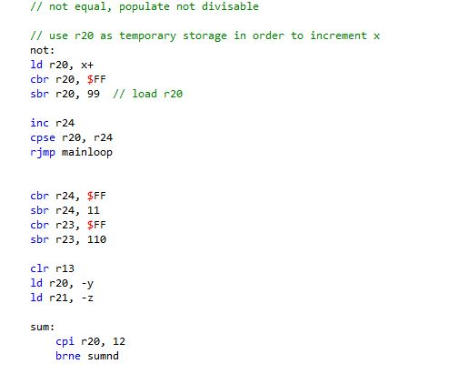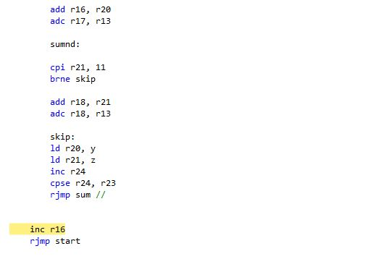

After simulating the code, results are as e xpected:

