CPE301 – SPRING 2019

Design Assignment 2C-Task3

Student Name: Ali Asadi

Student #: 5004200625

Student Email: aliasadivet@gmail.com

Primary Github address: https://github.com/aliasadivet/Submitions_DA_AliAsadi

Directory: DessignAssignments

The goal of the assignment is use GPIO and delays using Timers and Interrupts.

Programming

The following is the assembly code to implement Design Assignment 2C-Task3 using

TIMER0_OVF_vect interrupt mechanism in CTC mode.

;

; DA2C-T3.asm

;

; Created: 3/30/2019 9:21:15 AM

; Author : Ali Asadi

;

.org 0

rjmp main

.org 0x00E ;location for CTC interrupt

rjmp Int_CTC_ASM ; ISR Handler

.org 0x0100

Int_CTC_ASM:

in r18, SREG

push r18

ldi r18, 1

add r16, r18 ; Increment registers r17:r16

clr r18

adc r17, r18

pop r18

out SREG, r18

reti

main:

ldi r16, high (RAMEND)

out SPH, r16

ldi r16, low (RAMEND)

out SPL, r16 ;stack initialization

rcall Timer_Init_CTC_ASM

;rcall Pin_Init_CTC_ASM ;change to comment to execute second part of the task(just for convenience to avoid making two seperate projects)

rcall Switch_Init_CTC_ASM ;change to instruction in executing part 2

loop:

;rcall Pulse_CTC_ASM ;change to comment to execute second part of the task(just for convenience to avoid making two seperate projects)

rcall LED_CTC_ASM ;change to instruction in executing part 2

rjmp loop

Pin_Init_CTC_ASM:

sbi DDRB, 2 ; sbi - set bit I/O - set bit 2 in DDRB register - Output Mode

sbi PORTB, 2 ; cbi - clear bit I/O - clear bit 2 in PORTB register - Output Low

ret ; return from the function

Timer_Init_CTC_ASM:

ldi r16, 0x02 ; Enable CTC mode , WGM01 = 1, WGM00 = 0

out TCCR0A, r16 ; save it in register

ldi r16, 0x03 ; divide input clock by 64 => 8Mhz/64 ; CS02 = 0 CS01 = 1 CS00 = 1

out TCCR0B, r16 ; save it in register

ldi r16, 0x02 ; enable OCR0A interrupt OCIEA

sts TIMSK0, r16 ; save it in register

ldi r16, 249 ; set OCR0A = 249

out OCR0A, r16 ; therefore (8M / 64)hz = 8uS * 250 = 2mS

sei ; enable global interrupt

ret

Pulse_CTC_ASM:

ldi r24, low(435) ; ldi - load immediate load value of 87 in r24 - 435mS

ldi r25, high(435)

cbi PORTB, 2 ; set bit 2 in PORTB register - Output High

rcall Delay_ASM ; rcall - relative call , call Delay_ASM Function

sbi 0x05, 2 ; clear bit 2 in PORTB register - Output Low

ldi r24, low(290) ; load value of 58 in r24 - 145*2 = 290mS

ldi r25, high(290)

rcall Delay_ASM ; call Delay_ASM Function

ret ; return from the function

Delay_ASM:

lsr r25 ; r25:r24 contains delay in mS but clock generates a delay of 2mS

ror r24 ; so divide by 2 to get actual time of delays

clr r16 ; clr r17:r16 which is the counter in ISR

clr r17

cp r24, r16 ; compare two resister r24-r16

cpc r25, r17 ; compare with carry r25-r17-C

brne PC-2 ; branch if not equal i.e r25:r24 and r17:r16 are not equal

ret ; exit or return

Switch_Init_CTC_ASM:

cbi DDRD, 2 ; DDRD bit 2 = 0 INPUT Mode

sbi PORTD, 2 ; PORTD bit 2 = 1 PULLUP Enable

sbi DDRB, 2 ; PORTB.2 - Output

sbi PORTB, 2 ; PORTB.2 - Output Low

ret ; return from the function

LED_CTC_ASM:

sbis PIND, 2 ; skip if bit is set in I/O register, skip if HIGH state

rjmp pressed ; relative jump - jump to pressed label if State is low

brtc return ; branch if T bit is cleared - check the previous state

ldi r24, 10 ; load r24 with 2 to generate a delay of 10mS

ldi r25, 0

rcall Delay_ASM ; call Delay_ASM to generate debounce delay

sbis PIND, 2 ; check if the bit stays the same

rjmp return ; return if not

cbi PORTB, 2 ; PORTB.2 - Output High

ldi r24, low(1250) ; load r24 with 250 to generate a delay of 1250mS

ldi r25, high(1250)

sbiw r24, 10

rcall Delay_ASM ; call delay

sbi PORTB, 2 ; PORTB.2 - Output Low

clt ; clear T , previous state is high

rjmp return ; return

pressed:

ldi r24, 10 ; if state is low, then generate a debounce delay of 10mS

ldi r25, 0

rcall Delay_ASM ; call delay

sbis PIND, 2 ; check if the bit stays the same

set ; set T bit to indicate previous state is Low

return:

ret ; return from the function

The following screenshot demonstrates the simulation result of the code for the first part; 60% of the period and whole period respectively.

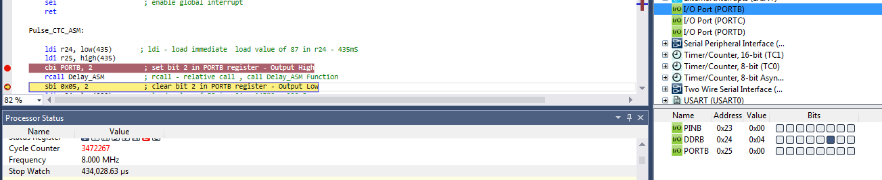

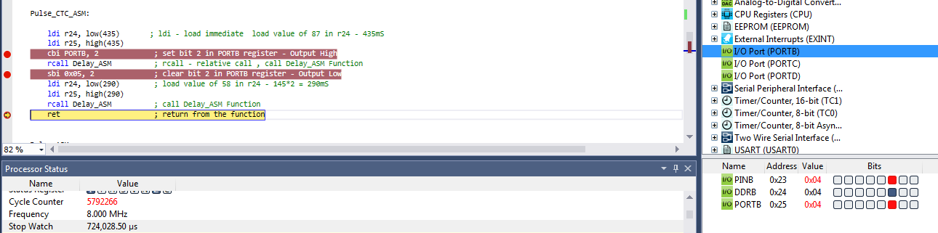

The following screenshot demonstrates the simulation result of the code for the second part; 1.25 sec delay.

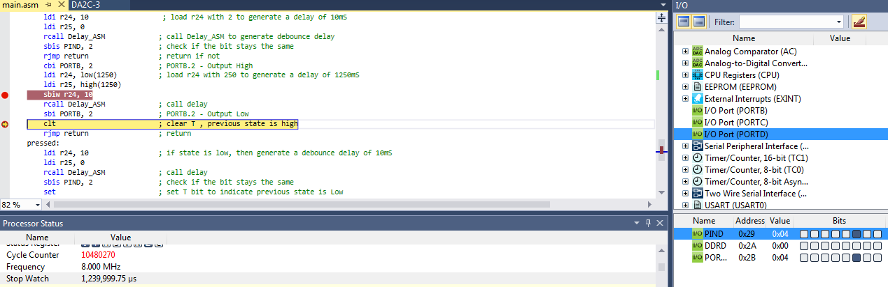

The following is the C code to implement Design Assignment 2C-Task3 using

TIMER0_OVF_vect interrupt mechanism in CTC mode.

/*

* DA2C-T3.c

*

* Created: 3/22/2019 7:30:02 PM

* Author : Ali Asadi

*/

#include <inttypes.h>

#include <avr/io.h>

#include <avr/interrupt.h>

#include <avr/sleep.h>

#include <util/delay.h>

volatile *uint16_t* tick;

ISR(TIMER0_COMPA_vect)

{

tick++; // increment delay counter

}

void delay_CTC(volatile *uint16_t* ms)

{

tick = 0; // counter = 0

ms >>= 1; // divide by 2 since timer generates a delay of 2.048mS for each increment

while(tick < ms); // wait counter to complete given time delay

}

void Pulse_Init_CTC()

{

DDRB |= _BV(2);

}

void Timer_Init_CTC()

{

TCCR0A = 0x02;

TCCR0B = 0x03;

TIMSK0 = 0x02;

OCR0A = 249;

sei();

}

void Pulse_CTC()

{

PORTB |= _BV(2);

delay_CTC(435);

PORTB &= ~_BV(2);

delay_CTC(290);

}

void LED_Init_CTC()

{

DDRD &= ~_BV(2);

PORTD |= _BV(2);

DDRB |= _BV(2);

PORTB |= _BV(2);

}

void LED_CTC()

{

static *uint8_t* pressed = 0;

if((PIND & _BV(2)) && pressed)

{

delay_CTC(10);

if(PIND & _BV(2))

{

PORTB &= ~_BV(2);

delay_CTC(1250);

PORTB |= _BV(2);

}

pressed = 0;

}

else if(!(PIND & _BV(2)))

{

delay_CTC(10);

if(!(PIND & _BV(2)))

pressed = 1;

}

}

void main()

{

//Pulse_Init_CTC();

LED_Init_CTC();

Timer_Init_CTC();

while(1)

//Pulse_CTC();

LED_CTC();

}

The following screenshot demonstrates the simulation result of the code for the first part; 60% of the period and whole period respectively.

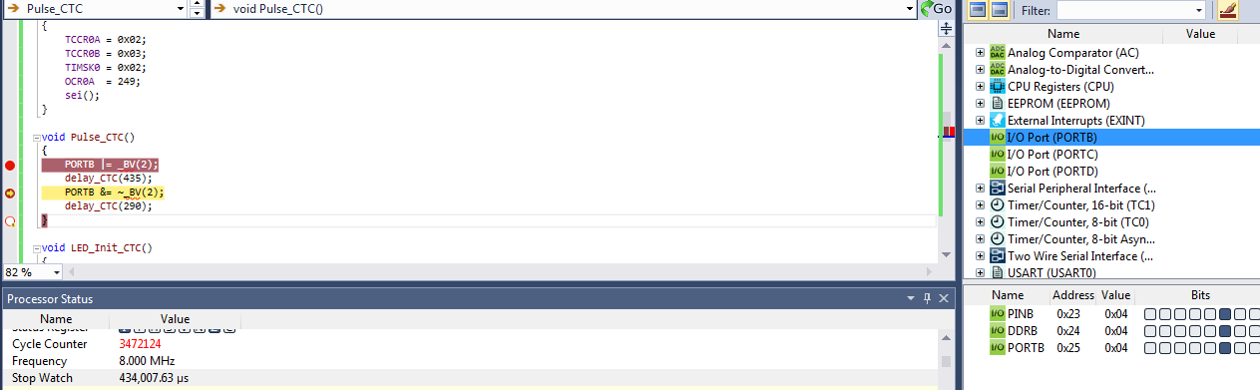

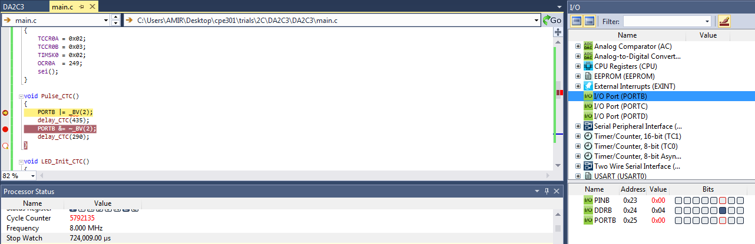

As it is shown in the screenshots below, the delay time of 1.25 sec has been executed.

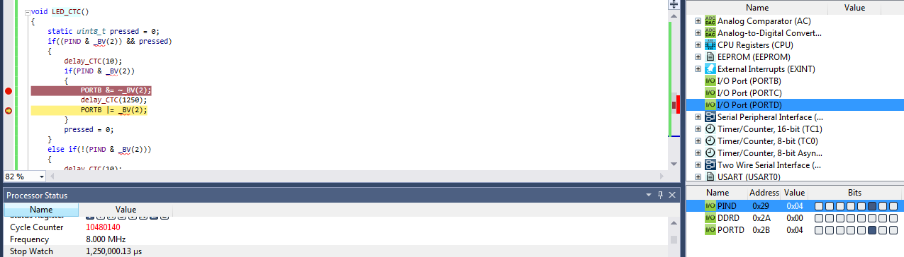

The simulation and emulation tesults are posted on YouTube, and can be found on linkes below:

<https://www.youtube.com/watch?v=uIKIEzNzsIQ>

<https://www.youtube.com/watch?v=kWE34Fe95bA>