CPE301 – SPRING 2019

Design Assignment 3A

Student Name: Ali Asadi

Student #: 5004200625

Student Email: aliasadivet@gmail.com

Primary Github address: https://github.com/aliasadivet/Submitions_DA_AliAsadi

Directory: DessignAssignments

Programming

The following C program displays a string, random integer and floating point values on the serial terminal every 1 sec.

In this code I have used timer1 with interrupt for the 1 sec delay.

# Also I have used FT232RL FTDI Mini USB to TTL Serial Converter Adapter

for serial to USB conversion.

/*

* DA3A.c

*

* Created: 3/28/2019 12:46:34 AM

* Author : Ali Asadi

*/

#include <stdlib.h>

#include <stdio.h>

#include <inttypes.h>

#include <avr/io.h>

#include <avr/interrupt.h>

#include <avr/sleep.h>

void Timer_init();

void USART_init();

void USART_send(char );

void sendString(char *);

volatile char temp[] = "Random:)\t"; // a random string

int randomInt[] = {1,2,689,48,25,1235,2548,322,465,415,471};

float temperature = 20.432 ; //just a number to generate a random floating point

ISR(TIMER1_COMPA_vect) //Interrupt Service Routine

{

char buffer[8];

sendString(temp);

*itoa*(*rand*(),buffer,10); //generate a random integer

sendString(buffer);

sendString("\t");

*dtostrf*(temperature\**rand*(),2,4,buffer); //generate a random floating point value

sendString(buffer);

sendString("\n\r");

}

int main()

{

USART_init();

Timer_init();

sei(); //set global interrupt

while (1);

return 0;

}

void Timer_init()

{

TCCR1B = 0x0C; //timer mode CTC, clock division 256 (WGM12 (CTC mode) CS12 CS11 CS10 (1, 0, 0 : clkI/O/256 (From prescaler)))

OCR1A = 62500; //to generate 1 sec delay

TIMSK1 = 0x02; //OCIE0=1 (OCIE1A=1)over flow output compare match A interrupt enable

}

void USART_init()

{

UCSR0B = 0x08; //Transmit enable

UCSR0C = 0x06; //databit= 8bit

//Transmitted Data Changed (Output of TxDn Pin): Rising XCKn Edge

//Received Data Sampled (Input on RxDnPin): Falling XCKn Edge

//UCSZn1 UCSZn0 UCPOLn : 1, 1, 0

UBRR0L = 51; //buadrate value=19200

}

void USART_send(char data)

{

while(!(UCSR0A & _BV(UDRE0))); //wait for data register to be empty

UDR0 = data; //send data

}

void sendString(char *str)

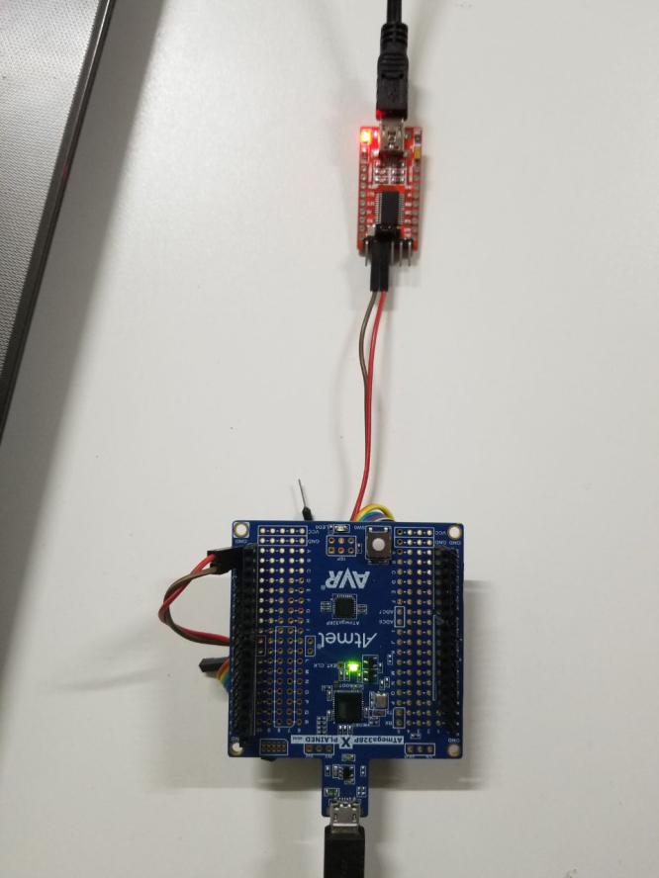{

while(*str) //loop till end

USART_send(*str++); //send data

}

The following screenshot demonstrates the connection between ATmega 328p Xplained Mini board and FT232RL FTDI Mini USB to TTL Serial Converter.

I have not connected the Vcc and even the GND pins because both modules are connected to the same power source (same laptop).

I have connected the Tx pin of the board to the Rx port of the converter and vice versa. (Full-duplex).

The execution results are posted on YouTube, and can be found on linkes below:

<https://www.youtube.com/watch?v=iMjegd_jPTY>