CPE301 – SPRING 2019

Design Assignment 3B

Student Name: Ali Asadi

Student #: 5004200625

Student Email: aliasadivet@gmail.com

Primary Github address: https://github.com/aliasadivet/Submitions_DA_AliAsadi

Directory: DessignAssignments

Programming

The following C program monitors the LM35 connected to Analog pin (channel 4)to display the temperature in F on the serial terminal every 1 sec. It uses timer 1 (16 bit) with CTC mode interrupt for the 1 sec delay. I have used FT232RL FTDI Mini USB to TTL Serial Converter for serial to USB conversion.

/*

* DA3B.c

*

* Created: 3/30/2019 11:29:01 AM

* Author : Ali Asadi

*/

#include <stdlib.h>

#include <stdio.h>

#include <inttypes.h>

#include <avr/io.h>

#include <avr/interrupt.h>

#include <avr/sleep.h>

void Timer_init();

void USART_init();

void ADC_init();

*uint16_t* readADC();

float readTemperatue(*uint16_t*);

float celciusToFarenheit(float faren);

void USART_send(char );

void sendString(char *);

char temp[] = "Temperature (F): "; //change to instruction to print Fahrenheit value

//char temp[] = "Temperature (C): "; //change to comment to print Fahrenheit value

float temperature ;

ISR(TIMER1_COMPA_vect)

{

char buffer[8];

sendString(temp);

temperature = celciusToFarenheit(readTemperatue(readADC())); //change to instruction to print Fahrenheit value

//temperature = readTemperatue(readADC()); //change to comment to print Fahrenheit value

*itoa*((int)temperature,buffer,10);

sendString((char*)buffer);

sendString("\n\r");

//sendString(" `F\n\r");

}

int main()

{

USART_init();

ADC_init();

Timer_init();

sei();

while (1);

return 0;

}

void Timer_init()

{

TCCR1B = 0x0C; // CTC mode, Prescalar 256

OCR1A = 62499; // generate 1 sec delay

TIMSK1 = 0x02; // enable OCIE1A Interrupt

}

void USART_init()

{

UCSR0B = 0x08; // TX enable

UCSR0C = 0x06; // 8 bit data

UBRR0L = 51; // Baud Rate 19200

}

void ADC_init()

{

ADMUX = 0x44; // AVcc reference, channel 4

ADCSRA = 0x82; // Enable ADC, set Clk

}

*uint16_t* readADC()

{

ADCSRA |= _BV(ADSC); // Start Conversion

while(!(ADCSRA & _BV(ADIF))); // wait for Conversion to happen

ADCSRA |= _BV(ADIF); // clear Conversion done Flag

return ADC; // return converted ADC value

}

float readTemperatue(*uint16_t* adc)

{

float temp = 0;

temp = (adc * 5.0) / 1023; // binary to voltage

temp /= 0.01; // divide by 10mV to get the temperature

return temp; // return Temperature

}

float celciusToFarenheit(float faren)

{

faren *= 1.8; // celsius = ( 9/5 * tempertaure ) + 32

faren += 32;

return faren;

}

void USART_send(char data)

{

while(!(UCSR0A & _BV(UDRE0))); // check if the Data register is empty

UDR0 = data; // send the data

}

void sendString(char *str)

{

while(*str) // send all the data till null Character

USART_send(*str++);

}

The screenshot below is from data visolizer termial window, showing the room temperature that prints every 1 second. I have touched the sensor for a moment and it has recorded 76 in one of prints.

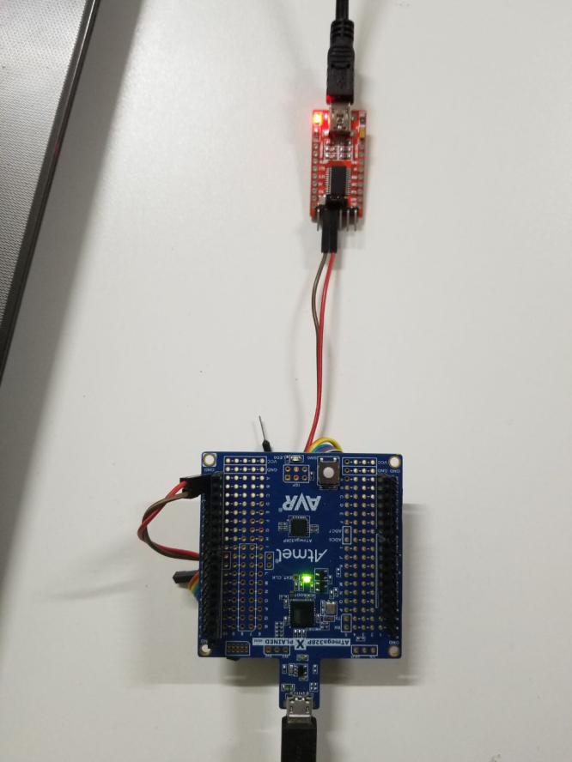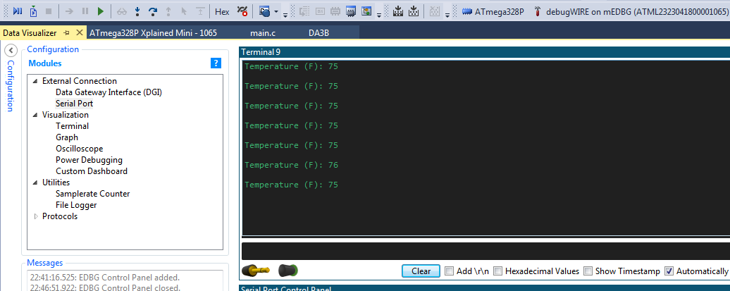

The following screenshot demonstrates the connection between ATmega 328p Xplained Mini board and FT232RL FTDI Mini USB to TTL Serial Converter.

I have not connected the Vcc and even the GND pins because both modules are connected to the same power source (same laptop).

I have connected the Tx pin of the board to the Rx port of the converter and vice versa. (Full-duplex).

The execution results are posted on YouTube, and can be found on linkes below:

<https://www.youtube.com/watch?v=JBrBitrz6e0>