CPE301 – SPRING 2019

MIDTERM 2

Student Name: Ali Aside

Student #: 5004200625

Student Email: aliasadivet@gmail.com

Primary Github address: https://github.com/aliasadivet/Submitions_DA_AliAsadi.git

Directory:

1. **COMPONENTS LIST AND CONNECTION BLOCK DIAGRAM w/ PINS**

List of Components used:

1. APDS9960
2. Esp-01 Adapter Module 3.3v 5v
3. ESP8266 ESP-01 Serial WIFI Wireless Transceiver Module
4. Atmega 328p Xplained Mini board
5. Breadboard
6. 22G jumper wires

The following picture is the connections of APDS9960 sensor and Atmega328p Xplained mini board.

Vcc-Vcc

GND-GND

SDA-CS4

SCL-CS5

Pull-up resistors(10k) from SDA and ASL to 3V on the sensor

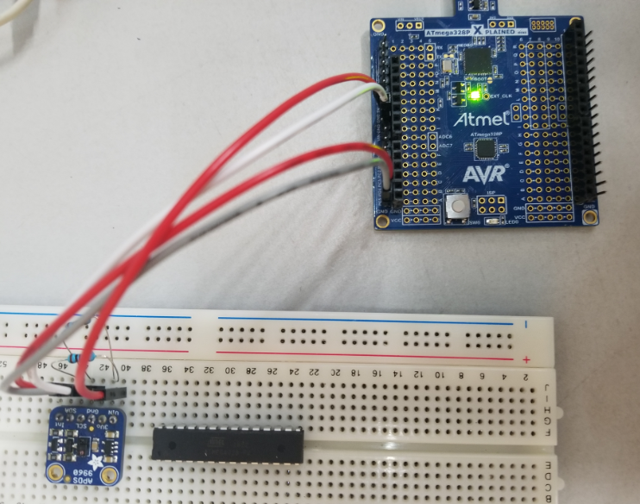

The following screenshot is the reading from the sensor. It demonstrates the intensity of light and three colors of red, green and blue respectively.

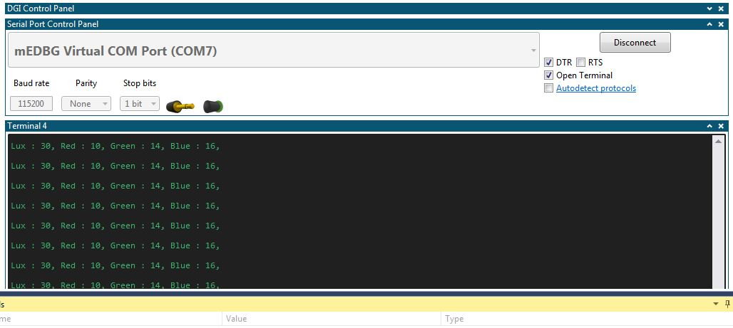

The following picture is the connections of APDS9960 sensor, Esp-01 Adapter, ESP8266 module and Atmega328p Xplained mini board.

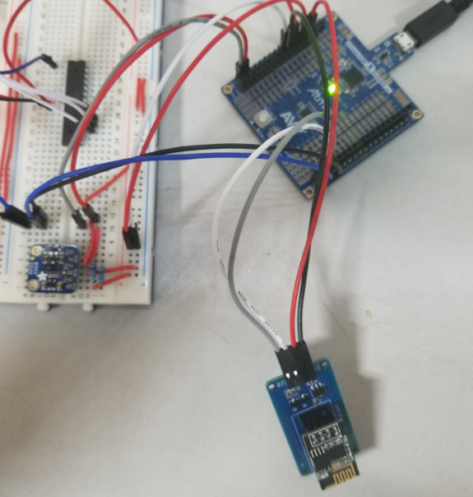

The following screenshot is the graph of Lux sensor values in Thingspeak.

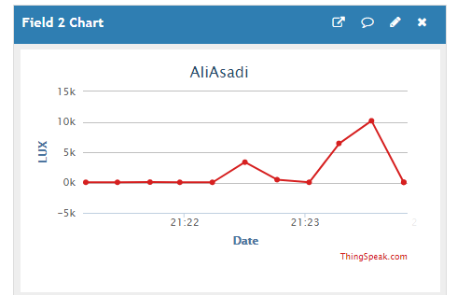

“This assignment submission is my own, original work”.

Ali Asadi