CPE301 – SPRING 2019

MIDTERM 2

Student Name: Ali Aside

Student #: 5004200625

Student Email: aliasadivet@gmail.com

Primary Github address: https://github.com/aliasadivet/Submitions_DA_AliAsadi.git

Directory:

1. **COMPONENTS LIST AND CONNECTION BLOCK DIAGRAM w/ PINS**

List of Components used:

1. APDS9960
2. Esp-01 Adapter Module 3.3v 5v
3. ESP8266 ESP-01 Serial WIFI Wireless Transceiver Module
4. Atmega 328p Xplained Mini board
5. Breadboard
6. 22G jumper wires

The following picture is the connections of APDS9960 sensor and Atmega328p Xplained mini board.

Vcc-Vcc

GND-GND

SDA-CS4

SCL-CS5

Pull-up resistors(10k) from SDA and ASL to 3V on the sensor

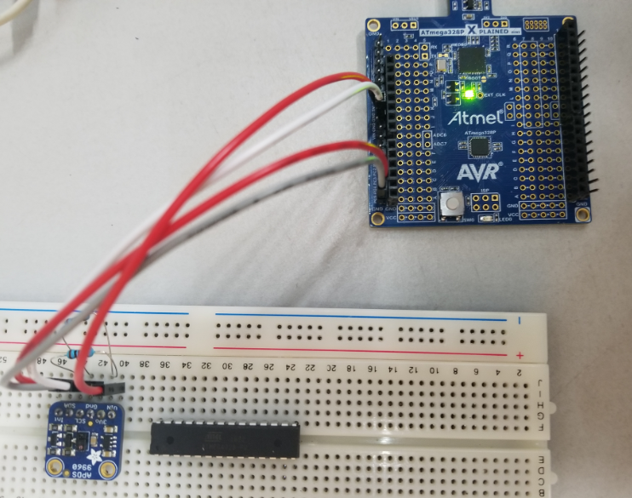

The following screenshot is the reading from the sensor. It demonstrates the intensity of light and three colors of red, green and blue respectively.

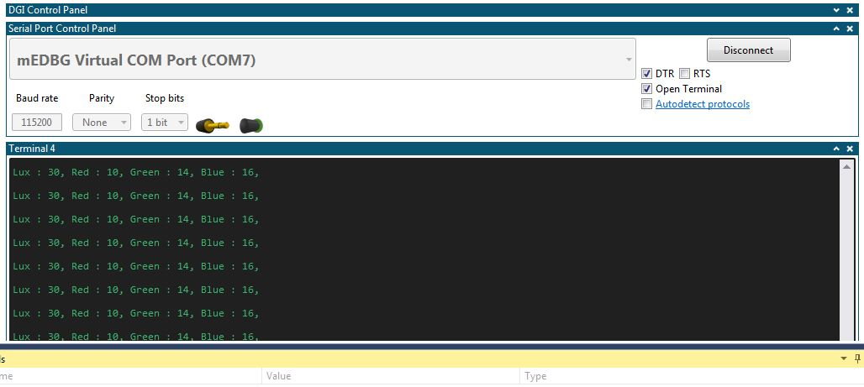

The following picture is the connections of APDS9960 sensor, Esp-01 Adapter, ESP8266 module and Atmega328p Xplained mini board.

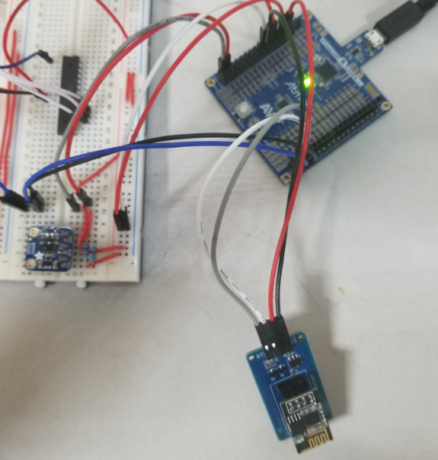

APDS9960-Atmega328p board:

Vcc-Vcc

GND-GND

SDA-CS4

SCL-CS5

Pull-up resistors(10k) from SDA and ASL to 3V on the sensor

ESP8266- Atmega328p board:

Vcc-Vcc

GND-GND

RX-TX

TX-RX

The following screenshot is the graph of Lux sensor values in Thingspeak.

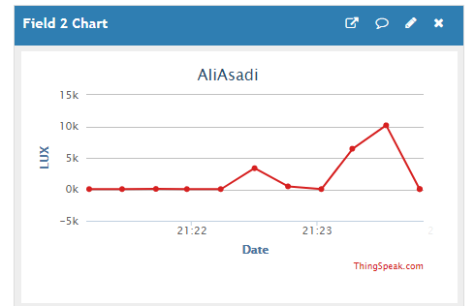

**Codes:**

**//main.c**

/*

* MT2.c

*

* Created: 5/13/2019 11:16:10 AM

* Author : Ali Asadi

*/

#include <stdlib.h>

#include <stdio.h>

#include <inttypes.h>

#include <avr/io.h>

#include <avr/interrupt.h>

#include <avr/sleep.h>

#include <String.h>

#include <util/delay.h>

#include "i2c.h"

#include "APDS9960_def.h"

#define APDS9960_WRITE (APDS9960_I2C_ADDR<<1)

#define APDS9960_READ ((APDS9960_I2C_ADDR<<1)|0x01)

void USART_init();

void USART_send(char );

void sendString(const char *);

void init_APDS9960();

*uint16_t* getreading(*uint8_t*);

void ESP_init();

void ESP_sendData(int);

char receiveString(char* ,const char* );

char buffer[128];

const char ssid[] = "\"D798BE\"", // The SSID (name) of the Wi-Fi network I connect to

pwd[] = "\"72C26B2B20500\"", // The password of the Wi-Fi network

ok[] = "\r\nOK\r\n", // OK respond after connection

sendOK[] = "\r\nSEND OK\r\n",

error[] = "ERROR",

apiKey[] = "1SFM68R6DZI4P8UG", // My channel's Write API Key

wifiMode[] = "AT+CWMODE_CUR=3",

connectWiFi[] = "AT+CWJAP_CUR=",

openTCP[] = "AT+CIPSTART=",

dataSend[] = "AT+CIPSEND=",

closeTCP[] = "AT+CIPCLOSE",

link[] = "GET /update?api_key=%s&field2=%d HTTP/1.1\r\n"

"Host: api.thingspeak.com\r\n"

"Connection: close\r\n\r\n",

send[] = "\r\n";

int main()

{

*uint8_t* status;

*uint16_t* value;

USART_init();

i2c_init(); // initialize I2C module

ESP_init(); // initialize ESP module

init_APDS9960(); // initialize APDS9960 module

while (1)

{

i2c_start(APDS9960_WRITE); // I2C start Slave Address + Write mode

i2c_write(APDS9960_STATUS); // set pointer

i2c_start(APDS9960_READ); // I2C start Slave Address + Read mode

status = i2c_read_nack(); // read status byte

i2c_stop();

if (status & 0x01) // check if Avalid Bit is Set

{

value = getreading(APDS9960_CDATAL); // read the LUX value

ESP_sendData(value) ; // sent the LUX value

}

else if ( status & 0x80) // check if saturation bit is set

{

i2c_start(APDS9960_READ);

i2c_write(APDS9960_CICLEAR); // clear all flags

i2c_stop();

i2c_start(APDS9960_READ);

i2c_write(APDS9960_AICLEAR); // clear all flags

i2c_stop();

}

*_delay_ms*(1000);

}

return 0;

}

void USART_init()

{

UCSR0B = 0x18; // TX enable

UCSR0C = 0x06; // 8 bit data

UBRR0L = 8; // Baud Rate 115200

}

void init_APDS9960(void) {

*_delay_ms*(150); /* Power up time >100ms */

i2c_start(APDS9960_WRITE); // I2C start Slave Address + Write mode

i2c_write(APDS9960_ENABLE); // set Address

i2c_write(APDS9960_PON | APDS9960_AEN | APDS9960_WEN); // enable PON, AEN, WEN

i2c_stop(); // I2C Stop

i2c_start(APDS9960_WRITE); // I2C start Slave Address + Write mode

i2c_write(APDS9960_ATIME); // set Address

i2c_write(DEFAULT_ATIME); // set adc integration time

i2c_stop(); // I2C Stop

i2c_start(APDS9960_WRITE); // I2C start Slave Address + Write mode

i2c_write(APDS9960_WTIME); // set Address

i2c_write(DEFAULT_WTIME); // set wait time

i2c_stop(); // I2C Stop

i2c_start(APDS9960_WRITE); // I2C start Slave Address + Write mode

i2c_write(APDS9960_CONFIG1); // set Address

i2c_write(DEFAULT_CONFIG1); // set Config

i2c_stop(); // I2C Stop

}

*uint16_t* getreading(*uint8_t* Register) {

*uint16_t* reading;

i2c_start(APDS9960_WRITE); // I2C start Slave Address + Write mode

i2c_write(Register); // set pointer

i2c_start(APDS9960_READ); // I2C start Slave Address + Read mode

reading = ((int)i2c_read_ack() | ((int)i2c_read_nack() << 8)); // read both low byte and High byte of 16 bit value

i2c_stop(); // I2C Stop

return reading; // return the reading

}

void USART_send(char data)

{

while (!(UCSR0A & _BV(UDRE0))); // check if the Data register is empty

UDR0 = data; // send the data

}

void sendString(const char *str)

{

while (*str) // send all the data till null Character

USART_send(*str++);

}

char USART_Receive()

{

while (!(UCSR0A & _BV(RXC0))); // wait for character in receiver

return UDR0;

}

void ESP_init()

{

sendString(wifiMode); // set wifimode = station + softAP

sendString(send);

if(!receiveString(buffer, ok))

{

return;

}

*strcpy*(buffer,connectWiFi); // connect to the router

*strcat*(buffer,ssid); // ssid

*strcat*(buffer,",");

*strcat*(buffer,pwd); // password for the router

*strcat*(buffer,send);

sendString(buffer); // connect

if(!receiveString(buffer, ok))

{

return;

}

}

void ESP_sendData(int temp)

{

*strcpy*(buffer,openTCP); // open TCP connection

*strcat*(buffer,"\"TCP\""); // type TCP

*strcat*(buffer,",");

*strcat*(buffer,"\"api.thingspeak.com\""); // host

*strcat*(buffer,",");

*strcat*(buffer,"80"); // port

*strcat*(buffer,send);

sendString(buffer); // send it to ESP

*memset*(buffer,0,128);

if(!receiveString(buffer, ok))

{

return;

}

*sprintf*(buffer,link,apiKey,temp);

char tmp[4];

*itoa*(*strlen*(buffer), tmp, 10);

*strcpy*(buffer,dataSend); // data send cmd

*strcat*(buffer,tmp); // number of data to be send

*strcat*(buffer,send);

sendString(buffer); // send to ESP

*memset*(buffer,0,128);

if(!receiveString(buffer, ok))

{

return;

}

*sprintf*(buffer,link,apiKey,temp); // send HTTP text to the ESP

*strcat*(buffer,send);

sendString(buffer);

*memset*(buffer,0,128);

if(!receiveString(buffer, sendOK))

{

return;

}

}

char receiveString(char* buffer,const char* limit)

{

char *ptr = buffer;

while(1)

{

*ptr++ = USART_Receive(); // store the received character in buffer

if(*strstr*(buffer, limit)) // check for ok

return 1;

if(*strstr*(buffer, error)) // check for error

return 0;

}

}

**//i2c.h**

#ifndef I2C_MASTER_H

#define I2C_MASTER_H

#define I2C_READ 0x01

#define I2C_WRITE 0x00

void i2c_init(void);

*uint8_t* i2c_start(*uint8_t* address);

*uint8_t* i2c_write(*uint8_t* data);

*uint8_t* i2c_read_ack(void);

*uint8_t* i2c_read_nack(void);

void i2c_stop(void);

#endif // I2C_MASTER_H

**//i2c.c**

#include <avr/io.h>

#include <util/twi.h>

#include "i2c.h"

#define F_SCL 100000UL // SCL frequency

#define Prescaler 1

#define TWBR_val ((((*F_CPU* / F_SCL) / Prescaler) - 16 ) / 2)

void i2c_init(void)

{

TWBR = (*uint8_t*)TWBR_val;

}

*uint8_t* i2c_start(*uint8_t* address)

{

// reset TWI control register

TWCR = 0;

// transmit START condition

TWCR = (1 << TWINT) | (1 << TWSTA) | (1 << TWEN);

// wait for end of transmission

while ( !(TWCR & (1 << TWINT)));

// check if the start condition was successfully transmitted

if ((TWSR & 0xF8) != *TW_START*) {

return 1;

}

// load slave address into data register

TWDR = address;

// start transmission of address

TWCR = (1 << TWINT) | (1 << TWEN);

// wait for end of transmission

while ( !(TWCR & (1 << TWINT)) );

// check if the device has acknowledged the READ / WRITE mode

*uint8_t* twst = TWSR & 0xF8;

if ( (twst != *TW_MT_SLA_ACK*) && (twst != *TW_MR_SLA_ACK*) ) return 1;

return 0;

}

*uint8_t* i2c_write(*uint8_t* data)

{

// load data into data register

TWDR = data;

// start transmission of data

TWCR = (1 << TWINT) | (1 << TWEN);

// wait for end of transmission

while ( !(TWCR & (1 << TWINT)) );

// check if data is acknowledged

if ( (TWSR & 0xF8) != *TW_MT_DATA_ACK* ) {

return 1;

}

return 0;

}

*uint8_t* i2c_read_ack(void)

{

// start TWI module and acknowledge data after reception

TWCR = (1 << TWINT) | (1 << TWEN) | (1 << TWEA);

// wait for end of transmission

while ( !(TWCR & (1 << TWINT)) );

// return received data from TWDR

return TWDR;

}

*uint8_t* i2c_read_nack(void)

{

// start receiving without acknowledging reception

TWCR = (1 << TWINT) | (1 << TWEN);

// wait for end of transmission

while ( !(TWCR & (1 << TWINT)) );

// return received data from TWDR

return TWDR;

}

void i2c_stop(void)

{

// transmit STOP condition

TWCR = (1 << TWINT) | (1 << TWEN) | (1 << TWSTO);

}

**//APDS9960_def.h**

/**

* @file SparkFun_APDS-9960.h

* @brief Library for the SparkFun APDS-9960 breakout board

* @author Shawn Hymel (SparkFun Electronics)

*

* @copyright This code is public domain but you buy me a beer if you use

* this and we meet someday (Beerware license).

*

* This library interfaces the Avago APDS-9960 to Arduino over I2C. The library

* relies on the Arduino Wire (I2C) library. to use the library, instantiate an

* APDS9960 object, call init(), and call the appropriate functions.

*/

#ifndef SparkFun_APDS9960_H

#define SparkFun_APDS9960_H

/* APDS-9960 I2C address */

#define APDS9960_I2C_ADDR 0x39

/* Gesture parameters */

#define GESTURE_THRESHOLD_OUT 10

#define GESTURE_SENSITIVITY_1 50

#define GESTURE_SENSITIVITY_2 20

/* Error code for returned values */

#define ERROR 0xFF

/* Acceptable device IDs */

#define APDS9960_ID_1 0xAB

#define APDS9960_ID_2 0x9C

/* Misc parameters */

#define FIFO_PAUSE_TIME 30 // Wait period (ms) between FIFO reads

/* APDS-9960 register addresses */

#define APDS9960_ENABLE 0x80

#define APDS9960_ATIME 0x81

#define APDS9960_WTIME 0x83

#define APDS9960_AILTL 0x84

#define APDS9960_AILTH 0x85

#define APDS9960_AIHTL 0x86

#define APDS9960_AIHTH 0x87

#define APDS9960_PILT 0x89

#define APDS9960_PIHT 0x8B

#define APDS9960_PERS 0x8C

#define APDS9960_CONFIG1 0x8D

#define APDS9960_PPULSE 0x8E

#define APDS9960_CONTROL 0x8F

#define APDS9960_CONFIG2 0x90

#define APDS9960_ID 0x92

#define APDS9960_STATUS 0x93

#define APDS9960_CDATAL 0x94

#define APDS9960_CDATAH 0x95

#define APDS9960_RDATAL 0x96

#define APDS9960_RDATAH 0x97

#define APDS9960_GDATAL 0x98

#define APDS9960_GDATAH 0x99

#define APDS9960_BDATAL 0x9A

#define APDS9960_BDATAH 0x9B

#define APDS9960_PDATA 0x9C

#define APDS9960_POFFSET_UR 0x9D

#define APDS9960_POFFSET_DL 0x9E

#define APDS9960_CONFIG3 0x9F

#define APDS9960_GPENTH 0xA0

#define APDS9960_GEXTH 0xA1

#define APDS9960_GCONF1 0xA2

#define APDS9960_GCONF2 0xA3

#define APDS9960_GOFFSET_U 0xA4

#define APDS9960_GOFFSET_D 0xA5

#define APDS9960_GOFFSET_L 0xA7

#define APDS9960_GOFFSET_R 0xA9

#define APDS9960_GPULSE 0xA6

#define APDS9960_GCONF3 0xAA

#define APDS9960_GCONF4 0xAB

#define APDS9960_GFLVL 0xAE

#define APDS9960_GSTATUS 0xAF

#define APDS9960_IFORCE 0xE4

#define APDS9960_PICLEAR 0xE5

#define APDS9960_CICLEAR 0xE6

#define APDS9960_AICLEAR 0xE7

#define APDS9960_GFIFO_U 0xFC

#define APDS9960_GFIFO_D 0xFD

#define APDS9960_GFIFO_L 0xFE

#define APDS9960_GFIFO_R 0xFF

/* Bit fields */

#define APDS9960_PON 0b00000001

#define APDS9960_AEN 0b00000010

#define APDS9960_PEN 0b00000100

#define APDS9960_WEN 0b00001000

#define APSD9960_AIEN 0b00010000

#define APDS9960_PIEN 0b00100000

#define APDS9960_GEN 0b01000000

#define APDS9960_GVALID 0b00000001

/* On/Off definitions */

#define OFF 0

#define ON 1

/* Acceptable parameters for setMode */

#define POWER 0

#define AMBIENT_LIGHT 1

#define PROXIMITY 2

#define WAIT 3

#define AMBIENT_LIGHT_INT 4

#define PROXIMITY_INT 5

#define GESTURE 6

#define ALL 7

/* LED Drive values */

#define LED_DRIVE_100MA 0

#define LED_DRIVE_50MA 1

#define LED_DRIVE_25MA 2

#define LED_DRIVE_12_5MA 3

/* Proximity Gain (PGAIN) values */

#define PGAIN_1X 0

#define PGAIN_2X 1

#define PGAIN_4X 2

#define PGAIN_8X 3

/* ALS Gain (AGAIN) values */

#define AGAIN_1X 0

#define AGAIN_4X 1

#define AGAIN_16X 2

#define AGAIN_64X 3

/* Gesture Gain (GGAIN) values */

#define GGAIN_1X 0

#define GGAIN_2X 1

#define GGAIN_4X 2

#define GGAIN_8X 3

/* LED Boost values */

#define LED_BOOST_100 0

#define LED_BOOST_150 1

#define LED_BOOST_200 2

#define LED_BOOST_300 3

/* Gesture wait time values */

#define GWTIME_0MS 0

#define GWTIME_2_8MS 1

#define GWTIME_5_6MS 2

#define GWTIME_8_4MS 3

#define GWTIME_14_0MS 4

#define GWTIME_22_4MS 5

#define GWTIME_30_8MS 6

#define GWTIME_39_2MS 7

/* Default values */

#define DEFAULT_ATIME 219 // 103ms

#define DEFAULT_WTIME 246 // 27ms

#define DEFAULT_PROX_PPULSE 0x87 // 16us, 8 pulses

#define DEFAULT_GESTURE_PPULSE 0x89 // 16us, 10 pulses

#define DEFAULT_POFFSET_UR 0 // 0 offset

#define DEFAULT_POFFSET_DL 0 // 0 offset

#define DEFAULT_CONFIG1 0x60 // No 12x wait (WTIME) factor

#define DEFAULT_LDRIVE LED_DRIVE_100MA

#define DEFAULT_PGAIN PGAIN_4X

#define DEFAULT_AGAIN AGAIN_4X

#define DEFAULT_PILT 0 // Low proximity threshold

#define DEFAULT_PIHT 50 // High proximity threshold

#define DEFAULT_AILT 0xFFFF // Force interrupt for calibration

#define DEFAULT_AIHT 0

#define DEFAULT_PERS 0x11 // 2 consecutive prox or ALS for int.

#define DEFAULT_CONFIG2 0x01 // No saturation interrupts or LED boost

#define DEFAULT_CONFIG3 0 // Enable all photodiodes, no SAI

#define DEFAULT_GPENTH 40 // Threshold for entering gesture mode

#define DEFAULT_GEXTH 30 // Threshold for exiting gesture mode

#define DEFAULT_GCONF1 0x40 // 4 gesture events for int., 1 for exit

#define DEFAULT_GGAIN GGAIN_4X

#define DEFAULT_GLDRIVE LED_DRIVE_100MA

#define DEFAULT_GWTIME GWTIME_2_8MS

#define DEFAULT_GOFFSET 0 // No offset scaling for gesture mode

#define DEFAULT_GPULSE 0xC9 // 32us, 10 pulses

#define DEFAULT_GCONF3 0 // All photodiodes active during gesture

#define DEFAULT_GIEN 0 // Disable gesture interrupts

#endif

The executions can be found in the linkes below:

<https://youtu.be/g_29rlQqzrw>

<https://youtu.be/TqGbmpHdRyQ>

“This assignment submission is my own, original work”.

Ali Asadi