POKEMON ENHANCED HEART GOLD
Pokémon Enhanced HeartGold is a Romhack inspired by Smith Playz’s Pokémon Legacy series; it is focused on making the game more replayable with more quality of life improvements. List of features changed:
- Gym Leaders: New teams, items and movesets for all 8 Johto leaders and all 8 Kanto leaders
- Team Rocket new built teams, new teams for executives and grunts, expanded story and rocket executives in Kanto
- General trainers Level curve, evolutions, better movesets, aiming to make level curve better and straight forward to avoid grinding and improve gameplay
- Move changes
- Game mechanics

Gameplay Changes:
- Reuse Repel after use
- Tms no longer break
- You can skip guide gent tutorial
- Chuck Jasmine and pryce have lvl scaling so you fight them in any order without any disadvantage
- New Static Pokemon in routes and dungeons
- Crits now deal 1.5x damage
- Master’s Dratini is lv 28, and shiny if you answer every quiz question right
- Bill’s eevee is lvl 25
- You can now battle Lyra/Ethan six times: four during the story (including a new scene and battle in Mahogany Town) and two in New Bark Town after the E4
- New Silver battle in Blackthorn
- GS Ball with Kurt if you give him 5 apricorns after E4 he will give you gs ball use it on the shrine you will awaken celebi
- Celebi event accessible with this Celebi
- Mew is capturable after defeating Blue: talk to Prof. Oak and he will give you the Mystic Flute. Surf into the water channel between the piers below the Vermilion Gym and play it; Mew appears and waits, talk to it to battle
- Hms forgettable
- Move reminder+ move deleter shift to ecruteak city
- Eusine has new battle in route 42. A new encounter in new bark town and a battle and has a revamped team and final battle before suicune,
- Johto gym rematches occur after E4 no phonecall needed and they are in their gyms, same for Kanto
- Much more Variety for pokemon in routes
- Trainers have less duplicates and more johto pokemon
- Solved lvl curve and should be around mid 40s by E4
- Soul Silver Pokemon exclusives added
- Many pokemon like skarmory houndour Sneasel, Murkrow can be obtained pre E4
- New Berry seller in Goldenrod she sells oran and status berries then after 7 badges lum and sitrus berry is added
- Stones are now much more accessible after 3rd gym in goldenrod department store you can buy thunder fire leaf water sun and moon stones (in the vitamin sections). After 7th gym badge Shiny Dusk and dawn stones are added
- Daycare guy gives you a egg which has a 12% percent shiny rate and it has chances of hatching elekid,magby, smoochum, phanpy and Pichu
- Weather changes, weather occurs more in routes and cities in Johto
- Follower pokemon now react to landmarks in johto and with friendship can cure status in overworld and can gift you items
- Vitamins price decreased to 5000
- Game corner now has money to coin converter and porygon added in goldenrod game corner at a reduced price (now 3k)
- Trainer lvl across both johto and kanto increased to increase exp for lvl curve
- Wild Pokemon lvls increased beyond Ecruteak city and in kanto boosted to reach 40s
- Trainers have more varied teams and pokemon
- More pokemon variety in Routes
- Nurse added in Radio tower (team rocket takeover) to make healing easier.
- You can now get a metal coat in Olivine city and after mahogany battle Lyra will give you a Kings Rock
- Lyra will give you a lucky egg in goldenrod tunnel post battle
- No trade evolutions: trade Pokémon evolve by level (Kadabra and Haunter at lv 38, Machoke and Graveler at lv 36) and trade items like King’s Rock, Metal Coat and Dragon Scale are used directly from the Bag
- Mr. Pokémon asks you to take an Egg to Bill’s family in Goldenrod after the Hive Badge (rewards: Up-Grade from Bill, Rare Candy from Mr. Pokémon)
- Elder Li in Sprout Tower trades his Victreebel for your Bellossom after the Fog Badge
- Bill battles you in his Goldenrod house after the E4 with his Eeveelutions and gives you the Dubious Disc
- Silver and you team up against Lance and Clair in Dragon’s Den, and Silver has a rematch at Indigo Plateau
- A man at Indigo Plateau gives you 5 Rare Candies before the Elite Four
- Gym guides now give hints about each Leader’s team and surprise moves
- Johto Gym Leaders’ phone calls are now short personal stories
- Kanto Gym Leaders have daily rematches in their Gyms once you have their badge (lv 65-70)
- Route 44, Route 45 and Ice Path levels raised, with 2 new Ice Path trainers
- Your friend’s following Pokémon is an Azumarill from the Mahogany battle on
- Many weak learnsets fixed: Pokémon that had no move of their own type by level-up until late now get one
- Leafeon (Leaf Stone), Glaceon (NeverMeltIce, used from the Bag) and Magnezone (Thunder Stone) can now be evolved in HeartGold
- Wild Gligar hold a Razor Fang and wild Sneasel a Razor Claw (5%), so Gliscor and Weavile no longer need the Battle Frontier
- Stat buffs for 22 more Pokémon: the official Gen 6/7 increases, plus Jumpluff, Granbull, Girafarig and Stantler; Jumpluff also learns Air Cutter, Giga Drain and Bounce earlier
- Steven Stone challenges you in Vermilion City (after the Fan Club's Lost Item; you can say no) and again at Silph Co. after you beat Red, with his Champion music; afterwards he waits in Diglett's Cave and gives you a Beldum
- Mr. Fuji gives you the Enigma Stone after you beat Steven, which unlocks Steven's Latios event in the Pewter Museum so that event is now accessible

Story Changes
Lance now appears more; he has a new appearance in goldenrod city and he will remark you defeating Team Rocket in Slowpoke well, he also appears in celadon city in Kanto in Post Game, he will foreshadow you battling Red, Lance will also appear in dragons den in the shrine he will be the one to make clair give the badge instead of the master and acknowledge the player.
Silver has a new battle in Blackthorn city, his story is expanded and enhanced, he realizes the player’s strengths and finds out what he was lacking when you find him in Kanto in Mt moon, he has an improved team and evolves his Golbat into a Crobat.

Giovanni now appears in the Radio Tower after you beat Archer. He tells Archer that he ended Team Rocket three years ago after losing to a child, that he isn’t finished with his training, and to stop this foolishness. Then he tells you that you remind him of that child and that you will meet again.
Team Rocket Executives are now in Kanto after Radio Tower they are finding their new path and life after looking for Giovanni and Team Rocket their locations are like this:
- Petrel Vermilion, disguised as a sailor in celadon restaurant and then finally Fuchsia city
- Proton Rock Tunnel, Mt Moon and he is the one to give you the machine part and he will appear in nugget bridge after chasing the rocket grunt there
- Ariana She is in cerulean cape and will battle you, next she is in Pewter Museum and then finally at cinnabar island
- Archer He is in Cerulean Cave waiting for you

Eusine and Morty have expanded character scenes, Eusine has new scene in new bark town post Ho-Oh, his dialogues are improved, Morty appear after you battle Ho-Oh and he is proud of the player for realizing his dream of seeing Ho-Oh, Morty also appears in Route 42 after Eusine battle(note I added him there since Ecruteak is nearby from there and Eusine is his friend)

New Blue scenes, Blue and Silver have a new scene in the Viridian gym it’s a top tier scene I won’t spoil it but to get it beat Silver in Mt Moon and then beat Blue at the Viridian Gym. After Beating Red in Mt Silver, he will appear in his house with his Pikachu and Professor Oak and Blue will show up and talk about him, Another good scene. Blue will also give you Rock climb instead of Prof Oak in the lab.

GYM LEADERS
Gym leaders were heavily lacking Johto Pokemon in base Hgss, I added more johto pokemon to them while keeping Kanto pokemon, like Pidgeotto for Falkner and Scyther for Bugsy, expect fights to be more challenging but still fair and exciting to playthrough. Kanto Gym leaders were heavily buffed and are now champion level. They can be tough and expect some difficulty I kept their original team and expanded it and added some johto pokemon when applicable like Politoed for Misty. The main goal was to make it more engaging and rewarding for the player while not making it crazy hard I tired really hard to have a balance between fun and hard.

Johto Gym Leaders

Falkner Violet City (Zephyr Badge) · TM: Roost
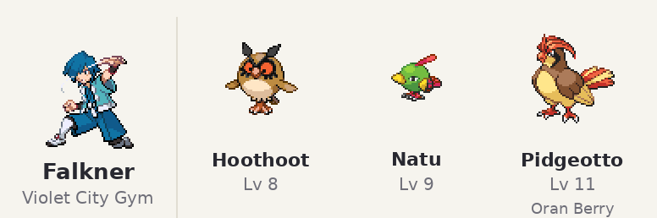
Pokémon | Lv | Item | Moves
Hoothoot | 8 |  | Tackle, Growl, Roost, Foresight
Natu | 9 |  | Peck, Night Shade, Roost, Teleport
Pidgeotto | 11 | Oran Berry | Roost, Tackle, Gust, Mud-Slap

Bugsy Azalea Town (Hive Badge) · TM: U-turn
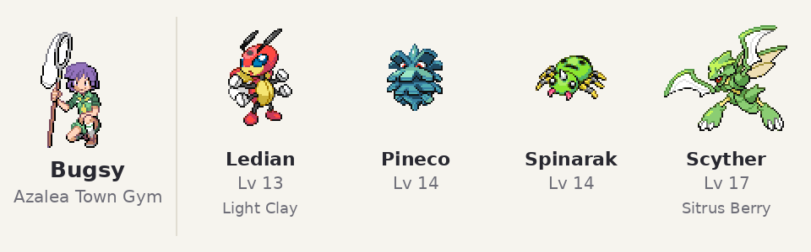
Pokémon | Lv | Item | Moves
Ledian | 13 | Light Clay | U-turn, Light Screen, Comet Punch, Supersonic
Pineco | 14 |  | Mega Drain, Protect, Bug Bite, Take Down
Spinarak | 14 |  | Poison Sting, Scary Face, Bug Bite, String Shot
Scyther | 17 | Sitrus Berry | U-turn, Quick Attack, Leer, Aerial Ace

Whitney Goldenrod City (Plain Badge) · TM: Attract
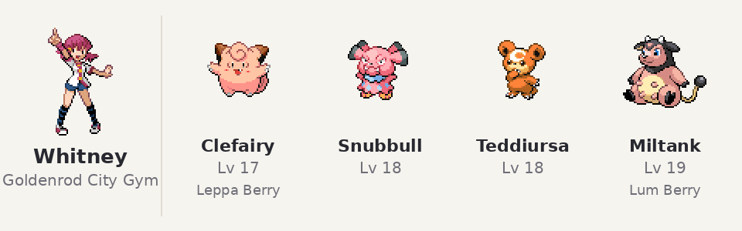
Pokémon | Lv | Item | Moves
Clefairy | 17 | Leppa Berry | DoubleSlap, Encore, Sing, Attract
Snubbull | 18 |  | Bite, Scary Face, Attract, Thunder Wave
Teddiursa | 18 |  | Attract, Fury Swipes, Faint Attack, Fake Tears
Miltank | 19 | Lum Berry | Rollout, Milk Drink, Stomp, Attract

Morty Ecruteak City (Fog Badge) · TM: Shadow Ball
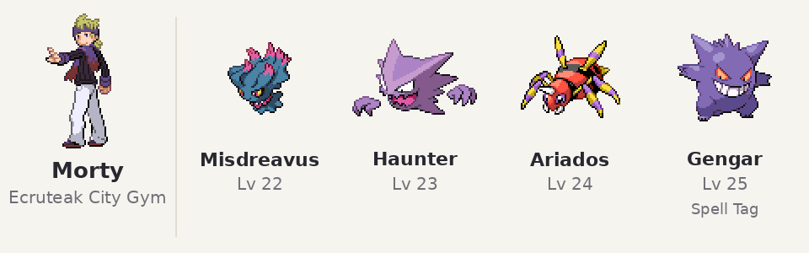
Pokémon | Lv | Item | Moves
Misdreavus | 22 |  | Confuse Ray, Astonish, Shadow Ball, Mean Look
Haunter | 23 |  | Night Shade, Hypnosis, Dream Eater, Shadow Ball
Ariados | 24 |  | Shadow Sneak, Poison Jab, Night Shade, Cut
Gengar | 25 | Spell Tag | Night Shade, Sucker Punch, Confuse Ray, Hypnosis

Chuck Cianwood City (Storm Badge) · TM: Focus Punch
Chuck, Jasmine and Pryce scale with your badge order (5th badge 2730, 6th 3133, 7th 3235). Shown at their usual slot.You can battle these three with scaling lvls depending on when you want to fight them.
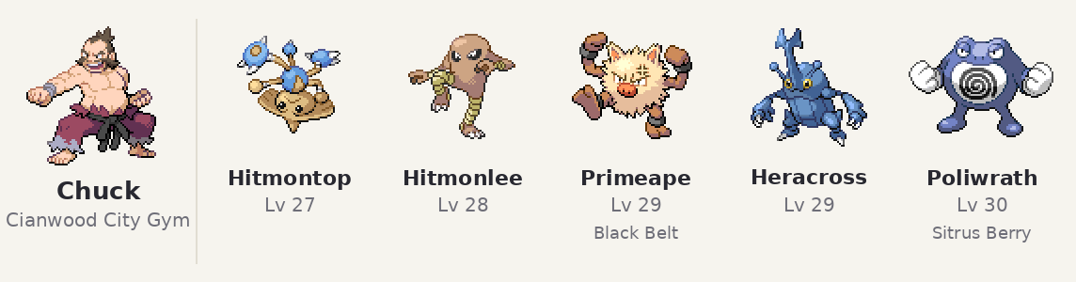
Pokémon | Lv | Item | Moves
Hitmontop | 27 |  | Triple Kick, Pursuit, Quick Attack, Rolling Kick
Hitmonlee | 28 |  | Brick Break, Focus Punch, Rolling Kick, Double Kick
Primeape | 29 | Black Belt | Seismic Toss, Assurance, Karate Chop, Focus Punch
Heracross | 29 |  | Aerial Ace, Brick Break, Rock Tomb, Focus Punch
Poliwrath | 30 | Sitrus Berry | Submission, Waterfall, Hypnosis, Ice Punch

Jasmine Olivine City (Mineral Badge) · TM: Iron Tail
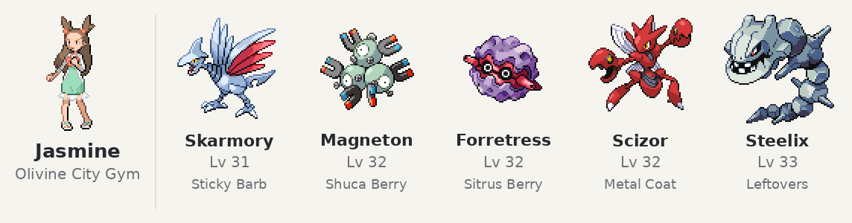
Pokémon | Lv | Item | Moves
Skarmory | 31 | Sticky Barb | Spikes, Agility, Air Cutter, Rain Dance
Magneton | 32 | Shuca Berry | Spark, Tri Attack, Thunder Wave, Supersonic
Forretress | 32 | Sitrus Berry | Spikes, Gyro Ball, Toxic, Rapid Spin
Scizor | 32 | Metal Coat | Bullet Punch, Pursuit, Metal Claw, X-Scissor
Steelix | 33 | Leftovers | Iron Tail, Earthquake, Rock Tomb, Sandstorm

Pryce Mahogany Town (Glacier Badge) · TM: Hail
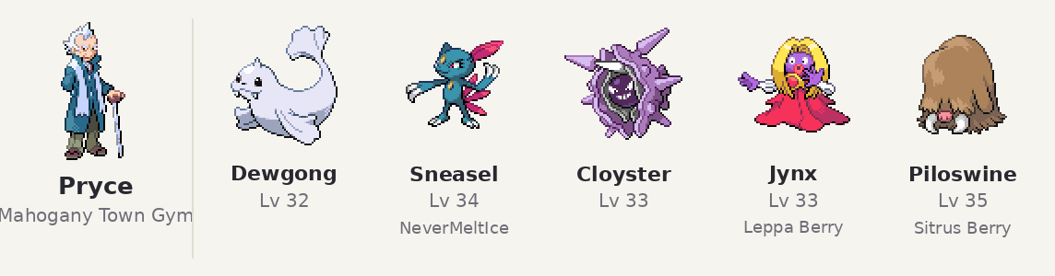
Pokémon | Lv | Item | Moves
Dewgong | 32 |  | Ice Shard, Aqua Jet, Aurora Beam, Hail
Sneasel | 34 | NeverMeltIce | Icy Wind, Faint Attack, Quick Attack, Hail
Cloyster | 33 |  | Aurora Beam, Supersonic, Toxic Spikes, Hail
Jynx | 33 | Leppa Berry | Ice Punch, Lovely Kiss, Psychic, Hail
Piloswine | 35 | Sitrus Berry | Avalanche, Hail, Icy Wind, Blizzard

Clair Blackthorn City (Rising Badge) · TM: Dragon Pulse
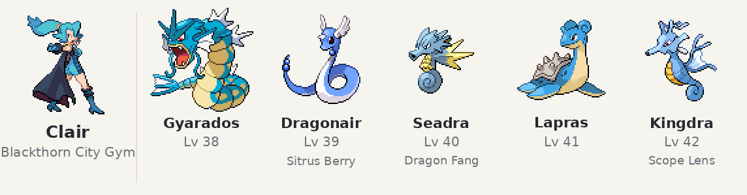
Pokémon | Lv | Item | Moves
Gyarados | 38 |  | Ice Fang, Bite, Aqua Tail, Dragon Pulse
Dragonair | 39 | Sitrus Berry | Dragon Pulse, Thunder Wave, Aqua Tail, Slam
Seadra | 40 | Dragon Fang | Dragon Pulse, Surf, Agility, Twister
Lapras | 41 |  | Ice Beam, Surf, Dragon Pulse, Sing
Kingdra | 42 | Scope Lens | Dragon Pulse, Hydro Pump, SmokeScreen, Ice Beam

Johto rematches (After E4 and becoming Champion)

Falkner rematch
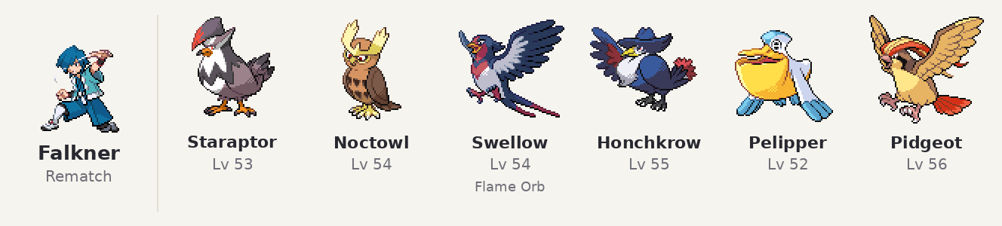
Pokémon | Lv | Item | Moves
Staraptor | 53 |  | Brave Bird, Close Combat, U-turn, Quick Attack
Noctowl | 54 |  | Air Slash, Shadow Ball, Psychic, Roost
Swellow | 54 | Flame Orb | Facade, Aerial Ace, U-turn, Quick Attack
Honchkrow | 55 |  | Night Slash, Sucker Punch, Aerial Ace, Shadow Ball
Pelipper | 52 |  | Surf, Ice Beam, Tailwind, U-turn
Pidgeot | 56 |  | Brave Bird, Return, Heat Wave, Roost

Bugsy rematch
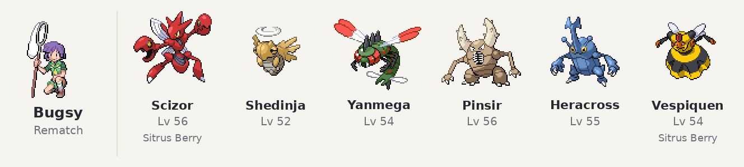
Pokémon | Lv | Item | Moves
Scizor | 56 | Sitrus Berry | Bullet Punch, X-Scissor, Swords Dance, Superpower
Shedinja | 52 |  | X-Scissor, Shadow Sneak, Shadow Claw, Toxic
Yanmega | 54 |  | Bug Buzz, Air Slash, AncientPower, U-turn
Pinsir | 56 |  | X-Scissor, Earthquake, Stone Edge, Superpower
Heracross | 55 |  | Close Combat, Megahorn, Stone Edge, Night Slash
Vespiquen | 54 | Sitrus Berry | Attack Order, Defend Order, Power Gem, Aerial Ace

Whitney rematch
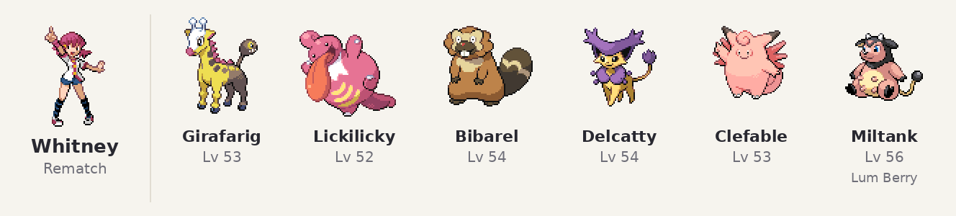
Pokémon | Lv | Item | Moves
Girafarig | 53 |  | Psychic, Shadow Ball, Calm Mind, Thunderbolt
Lickilicky | 52 |  | Wring Out, Flamethrower, Ice Beam, Thunderbolt
Bibarel | 54 |  | Waterfall, Hyper Fang, Superpower, Iron Tail
Delcatty | 54 |  | Fake Out, Return, Iron Tail, Shadow Ball
Clefable | 53 |  | Ice Beam, Thunderbolt, Flamethrower, Calm Mind
Miltank | 56 | Lum Berry | Body Slam, Milk Drink, Earthquake, Zen Headbutt

Morty rematch
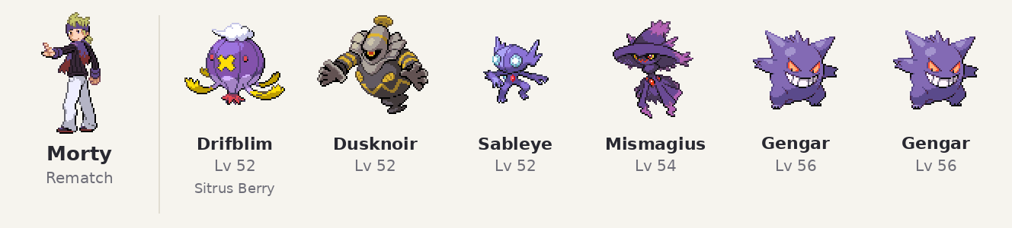
Pokémon | Lv | Item | Moves
Drifblim | 52 | Sitrus Berry | Shadow Ball, Thunderbolt, Psychic, Substitute
Dusknoir | 52 |  | Shadow Punch, Earthquake, Ice Punch, Will-O-Wisp
Sableye | 52 |  | Shadow Claw, Sucker Punch, Fake Out, Brick Break
Mismagius | 54 |  | Shadow Ball, Thunderbolt, Psychic, Confuse Ray
Gengar | 56 |  | Shadow Ball, Focus Blast, Sludge Bomb, Hypnosis
Gengar | 56 |  | Shadow Ball, Thunderbolt, Dark Pulse, Destiny Bond

Chuck rematch
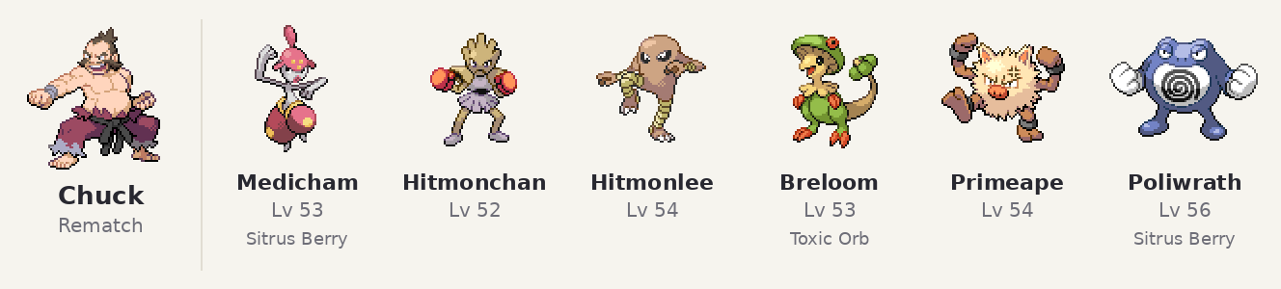
Pokémon | Lv | Item | Moves
Medicham | 53 | Sitrus Berry | Hi Jump Kick, Psycho Cut, ThunderPunch, Ice Punch
Hitmonchan | 52 |  | Sky Uppercut, Mach Punch, ThunderPunch, Ice Punch
Hitmonlee | 54 |  | Close Combat, Blaze Kick, Stone Edge, Fake Out
Breloom | 53 | Toxic Orb | Seed Bomb, Drain Punch, Mach Punch, Stone Edge
Primeape | 54 |  | Close Combat, U-turn, Stone Edge, Earthquake
Poliwrath | 56 | Sitrus Berry | Waterfall, Brick Break, Earthquake, Hypnosis

Jasmine rematch
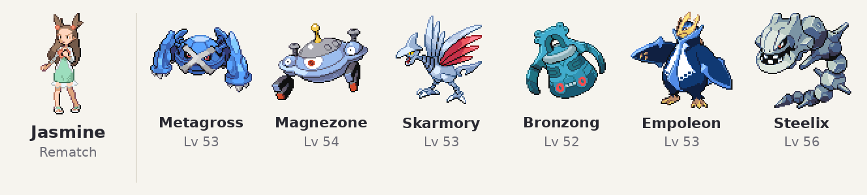
Pokémon | Lv | Item | Moves
Metagross | 53 |  | Meteor Mash, Bullet Punch, Earthquake, Hammer Arm
Magnezone | 54 |  | Thunderbolt, Flash Cannon, Mirror Coat, Discharge
Skarmory | 53 |  | Steel Wing, Night Slash, Aerial Ace, Spikes
Bronzong | 52 |  | Gyro Ball, Extrasensory, Earthquake, Hypnosis
Empoleon | 53 |  | Surf, Ice Beam, Flash Cannon, Aqua Jet
Steelix | 56 |  | Iron Tail, Stone Edge, Earthquake, Crunch

Pryce rematch
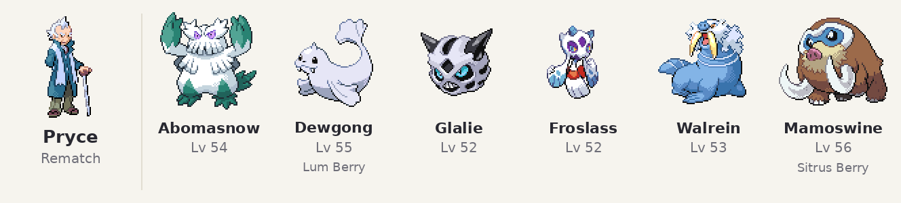
Pokémon | Lv | Item | Moves
Abomasnow | 54 |  | Ice Shard, Wood Hammer, Earthquake, Blizzard
Dewgong | 55 | Lum Berry | Surf, Ice Beam, Signal Beam, Aqua Jet
Glalie | 52 |  | Ice Beam, Crunch, Earthquake, Shadow Ball
Froslass | 52 |  | Ice Beam, Shadow Ball, Thunderbolt, Ice Shard
Walrein | 53 |  | Surf, Ice Beam, Earthquake, Body Slam
Mamoswine | 56 | Sitrus Berry | Earthquake, Avalanche, Stone Edge, Ice Fang

Clair rematch
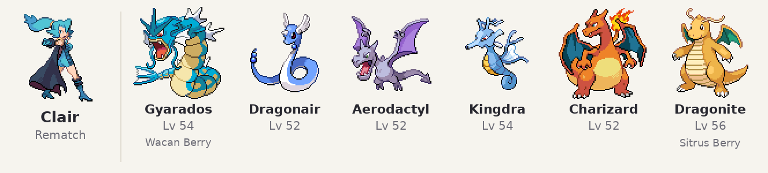
Pokémon | Lv | Item | Moves
Gyarados | 54 | Wacan Berry | Dragon Dance, Waterfall, Earthquake, Ice Fang
Dragonair | 52 |  | Dragon Rush, Aqua Tail, Iron Tail, Thunder Wave
Aerodactyl | 52 |  | Rock Slide, Earthquake, Crunch, Fire Fang
Kingdra | 54 |  | Surf, Dragon Pulse, Ice Beam, Yawn
Charizard | 52 |  | Flamethrower, Air Slash, Dragon Pulse, Focus Blast
Dragonite | 56 | Sitrus Berry | Dragon Claw, Earthquake, Fire Punch, ThunderPunch

Kanto Gym Leaders

Lt. Surge Vermilion City (Thunder Badge)
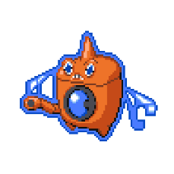
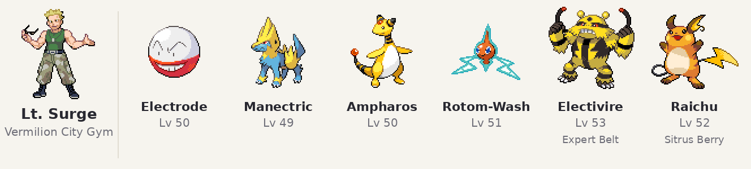
Pokémon | Lv | Item | Moves
Electrode | 50 |  | Signal Beam, Thunderbolt, Taunt, Explosion
Manectric | 49 |  | Thunderbolt, Flamethrower, Bite, Thunder Wave
Ampharos | 50 |  | Thunderbolt, Signal Beam, Power Gem, Focus Blast
RotomWash | 51 |  | Hydro Pump, Shadow Ball, Thunderbolt, Will-O-Wisp
Electivire | 53 | Expert Belt | Thunderbolt, Ice Punch, Fire Punch, Earthquake
Raichu | 52 | Sitrus Berry | Thunderbolt, Surf, Focus Blast, Quick Attack

Sabrina Saffron City (Marsh Badge)
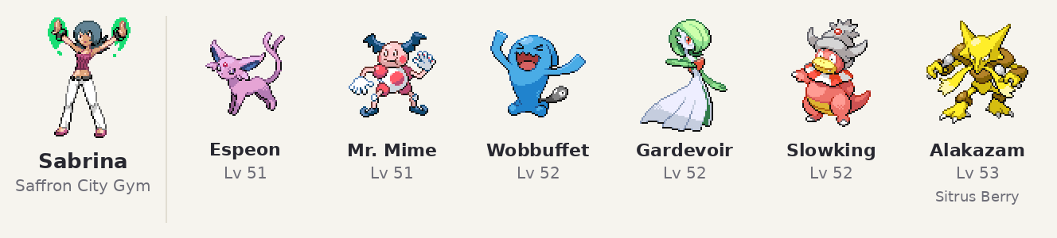
Pokémon | Lv | Item | Moves
Espeon | 51 |  | Psychic, Shadow Ball, Signal Beam, Calm Mind
Mr. Mime | 51 |  | Psychic, Thunderbolt, Reflect, Light Screen
Wobbuffet | 52 |  | Counter, Mirror Coat, Encore, Destiny Bond
Gardevoir | 52 |  | Psychic, Focus Blast, Thunderbolt, Thunder Wave
Slowking | 52 |  | Surf, Psychic, Ice Beam, Slack Off
Alakazam | 53 | Sitrus Berry | Psychic, Focus Blast, Shadow Ball, Recover

Misty Cerulean City (Cascade Badge)
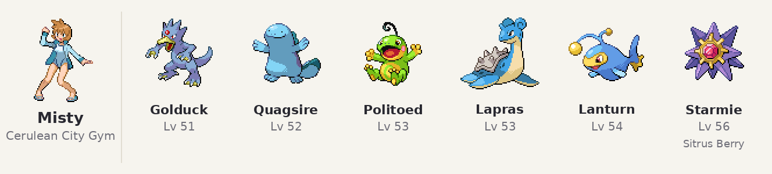
Pokémon | Lv | Item | Moves
Golduck | 51 |  | Rain Dance, Surf, Psychic, Hypnosis
Quagsire | 52 |  | Earthquake, Waterfall, Ice Punch, Yawn
Politoed | 53 |  | Rain Dance, Surf, Ice Beam, Hypnosis
Lapras | 53 |  | Hydro Pump, Ice Beam, Thunder, Sing
Lanturn | 54 |  | Thunderbolt, Surf, Ice Beam, Confuse Ray
Starmie | 56 | Sitrus Berry | Hydro Pump, Psychic, Thunderbolt, Ice Beam

Erika Celadon City (Rainbow Badge).
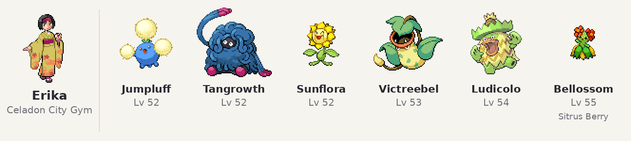
Pokémon | Lv | Item | Moves
Jumpluff | 52 |  | Sleep Powder, Sunny Day, Bounce, Leech Seed
Tangrowth | 52 |  | Giga Drain, Rock Slide, Sludge Bomb, Stun Spore
Sunflora | 52 |  | Sunny Day, SolarBeam, Earth Power, Sludge Bomb
Victreebel | 53 |  | SolarBeam, Weather Ball, Sludge Bomb, Sucker Punch
Ludicolo | 54 |  | Surf, Energy Ball, Ice Beam, Toxic
Bellossom | 55 | Sitrus Berry | SolarBeam, Sludge Bomb, Moonlight, Stun Spore

Janine Fuchsia City (Soul Badge)
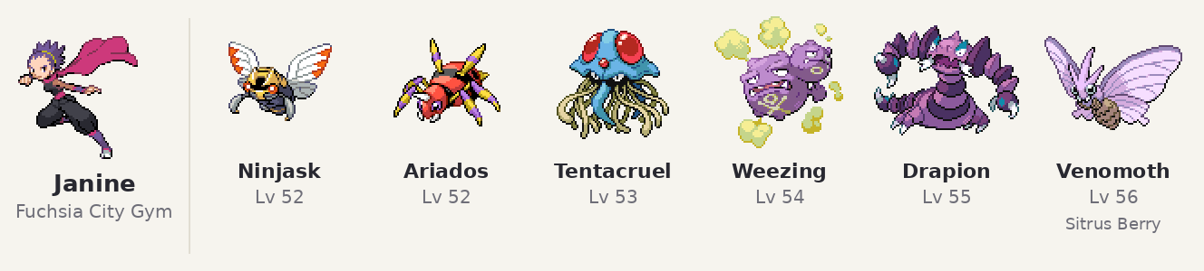
Pokémon | Lv | Item | Moves
Ninjask | 52 |  | X-Scissor, Aerial Ace, Toxic, Protect
Ariados | 52 |  | Shadow Sneak, Sucker Punch, Poison Jab, Night Shade
Tentacruel | 53 |  | Toxic Spikes, Surf, Sludge Bomb, Giga Drain
Weezing | 54 |  | Sludge Bomb, Fire Blast, Thunderbolt, Explosion
Drapion | 55 |  | Cross Poison, Night Slash, Ice Fang, Earthquake
Venomoth | 56 | Sitrus Berry | Bug Buzz, Psychic, Sleep Powder, Double Team

Brock Pewter City (Boulder Badge)
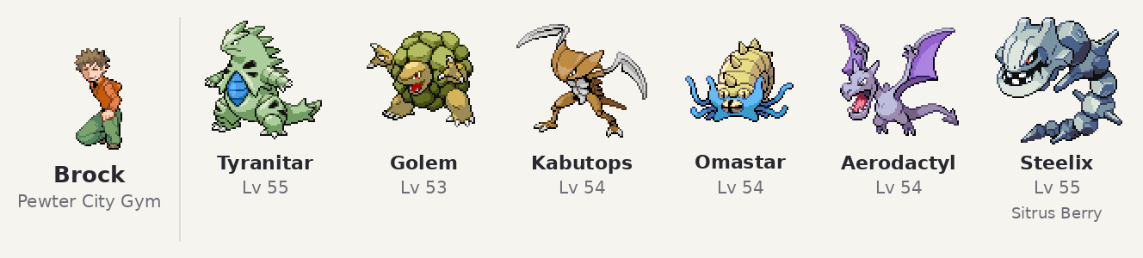
Pokémon | Lv | Item | Moves
Tyranitar | 55 |  | Crunch, Rock Slide, Earthquake, Fire Punch
Golem | 53 |  | Earthquake, Stone Edge, Sucker Punch, Explosion
Kabutops | 54 |  | Aqua Jet, Waterfall, Stone Edge, Swords Dance
Omastar | 54 |  | Surf, Ice Beam, AncientPower, Earth Power
Aerodactyl | 54 |  | Rock Slide, Earthquake, Aerial Ace, Ice Fang
Steelix | 55 | Sitrus Berry | Iron Head, Earthquake, Stone Edge, Curse

Blaine Seafoam Islands (Volcano Badge)
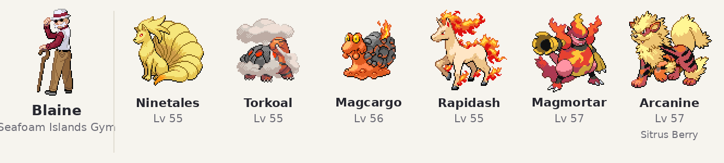
Pokémon | Lv | Item | Moves
Ninetales | 55 |  | Sunny Day, Fire Blast, SolarBeam, Will-O-Wisp
Torkoal | 55 |  | Earthquake, Yawn, Overheat, Stealth Rock
Magcargo | 56 |  | Flamethrower, Earth Power, AncientPower, Will-O-Wisp
Rapidash | 55 |  | Flare Blitz, Megahorn, Bounce, Hypnosis
Magmortar | 57 |  | SolarBeam, Flamethrower, Thunderbolt, Confuse Ray
Arcanine | 57 | Sitrus Berry | Flare Blitz, ExtremeSpeed, Crunch, Thunder Fang

Blue Viridian City (Earth Badge)
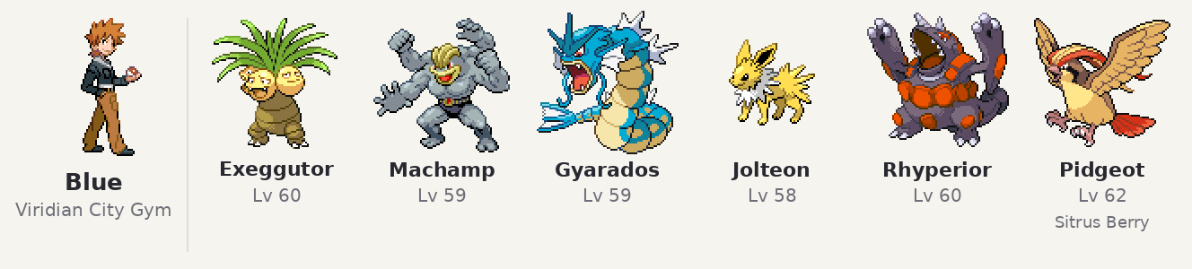
Pokémon | Lv | Item | Moves
Exeggutor | 60 |  | Sleep Powder, Leaf Storm, Psychic, Explosion
Machamp | 59 |  | DynamicPunch, Stone Edge, ThunderPunch, Earthquake
Gyarados | 59 |  | Waterfall, Ice Fang, Dragon Dance, Return
Jolteon | 58 |  | Thunderbolt, Shadow Ball, Signal Beam, Yawn
Rhyperior | 60 |  | Earthquake, Rock Wrecker, Megahorn, Thunder Fang
Pidgeot | 62 | Sitrus Berry | Brave Bird, Return, Heat Wave, Roost

Kanto rematches

Lt. Surge rematch
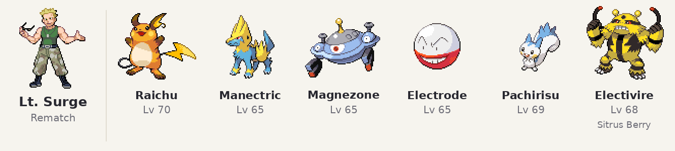
Pokémon | Lv | Item | Moves
Raichu | 70 |  | Thunderbolt, Grass Knot, Focus Blast, Thunder Wave
Manectric | 65 |  | Thunderbolt, Overheat, Signal Beam, Thunder Wave
Magnezone | 65 |  | Thunderbolt, Flash Cannon, Thunder Wave, Magnet Rise
Electrode | 65 |  | Thunderbolt, Thunder Wave, Taunt, Explosion
Pachirisu | 69 |  | Discharge, Super Fang, Thunder Wave, U-turn
Electivire | 68 | Sitrus Berry | Thunderbolt, Cross Chop, Ice Punch, Earthquake

Sabrina rematch
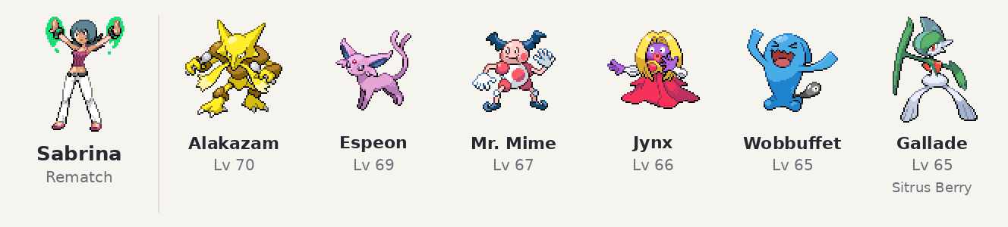
Pokémon | Lv | Item | Moves
Alakazam | 70 |  | Psychic, Focus Blast, Energy Ball, Shadow Ball
Espeon | 69 |  | Psychic, Shadow Ball, Calm Mind, Grass Knot
Mr. Mime | 67 |  | Psychic, Thunderbolt, Reflect, Light Screen
Jynx | 66 |  | Ice Beam, Psychic, Focus Blast, Lovely Kiss
Wobbuffet | 65 |  | Counter, Mirror Coat, Destiny Bond, Encore
Gallade | 65 | Sitrus Berry | Close Combat, Psycho Cut, Night Slash, Stone Edge

Misty rematch
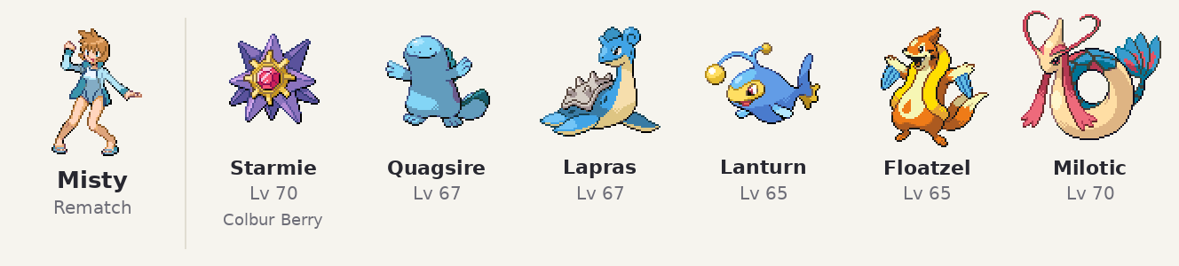
Pokémon | Lv | Item | Moves
Starmie | 70 | Colbur Berry | Surf, Thunderbolt, Ice Beam, Psychic
Quagsire | 67 |  | Earthquake, Waterfall, Stone Edge, Rain Dance
Lapras | 67 |  | Surf, Ice Beam, Thunderbolt, Sing
Lanturn | 65 |  | Confuse Ray, Thunderbolt, Surf, Ice Beam
Floatzel | 65 |  | Waterfall, Ice Fang, Crunch, Aqua Jet
Milotic | 70 |  | Surf, Ice Beam, Recover, Toxic

Erika rematch
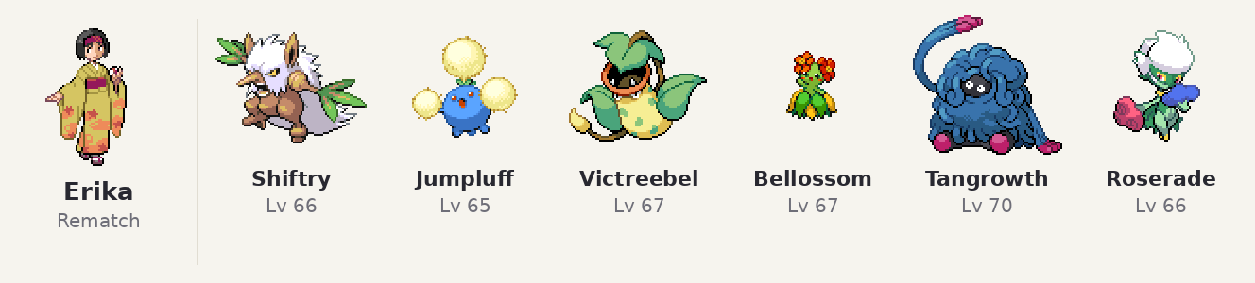
Pokémon | Lv | Item | Moves
Shiftry | 66 |  | Leaf Storm, Sucker Punch, Dark Pulse, Explosion
Jumpluff | 65 |  | Sleep Powder, U-turn, Giga Drain, Leech Seed
Victreebel | 67 |  | Leaf Blade, Sludge Bomb, Swords Dance, Sleep Powder
Bellossom | 67 |  | Leaf Storm, Sludge Bomb, Sunny Day, Stun Spore
Tangrowth | 70 |  | Power Whip, Earthquake, Rock Slide, Swords Dance
Roserade | 66 |  | Energy Ball, Sludge Bomb, Weather Ball, Shadow Ball

Janine rematch
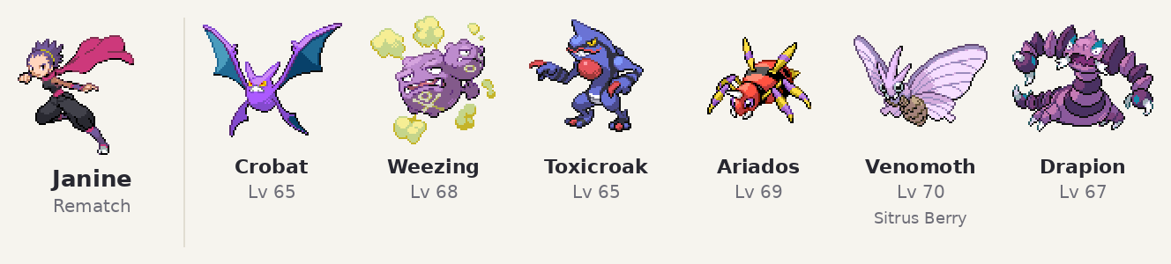
Pokémon | Lv | Item | Moves
Crobat | 65 |  | Heat Wave, Cross Poison, Confuse Ray, U-turn
Weezing | 68 |  | Thunderbolt, Sludge Bomb, Toxic, Explosion
Toxicroak | 65 |  | Cross Chop, Poison Jab, Sucker Punch, Swords Dance
Ariados | 69 |  | Poison Jab, Sucker Punch, Shadow Sneak, Bug Bite
Venomoth | 70 | Sitrus Berry | Bug Buzz, Psychic, Sleep Powder, Sludge Bomb
Drapion | 67 |  | Cross Poison, Crunch, Earthquake, Swords Dance

Brock rematch
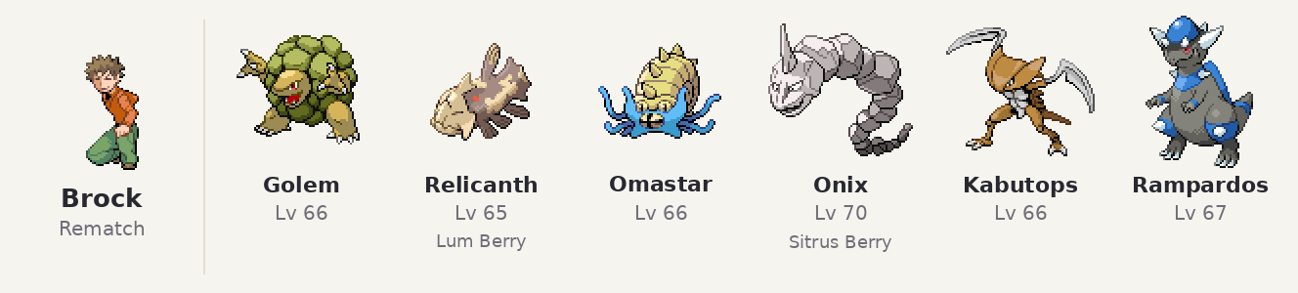
Pokémon | Lv | Item | Moves
Golem | 66 |  | Earthquake, Stone Edge, Rock Polish, Explosion
Relicanth | 65 | Lum Berry | Head Smash, Aqua Tail, Earthquake, Rock Polish
Omastar | 66 |  | Surf, Ice Beam, AncientPower, Stealth Rock
Onix | 70 | Sitrus Berry | Stone Edge, Earthquake, Rock Polish, Stealth Rock
Kabutops | 66 |  | Stone Edge, Waterfall, Aqua Jet, Swords Dance
Rampardos | 67 |  | Earthquake, Stone Edge, Avalanche, Rock Polish

Blaine rematch
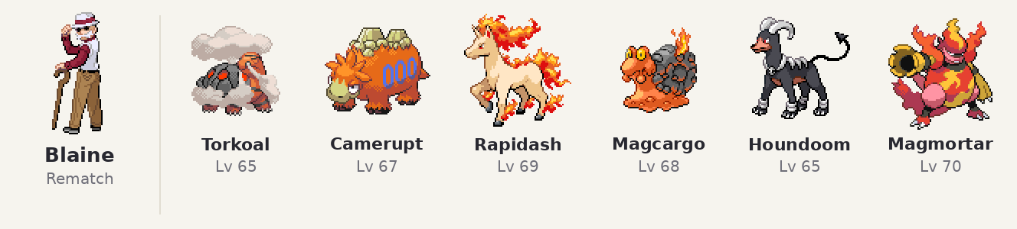
Pokémon | Lv | Item | Moves
Torkoal | 65 |  | Overheat, Earthquake, Stealth Rock, Yawn
Camerupt | 67 |  | Eruption, Earthquake, SolarBeam, Sunny Day
Rapidash | 69 |  | Flare Blitz, Megahorn, Bounce, Quick Attack
Magcargo | 68 |  | Flamethrower, Stone Edge, Earthquake, Will-O-Wisp
Houndoom | 65 |  | Shadow Ball, Dark Pulse, Flamethrower, Sucker Punch
Magmortar | 70 |  | Flamethrower, Thunderbolt, Focus Blast, Confuse Ray

Blue rematch
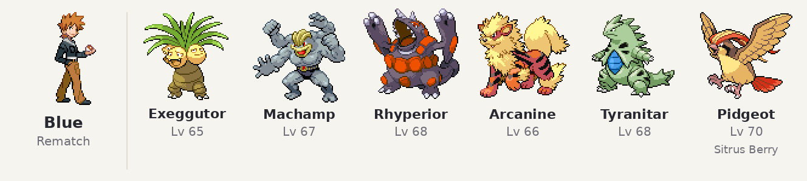
Pokémon | Lv | Item | Moves
Exeggutor | 65 |  | Leaf Storm, Psychic, Hypnosis, Explosion
Machamp | 67 |  | DynamicPunch, Stone Edge, Earthquake, ThunderPunch
Rhyperior | 68 |  | Megahorn, Stone Edge, Thunder Fang, Earthquake
Arcanine | 66 |  | Flare Blitz, ExtremeSpeed, Thunder Fang, Crunch
Tyranitar | 68 |  | Crunch, Stone Edge, Earthquake, Fire Punch
Pidgeot | 70 | Sitrus Berry | Brave Bird, Return, Heat Wave, Roost

Rivals Silver and Lyra/Ethan
Lyra/Ethan are someone who can battle you they have the starter weaker than yours acting as a complement to Silver, they are friendly and offer you items sometimes like the lucky egg and kings rock and in the post game you can battle them twice, the main goal was to utilize their character more and act as a contrast to silver. Also, they are aimed to act as a bridge when silver isn’t present as a rival to the player and they have one more appperence in mahogany town to make their journey match the player, meanwhile I expanded Silver in this Romhack he has a nicer character growth and here he understands the player’s journey and by Kanto he understands what he was missing and with his friendship with his pokemon he evolves his golbat into a Crobat. I also added a new battle in Blackthron which acts as a bridge to his journey in dragons’ den and his encounter with lance, his teams are also better and more competitive showing his overall growth, Silver is a nice character so throughout the game you will see him grow.

Silver (rival): every battle

Cherrygrove City
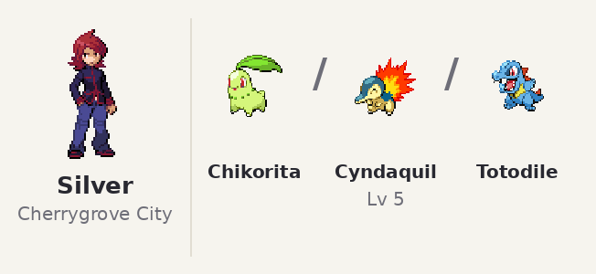
Pokémon | Lv | Item | Moves
Chikorita | 5 |  | Tackle, Growl
Cyndaquil | 5 |  | Tackle, Leer
Totodile | 5 |  | Scratch, Leer

Azalea Town
After defeating team rocket and going toward Ilex Forest Silver will appear and battle you
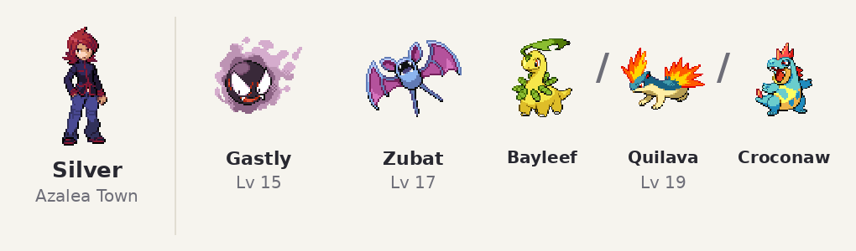
Pokémon | Lv | Item | Moves
Gastly | 15 |  | Spite, Mean Look, Curse, Night Shade
Zubat | 17 |  | Supersonic, Astonish, Wing Attack, Bite
Bayleef | 19 |  | PoisonPowder, Leech Seed, Synthesis, Reflect
Quilava | 19 |  | Leer, SmokeScreen, Ember, Quick Attack
Croconaw | 19 |  | Rage, Bite, Scary Face, Water Pulse

Burned Tower
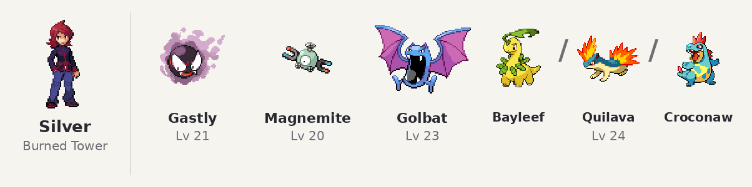
Pokémon | Lv | Item | Moves
Gastly | 21 |  | Lick, Confuse Ray, Mean Look, Shadow Ball
Magnemite | 20 |  | Thunder Wave, Spark, Supersonic, SonicBoom
Golbat | 23 |  | Mean Look, Supersonic, Bite, Wing Attack
Bayleef | 24 |  | Synthesis, Reflect, Magical Leaf, PoisonPowder
Quilava | 24 |  | Flame Wheel, SmokeScreen, Ember, Quick Attack
Croconaw | 24 |  | Scary Face, Ice Fang, Water Gun, Bite

Goldenrod Underground
Batlle during Radio tower in underground Silver appear when you head inside
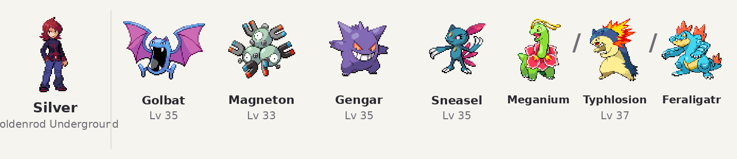
Pokémon | Lv | Item | Moves
Golbat | 35 |  | Astonish, Bite, Confuse Ray, Air Cutter
Magneton | 33 |  | Supersonic, Spark, SonicBoom, Thunder Wave
Gengar | 35 |  | Confuse Ray, Mean Look, Curse, Shadow Ball
Sneasel | 35 |  | Icy Wind, Quick Attack, Fury Swipes, Faint Attack
Meganium | 37 |  | Reflect, Synthesis, Body Slam, Giga Drain
Typhlosion | 37 |  | Flamethrower, ThunderPunch, Quick Attack, Rockslide
Feraligatr | 37 |  | Ice Fang, Waterfall, Crunch, Thrash

Blackthorn City (new)
Coming out of Ice Path, before the Rising Badge. The last Pokémon depends on your starter. This is a new fight I made for this romhack since silver needed more fights.
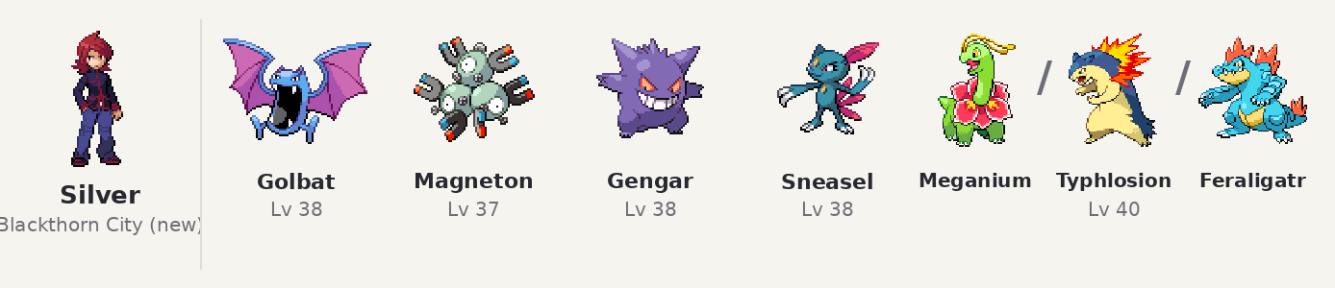
Pokémon | Lv | Item | Moves
Golbat | 38 |  | Astonish, Bite, Confuse Ray, Air Cutter
Magneton | 37 |  | Spark, Supersonic, Thunder Wave, Magnet Bomb
Gengar | 38 |  | Confuse Ray, Mean Look, Curse, Shadow Ball
Sneasel | 38 |  | Icy Wind, Quick Attack, Slash, Faint Attack
Meganium | 40 |  | Reflect, Petal Dance, Body Slam, Synthesis
Typhlosion | 40 |  | Flamethrower, ThunderPunch, Quick Attack, Rock Slide
Feraligatr | 40 |  | Waterfall, Ice Fang, Crunch, Slash

Victory Road
Before going toward the exit Silver appears and fights you.
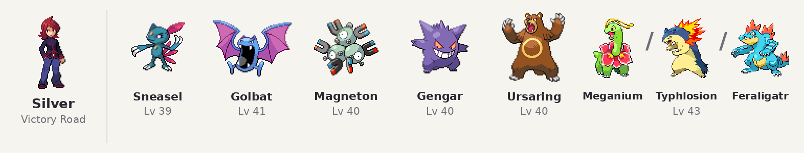
Pokémon | Lv | Item | Moves
Sneasel | 39 |  | Quick Attack, Icy Wind, Faint Attack, Fury Swipes
Golbat | 41 |  | Astonish, Bite, Confuse Ray, Air Cutter
Magneton | 40 |  | Spark, Supersonic, Thunder Wave, Magnet Bomb
Gengar | 40 |  | Mean Look, Curse, Shadow Ball, Confuse Ray
Ursaring | 40 |  | Slash, Facade, Brick Break, Earthquake
Meganium | 43 |  | Reflect, Petal Dance, Body Slam, Synthesis
Typhlosion | 43 |  | ThunderPunch, Flamethrower, Quick Attack, Rock Slide
Feraligatr | 43 |  | Waterfall, Ice Fang, Crunch, Slash

Mt. Moon
Silver is here in Mt moon and you can battle him here.
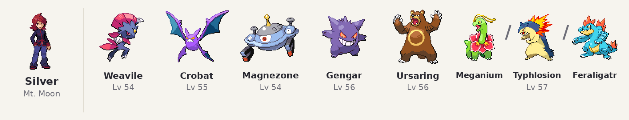
Pokémon | Lv | Item | Moves
Weavile | 54 |  | Night Slash, Ice Punch, Brick Break, Swords Dance
Crobat | 55 |  | Cross Poison, Air Slash, Confuse Ray, U-turn
Magnezone | 54 |  | Thunderbolt, Flash Cannon, Thunder Wave, Magnet Rise
Gengar | 56 |  | Shadow Ball, Sludge Bomb, Focus Blast, Hypnosis
Ursaring | 56 |  | Slash, Earthquake, Stone Edge, Swords Dance
Meganium | 57 |  | Energy Ball, Earthquake, Body Slam, Synthesis
Typhlosion | 57 |  | Eruption, Flamethrower, Focus Blast, ThunderPunch
Feraligatr | 57 |  | Waterfall, Crunch, Earthquake, Ice Punch

Dragon's Den tag battle
You and Silver against Lance and Clair.
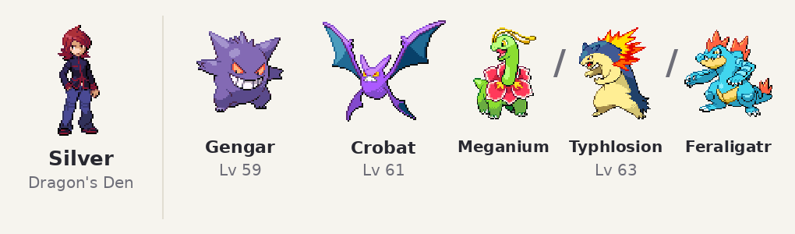
Pokémon | Lv | Item | Moves
Gengar | 59 |  | Shadow Ball, Sludge Bomb, Focus Blast, Hypnosis
Crobat | 61 |  | Cross Poison, Air Slash, Confuse Ray, U-turn
Meganium | 63 |  | Energy Ball, Earthquake, Body Slam, Synthesis
Typhlosion | 63 |  | Eruption, Flamethrower, Focus Blast, Thunder Punch
Feraligatr | 63 |  | Waterfall, Crunch, Earthquake, Ice Punch

Lance (tag battle opponent)
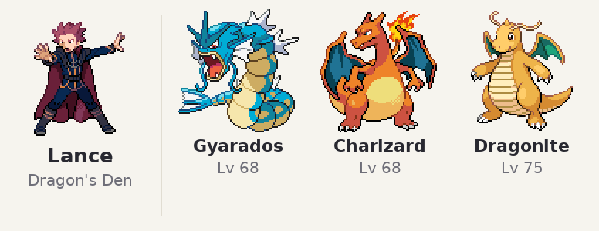
Pokémon | Lv | Item | Moves
Gyarados | 68 |  | Thunder Wave, Ice Fang, Waterfall, Dragon Dance
Charizard | 68 |  | Flamethrower, Air Slash, Dragon Claw, Hyper Beam
Dragonite | 75 |  | Fire Punch, Safeguard, Draco Meteor, Hyper Beam

Clair (tag battle opponent)
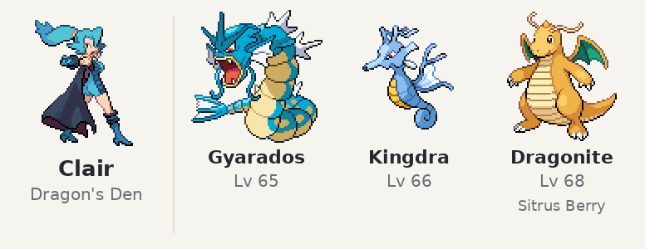
Pokémon | Lv | Item | Moves
Gyarados | 65 |  | Waterfall, Ice Fang, Earthquake, Dragon Dance
Kingdra | 66 |  | Rain Dance, Surf, Dragon Pulse, Ice Beam
Dragonite | 68 | Sitrus Berry | Dragon Dance, Outrage, Earthquake, Fire Punch

Indigo Plateau rematch
Pokémon League entrance, Mondays and Wednesdays. The last Pokémon depends on your starter.
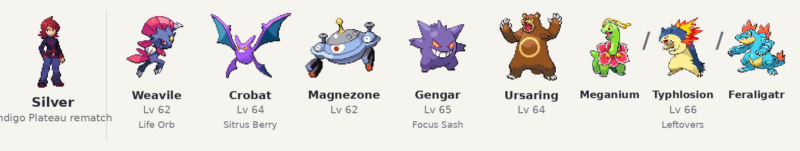
Pokémon | Lv | Item | Moves
Weavile | 62 | Life Orb | Night Slash, Ice Punch, Brick Break, Swords Dance
Crobat | 64 | Sitrus Berry | Cross Poison, Air Slash, Confuse Ray, U-turn
Magnezone | 62 |  | Thunderbolt, Flash Cannon, Thunder Wave, Magnet Rise
Gengar | 65 | Focus Sash | Shadow Ball, Sludge Bomb, Focus Blast, Hypnosis
Ursaring | 64 |  | Slash, Earthquake, Stone Edge, Swords Dance
Meganium | 66 | Leftovers | Energy Ball, Earthquake, Body Slam, Synthesis
Typhlosion | 66 | Leftovers | Eruption, Flamethrower, Focus Blast, ThunderPunch
Feraligatr | 66 | Leftovers | Waterfall, Crunch, Earthquake, Ice Punch

Lyra / Ethan

Battle 1: Route 31 gate
After she gives you the Vs. Recorder, before Falkner. The last Pokémon depends on your starter.She has the starter weak to you(ie if you choose todoile she gets cyndaquil)
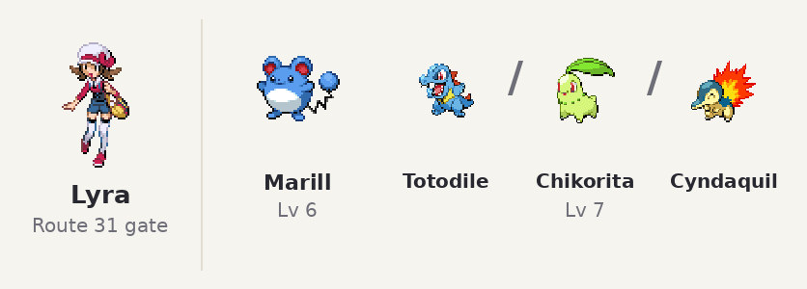
Pokémon | Lv | Item | Moves
Marill | 6 |  | Tackle, Defense Curl
Totodile | 7 |  | Scratch, Leer, Water Gun
Chikorita | 7 |  | Tackle, Growl, Razor Leaf
Cyndaquil | 7 |  | Tackle, Leer, SmokeScreen

Battle 2: Route 34 DayCare
When she introduces you to her grandpa. The last Pokémon depends on your starter.
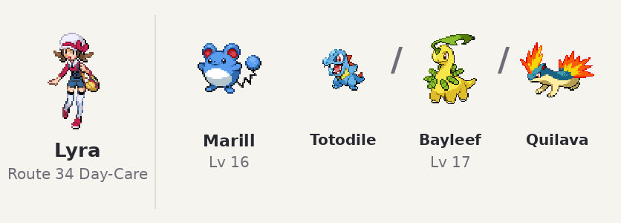
Pokémon | Lv | Item | Moves
Marill | 16 |  | Defense Curl, Tail Whip, Water Gun, Rollout
Totodile | 17 |  | Water Gun, Rage, Bite, Scary Face
Bayleef | 17 |  | Razor Leaf, PoisonPowder, Leech Seed, Synthesis
Quilava | 17 |  | Leer, SmokeScreen, Ember, Quick Attack

Battle 3: Goldenrod Tunnel
An optional battle, if you wish you can fight her here, After the Fashion Case, before Whitney; she gives you a Lucky Egg.
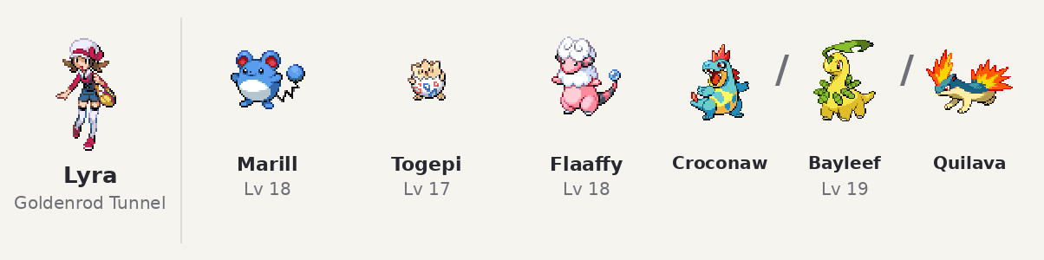
Pokémon | Lv | Item | Moves
Marill | 18 |  | Tail Whip, Water Gun, Rollout, BubbleBeam
Togepi | 17 |  | Charm, Metronome, Sweet Kiss, Yawn
Flaaffy | 18 |  | Growl, ThunderShock, Thunder Wave, Shock Wave
Croconaw | 19 |  | Rage, Bite, Scary Face, Water Pulse
Bayleef | 19 |  | PoisonPowder, Leech Seed, Synthesis, Reflect
Quilava | 19 |  | Leer, SmokeScreen, Ember, Quick Attack

Battle 4: Mahogany Town
New encounter with lyra added here, now the first time you enter town after battling you she gives you a King's Rock.
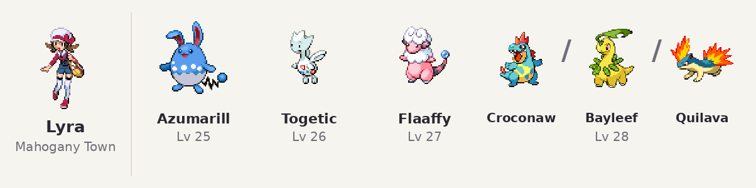
Pokémon | Lv | Item | Moves
Azumarill | 25 |  | Tail Whip, Water Gun, Rollout, BubbleBeam
Togetic | 26 |  | Sweet Kiss, Yawn, Encore, Air Slash
Flaaffy | 27 |  | Thunder Wave, Shock Wave, Cotton Spore, Signal Beam
Croconaw | 28 |  | Scary Face, Water Pulse, Ice Fang, Flail
Bayleef | 28 |  | Sleep Powder, Body Slam, Magical Leaf, Giga Drain
Quilava | 28 |  | Ember, Quick Attack, Flame Wheel, Defense Curl

Battle 5: New Bark Town
After you beat the Elite Four in her house in New bark Town you can fight her if you want to.
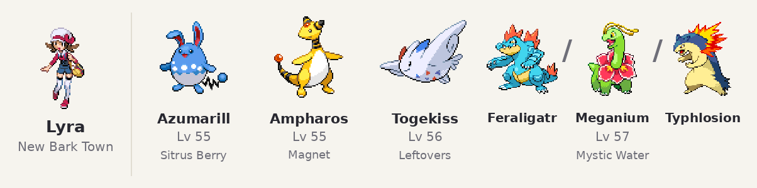
Pokémon | Lv | Item | Moves
Azumarill | 55 | Sitrus Berry | Aqua Tail, Double-Edge, Brick Break, Ice Beam
Ampharos | 55 | Magnet | Thunderbolt, Focus Blast, Signal Beam, Thunder Wave
Togekiss | 56 | Leftovers | Air Slash, Aura Sphere, Extrasensory, Roost
Feraligatr | 57 | Mystic Water | Waterfall, Ice Fang, Crunch, Earthquake
Meganium | 57 | Miracle Seed | Energy Ball, Earthquake, Body Slam, Synthesis
Typhlosion | 57 | Charcoal | Flamethrower, Overheat, Focus Blast, SolarBeam

Battle 6: New Bark Town
In their house in New Bark Town. After you beat the Elite Four again with all 8 Kanto badges. The last Pokémon depends on your starter.
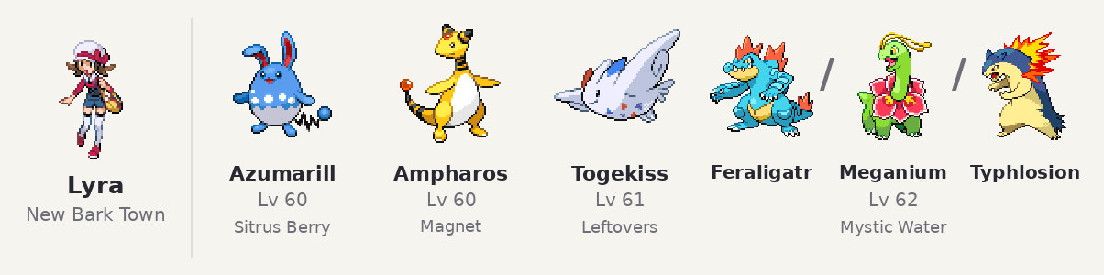
Pokémon | Lv | Item | Moves
Azumarill | 60 | Sitrus Berry | Aqua Tail, Double-Edge, Brick Break, Ice Beam
Ampharos | 60 | Magnet | Thunderbolt, Focus Blast, Signal Beam, Thunder Wave
Togekiss | 61 | Leftovers | Air Slash, Aura Sphere, Extrasensory, Roost
Feraligatr | 62 | Mystic Water | Waterfall, Ice Fang, Crunch, Earthquake
Meganium | 62 | Miracle Seed | Energy Ball, Earthquake, Body Slam, Synthesis
Typhlosion | 62 | Charcoal | Flamethrower, Overheat, Focus Blast, SolarBeam

Johto

Proton Slowpoke well
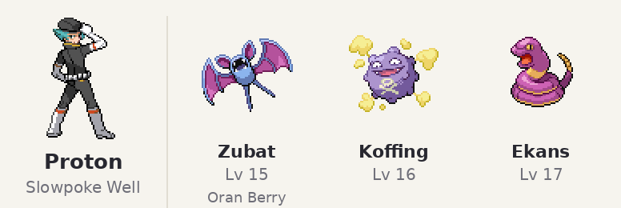
Pokémon | Lv | Item | Moves
Zubat | 15 | Oran Berry | Absorb, Bite, Astonish, Supersonic
Koffing | 16 |  | SmokeScreen, Smog, Assurance, Tackle
Ekans | 17 |  | Glare, Poison Sting, Screech, Bite

Petrel Mahogany Hideout
Team Rocket Hideout, Mahogany Town
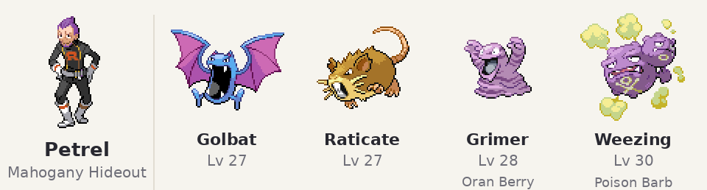
Pokémon | Lv | Item | Moves
Golbat | 27 |  | Confuse Ray, Pluck, Aerial Ace, Giga Drain
Raticate | 27 |  | Quick Attack, Hyper Fang, Tackle, Sucker Punch
Grimer | 28 | Oran Berry | Sludge, Rock Slide, Rock Tomb, Giga Drain
Weezing | 30 | Poison Barb | Will-O-Wisp, Sludge, Smog, Shock Wave

Ariana Mahogany Hideout
Team Rocket Hideout, Mahogany Town, near the generator room.
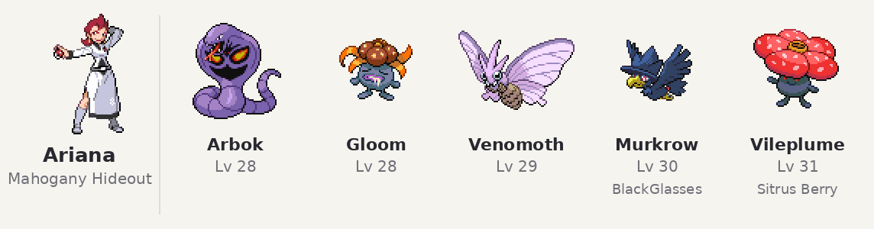
Pokémon | Lv | Item | Moves
Arbok | 28 |  | Glare, Acid, Poison Sting, Rock Slide
Gloom | 28 |  | Mega Drain, Acid, Absorb, Drain Punch
Venomoth | 29 |  | Sleep Powder, Silver Wind, Leech Life, Giga Drain
Murkrow | 30 | BlackGlasses | Dark Pulse, Pluck, Aerial Ace, Steel Wing
Vileplume | 31 | Sitrus Berry | Stun Spore, Energy Ball, Giga Drain, Drain Punch

Petrel Radio Tower
Radio Tower top floor.
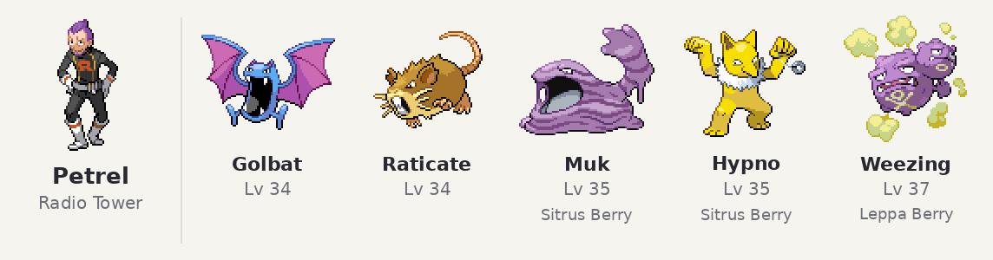
Pokémon | Lv | Item | Moves
Golbat | 34 |  | Confuse Ray, Sludge Bomb, Pluck, Giga Drain
Raticate | 34 |  | Quick Attack, Hyper Fang, Tackle, Sucker Punch
Muk | 35 | Sitrus Berry | Poison Jab, Sludge Bomb, Sludge, Brick Break
Hypno | 35 | Sitrus Berry | Psychic, Hypnosis, Shadow Ball, Dream Eater
Weezing | 37 | Leppa Berry | Explosion, Sludge Bomb, Sludge, Shock Wave

Proton — Radio Tower

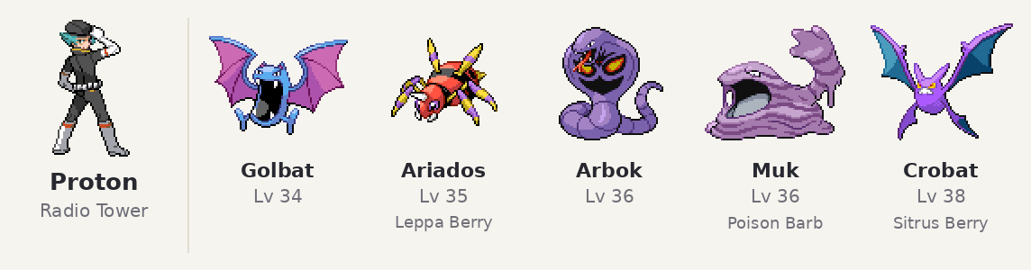
Pokémon | Lv | Item | Moves
Golbat | 34 |  | Confuse Ray, Sludge Bomb, Pluck, Giga Drain
Ariados | 35 | Leppa Berry | Poison Jab, Bug Bite, Sucker Punch, Toxic
Arbok | 36 |  | Glare, Poison Jab, Sludge Bomb, Rock Slide
Muk | 36 | Poison Barb | Poison Jab, Sludge Bomb, Sludge, Brick Break
Crobat | 38 | Sitrus Berry | Confuse Ray, Cross Poison, Pluck, U-turn

Ariana — Radio Tower
Radio Tower (takeover), before the Director's office.
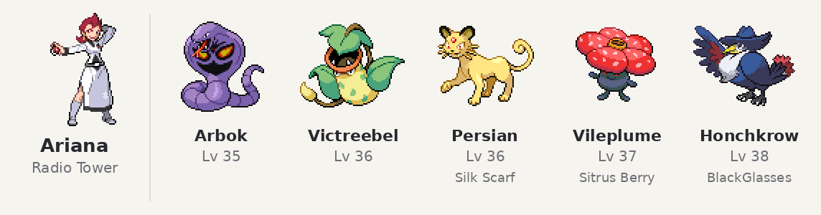
Pokémon | Lv | Item | Moves
Arbok | 35 |  | Glare, Poison Jab, Sludge Bomb, Rock Slide
Victreebel | 36 |  | Sleep Powder, Sludge Bomb, Energy Ball, Giga Drain
Persian | 36 | Silk Scarf | Dark Pulse, Shadow Ball, Power Gem, U-turn
Vileplume | 37 | Sitrus Berry | Stun Spore, Sludge Bomb, Energy Ball, Drain Punch
Honchkrow | 38 | BlackGlasses | Dark Pulse, Pluck, Aerial Ace, Steel Wing

Archer — Radio Tower
Radio Tower 5F: the takeover leader. Afterwards Giovanni arrives and confronts him (no battle).
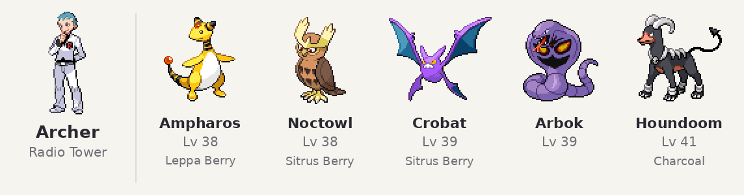
Pokémon | Lv | Item | Moves
Ampharos | 38 | Leppa Berry | Thunderbolt, Light Screen, Thunder Wave, Focus Blast
Noctowl | 38 | Sitrus Berry | Hyper Voice, Air Slash, Hypnosis, Shadow Ball
Crobat | 39 | Sitrus Berry | Confuse Ray, Cross Poison, Pluck, U-turn
Arbok | 39 |  | Glare, Poison Jab, Sludge Bomb, Rock Slide
Houndoom | 41 | Charcoal | Will-O-Wisp, Flamethrower, Dark Pulse, Thunder Fang

Kanto (after the Elite Four)

Petrel — Vermilion City
Vermilion City, north side by the road to Route 6. He just wants to see how strong he has become.
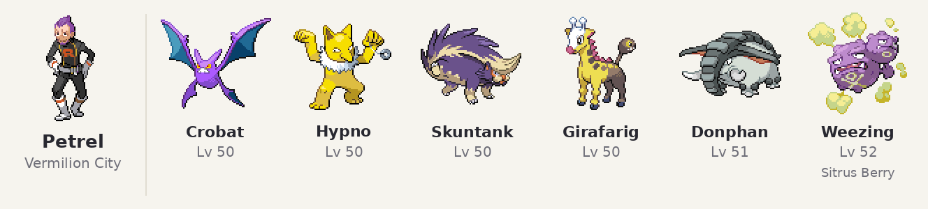
Pokémon | Lv | Item | Moves
Crobat | 50 |  | Cross Poison, Aerial Ace, U-turn, Confuse Ray
Hypno | 50 |  | Psychic, Calm Mind, Shadow Ball, Focus Blast
Skuntank | 50 |  | Poison Jab, Night Slash, Flamethrower, Explosion
Girafarig | 50 |  | Psychic, Crunch, Thunderbolt, Calm Mind
Donphan | 51 |  | Earthquake, Stone Edge, Knock Off, Rapid Spin
Weezing | 52 | Sitrus Berry | Sludge Bomb, Flamethrower, Thunderbolt, Will-O-Wisp

Petrel: Celadon restaurant (no battle)
Disguised as a Sailor; talk to him and he spins round and drops the disguise.

Petrel — Fuchsia City
Fuchsia City, south of the center: his last battle, after he has put Team Rocket behind him.
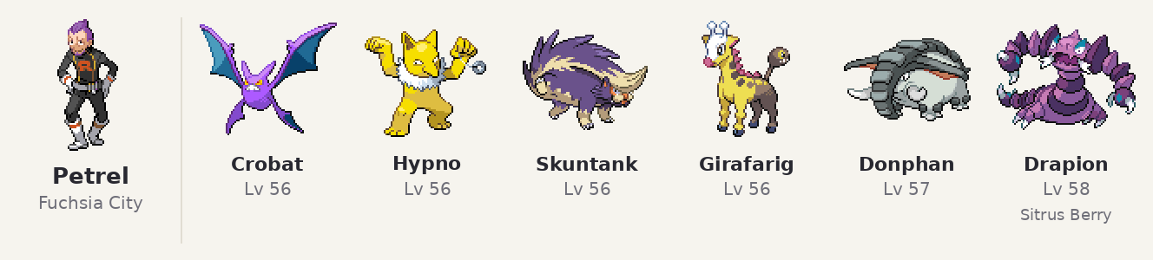
Pokémon | Lv | Item | Moves
Crobat | 56 |  | Cross Poison, Aerial Ace, U-turn, Confuse Ray
Hypno | 56 |  | Psychic, Calm Mind, Shadow Ball, Focus Blast
Skuntank | 56 |  | Poison Jab, Night Slash, Flamethrower, Explosion
Girafarig | 56 |  | Psychic, Crunch, Thunderbolt, Calm Mind
Donphan | 57 |  | Earthquake, Stone Edge, Knock Off, Rapid Spin
Drapion | 58 | Sitrus Berry | Poison Jab, Crunch, Earthquake, Ice Fang

Ariana — Route 25 (Cerulean Cape)
Route 25, in the corner below the fence east of Bill's house. She still believes Giovanni will return.
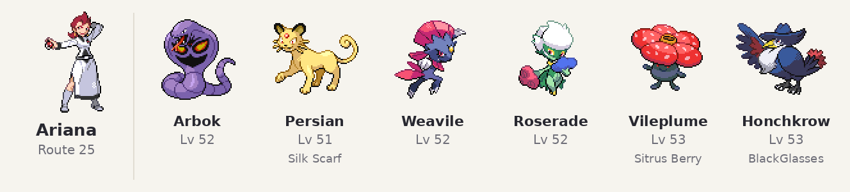
Pokémon | Lv | Item | Moves
Arbok | 52 |  | Poison Jab, Crunch, Glare, Earthquake
Persian | 51 | Silk Scarf | Fake Out, Slash, Power Gem, Shadow Claw
Weavile | 52 |  | Night Slash, Avalanche, Brick Break, Quick Attack
Roserade | 52 |  | Energy Ball, Sludge Bomb, Shadow Ball, Toxic Spikes
Vileplume | 53 | Sitrus Berry | Energy Ball, Sludge Bomb, Stun Spore, Moonlight
Honchkrow | 53 | BlackGlasses | Dark Pulse, Night Slash, Aerial Ace, Psychic

Ariana: Pewter Museum of Science (no battle)
Standing at a fossil case; she turns round, spots you and talks about bringing back what was lost.

Ariana — Cinnabar Island
Cinnabar Island, by the Pokémon Center, after her Pewter Museum scene (no battle there).
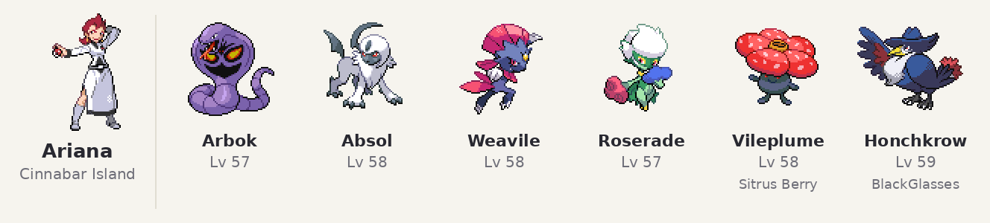
Pokémon | Lv | Item | Moves
Arbok | 57 |  | Poison Jab, Crunch, Glare, Earthquake
Absol | 58 |  | Night Slash, Sucker Punch, X-Scissor, Swords Dance
Weavile | 58 |  | Night Slash, Avalanche, Brick Break, Quick Attack
Roserade | 57 |  | Energy Ball, Sludge Bomb, Shadow Ball, Toxic Spikes
Vileplume | 58 | Sitrus Berry | Energy Ball, Sludge Bomb, Stun Spore, Moonlight
Honchkrow | 59 | BlackGlasses | Dark Pulse, Night Slash, Aerial Ace, Psychic

Proton: Rock Tunnel, Mt. Moon and Nugget Bridge (no battle)
Rock Tunnel 1F and Mt. Moon: lost without Team Rocket, hiding and thinking things over. Route 24 (Nugget Bridge): after you beat the grunt who stole the Machine Part, Proton tells him Team Rocket is finished, takes the part from him and hands it to you.

Archer — Cerulean Cave B1F
Cerulean Cave B1F, deep inside on the way to Mewtwo (the cave opens after you beat Blue). The last holdout.
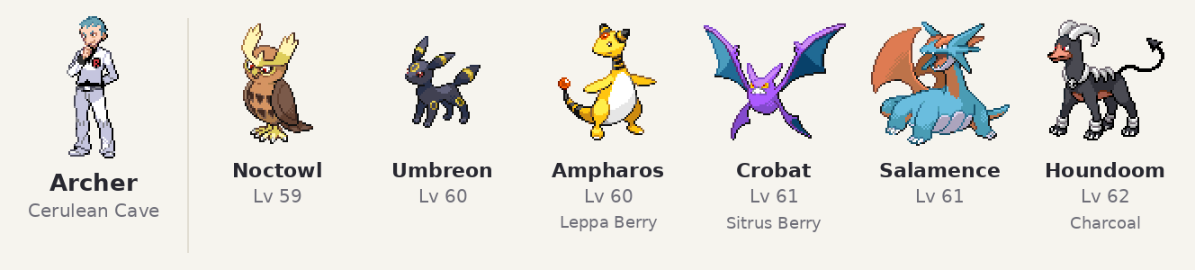
Pokémon | Lv | Item | Moves
Noctowl | 59 |  | Air Slash, Psychic, Shadow Ball, Hypnosis
Umbreon | 60 |  | Dark Pulse, Toxic, Confuse Ray, Protect
Ampharos | 60 | Leppa Berry | Thunderbolt, Focus Blast, Signal Beam, Thunder Wave
Crobat | 61 | Sitrus Berry | Cross Poison, Air Slash, U-turn, Confuse Ray
Salamence | 61 |  | Dragon Claw, Flamethrower, Earthquake, Crunch
Houndoom | 62 | Charcoal | Flamethrower, Dark Pulse, Sludge Bomb, Nasty Plot

Giovanni

Giovanni: Radio Tower
After you beat Archer at the top of the Radio Tower, Giovanni arrives. He says he ended Team Rocket three years ago after losing to a child, that he is not finished with his training, and tells Archer to stop this foolishness. To you: "You remind me of that child. Hmph... I shall step aside this time. We will meet again." Then he leaves.

Giovanni the Celebi event (postgame)
Tohjo Falls, Rhyperior has max IVs.
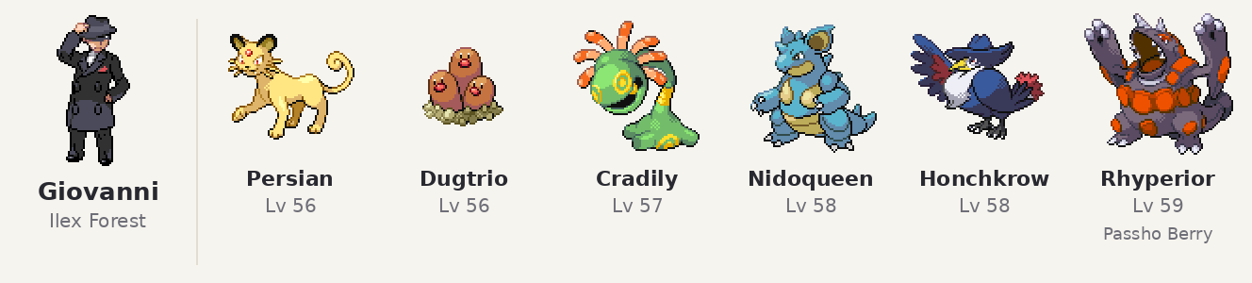
Pokémon | Lv | Item | Moves
Persian | 56 |  | Fake Out, Slash, Shadow Claw, Thunderbolt
Dugtrio | 56 |  | Earthquake, Stone Edge, Sucker Punch, Night Slash
Cradily | 57 |  | Stealth Rock, Energy Ball, AncientPower, Toxic
Nidoqueen | 58 |  | Earth Power, Sludge Bomb, Ice Beam, Superpower
Honchkrow | 58 |  | Nasty Plot, Dark Pulse, Shadow Ball, Psychic
Rhyperior | 59 | Passho Berry | Earthquake, Stone Edge, Megahorn, Avalanche

Special Fights

Eusine

Eusine — Cianwood City
Cianwood City, after the Suicune scene by the shore. His original battle, with a new team and moves.
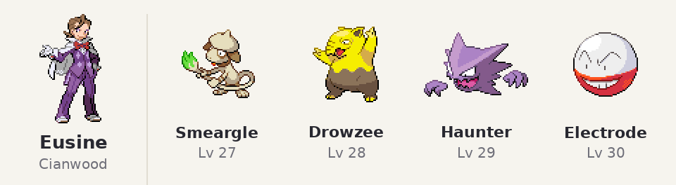
Pokémon | Lv | Item | Moves
Smeargle | 27 |  | Water Pulse, Flame Wheel, Swift, Thunder Wave
Drowzee | 28 |  | Psybeam, Hypnosis, Dream Eater, Headbutt
Haunter | 29 |  | Shadow Ball, Hypnosis, Mean Look, Dream Eater
Electrode | 30 |  | Thunderbolt, Light Screen, Signal Beam, Screech

Eusine — Route 42
Route 42, after the Suicune scene. A new battle; if you lose, the scene simply ends (no whiteout). Morty walks in afterwards.
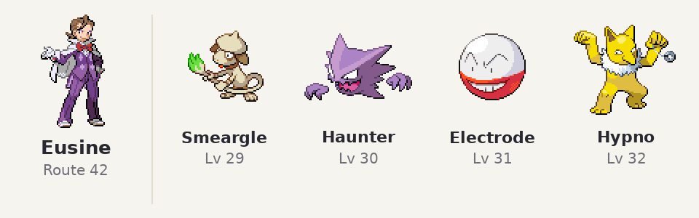
Pokémon | Lv | Item | Moves
Smeargle | 29 |  | Water Pulse, Flamethrower, Swift, Thunder Wave
Haunter | 30 |  | Shadow Ball, Hypnosis, Dream Eater, Thunderbolt
Electrode | 31 |  | Thunderbolt, Energy Ball, Signal Beam, Light Screen
Hypno | 32 |  | Psychic, Payback, Hypnosis, Headbutt

Eusine — New Bark Town
New Bark Town, after the HoOh event and the Master Ball from Elm (and after both earlier Eusine scenes): walk to the shore east of town, Suicune leaps away and Eusine battles you. One time; losing is allowed (no whiteout).
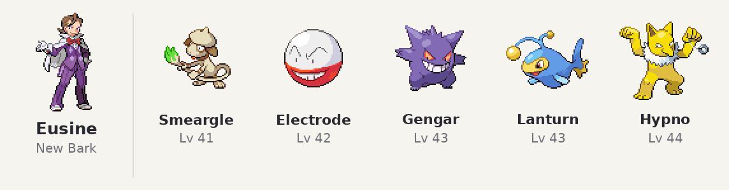
Pokémon | Lv | Item | Moves
Smeargle | 41 |  | Surf, Flamethrower, Swift, Thunder Wave
Electrode | 42 |  | Thunderbolt, Energy Ball, Signal Beam, Light Screen
Gengar | 43 |  | Shadow Ball, Thunderbolt, Hypnosis, Dream Eater
Lanturn | 43 |  | Surf, Thunderbolt, Signal Beam, Confuse Ray
Hypno | 44 |  | Psychic, Payback, Hypnosis, ThunderPunch

Eusine — Cerulean Cape (last battle)
Route 25, Cerulean Cape, before Suicune (after you have seen it on Route 14). His last battle; losing is a normal whiteout and the scene replays. Morty joins the scene afterwards.
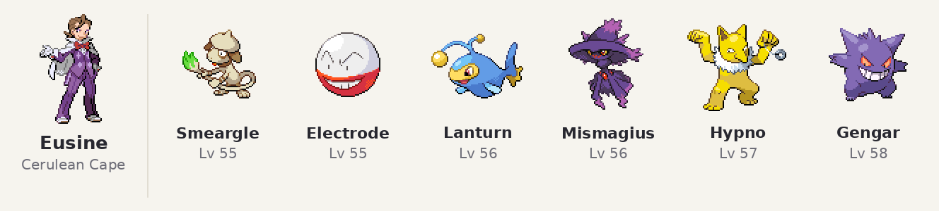
Pokémon | Lv | Item | Moves
Smeargle | 55 |  | Surf, Flamethrower, Ice Beam, Thunder Wave
Electrode | 55 |  | Thunderbolt, Signal Beam, Light Screen, Explosion
Lanturn | 56 |  | Surf, Thunderbolt, Ice Beam, Confuse Ray
Mismagius | 56 |  | Shadow Ball, Power Gem, Will-O-Wisp, Calm Mind
Hypno | 57 |  | Psychic, ThunderPunch, Hypnosis, Nasty Plot
Gengar | 58 |  | Shadow Ball, Sludge Bomb, Thunderbolt, Hypnosis

Bill

Bill — Goldenrod City
Postgame: after you beat the Elite Four, talk to Bill in his Goldenrod house. Win and he gives you the Dubious Disc (if your Bag is full, talk to him again). Losing works like any normal trainer battle.
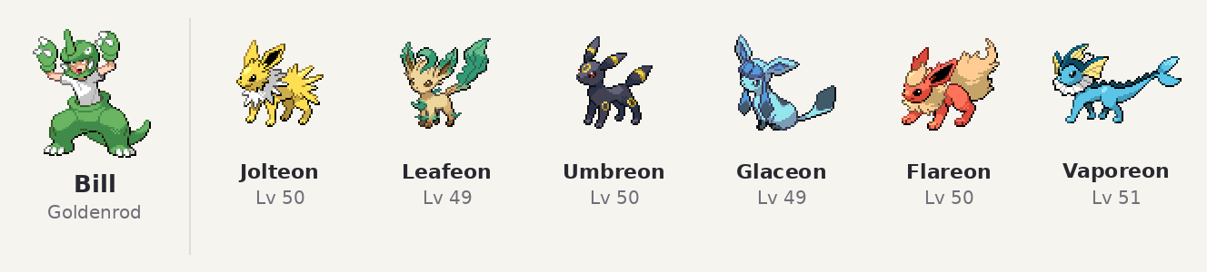
Pokémon | Lv | Item | Moves
Jolteon | 50 |  | Thunderbolt, Shadow Ball, Pin Missile, Thunder Wave
Leafeon | 49 |  | Leaf Blade, X-Scissor, Swords Dance, Quick Attack
Umbreon | 50 |  | Dark Pulse, Toxic, Moonlight, Confuse Ray
Glaceon | 49 |  | Ice Beam, Shadow Ball, Ice Shard, Barrier
Flareon | 50 |  | Flare Blitz, Superpower, Fire Fang, Quick Attack
Vaporeon | 51 |  | Surf, Ice Beam, Shadow Ball, Aqua Ring

Steven

Steven — Vermilion City
Outside in Vermilion City, after the guy in pokemon fanclub gives you the Lost Item (once the Power Plant is fixed). After leaving the buding Steven introduces himself and asks for a battle (Yes/No).. Afterwards Steven is in Diglett's Cave, next to the ladder down from the Route 11 entrance. If you said no, you can battle him there instead. Talk to him after the battle and he gives you a Beldum (Lv 40); with a full party he asks you to make room first. One time only.
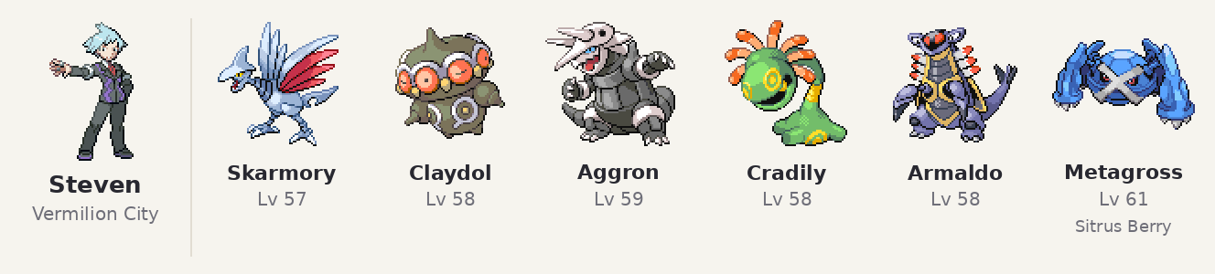
Pokémon | Lv | Item | Moves
Skarmory | 57 |  | Air Slash, Steel Wing, Spikes, Roost
Claydol | 58 |  | Earthquake, Psychic, Reflect, Light Screen
Aggron | 59 |  | Iron Head, Earthquake, Stone Edge, Dragon Claw
Cradily | 58 |  | Energy Ball, AncientPower, Earthquake, Confuse Ray
Armaldo | 58 |  | X-Scissor, Rock Slide, Earthquake, Swords Dance
Metagross | 61 | Sitrus Berry | Meteor Mash, Earthquake, Psychic, Hammer Arm

Steven — Silph Co. (after Red)

After you beat Red on Mt. Silver, Steven is at Silph Co. in Saffron City and offers a battle. Win: he gives you a Hoenn starter (Treecko, Torchic or Mudkip), as in the original game. Losing is a normal white-out; talk to him again for another try. One time only.
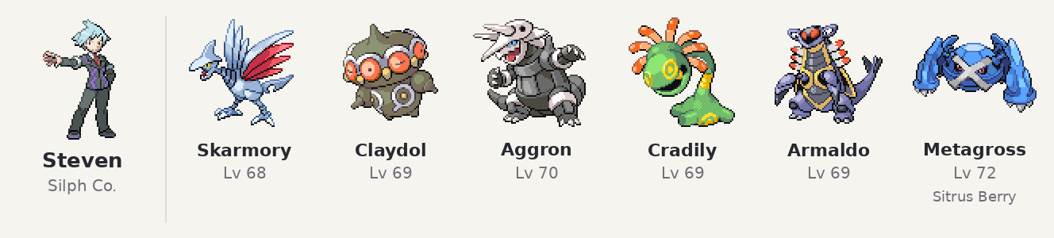
Pokémon | Lv | Item | Moves
Skarmory | 68 |  | Air Slash, Steel Wing, Spikes, Roost
Claydol | 69 |  | Earthquake, Psychic, Reflect, Light Screen
Aggron | 70 |  | Iron Head, Earthquake, Stone Edge, Dragon Claw
Cradily | 69 |  | Energy Ball, AncientPower, Earthquake, Confuse Ray
Armaldo | 69 |  | X-Scissor, Rock Slide, Earthquake, Swords Dance
Metagross | 72 | Sitrus Berry | Meteor Mash, Earthquake, Psychic, Hammer Arm

Enigma Stone and Latios: after you beat Steven (in Vermilion City or Diglett's Cave), Mr. Fuji (House of Memories, Lavender Town) gives you the Enigma Stone. Take it to the Pewter Museum, where Steven meets you for the Latios event (his lines there are rewritten so he knows you and the stone).

Mew

Mew Vermilion City
After you beat Blue, Professor Oak gives you the Mystic Flute. Surf into the channel between the piers below the Vermilion Gym and play the flute: Mew appears in the middle of the channel and waits. Talk to it to start the battle.).
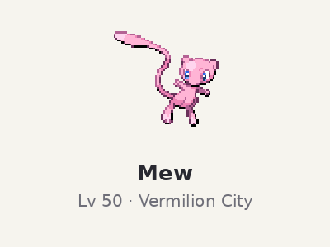
Pokémon | Lv | Item | Moves
Mew | 50 |  | Metronome, Psychic, Barrier, AncientPower

Celebi

Celebi Ilex Forest shrine
Postgame: after the Elite Four, Kurt in Azalea Town tells you about the shrine and makes the GS Ball. Examine the Ilex Forest shrine with it: Celebi appears, and the battle starts. Caught: the GS Ball is used up. Fainted or fled: keep the GS Ball and try again. With Celebi in the lead, the timetravel scene at the shrine then works and the event is accessible.
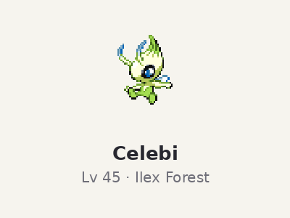
Pokémon | Lv | Item | Moves
Celebi | 45 |  | Safeguard, Magical Leaf, AncientPower, Baton Pass

Static Pokemon(New encounters found in Johto)

In the order you can reach them

Ledian — Ilex Forest
Top-right clearing. 31 IVs in every stat; knows the egg move Bug Buzz (instead of Safeguard).
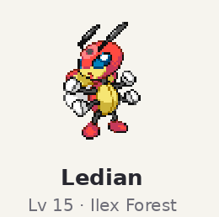
Pokémon | Lv | Item | Moves
Ledian | 15 | - | Comet Punch, Light Screen, Reflect, Bug Buzz

Quagsire — Union Cave B1F
West end of the south walkway. 31 IVs in every stat; knows the egg move AncientPower (instead of Slam).
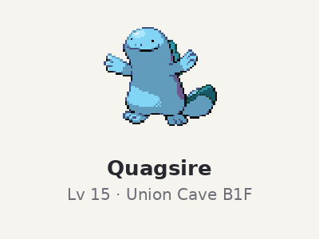
Pokémon | Lv | Item | Moves
Quagsire | 15 | - | Tail Whip, Mud Sport, Mud Shot, AncientPower

Gligar — Dark Cave (Violet side)
Past the two Rock Smash rocks, before the Strength boulder. Needs Rock Smash. 31 IVs in every stat; knows the egg move Night Slash (instead of Knock Off).
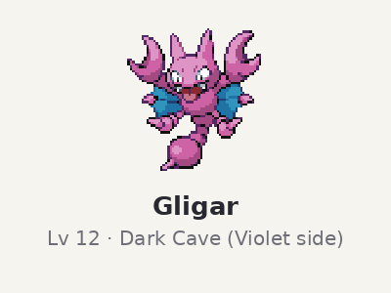
Pokémon | Lv | Item | Moves
Gligar | 12 | - | Poison Sting, Sand-Attack, Mud-Slap, Night Slash

Houndour — Burned Tower B1F
Just right of the pit where the legendary beasts stood. Appears the next time you enter after the beasts run off. 31 IVs in every stat; knows the egg move Thunder Fang (instead of Howl).
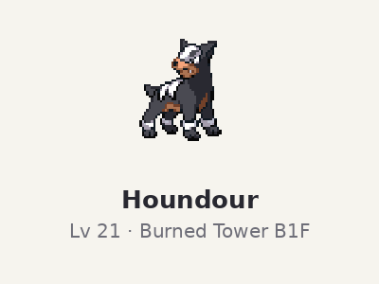
Pokémon | Lv | Item | Moves
Houndour | 21 | - | Thunder Fang, Smog, Roar, Bite

Lanturn — Slowpoke Well B2F
In the water south of the ladder island. Needs Surf. 31 IVs in every stat; knows the egg move Amnesia (instead of Take Down).
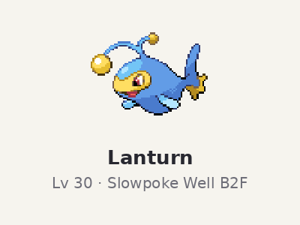
Pokémon | Lv | Item | Moves
Lanturn | 30 | - | Confuse Ray, Charge Beam, BubbleBeam, Amnesia

Lapras Union Cave (lower floor)
The game's own Lapras spot. Needs Surf. This was in the original game aswell but now it’s here everyday.
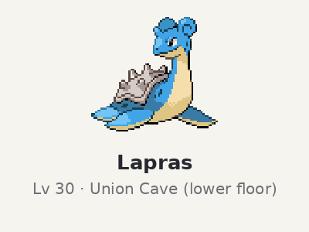
Pokémon | Lv | Item | Moves
Lapras | 30 | - | Water Pulse, Body Slam, Rain Dance, Dragon Dance

Rhyhorn — Mt. Mortar
Small side room in the big lower cave, near a ladder. Needs Surf and Strength. 31 IVs in every stat; knows the egg move Crunch (instead of Scary Face).
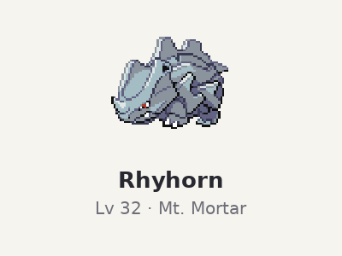
Pokémon | Lv | Item | Moves
Rhyhorn | 32 | - | Rock Blast, Fury Attack, Rock Tomb, Crunch

Jynx — Ice Path B3F
Top corridor. 31 IVs in every stat; knows the egg move Nasty Plot (instead of Avalanche).
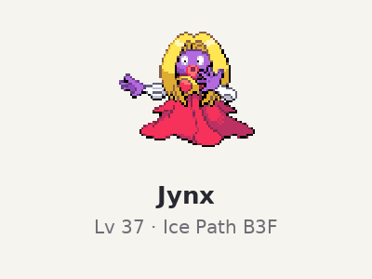
Pokémon | Lv | Item | Moves
Jynx | 37 | - | Mean Look, Fake Tears, Wake-Up Slap, Nasty Plot

Dragonair — Dragon's Den
East ledge with the Dragon Fang, halfway down. Appears once you have the Rising Badge and the Dragon Shrine master's approval 31 IVs in every stat; knows the egg move Dragon Rush (instead of Slam).
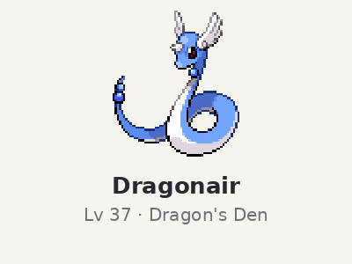
Pokémon | Lv | Item | Moves
Dragonair | 37 | - | Dragon Rush, DragonBreath, Agility, Aqua Tail

Donphan — Victory Road 3F
NE corner of the room with the Rock Smash rocks and an item ball (up the east stairs on 2F). 31 IVs in every stat; knows the egg move AncientPower (instead of Scary Face).
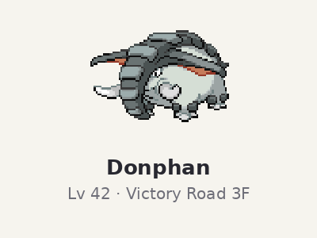
Pokémon | Lv | Item | Moves
Donphan | 42 | - | Slam, Fury Attack, Assurance, AncientPower

Pokemon Changes and Move Changes
Trade evolution pokemon evolve via level up and if they need trade plus item only that item is required and now it can be used as a stone evolution (ie Scyther to Scisor via metalcoat), Many weak Pokemon have been buffed and given better movesets, many moves are buffed and some changed like cut to being a bug type move, additionally some pokemon have been compensated like Kingdra who is getting a small buff to compensate for Critical hit nerf to 1.5x instead of 2x. The main goal is to allow more pokemon to be used in a playthrough.

Move changes
52 moves changed. Power, accuracy and PP were retuned toward their latergeneration values; a few moves changed type (Cut is now Bug type). New values shown; the last column lists what changed.
Move | Type | Category | Power | Accuracy | PP | Change
Cut | Bug | Physical | 60 | 100 | 30 | Type Normal → Bug; Power 50 → 60; Accuracy 95 → 100
Bind | Normal | Physical | 15 | 85 | 20 | Accuracy 75 → 85
Vine Whip | Grass | Physical | 45 | 100 | 25 | Power 35 → 45; PP 15 → 25
Jump Kick | Fighting | Physical | 100 | 95 | 10 | Power 85 → 100; PP 25 → 10
Tackle | Normal | Physical | 40 | 100 | 35 | Power 35 → 40; Accuracy 95 → 100
Wrap | Normal | Physical | 15 | 90 | 20 | Accuracy 85 → 90
Thrash | Normal | Physical | 120 | 100 | 10 | Power 90 → 120; PP 20 → 10
Pin Missile | Bug | Physical | 25 | 95 | 20 | Power 14 → 25; Accuracy 85 → 95
Flamethrower | Fire | Special | 90 | 100 | 15 | Power 95 → 90
Hydro Pump | Water | Special | 110 | 80 | 5 | Power 120 → 110
Surf | Water | Special | 90 | 100 | 15 | Power 95 → 90
Ice Beam | Ice | Special | 90 | 100 | 10 | Power 95 → 90
Blizzard | Ice | Special | 110 | 70 | 5 | Power 120 → 110
Submission | Fighting | Physical | 80 | 100 | 25 | Accuracy 80 → 100 Now lowers defense with a chance of 50%
Fire Spin | Fire | Special | 35 | 85 | 15 | Power 15 → 35; Accuracy 70 → 85
Thunderbolt | Electric | Special | 90 | 100 | 15 | Power 95 → 90
Thunder | Electric | Special | 110 | 70 | 10 | Power 120 → 110
Fire Blast | Fire | Special | 110 | 85 | 5 | Power 120 → 110
Clamp | Water | Physical | 35 | 85 | 15 | Accuracy 75 → 85; PP 10 → 15
Skull Bash | Normal | Physical | 130 | 100 | 10 | Power 100 → 130; PP 15 → 10
Hi Jump Kick | Fighting | Physical | 130 | 90 | 10 | Power 100 → 130; PP 20 → 10
Leech Life | Bug | Physical | 75 | 100 | 10 | Power 20 → 75; PP 15 → 10
Bubble | Water | Special | 40 | 100 | 30 | Power 20 → 40
Crabhammer | Water | Physical | 100 | 90 | 10 | Power 90 → 100; Accuracy 85 → 90
Rockslide | Rock | Physical | 85 | 95 | 10 | Power 75 → 85; Accuracy 90 → 95
Thief | Dark | Physical | 60 | 100 | 25 | Power 40 → 60; PP 10 → 25
Giga Drain | Grass | Special | 75 | 100 | 10 | Power 60 → 75
Fury Cutter | Bug | Physical | 40 | 95 | 20 | Power 10 → 40
Rapid Spin | Normal | Physical | 50 | 100 | 40 | Power 20 → 50
Rock Smash | Fighting | Physical | 65 | 100 | 15 | Power 40 → 65; Effect chance 50 → 30
Whirlpool | Water | Special | 35 | 85 | 15 | Power 15 → 35; Accuracy 70 → 85
Heat Wave | Fire | Special | 95 | 90 | 10 | Power 100 → 95
Knock Off | Dark | Physical | 65 | 100 | 20 | Power 20 → 65
Air Cutter | Flying | Special | 60 | 95 | 25 | Power 55 → 60
Overheat | Fire | Special | 130 | 90 | 5 | Power 140 → 130
Rock Tomb | Rock | Physical | 60 | 95 | 15 | Power 50 → 60; Accuracy 80 → 95; PP 10 → 15
Sand Tomb | Ground | Physical | 35 | 85 | 15 | Power 15 → 35; Accuracy 70 → 85
Muddy Water | Water | Special | 90 | 85 | 10 | Power 95 → 90
Dragon Claw | Dragon | Physical | 85 | 100 | 15 | Power 80 → 85
Covet | Normal | Physical | 60 | 100 | 25 | Power 40 → 60; PP 40 → 25
Wake-Up Slap | Fighting | Physical | 70 | 100 | 10 | Power 60 → 70
Sucker Punch | Dark | Physical | 70 | 100 | 5 | Power 80 → 70
X-Scissor | Bug | Physical | 85 | 100 | 15 | Power 80 → 85; increased crit chance
Dragon Pulse | Dragon | Special | 85 | 100 | 10 | Power 90 → 85
Dragon Rush | Dragon | Physical | 100 | 85 | 10 | Accuracy 75 → 85
Drain Punch | Fighting | Physical | 75 | 100 | 10 | Power 60 → 75; PP 5 → 10
Fire Fang | Fire | Physical | 85 | 95 | 15 | Power 65 → 85
Draco Meteor | Dragon | Special | 130 | 90 | 5 | Power 140 → 130
Leaf Storm | Grass | Special | 130 | 90 | 5 | Power 140 → 130
Stone Edge | Rock | Physical | 100 | 90 | 5 | Accuracy 80 → 90
Bug Bite | Bug | Physical | 40 | 100 | 20 | Power 60 → 40
Magma Storm | Fire | Special | 100 | 75 | 5 | Power 120 → 100; Accuracy 70 → 75

Base stats, types and abilities
48 Pokémon changed. Old → new for each stat; raised stats in green.
Species | Pokémon | HP | Atk | Def | SpA | SpD | Spe | Total(bst) | Other
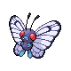 | Butterfree | 60→70 | 45 | 50→55 | 80→100 | 80→85 | 70→85 | 385→440
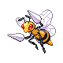 | Beedrill | 65→70 | 80→100 | 40→50 | 45 | 80 | 75→95 | 385→440
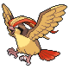 | Pidgeot | 83 | 80→90 | 75 | 70 | 70 | 91 | 469→479
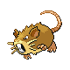 | Raticate | 55→60 | 81→95 | 60→63 | 50 | 70 | 97 | 413→435
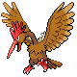 | Fearow | 65→68 | 90→100 | 65→70 | 61 | 61 | 100 | 442→460
 | Arbok | 60→65 | 85→95 | 69→76 | 65 | 79 | 80 | 438→460
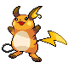 | Raichu | 60 | 90 | 55 | 90 | 80 | 100→110 | 475→485
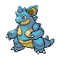 | Nidoqueen | 90 | 82→92 | 87 | 75 | 85 | 76 | 495→505
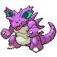 | Nidoking | 81 | 92→102 | 77 | 85 | 75 | 85 | 495→505
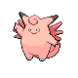 | Clefable | 95 | 70 | 73 | 85→95 | 90 | 60 | 473→483
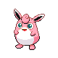 | Wigglytuff | 140 | 70 | 45 | 75→85 | 50 | 45 | 425→435
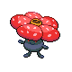 | Vileplume | 75 | 80 | 85 | 100→110 | 90 | 50 | 480→490
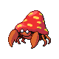 | Parasect | 60→70 | 95→105 | 80→85 | 60 | 80→85 | 30 | 405→435
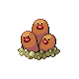 | Dugtrio | 35 | 80→100 | 50 | 50 | 70 | 120 | 405→425
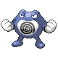 | Poliwrath | 90 | 85→95 | 95 | 70 | 90 | 70 | 500→510
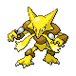 | Alakazam | 55 | 50 | 45 | 135 | 85→95 | 120 | 490→500
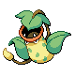 | Victreebel | 80 | 105 | 65 | 100 | 60→70 | 70 | 480→490
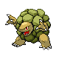 | Golem | 80 | 110→120 | 130 | 55 | 65 | 45 | 485→495
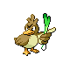 | Farfetch'd | 52→62 | 65→100 | 55→70 | 58 | 62→72 | 60→75 | 352→437
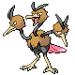 | Dodrio | 60 | 110 | 70 | 60 | 60 | 100→110 | 460→470
 | Electrode | 60 | 50 | 70 | 80 | 80 | 140→150 | 480→490
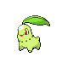 | Chikorita | 45 | 49 | 65 | 49 | 65 | 45 | 318 | Ability: Overgrow → Overgrow / Chlorophyll
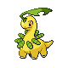 | Bayleef | 60 | 62 | 80 | 63 | 80 | 60 | 405 | Ability: Overgrow → Overgrow / Chlorophyll
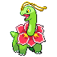 | Meganium | 80 | 82 | 100 | 83 | 100 | 80 | 525 | Ability: Overgrow → Overgrow / Chlorophyll
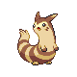 | Furret | 85→90 | 76→85 | 64→70 | 45→55 | 55→60 | 90→100 | 415→460
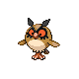 | Hoothoot | 60→65 | 30 | 30→35 | 36→46 | 56→60 | 50→55 | 262→291
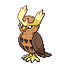 | Noctowl | 100 | 50→42 | 50→75 | 76→107 | 96 | 70→75 | 442→495
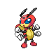 | Ledian | 55→65 | 35→55 | 50→65 | 55→70 | 110 | 85→95 | 390→460
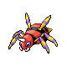 | Ariados | 70→75 | 90→110 | 70→80 | 60 | 60→70 | 40→65 | 390→460
 | Lanturn | 125 | 58 | 58→63 | 76→96 | 76 | 67 | 460→485
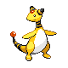 | Ampharos | 90 | 75 | 75→85 | 115 | 90 | 55 | 500→510
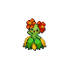 | Bellossom | 75 | 80 | 85→95 | 90 | 100 | 50 | 480→490
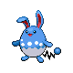 | Azumarill | 100 | 50 | 80 | 50→60 | 80 | 50 | 410→420
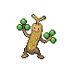 | Sudowoodo | 70→85 | 100→115 | 115 | 30 | 65→70 | 30→35 | 410→450
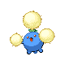 | Jumpluff | 75 | 55 | 70 | 55→80 | 85→95 | 110 | 450→485
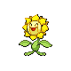 | Sunflora | 75→80 | 75 | 55→85 | 105 | 85→90 | 30 | 425→465
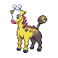 | Girafarig | 70→80 | 80 | 65 | 90→100 | 65 | 85 | 455→475
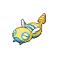 | Dunsparce | 100→105 | 70→95 | 70→75 | 65→70 | 65→70 | 45→55 | 415→470
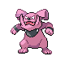 | Granbull | 90 | 120 | 75 | 60 | 60 | 45→65 | 450→470
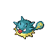 | Qwilfish | 65 | 95 | 75→85 | 55 | 55 | 85 | 430→440
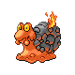 | Magcargo | 50→60 | 50 | 120 | 80→95 | 80→90 | 30→40 | 410→455
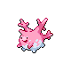 | Corsola | 55→70 | 55→70 | 85→95 | 65→75 | 85→95 | 35→45 | 380→450
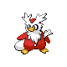 | Delibird | 45→70 | 55→80 | 45→55 | 65→85 | 45→55 | 75→95 | 330→440
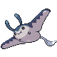 | Mantine | 65→85 | 40 | 70 | 80 | 140 | 70 | 465→485
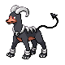 | Houndoom | 75 | 90 | 50→60 | 110 | 80 | 95 | 500→510
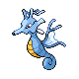 | Kingdra | 75 | 95 | 95 | 95→110 | 95 | 85 | 540→555
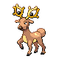 | Stantler | 73 | 95→105 | 62→72 | 85 | 65 | 85 | 465→485
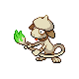 | Smeargle | 55→65 | 20→45 | 35→50 | 20→45 | 45→60 | 75→85 | 250→350

Evolution changes
28 Pokémon evolve differently. Trade evolutions are gone: those Pokémon now evolve by level, or with the item they used to hold during the trade (use it like an evolution use directly). Leafeon, Glaceon and Magnezone used to need places in Sinnoh: Leafeon now evolves with a Leaf Stone, Magnezone with a Thunder Stone, and Glaceon by using NeverMeltIce (found in Ice Path).
Pokémon | Original | Enhanced HeartGold
Pidgey | Pidgeotto (Level 18) | Pidgeotto (Level 14)
Pidgeotto | Pidgeot (Level 36) | Pidgeot (Level 27)
Poliwhirl | Politoed (Trade holding: King's Rock) | Politoed (Use directly: King's Rock)
Kadabra | Alakazam (Trade) | Alakazam (Level 38)
Machop | Machoke (Level 28) | Machoke (Level 22)
Machoke | Machamp (Trade) | Machamp (Level 36)
Geodude | Graveler (Level 25) | Graveler (Level 22)
Graveler | Golem (Trade) | Golem (Level 36)
Slowpoke | Slowking (Trade holding: King's Rock) | Slowking (Use directly: King's Rock)
Magneton | Magnezone (Mt. Coronet) | Magnezone (Use directly: Thunderstone)
Haunter | Gengar (Trade) | Gengar (Level 38)
Onix | Steelix (Trade holding: Metal Coat) | Steelix (Use directly: Metal Coat)
Rhyhorn | Rhydon (Level 42) | Rhydon (Level 36)
Rhydon | Rhyperior (Trade holding: Protector) | Rhyperior (use directly: Protector)
Seadra | Kingdra (Trade holding: Dragon Scale) | Kingdra (Use directly: Dragon Scale)
Scyther | Scizor (Trade holding: Metal Coat) | Scizor (Use directly: Metal Coat)
Electabuzz | Electivire (Trade holding: Electirizer) | Electivire (Use directly: Electirizer)
Magmar | Magmortar (Trade holding: Magmarizer) | Magmortar (Use directly: Magmarizer)
Eevee | Leafeon (Eterna Forest); Glaceon (Route 217); Jolteon (Stone: Thunderstone); Vaporeon (Stone: Water Stone); Flareon (Stone: Fire Stone); Espeon (Friendship (day)); Umbreon (Friendship (night)) | Leafeon (Use directly: Leaf Stone); Glaceon (Use directly: NeverMeltIce); Jolteon (Use directly: Thunderstone); Vaporeon (Use directly: Water Stone); Flareon (Use directly: Fire Stone); Espeon (Friendship (day)); Umbreon (Friendship (night))
Porygon | Porygon2 (Trade holding: Up~Grade) | Porygon2 (Use directly: Up~Grade)
Dragonair | Dragonite (Level 55) | Dragonite (Level 50)
Chikorita | Bayleef (Level 16) | Bayleef (Level 14)
Bayleef | Meganium (Level 32) | Meganium (Level 30)
Hoothoot | Noctowl (Level 20) | Noctowl (Level 28)
Porygon2 | PorygonZ (Trade holding: Dubious Disc) | PorygonZ (use directly: Dubious Disc)
Pupitar | Tyranitar (Level 55) | Tyranitar (Level 50)
Dusclops | Dusknoir (Trade holding: Reaper Cloth) | Dusknoir (Use directly: Reaper Cloth)
Clamperl | Huntail (Trade holding: DeepSeaTooth); Gorebyss (Trade holding: DeepSeaScale) | Huntail (Use directly: DeepSeaTooth); Gorebyss (Use directly: DeepSeaScale)

Levelup learnset changes
163 Pokémon have changed levelup moves. "Added" moves are new to that Pokémon (level in brackets); "moved" moves are learned at a different level (old → new); "removed" moves are no longer learned by levelup.
Pokémon | Added | Moved | Removed
Caterpie |  | Bug Bite (15→6)
Butterfree | Leech Life (28) | Confusion (10→1)
Beedrill | Leech Life (28) | Fury Attack (10→1)
Pidgey | Pluck (15), Air Cutter (21) | Gust (9→6)
Pidgeotto | Pluck (15), Air Cutter (21) | Sand-Attack (5→1), Gust (9→1)
Pidgeot | Heat Wave (40), Brave Bird (44) | Sand-Attack (5→1), Gust (9→1), Quick Attack (13→1), Air Slash (62→37)
Spearow | Pluck (11)
Ekans | Poison Jab (30)
Arbok | Poison Jab (30) | Poison Sting (4→1)
Raichu | Discharge (35), ThunderPunch (40), Thunder (45), Nasty Plot (50)
Sandshrew | Magnitude (14) | Sand Tomb (27→9)
Sandslash | Magnitude (14), Dig (34) | Defense Curl (3→1), Sand-Attack (7→1)
Nidoran |  | Poison Sting (13→9)
Nidorina | Poison Jab (30)
Nidoqueen | Poison Jab (35), Dig (40), Sludge Bomb (47) | Superpower (58→50)
Nidoran |  | Poison Sting (13→9)
Nidorino |  | Poison Jab (43→30)
Nidoking | Poison Jab (35), Dig (40), Sludge Bomb (47) | Megahorn (58→50)
Clefable | Meteor Mash (35), Hyper Voice (40), Moonlight (45), Cosmic Power (50), Healing Wish (55)
Ninetales | Extrasensory (35), Flamethrower (40), Will-O-Wisp (44), Fire Blast (48), Dark Pulse (52), Heat Wave (56)
Wigglytuff | Body Slam (35), Hyper Voice (40), Double-Edge (45), Wake-Up Slap (50), Gyro Ball (55)
Zubat | Absorb (1) | Wing Attack (17→9) | Leech Life
Golbat | Absorb (1) | Supersonic (5→1), Astonish (9→1) | Leech Life
Oddish |  | Giga Drain (37→29)
Gloom |  | Sweet Scent (5→1), Acid (9→1), Giga Drain (47→31)
Vileplume | Moonlight (35), Giga Drain (44), Sludge Bomb (48) | Petal Dance (53→40), SolarBeam (65→50)
Paras | Bug Bite (9) | Leech Life (11→28)
Parasect | Bug Bite (1) | Stun Spore (6→1), PoisonPowder (6→1), Leech Life (11→28)
Venonat | Bug Bite (9) | Leech Life (17→28)
Venomoth | Bug Bite (17) | Supersonic (5→1), Leech Life (17→28)
Diglett |  | Mud-Slap (15→9)
Mankey |  | Karate Chop (13→9)
Arcanine | Crunch (35), Flare Blitz (45), Close Combat (50), Outrage (55) | Thunder Fang (1→36)
Poliwrath | Waterfall (35), Brick Break (39), Hydro Pump (52) | Mind Reader (53→48)
Machop |  | Karate Chop (10→9)
Bellsprout |  | Razor Leaf (39→23)
Weepinbell |  | Growth (7→1), Wrap (11→1), Razor Leaf (39→23)
Victreebel | Poison Jab (35), Sludge Bomb (44), Power Whip (52) | Leaf Blade (47→40)
Geodude | Mud-Slap (4), Rock Tomb (15) | Rock Throw (11→9) | Mud Sport
Graveler | Mud-Slap (4), Rock Tomb (15) | Mud Sport (4→1), Rock Polish (8→1)
Ponyta |  | Ember (10→9)
Rapidash |  | Tail Whip (6→1), Ember (10→1), Flare Blitz (56→40)
Slowpoke |  | Water Gun (11→9)
Doduo | Pluck (10) |  | Rage
Seel |  | Aqua Jet (31→9)
Shellder |  | Clamp (25→9)
Cloyster | Ice Shard (32), Avalanche (40), Hydro Pump (45), Rock Blast (50)
Onix | Dig (28) | Sand Tomb (46→14) | Rage
Krabby |  | Crabhammer (41→35)
Kingler |  | ViceGrip (5→1), Crabhammer (56→36)
Voltorb |  | Charge Beam (26→9)
Exeggcute |  | Bullet Seed (17→9)
Exeggutor | Psychic (42), Zen Headbutt (50) | Stomp (17→1)
Cubone |  | Bonemerang (21→9)
Lickitung |  | Wrap (17→9)
Koffing |  | Sludge (24→15)
Weezing |  | Smog (6→1), SmokeScreen (10→1), Sludge (24→15)
Rhyhorn | Mud-Slap (5), Rock Tomb (17) | Rock Blast (25→9)
Rhydon | Mud-Slap (5), Rock Tomb (17) | Stomp (9→1), Fury Attack (13→1)
Tangela | Giga Drain (30) | - | -
Goldeen |  | Water Pulse (17→9)
Starmie | Psychic (37), Power Gem (40), Hydro Pump (44), Cosmic Power (50)
Scyther |  | Wing Attack (21→9), X-Scissor (41→32)
Jynx |  | Lick (5→1), Lovely Kiss (8→1), Powder Snow (11→1), Blizzard (55→44)
Gyarados |  | Aqua Tail (35→33)
Vaporeon | Water Pulse (30) | Muddy Water (78→40)
Jolteon | Shock Wave (20) | Discharge (78→36)
Flareon | Flame Wheel (25), Dig (31), Flare Blitz (40), Superpower (47) | Fire Fang (43→36)
Porygon |  | Tri Attack (51→34)
Omanyte | Rock Tomb (21) | Water Gun (10→9)
Kabuto | Rock Tomb (21) | Aqua Jet (31→9)
Aerodactyl | Rock Tomb (17)
Dratini | DragonBreath (21) | Twister (11→9)
Dragonair | DragonBreath (21) | Thunder Wave (5→1), Twister (11→1)
Chikorita | Leech Seed (9), Sleep Powder (19), Giga Drain (23) | PoisonPowder (9→14) | Natural Gift
Bayleef | Leech Seed (9), Sleep Powder (20), Giga Drain (24) | Razor Leaf (6→1), PoisonPowder (9→1), Body Slam (40→20) | Natural Gift
Meganium | Leech Seed (9), Sleep Powder (20), Giga Drain (24) | Razor Leaf (6→1), PoisonPowder (9→1), Body Slam (46→44), Safeguard (54→48), Aromatherapy (60→52), SolarBeam (66→56) | Natural Gift
Cyndaquil |  | Ember (10→9)
Totodile | Water Pulse (18)
Croconaw | Water Pulse (18) | Water Gun (6→1), Aqua Tail (48→33)
Feraligatr | Water Pulse (18) | Water Gun (6→1), Rage (8→1), Aqua Tail (58→33)
Hoothoot | Air Cutter (19) | Confusion (21→15)
Noctowl | Air Cutter (19), Hyper Voice (36) | Hypnosis (5→1)
Ledyba |  | Silver Wind (25→9)
Ledian | Air Slash (33) | Supersonic (6→1), Comet Punch (9→1) | -
Spinarak | Bug Bite (12) | Leech Life (12→28)
Ariados |  | Scary Face (5→1), Constrict (8→1), Leech Life (12→29)
Crobat | Absorb (1) | Supersonic (5→1), Astonish (9→1) | Leech Life
Chinchou | ThunderShock (1), Charge Beam (20), Thunderbolt (40), Thunder (47) | Water Gun (12→9), Flail (9→12), BubbleBeam (28→23), Take Down (23→26), Discharge (34→31), Signal Beam (31→35), Aqua Ring (39→43), Hydro Pump (42→49), Charge (45→52) | Spark
Lanturn | ThunderShock (1), Charge Beam (20), Thunderbolt (40), Thunder (47) | Stockpile (27→1), Swallow (27→1), Spit Up (27→1), Thunder Wave (6→1), Water Gun (12→9), Flail (9→12), BubbleBeam (30→23), Take Down (23→26), Discharge (40→31), Aqua Ring (47→43), Hydro Pump (52→49), Charge (57→52) | Spark
Togepi | Swift (20) | - | -
Togetic | Swift (20), Air Slash (30) | Metronome (6→1), Sweet Kiss (10→1) | -
Natu | Confusion (12), Air Cutter (20), Psybeam (25) | - | Me First
Xatu | Confusion (12), Air Cutter (20), Psybeam (25) | - | Me First
Mareep | Shock Wave (18) | ThunderShock (10→9)
Flaaffy | Shock Wave (18) | Growl (5→1), ThunderShock (10→1)
Bellossom | Moonlight (35), Petal Dance (40), Giga Drain (44), SolarBeam (55) | Leaf Storm (53→50)
Sudowoodo |  | Flail (6→1), Low Kick (9→1), Rock Throw (14→1), Rock Tomb (30→18)
Hoppip | Air Cutter (24) | Bullet Seed (19→9), Mega Drain (25→15), Giga Drain (37→30), Bounce (40→36)
Skiploom | Air Cutter (24) | Synthesis (4→1), Tail Whip (7→1), Tackle (10→1), Mega Drain (28→15), Giga Drain (44→30), Bounce (48→36)
Jumpluff | Air Cutter (24) | Synthesis (4→1), Tail Whip (7→1), Tackle (10→1), Mega Drain (28→15), Giga Drain (44→30), Bounce (48→36)
Sunflora | Giga Drain (24)
Yanma | Silver Wind (22) | Wing Attack (43→9) | -
Wooper | Aqua Tail (29) | - | -
Quagsire | Aqua Tail (29) | Mud Sport (5→1) | -
Espeon |  | Psybeam (36→20)
Umbreon |  | Faint Attack (36→20)
Misdreavus |  | Astonish (10→9), Shadow Ball (37→28)
Dunsparce | Headbutt (21) | - | -
Gligar | Mud-Slap (9), Aerial Ace (15), Dig (28) | - | Harden
Steelix | Dig (28), Iron Head (34) | - | Mud Sport, Rage
Qwilfish |  | Poison Jab (49→25)
Scizor |  | X-Scissor (41→32)
Shuckle | Rock Throw (9), Rock Tomb (18) | Bug Bite (40→9)
Heracross | X-Scissor (30)
Sneasel | Ice Punch (30) | Faint Attack (14→9), Ice Shard (49→14) | -
Slugma | Rock Tomb (20) | Lava Plume (38→29) | -
Magcargo | Rock Tomb (20) | Ember (8→1), Rock Throw (11→1), Lava Plume (40→29) | -
Corsola | Rock Tomb (15)
Delibird | Ice Shard (9), Icy Wind (18), Ice Beam (35), Drill Peck (40) | - | -
Skarmory |  | Air Cutter (23→17)
Houndour | Flame Wheel (23)
Houndoom | Flame Wheel (23) | Howl (4→1), Smog (9→1)
Phanpy | Mud-Slap (6), Sand Tomb (12), Magnitude (19) |  | Natural Gift
Donphan | Mud-Slap (6), Sand Tomb (12)
Smoochum |  | Powder Snow (11→9)
Torchic |  | Ember (10→9)
Mudkip |  | Water Gun (10→9)
Poochyena |  | Bite (13→9)
Wurmple |  | Bug Bite (15→6)
Nincada | Bug Bite (5) | Leech Life (5→28)
Ninjask |  | Sand-Attack (9→1), Leech Life (5→28)
Shedinja | Bug Bite (5) | Leech Life (5→28)
Nosepass |  | Rock Throw (13→9)
Sableye |  | Astonish (11→9)
Aron |  | Metal Claw (15→9)
Trapinch |  | Sand Tomb (25→9)
Seviper |  | Poison Tail (16→9)
Lileep |  | AncientPower (43→9)
Anorith |  | AncientPower (31→9)
Shuppet |  | Shadow Sneak (20→9)
Duskull |  | Astonish (14→9)
Absol |  | Pursuit (20→9)
Bagon |  | DragonBreath (31→9)
Kricketot |  | Bug Bite (16→9)
Kricketune | Bug Bite (14) | Leech Life (14→28)
Roserade | Energy Ball (35), Sludge Bomb (40), Toxic Spikes (45), Leaf Storm (50), Petal Dance (55)
Cranidos |  | AncientPower (28→9)
Shieldon |  | AncientPower (28→9)
Burmy |  | Bug Bite (15→9)
Cherubi |  | Magical Leaf (19→9)
Mismagius | Shadow Ball (35), Dark Pulse (40), Power Gem (45), Nasty Plot (50)
Chingling |  | Confusion (14→9)
Bonsly |  | Rock Throw (14→9), Rock Tomb (30→18)
Gible |  | Sand Tomb (19→9)
Riolu |  | Force Palm (11→9)
Hippopotas |  | Sand Tomb (25→9)
Carnivine |  | Vine Whip (11→9)
Weavile | Ice Shard (14), Ice Punch (30) | Quick Attack (8→1) | -
Tangrowth | Giga Drain (30) | - | -
Togekiss | Extrasensory (40), Roost (50) | Air Slash (1→35), Aura Sphere (1→45)
Yanmega | Silver Wind (22) | Double Team (11→1) | -
Gliscor | Mud-Slap (9), Aerial Ace (15), Dig (28) | Knock Off (12→1) | -

Lost move | Pokémon
Leech Life | Zubat, Golbat, Crobat (they get Absorb)
Mud Sport | Geodude, Steelix
Rage | Doduo, Onix, Steelix
Natural Gift | Chikorita line, Phanpy
Spark | Chinchou, Lanturn
Me First | Natu, Xatu
Harden | Gligar

