DOCUMENTATION

Run the script ‘Analysis & Insights’

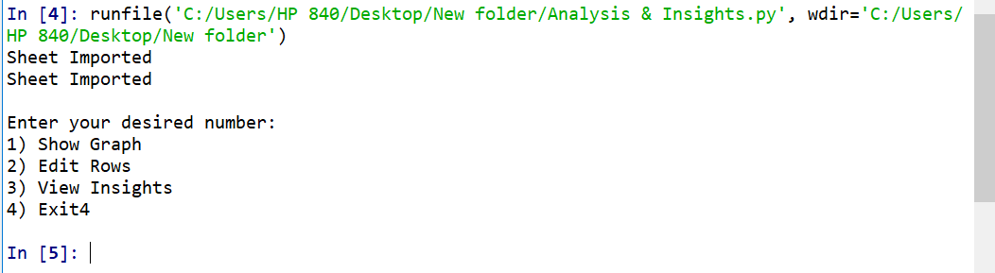

Enter number you want to run

When Entered

1. Show Graph: 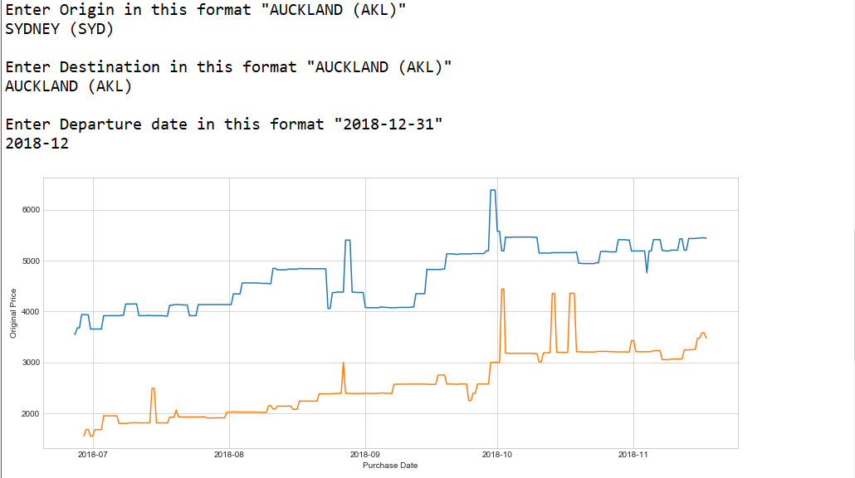
2. Edit Rows: 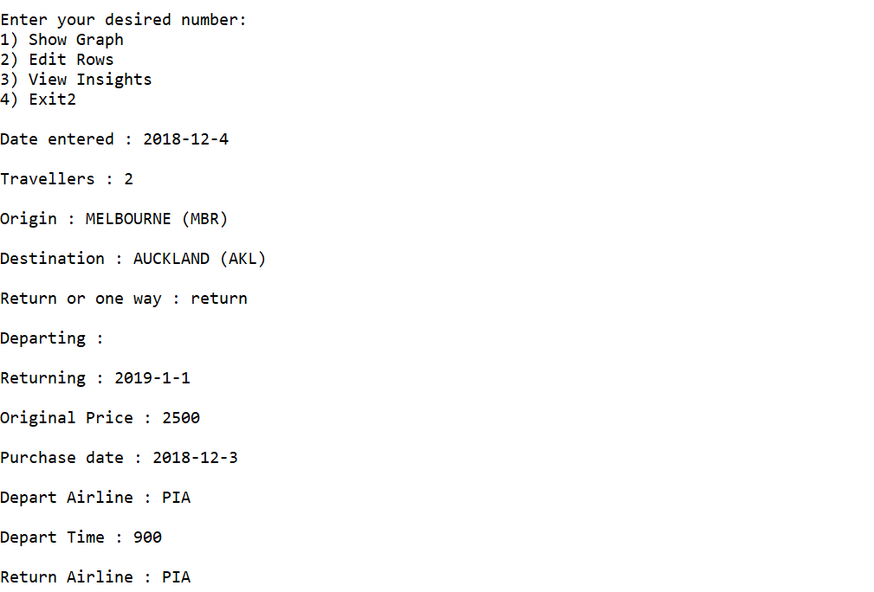
3. View Insights: 