**CMS Made Easy…Automated Chatbot for Students**

FYP-Propsl-Tmplt-03

**FYP Proposal Number**

CS-FYP-2018-001

**Date of Submission**

25-Nov-2019

**Students:**

Balaj Yousuf / BSCS/F15/0109

Saad Nasir / BSCS/F15/0107

Usama Amjad / BSCS/F15/0147

**Supervisor**

Asst. Prof Imran Khan

**Co-Supervisor**

Asst. Prof Iqbal Uddin Khan



Department of Computing

Faculty of Engineering & Science

Hamdard University

Contents

1.0 Introduction 4

1.1 Problem Statement 4

1.2 Motivation 4

1.3 Aims and Objectives 4

1.3.1 Research Objectives 4

1.3.2 Academic Objectives 4

1.3.3 Commercial Objectives 4

1.4 Literature Review 5

2.0 Project Scope 6

3.0 Methodology 8

3.1 Project Approach 8

3.2 Team Roles & Responsibilities 8

3.3 Requirement Development 8

3.3.1 Functional Requirement 8

3.3.2 Non-functional Requirement 9

3.4 Architect / Design 9

3.5 Development / Construction 10

3.5.1 Datasets 10

3.5.2 Data preparation 10

3.5.3 Developing algorithm 10

3.5.4 Training algorithm 10

3.5.5 Web Application 11

3.6 Application (or Project) Testing 11

4.0 Project Planning 11

4.1 Timeline 11

4.2 Milestones 12

5.0 Project Requirements 12

5.1 Software tools requirements 12

5.2 Hardware requirements 12

6.0 Budget/Costing 12

6.1 Budgeting Cost **-** of the Project 12

6.2 Total Budgeted Cost **-** of the Project 13

7.0 Project Deliverables 13

8.0 References 13

Table of Figures

Figure 1 - Work Flow diagram of CMS Made Easy…Automated Chatbot for Students 8

Figure 2 - Agile Diagram Flow CMS Made Easy…Automated Chatbot for Students 8

Figure 3 - Design/Architect for CMS Made Easy…Automated Chatbot for Students. 9

Figure 4 - Gantt Chart for CMS Made Easy…Automated Chatbot for Students 111

Figure 5 - Intel i7th - 5600U 122

# 1.0 Introduction

1.1 Problem Statement

In this technologically advanced world, navigating between pages or to perform queries in every other pages wastes a lot of time. People now a days prefer those applications where they can see everything in just one place. Stereotype websites are being replaced by Single Page Applications and Progressive Web Apps.

## 1.2 Motivation

From my personal experience, navigating between CMS takes a lot of time. For e.g. just to see my current schedule or transport or tuition fee we have to navigate back and forth on average 4 times. In the age where 5G is evolving the world, this is a no brainer. Chatbots are one of many solutions that can solve this problem. You just ask chatbot the question, it will provide with you the relevant answers.

* 1. Aims and Objectives

The objective is to develop a generalized algorithm that is able to detect what user wants to know with the help of Artificial Intelligence and provide appropriate answer. The Aim is to develop a model that can be integrated with our own university CMS and help students serve better way.

### Research Objectives:

* To research, it can provide extension of Machine Learning and natural language processing from chat bots to in web-applications.
* To develop the project, this requires extensive amount of research on human behavior, text behavior.

### Academic Objectives:

* To write a university-based chapter on machine learning and natural language processing.
* To integrate the chatbot with our own CMS

### Commercial Objectives:

* After the development of the project, it can be commercialized mainly in academic organizations where the same problem is faced by other university students as well.
* To take this step further and implement in other organizations as well
  1. Literature Review

Chatbots are becoming a ubiquitous trend in many fields such as medicine, product and service industry, and education. Chatbots are computer programs used to conduct auditory or textual conversations. A growing body of evidence suggests that these programs have the potential to change the way students learn and search for information. Especially in large-scale learning scenarios with more than 100 students per lecturer, Chatbots are able to solve the problem of individual student support. However, until now, there has been no systematic, structured overview of their use in education. Few studies suggest the potential of Chatbots for improving learning processes and outcomes. Nevertheless, past research has revealed that the effectiveness of Chatbots in education is complex and depends on a variety of factors [1]. Conversational agents change the way we think and live, as they have the ability of being present and ready to provide help anytime and anywhere. From mobile phones or PCs to smart homes, virtual assistants may ease our lives, by doing tasks while conducting conversations. The effects bots can have on education change the humanity forever, implementing new educational principles designed as complementary to traditional methods and to teachers. They may have a major role in delivering pedagogical content and assessing, covering a wide variety of lessons and subjects by using multimedia content and speeches. [2]. When combined social media with Artificial Intelligence it harnesses so much power i.e. user data which could be used to learn more about the user. More and more people join social media every day which is directly proportional to data being increasing every day on social media. There is a great opportunity to gather social media data of user and use it for professional purpose.

[3]. https://expertsystem.com/chatbot/The ability to identify the user’s intent and extract data and relevant entities contained in the user’s request is the first condition and the most relevant step at the core of a chatbot: If you are not able to correctly understand the user’s request, you won’t be able to provide the correct answer.

Returning the response: once the user’s intent has been identified, the chatbot must provide the most appropriate response for the user’s request. The answer may be:

• A generic and predefined text

• A text retrieved from a knowledge base that contains different answers

• A contextualized piece of information based on data the user has provided

• Data stored in enterprise systems

• The result of an action that the chatbot performed by interacting with one or more backend application

• A disambiguating question that helps the chatbot to correctly understand the user’s request

[4]. the evolution of artificial intelligence is now in full swing and Chatbots are only a faint splash on a huge wave of progress. Today the number of users of messaging apps like WhatsApp, Slack, Skype and their analogs is skyrocketing, Facebook Messenger alone has more than 1.2 billion monthly users. With the spread of messengers, virtual chatterbots that imitate human conversations for solving various tasks are becoming increasingly in demand. Chinese WeChat bots can already set medical appointments, call a taxi, send money to friends, and check in for a flight and many other.

[5]. by automating conversations that would otherwise require an employee to answer, organizations save time and money that can then be allocated to other efforts.

Instead of having your reps spending all of their time answering inbound questions, those individuals reallocate time to proactively finding relevant conversations to join with social listening tools.

The amount of time you save increases as your inbound message quantity increases. And since Sprout Social research shows the number of social messages requiring a response from a brand increased by 18% from 2015 to 2016, you save countless hours by automating responses with a chatbot.

Chatbots use direct messages to gather information necessary to provide effective support. For example, asking users why they’re visiting your page is one question that is likely asked in every engagement.

Automating this initial interaction allows users to share the information needed for the agent to better serve them without requiring a human to ask for it. For example, Drift’s website chatbot qualifies prospects and gathers their email addresses so a sales rep can follow up.

# 2.0 Project Scope

It centers on the ability to help user create an interactive way to use CMS. Chatbot will provide a unique way of seeing data and visualizing with CMS. It will make user fun to open CMS.

We will train our machine learning models until they are fitting enough to be used on application. Our project will mainly hub on developing a machine learning model and training it to accomplish high level of accuracy so it can be used for other research oriented projects and can be further specified according to the need of the organization.

Our basic endeavor is to train model using Generative approach and generative models on the seq2seq neural network. This network was initially released for machine translation, but has also proved to be quite effective when it comes to building generative [Chatbots](https://chatbotslife.com/) . Generative Chatbots also require a very large amount of conversational data to train. We will first train our seq2seq implementation for our chatbot using more 2 million conversations. also require a very large amount of conversational data to train. If we think that Generative approach is not working according to our need we will switch to Retrieval Based bots. Retrieval based bots work on the principle of directed flows or graphs. The bot is trained to rank the best response from a finite set of predefined responses.

If we are successful in this, we will then use National Language Processing to generate an automated response to according to users’ profile to make it more intuitive.

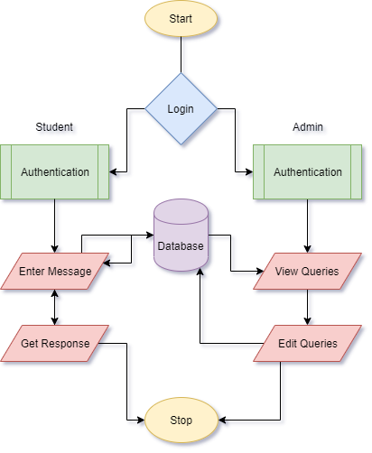

Figure 1 – Work Flow Diagram for cms made easy – automated chatbot for students

# 3.0 Methodology

3.1 Project Approach(Agile)

Project approach to be followed is Agile.

Figure 2 - Agile Diagram Flow for cms made easy – automated chatbot for students

3.2 Team Roles & Responsibilities(RACI matrix)

R = Responsible, A = Accountable, C = Consulted, I = Informed

Responsible, Accountable, Consulted, Informed

|  |  |  |  |  |
| --- | --- | --- | --- | --- |
| WBS | Balaj Yousuf | Saad Nasir | Usama Amjad | Imran Khan |
| Problem statement | A/R | A/R | A/R | C/I |
| Requirements | A/R | A/R | A/R | C/I |
| Design | A/R | A/R | A/R | C/I |
| Development | A/R | A/R | A/R | C/I |
| Testing | A/R | A/R | A/R | C/I |

## 3.3 Requirement Development

### 3.3.1 Functional Requirement

* **Login Module:**

This user will be required to login using his/her CMS ID and Password

* **User module**

After user Sign In’s to our application his id will be saved in the cache. Whenever user performs some operations, the id will be used to return data from database

* **Admin module**

Admin module will be used to enter some manual data in few exceptional cases.

### 3.3.2 Non-functional Requirement

* **Environment:**

As the web app is Internet based so it will run on any operating system with internet access having the following browsers:

* Google Chrome version 41+.
* Firefox version 40+.
* Internet explorer version 10+.

3.5 Development / Construction

We will develop web-based project using HTML5, CSS3, and Angular 8 for User Interface.

For back-end processing of this project, we will be using python, NLP, NLTK, scikit and other

### Generating Datasets

We will use premade datasets easily available on Kaggle and other open source websites. It will help us develop a chatbot which will be able to solve general level queries. Then for our specific task we will generate our own dataset and train it enough so that it could detect what user is saying and perform queries.

### 3.5.2 Data preparation

After collecting data, we will need to prepare data to convert it into meaningful information so it can be used to train our model. First, we will run query to remove all duplicate texts so that file contains only unique texts. Then we will try to fill up any missing values through various techniques available in Python`s Panda library. If still missing values cannot be filled so we will remove all those rows with missing values. These procedures will be used for data cleansing operations and so that our data can be prepared to train our own model. We will remove all those columns from our dataset which is not important for us so that when processing takes place it does not waste our time.

### 3.5.3 Training model

The model will be trained using datasets designed above so that it can achieve high level of accuracy and can be used in our application. The model would be trained using 100000+ user’s chats in plain text form in our dataset. The model would be trained using different techniques used in Machine Learning until we find the one which best suits our data and has very high score of efficiency.

### 3.5.4 Web Application

The web application will have a messenger-based platform where user will feel like talking to a human. The environment will be super responsive. User will ask something and the query will be sent to our server which will return the response and show it to the user as someone replies.

## 3.6 Application (or Project) Testing

Following testing methods will be applied to the project:

* Black Box Testing
* White Box Testing
* Regression Testing

# 4.0 Project Planning

4.1 Timeline

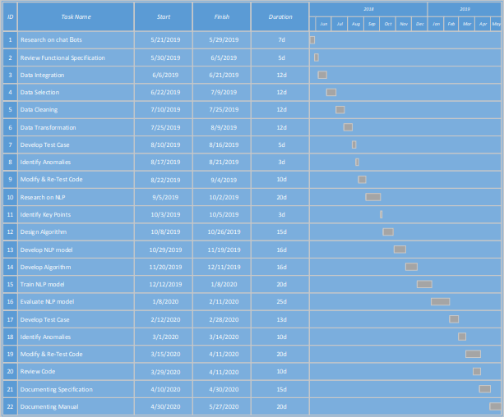

Figure 4 - Gantt chart for the CMS Made Easy…Automated Chatbot for Students

4.2 Milestones

* **First Evaluation:**

By the end of first evaluation, we will have decided which approach will be used to train the model and model will be trained sufficient enough to perform simple queries. Database part will also be completed and integrated with chatbot.

* **Final Evaluation:**

By the end of final evaluation, the model will be trained with high accuracy and high efficiency and will be able to perform complex queries as well. An interactive messenger application will also be developed in which chatbot will be integrated.

# 5.0 Project Requirements

5.1 Software tools requirements

* Python – Programming language.
* HTML, CSS3, Angular 8, Flask – For Web-Development.
* Anaconda – for Large-Scale data processing and scientific computing.
* Tensor Flow, Scikit, Textblob – Open Source library for machine Learning
* Natural Language Processing Libraries

## 5.2 Hardware requirements

* Intel i7th-5600 (Client – Machine).



Figure 5 - Intel i7th - 5600U

# 6.0 Budget/Costing

## Budgeting Cost **-** of the Project

1. GPU`s are required for high-end processing which are pretty expensive hence we have decided to use Amazon’s micro services or AWS which are estimated to be $250.
2. 4 Udemy Courses for Chatbot Implementation which will cost $12/course

## 6.2 Total Budgeted Cost **-** of the Project

The total budgeted cost for the project is estimated up to be **50,000**

7.0 Project Deliverables

Following are the **project deliverables**:

* Requirements documentation.
* Design documents.
* Our own trained machine learning model

8.0 References

1. Kerlyl, Alice, Phil Hall, and Susan Bull. "Bringing chatbots into education: Towards natural language negotiation of open learner models." In International Conference on Innovative Techniques and Applications of Artificial Intelligence, pp. 179-192. Springer, London, 2006.
2. Georgescu, Alin-Andrei. "Chatbots for Education–Trends, Benefits and Challenges." In *Conference proceedings of» eLearning and Software for Education «(eLSE)*, vol. 2, no. 14, pp. 195-200. ” Carol I” National Defence University Publishing House, 2018..
3. Benotti, Luciana, María Cecilia Martínez, and Fernando Schapachnik. "Engaging high school students using chatbots." In *Proceedings of the 2014 conference on Innovation & technology in computer science education*, pp. 63-68. ACM, 2014.
4. Georgescu, Alin-Andrei. "Chatbots for Education–Trends, Benefits and Challenges." In *Conference proceedings of» eLearning and Software for Education «(eLSE)*, vol. 2, no. 14, pp. 195-200. ” Carol I” National Defence University Publishing House, 2018.

1. Leonhardt, Michelle Denise, Liane Tarouco, Rosa Maria Vicari, Elder Rizzon Santos, and Michele dos Santos da Silva. "Using chatbots for network management training through problem-based oriented education." In *Seventh IEEE International Conference on Advanced Learning Technologies (ICALT 2007)*, pp. 845-847. IEEE, 2007.
2. Golbeck, Roos, Sofie. "Chatbots in education: A passing trend or a valuable pedagogical tool?." (2018).
3. Roos, Sofie. "Chatbots in education: A passing trend or a valuable pedagogical tool?." (2018)..
4. Shawar, Bayan Abu, and Eric Atwell. "Chatbots: are they really useful?." In *Ldv forum*, vol. 22, no. 1, pp. 29-49. 2007.

1. Kowalski, Stewart, Katarina Pavlovska, and Mikael Goldstein. "Two case studies in using chatbots for security training." In *IFIP World Conference on Information Security Education*, pp. 265-272. Springer, Berlin, Heidelberg, 2009..
2. Molnár, György, and Zoltán Szüts. "The Role of Chatbots in Formal Education." In *2018 IEEE 16th International Symposium on Intelligent Systems and Informatics (SISY)*, pp. 000197-000202. IEEE, 2018.