**Traffic Violation Detection Using Smart Systems**

FYP-Propsl-Tmplt-03

**FYP Proposal Number**

CS-FYP-2019-001

**Date of Submission**

25-Nov-2019

**Students:**

Abdul Sami Khan / BSCS/F15/0144

M. Ehtisham Siddiqui / BSCS/F15/0151

M. Faraz Khalid / BSCS/F15/0104

**Supervisor**

M. Imran Khan

**Co-Supervisor**



Department of Computing

Faculty of Engineering & Science

Hamdard University

Contents

1.0 Introduction 4

1.1 Problem Statement 4

1.2 Motivation 4

1.3 Aims and Objectives 4

1.3.1 Research Objectives 4

1.3.2 Academic Objectives 4

1.3.3 Commercial Objectives 4

1.4 Literature Review 5

2.0 Project Scope 6

3.0 Methodology 7

3.1 Project Approach 7

3.2 Team Roles & Responsibilities 8

3.3 Requirement Development 8

3.3.1 Functional Requirement 8

3.3.2 Non-functional Requirement 8

3.5 Development / Construction 9

3.5.1 Datasets 9

3.5.2 Data preparation 10

3.5.3 Developing algorithm 10

3.5.4 Training algorithm 10

3.5.5 Web Application 10

3.6 Application (or Project) Testing 10

4.0 Project Planning 11

4.1 Timeline 11

4.2 Milestones 12

5.0 Project Requirements 12

5.1 Software tools requirements 12

5.2 Hardware requirements 12

6.0 Budget/Costing 12

6.1 Budgeting Cost **-** of the Project 12

6.2 Total Budgeted Cost **-** of the Project 12

7.0 Project Deliverables 13

8.0 References 13

Table of Figures

Figure 1 - Work Flow diagram of Traffic Violation Detection Using Smart Systems 7

Figure 2 - Agile Diagram Flow Traffic Violation Detection Using Smart Systems 7

Figure 3 - Design/Architect Traffic Violation Detection Using Smart Systems. 9

Figure 4 - Gantt Chart Traffic Violation Detection Using Smart Systems 111

Figure 5 - Intel i7th - 5600U 122

# 1.0 Introduction

1.1 Problem Statement

In the past few years, almost all the big and smart cities have been suffering from this severe issue called traffic violations. This problem is continuously increasing because of industrialization and it is observed that people are not the following the traffic rules which results in high ratio of accidents and loss of precious lives.

## 1.2 Motivation

Karachi is a metropolitan city. Mostly in metropolitan cities, life routine is really tight, due to which people are not following rules be it traffic or some other. There must be some kind of strictness embossed which should bind people to follow the rules. The loss of live due to road accidents is very high in Karachi. Our aim is to reduce that by making people follow traffic rules and regulations implemented by the government.

* 1. Aims and Objectives

The Aim is to develop a generalized algorithm that is able to detect different types of traffic violations. The objective is to make people follow rules and regulations and to end bribery and corruption in traffic police department. When people will follow traffic rules, precious lives will be saved as ratio of accidents will become very low.

### Research Objectives:

* To research, it can provide extension of Machine Learning and image recognition to in web-applications.
* To develop the project, this requires extensive amount of research on human behavior and Artificial Intelligence.

### Academic Objectives:

* To write a university-based chapter on deep learning in Traffic problems.
* To identify the power of Artificial Intelligence and how it can be used to solve complex problems very easily.

### Commercial Objectives:

* After the development of the project, it can be commercialized mainly in government organizations because they are the one controlling traffic flow.
* To implement the project in newly build private societies such as Bahria Town, Naya Nazimabad etc.
  1. Literature Review

A traffic violation or event detection, recording and processing system and method is disclosed which includes at least one camera (20 and 30) for monitoring a region under surveillance (31 and 33); means for supplying independently sourced and verifiable time, date and location of a violation; a storing means (54) for storing continuous images taken by the camera; a non-intrusive violation detection means for detecting vehicle presence and movement and for providing an indication of a violation; and processing means for identifying images stored in the storage means and which relate to a violation detected by the violation detection means so that images associated with a violation are identifiable and can be processed to provide evidence of the violation and also identify the vehicle associated with the violation.

A system and method for detecting and filtering non-violation events in a traffic light violation prediction and recording system, including at least one violation prediction image capturing device, such as a video camera, and a violation prediction unit. The prediction unit generates a prediction reflecting a probability that the vehicle will violate a red-light phase of the traffic signal. A non-violation event filter determines whether the vehicle approaching the traffic signal is actually performing a non-violation action.

Recent advances in computer vision technology and the falling prices of related devices has extended the use of video/CCTV by making it practical to automatically identify vehicles visually either online or off-line. The objective of the research is to develop a computer-vision based automatic vehicle identification system to achieve vehicle identification using optical character recognition (OCR) techniques.

Automatic number plate recognition (ANPR) is an image processing technology which uses number (license) plate to identify the vehicle. The objective is to design an efficient automatic authorized vehicle identification system by using the vehicle number plate. The system is implemented on the entrance for security control of a highly restricted area like military zones or area around top government offices e.g. Parliament, Supreme Court etc. The developed system first detects the vehicle and then captures the vehicle image. Vehicle number plate region is extracted using the image segmentation in an image. Optical character recognition technique is used for the character recognition.

This work deals with problematic from field of artificial intelligence, machine vision and neural

networks in construction of an automatic number plate recognition system (ANPR). This

problematic includes mathematical principles and algorithms, which ensure a process of number plate detection, processes of proper characters segmentation, normalization and recognition.

# 2.0 Project Scope

It centers on the ability to judge whether a person has committed any traffic violation or not. A camera will be connected with our server which will scan every passing vehicles in its frame and mark the objects which it identifies committing any traffic violation. Once it marks the object it will try to scan its number plate if possible but if it is not possible due to some blockage like car in between, it will mark the object and try to process its number plate until the object is in the frame.

We will train our deep learning models until they are fitting enough to be used on application. Our project will mainly hub on developing a deep learning model and training it to accomplish high level of accuracy so it can be advanced for other research-oriented projects and can be further specified according to the need of the organization.

Our basic endeavor is to detect the object first and then send the mapped object to our trained model to detect number plate in it.

If we are successful in this, we will then try to increase the efficiency and accuracy of the application and make it able to detect more types of traffic violations.

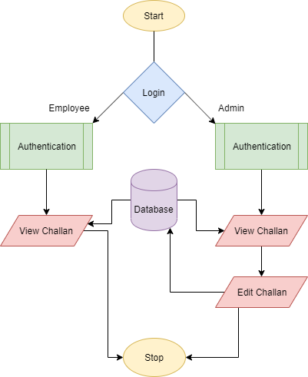

Figure 1 – Work Flow Diagram Traffic Violation Detection Using Smart Systems

# 3.0 Methodology

3.1 Project Approach(Agile)

Project approach to be followed is Agile.

Figure 2 - Agile Diagram Flow Traffic Violation Detection Using Smart Systems

3.2 Team Roles & Responsibilities(RACI matrix)

R = Responsible, A = Accountable, C = Consulted, I = Informed

Responsible, Accountable, Consulted, Informed

|  |  |  |  |  |
| --- | --- | --- | --- | --- |
| WBS | Abdul Sami Khan | M. Ehtisham Siddiqui | M. Faraz Khalid | M. Imran Khan |
| Problem statement | A/R | A/R | A/R | C/I |
| Requirements | A/R | A/R | A/R | C/I |
| Design | A/R | A/R | A/R | C/I |
| Development | A/R | A/R | A/R | C/I |
| Testing | A/R | A/R | A/R | C/I |

## 3.3 Requirement Development

### 3.3.1 Functional Requirement

* **Login Module:**

This user will be required to login to the application. There will be two log ins for user and admin.

* **Server module**

The server module will be the brain of our application. It will monitor everything with the help of a camera and then generate challan according to the violation committed.

### 3.3.2 Non-functional Requirement

* **Environment:**

As the web app is Internet based so it will run on any operating system with internet access having the following browsers:

* Google Chrome version 41+.
* Firefox version 40+.
* Internet explorer version 10+.

3.5 Development / Construction

We will develop web-based project using HTML5, CSS3, and Angular 8 for User Interface.

For back-end processing of this project, we will be using python, OpenCV, Deep Learning and Image Classification libraries i.e. OpenCV and other Machine Learning techniques.

### Datasets

The project Datasets will have to be designed by ourselves. We will use existing number plates datasets and merge with our own image datasets. The target behind developing our own dataset is because every country has its own unique pattern and style of number plate. We will use custom dataset to recognize the number plates and find the number and digits.

### 3.5.2 Training Model

After generating dataset, I’ll train it using Neural Network Libraries of TensorFlow Deep Learning by Google. We will also try some other deep learning algorithms like RNN – Recurrent Neural Network and CNN – Convolutional Neural Network.

### 3.5.3 Integrating with OpenCV

After training our model we will integrate it with our OpenCV script which will be used to detect different types of vehicles and also create a custom script which will detect if a person crosses the danger line when the signal is red and or is the person wearing helmet or not.

### 3.5.4 Web Application

The web application will have an embedded Deep Learning model, which will have a camera working as an input module, which will detect the traffic violation. The web application will help the user to see all the generated challan and also able to edit or remove the challan if our model is not able to detect it properly. User feedback will help us train our model more sufficiently.

## 3.6 Application (or Project) Testing

Following testing methods will be applied to the project:

* Black Box Testing
* White Box Testing
* Regression Testing

# 4.0 Project Planning

4.1 Timeline

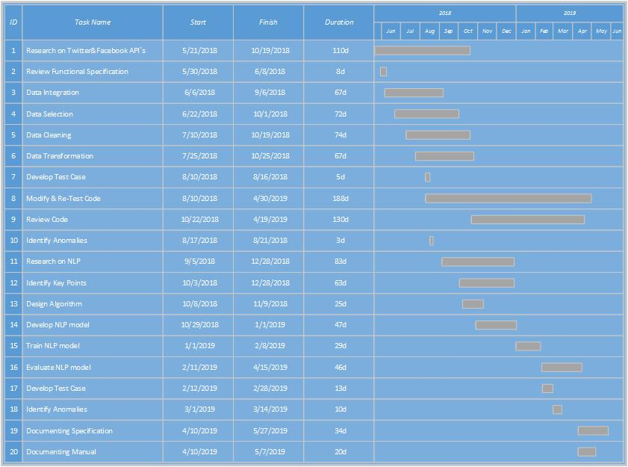

Figure 4 - Gantt chart for the Traffic Violation Detection Using Smart Systems

4.2 Milestones

* **At the end of First Evaluations**

By the end of first evaluation, we will have trained our model and that model will be able to differentiate between different types of vehicles. We will also be able to detect the first kind of violation i.e. when the signal is red and someone breaks the signal. The system will generate an alert

* **At the end of Second Evaluation:**

At the time of final evaluation, our model will be trained enough to detect few kinds of traffic violations and detect their number plates also.

# 5.0 Project Requirements

5.1 Software tools requirements

* Python – Programming language.
* HTML, CSS3, Angular 8 – For Web-Development.
* Anaconda – for Large-Scale data processing and scientific computing.
* Tensor Flow, Scikit, OpenCV – Open Source library for machine Learning

## 5.2 Hardware requirements

* Intel i7th-5600 (Client – Machine).



Figure 5 - Intel i7th - 5600U

# 6.0 Budget/Costing

## Budgeting Cost **-** of the Project

GPU`s are required for high-end processing which are pretty expensive hence we have decided to use Amazon Web Services (AWS) for our backend and model training which will cost us around 300$.

## 6.2 Total Budgeted Cost **-** of the Project

The total budgeted cost for the project is estimated up to be **50,000**

7.0 Project Deliverables

Following are the **project deliverables**:

* Requirements documentation.
* Design documents.
* Our own trained machine learning model

8.0 References

1. Ciolli, Robert. "Traffic violation detection, recording and evidence processing system." U.S. Patent 8,134,693, issued March 13, 2012.
2. Ciolli, Robert. "Traffic violation detection, recording and evidence processing system." U.S. Patent Application 10/555,634, filed November 30, 2006.
3. Vijverberg, Julien A., Nick AHM de Koning, Jungong Han, Peter HN de With, and Dion Cornelissen. "High-level traffic-violation detection for embedded traffic analysis." In *2007 IEEE International Conference on Acoustics, Speech and Signal Processing-ICASSP'07*, vol. 2, pp. II-793. IEEE, 2007.
4. Ni, Sze-Yao, Yuang-Tzong Lan, Tom CI Lin, and Yi-Wei Chen. "Automatic traffic violation detection system and method of the same." U.S. Patent Application 12/963,861, filed June 14, 2012.
5. Uy, Aaron Christian P., Rhen Anjerome Bedruz, Ana Riza Quiros, Argel Bandala, and Elmer P. Dadios. "Machine vision for traffic violation detection system through genetic algorithm." In *2015 International Conference on Humanoid, Nanotechnology, Information Technology, Communication and Control, Environment and Management (HNICEM)*, pp. 1-7. IEEE, 2015.
6. Danis, Robert. "Traffic Violation Photo Enforcement System." U.S. Patent Application 13/107,933, filed November 15, 2012.
7. A Lotufo, R. A., A. D. Morgan, and A. S. Johnson. "Automatic number-plate recognition." In *IEE Colloquium on Image Analysis for Transport Applications*, pp. 6-1. IET, 1990.
8. Fahmy, Maged MM. "Automatic number-plate recognition: neural network approach." In *Proceedings of VNIS'94-1994 Vehicle Navigation and Information Systems Conference*, pp. 99-101. IEEE, 1994.
9. Martinsky, Ondrej. "Algorithmic and mathematical principles of automatic number plate recognition systems." *Brno University of technology* (2007): 20-23.
10. Dhage, Manisha R., Gaurav V. Patil, Shrayank J. Mistry, Prathamesh N. Tambe, and Parag H. Nankar. "Automatic Traffic E-challan Generation Using Computer Vision." In *International Conference on Sustainable Communication Networks and Application*, pp. 203-213. Springer, Cham, 2019.