**pseudocode**

**Algorithm is_triangular(A)**

**//Array A is passed**

**n** ←size[A]

For j ← i+1 to n-3 do

For i ← 0 to n-2 do

For k ← j+1 to n-1 do

if A[i] + A[j] > A[k] and A[i] + A[k] > A[j] and A[j] + A[k] > A[i]

then return 1

return 0

**Analysis**

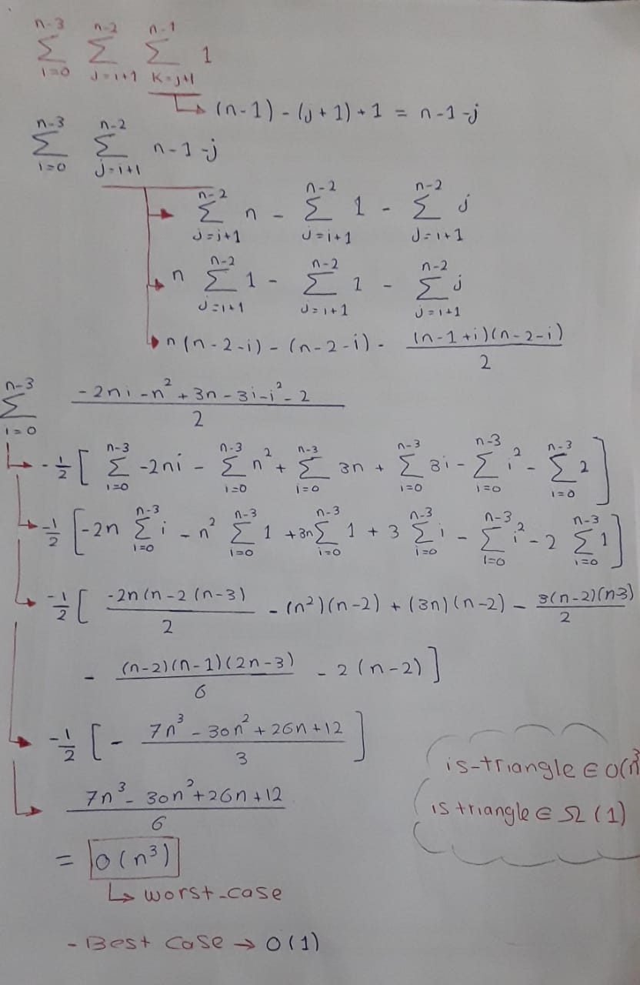

**Best Case** 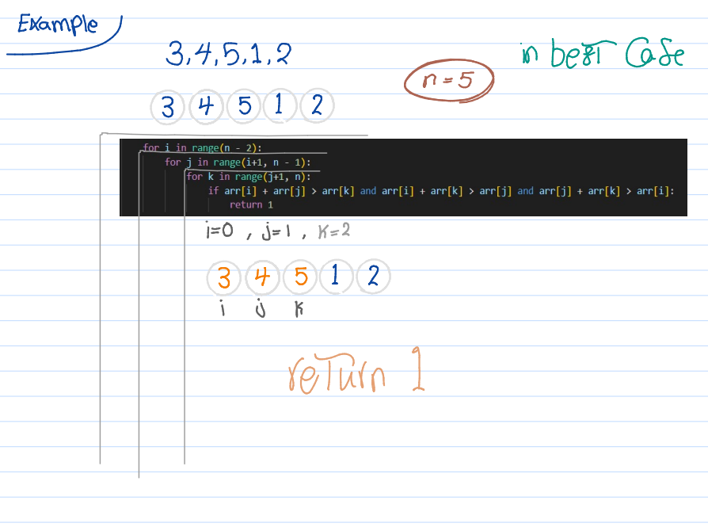

**Worst Case**

